Home work

BozhaoLi

9045 6522 68

Here are questions and deliverables for this problem.

1. Draw a diagram depicting the star schema of the warehouse. Indicate the keys and foreign keys in the tables.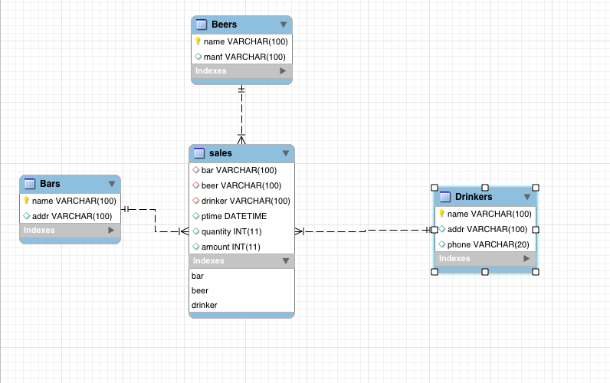

Bars key: name

Beers key: name

Drinkers key : name

Sales foreign keys: bar->Bars(name), beer->Beers(name), drinker->Drinkers(name)

1. Submit a SQL script that creates the “sales” table and load data (using “insert” command) into the table. You do not need to recreate dimension tables. . You should ignore the tuples in the Sells table with unknown prices, i.e., price is null

drop table if exists sales;

create table sales(bar varchar(100) ,

beer varchar(100) ,

drinker varchar(100) ,

ptime datetime, -- purchase time

quantity int

);

insert into sales select * from Purchase;

alter table sales add column amount int;

alter table sales add foreign key(bar) references Bars(name);

alter table sales add foreign key(beer)references Beers(name);

alter table sales add foreign key(drinker) references Drinkers(name);

SET SQL_SAFE_UPDATES = 0;

update sales,Sells set amount = Sells.price * quantity

where sales.bar = Sells.bar and sales.beer = Sells.beer;

delete from sales where amount is null;

1. Write SQL queries to perform the following analysis.
   1. Compute a breakdown of total sales amount by month. Which month has a better sale?

select month(ptime) , sum(amount) from sales

group by month(ptime)

order by sum(amount) desc;

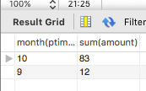

October has a better sale.

* 1. Slice result in 1) on the month of September and further drill down to bars dimension.

select bar,sum(amount) from sales

where month(ptime)=9

group by bar;

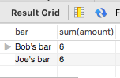

* 1. Slice result in 1) on the month of October and further drill down to bars dimension.

select bar,sum(amount) from sales

where month(ptime)=10

group by bar

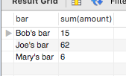;

* 1. Based on the analysis results so far, did you observe some bars sold more beers than other? If so, what are they? In which month?

Yes.

select bar, month(ptime),sum(amount) from sales

group by bar,month(ptime)

order by sum(ptime) desc;

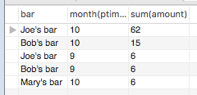

* 1. Now compute a breakdown of total sales amount by the manufacturer of beers. Which company was best performing (in terms of the total sales amount of its beers)?

select beer ,sum(amount) from sales

group by beer

order by sum(amount) desc;

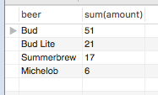

Bud company was best performing.

* 1. Drill-down the result in 5) by bars. Which bars helped most in selling the beers from the best performing company?

select bar ,sum(amount) from sales

where beer = (select beer from sales group by beer order by sum(amount) desc limit 1)

group by bar

order by sum(amount) desc;

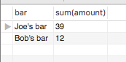

Joe’s bar helped most in selling the beers from the best performing company.

* 1. Now compute the breakdown of total sales amount by the bars. Which bars generated most of the revenue (in terms of total sales amount by the bar)?

select bar ,sum(amount) from sales

group by bar

order by sum(amount) desc;

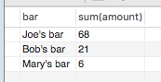

Joe’s bars generated most of revenue

* 1. Drill down result in 7) by location of bars. Where the most lucrative bars located?

select addr from Bars

where (select bar from sales group by bar order by sum(amount) desc limit 1) = name;

/Users/Joshua/Desktop/Screen Shot 2015-10-29 at 12.39.15.png

Maple St.

1. To speed up OLAP operations, data warehouse often anticipates the analytical needs and precompute some analysis results (stored in materialized views) which can then be utilized to answer new analytical queries. A key problem is to determine which views can be used to answer a given query. In this question, suppose that we have the following view:

create view bar_mon_view as

select bar, extract(month from ptime) mon, sum(amount) amt

from sales

group by bar, mon;

1. Can this view be used to compute the query “compute a breakdown of total sales amount by month”? If yes, write a SQL script that uses the view to answer the query.

Yes.

select mon,sum(amt) from bar_mon_view

group by mon

order by sum(amt) desc;

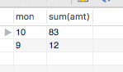

1. Can this view be used to compute the query “compute a breakdown of total sales amount by bar for the month of October”? If yes, write a SQL script that uses the view to answer the query.

Yes.

select sum(amt) from bar_mon_view

where mon=10

group by mon;

/Users/Joshua/Desktop/Screen Shot 2015-10-29 at 12.41.30.png