Crystal’s Airline Registration Engine

CPSC 3118

4 May 2014

Crystal Pendergrass

REQUIREMENTS DOCUMENT

|  |  |
| --- | --- |
| **Date submitted:** | 4 May 2015 |
| **Application title:** | Crystal’s Airline Registration Engine |
| **Purpose:** | The airline registration program allows the user to select a flight and enter personal details and ticket holder details. This information is added to a database. The user can also search for a ticket holder and view the ticket holder details. The user can also delete a ticket holder, freeing the ticket holder's seat |
| **Program Procedure:** | From a window the user should select flight details and enter name and contact information and the names and seat selection for each ticket. In a second window the user can search for a ticket and choose to delete that user. |
| **Algorithms, Processing, Conditions:** | 1. The user must select the origin city, destination city, flight date and ticket number in that order. 2. If the user does not properly select flight details then the user is warned by a message box and cannot proceed with flight selection. 3. Once the user selects a flight, the user can then enter contact information and the ticker holder information 4. Only the number textboxes corresponding to the number of tickets will be displayed 5. As the user selects a seat for each ticket, the seat becomes unavailable for other tickets. 6. When the user purchases the ticket(s) a message is displayed to confirm the purchase. 7. The user can open a second window to search for a ticket. 8. When the user successfully finds a ticket, information associated with that ticket is displayed, along with a button to delete that ticket. 9. If the user decided to delete the ticket, a message box appears to confirm the deletion and a message is displayed to confirm the user’s deletion. |
| **Notes and Restrictions:** | 1. This is a much scaled down system. 2. If there are multiple ticket holders sharing the same name, only the first will be displayed. This could be remedied in the future by populating a combobox with the flight details and seat selection that distinguish the two ticket holders. 3. Loading time for customer and ticket holder details is slow because multiple database queries are occurring at the same time. |

PRELIMINARY WIREFRAMES

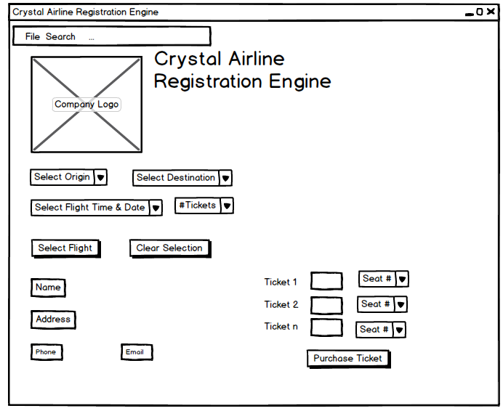

**Main Screen**

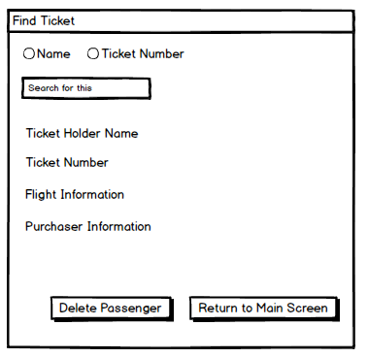

**Search Screen**

USER CASE DEFINITION

1. When the user opens the application a splash screen appears.
2. After the final screen the user can select a city of flight origin and the user’s flight destination and the number of tickets needed. If both the flight origin and destination are the same and error is displayed in message box.
3. The user is then prompted to select from a combobox of available flight dates and times.
4. If there are not enough tickets available on that flight the user is prompted to select another flight.
5. If there are enough tickets available on the flight, the user is prompted to provide contact information address, phone and e-mail address. The user is also prompted to enter ticket holder name and seat selection for each ticket.
6. Also from the menu strip, the user can search for a ticket holder and delete that ticket holder.
7. Also from the menu strip, when the selects Clear, the user is returned to original screen to begin the selection process all over again. User closes the reservation system by selecting Exit in the menu.