Crystal Pendergrass

Project Assignment #1

CPSC 3118

27 February 2015

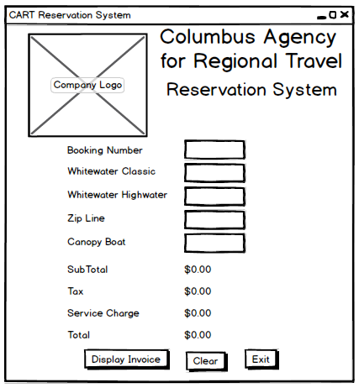

**USER CASE DEFINITION**

1. User enters the booking number and numbers of passengers for Whitewater Classic, Whitewater Highwater, Zip Line and Canopy Boat adventures into their respective textboxes.

2. When the user enters a booking number, the “Display Invoice” button is enabled.

3. If the user has entered a booking number and a number of passengers for at least one adventure, when the user clicks the “Display Invoice” button, the subtotal for all the adventures, tax, service charge and the final total for the reservation are calculated.

4. If the user either has not provided a booking number or a number of passengers for at least one adventure (i.e. the user entered these values previously thereby enabling the “Display Invoice,” but then deleting value(s)), when the user clicks the “Display Invoice” button, a warning is displayed, the “Display Invoice” button is disabled and no calculation is performed.

5. When the user clicks the “Clear” button, the textboxes and any current values calculated for the subtotal of all the adventures, tax, service charge and the final total for the reservation are cleared and the “Display Invoice” button is disabled.

6. User closes the reservation system by clicking the “Exit” button.