Crystal Pendergrass

Project Assignment #2

CPSC 3118

3 April 2015

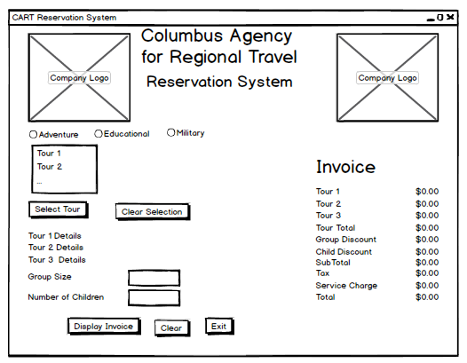

**USER CASE DEFINITION**

1. User selects what category of tours his group will take

2. When the user selects a category, then a list of tours available under that category is displayed. Buttons to select tours and clear tour selection become visible, but are not enabled.

3. When the user selects at least one tour then the select tours and clear tour selection buttons are enabled. If the user chooses a different category of tours or clicks the clear tour selections button, then his previous selections are erased. If the user selects more than 3 tours, he is warned with a message box and his selection is cleared.

4. When the user clicks the select tours button, then textboxes to enter the size of the group taking the tours and the number children aged less than 12 are visible.

5. Error message boxes are generated if the user enters negative numbers, non-numeric values or a value where the group size is less than the number of children in the group.

6. When the user clicks the display invoice button a invoice is generated summarizing the final cost of the tour(s) selected.

7. When the user clicks the “Clear” button, the user returns to the beginning of the tour selection process, seeing only the radio buttons to select what category of tour he would like to select. .

8. User closes the reservation system by clicking the “Exit” button.