Crystal Pendergrass

Project Assignment #3

CPSC 3118

17 April 2015

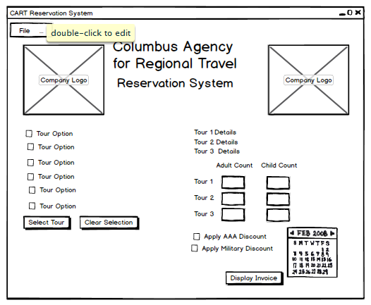

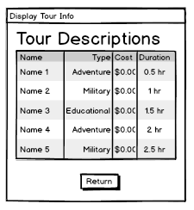 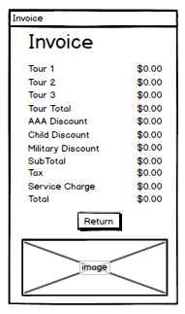

**USER CASE DEFINITION**

1. User will see a checkbox list of all available tours that the user can select from. Buttons to select tours and clear tour selection are visible and enabled.

2. If the user selects more than 3 tours, he is warned with a message box and his selection is cleared. If the user does not select any tours, the user is also warned. When the user selects 1 to 3 tours, a list is presented of all the tours selected and their respective price per participants.

3. Also when the user clicks the select tours button, then textboxes to enter the number of adults and children taking each tour, checkboxes to indicate if the user is eligible for AAA and/or military discounts and the user can schedule a date to take the tours.

4. Error message boxes are generated if the user enters negative numbers, non-numeric values or a value where the group size is less than the number of children in the group and if the user selects a date previous to today’s date to schedule the tour.

5. When the user clicks the display invoice button a new windows opens displaying the invoice which summarizes the final cost of the tour(s) selected.

6. At the top of the window is a menu. When the user selects Display Tour Cost, the name, type, cost and duration of each tour is displayed in a second window. When the selects Clear, the user is returned to original screen which just listed all available tours. User closes the reservation system by selecting Exit in the menu.