 | REPUBLIC OF THE PHILIPPINES  PROVINCE OF CAMARINES SUR  CITY OF IRIGA  PANLUNGSOD NA PEDERASYON NG MGA  SANGGUNIANG KABATAAN NG IRIGA | 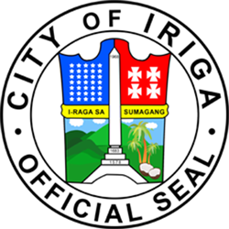

PANLUNGSOD NA PEDERASYON NG MGA KABATAAN
OFFICIAL LIST

User ID | Barangay | Name | Age | Birthday | Sex | Position
25-000001 | Antipolo | Luzano, Christian Nico Brizuela | 21 | 01/22/2004 | Male | Pederasyon President
25-826206 | Antipolo | Briones, Jillian Rose Briones | 21 | 05/13/2004 | Male | SK Councilor
25-301081 | Cristo Rey | Bayos, Dominic Barandon | 22 | 07/17/2003 | Male | Pederasyon Vice President

Prepared by:  _________________________  ________________  Pederasyon Secretary | Approved by:  _________________________  Christian Nico Brizuela Luzano  Pederasyon President

