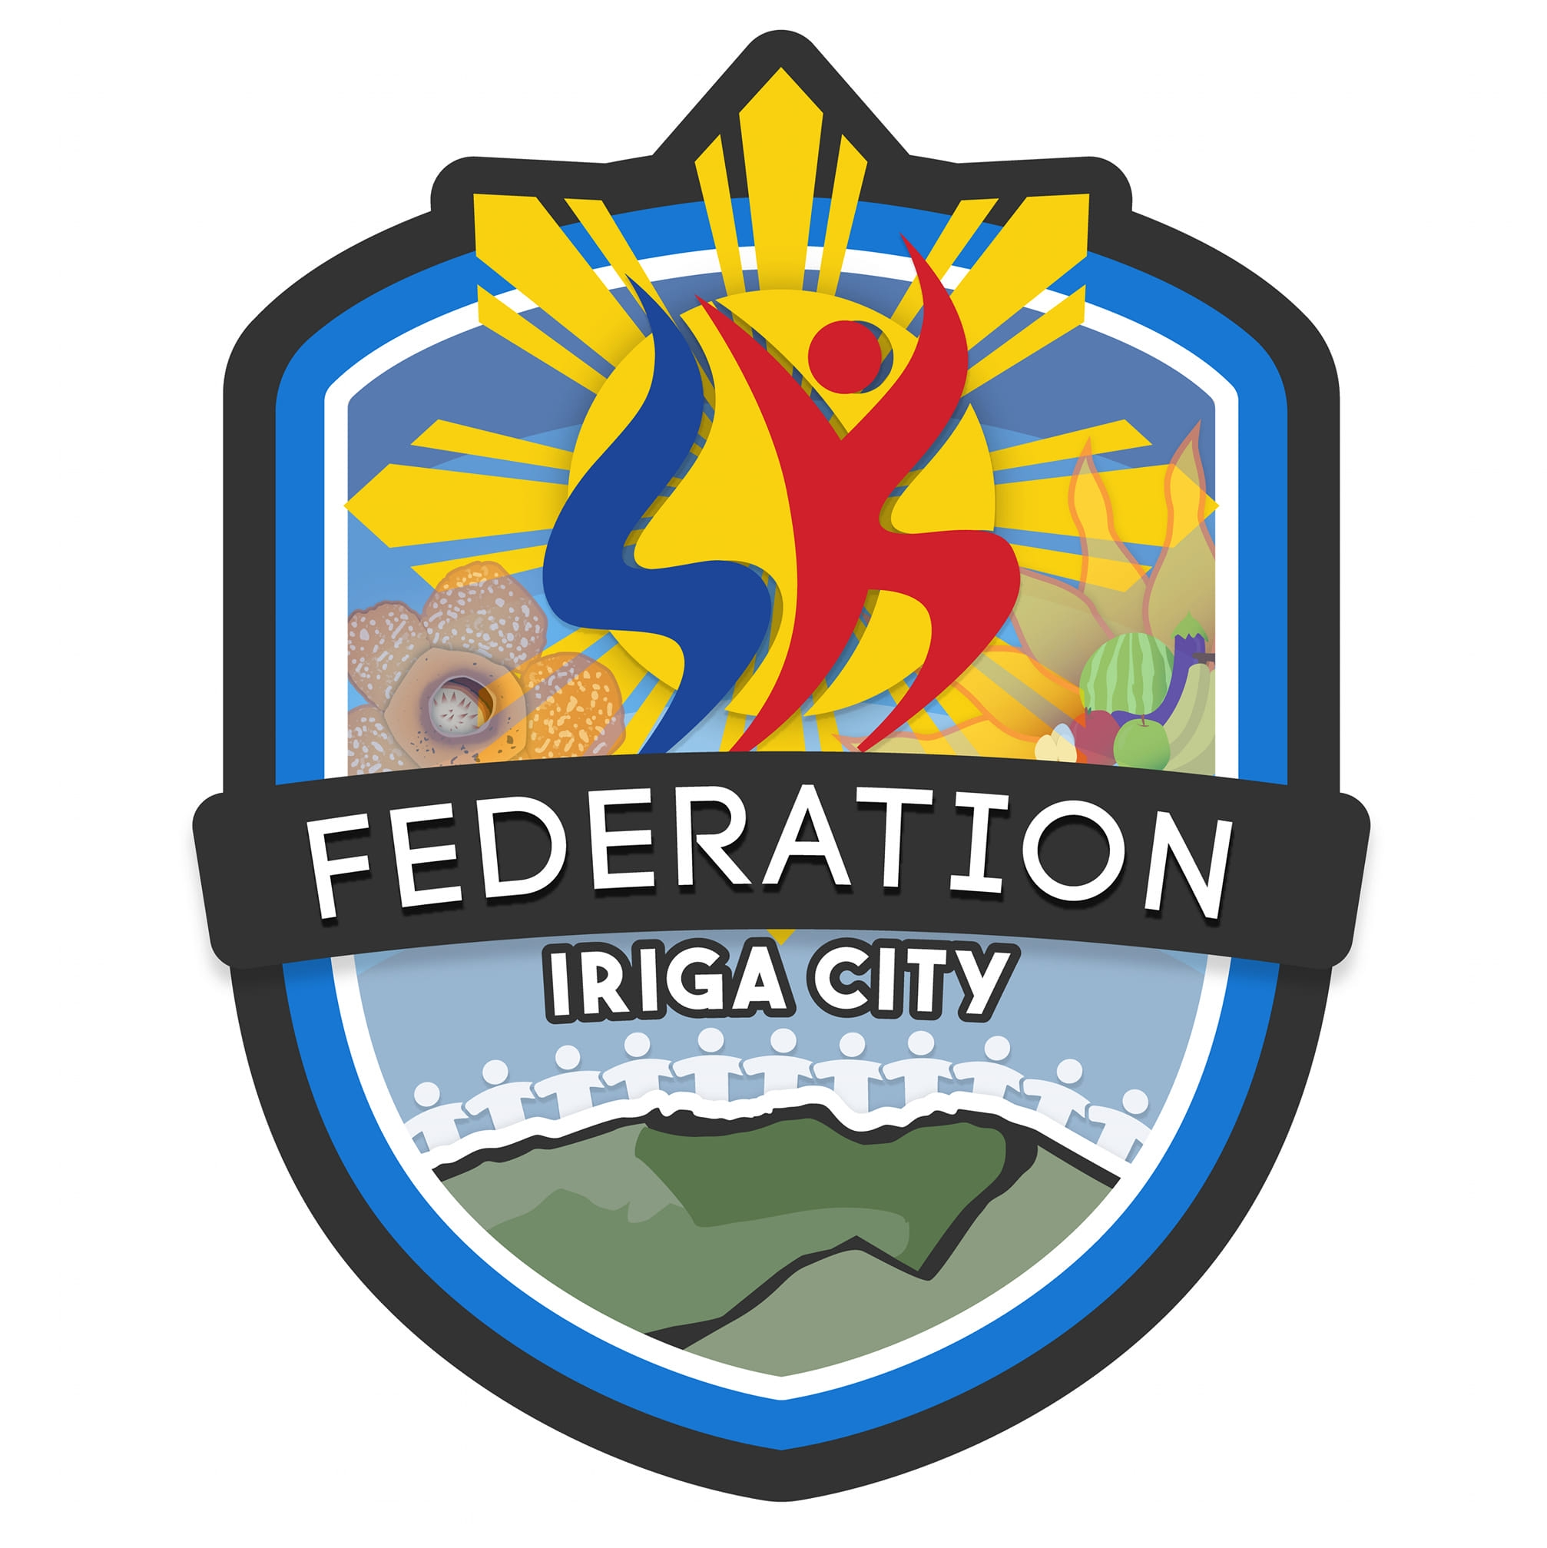 | REPUBLIC OF THE PHILIPPINES  PROVINCE OF CAMARINES SUR  CITY OF IRIGA  PANLUNGSOD NA PEDERASYON NG MGA  SANGGUNIANG KABATAAN | 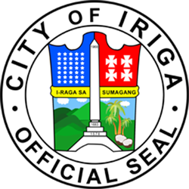

ATTENDANCE REPORT

Event: Green Youth Movement: Tree Planting and Clean-Up Drive
Date: September 26, 2025
Time: 5:00 AM - 5:00 PM
Location: Nabontolan Riverbanks, Iriga City

No. | KK Number | Name | Zone | AM Time-In | AM Time-Out | AM Status | PM Time-In | PM Time-Out | PM Status
1 | 25-000001 | Luzano, Christian Nico Brizuela | 1 | - | - | Absent | 06:00 PM | 07:43 PM | Complete

