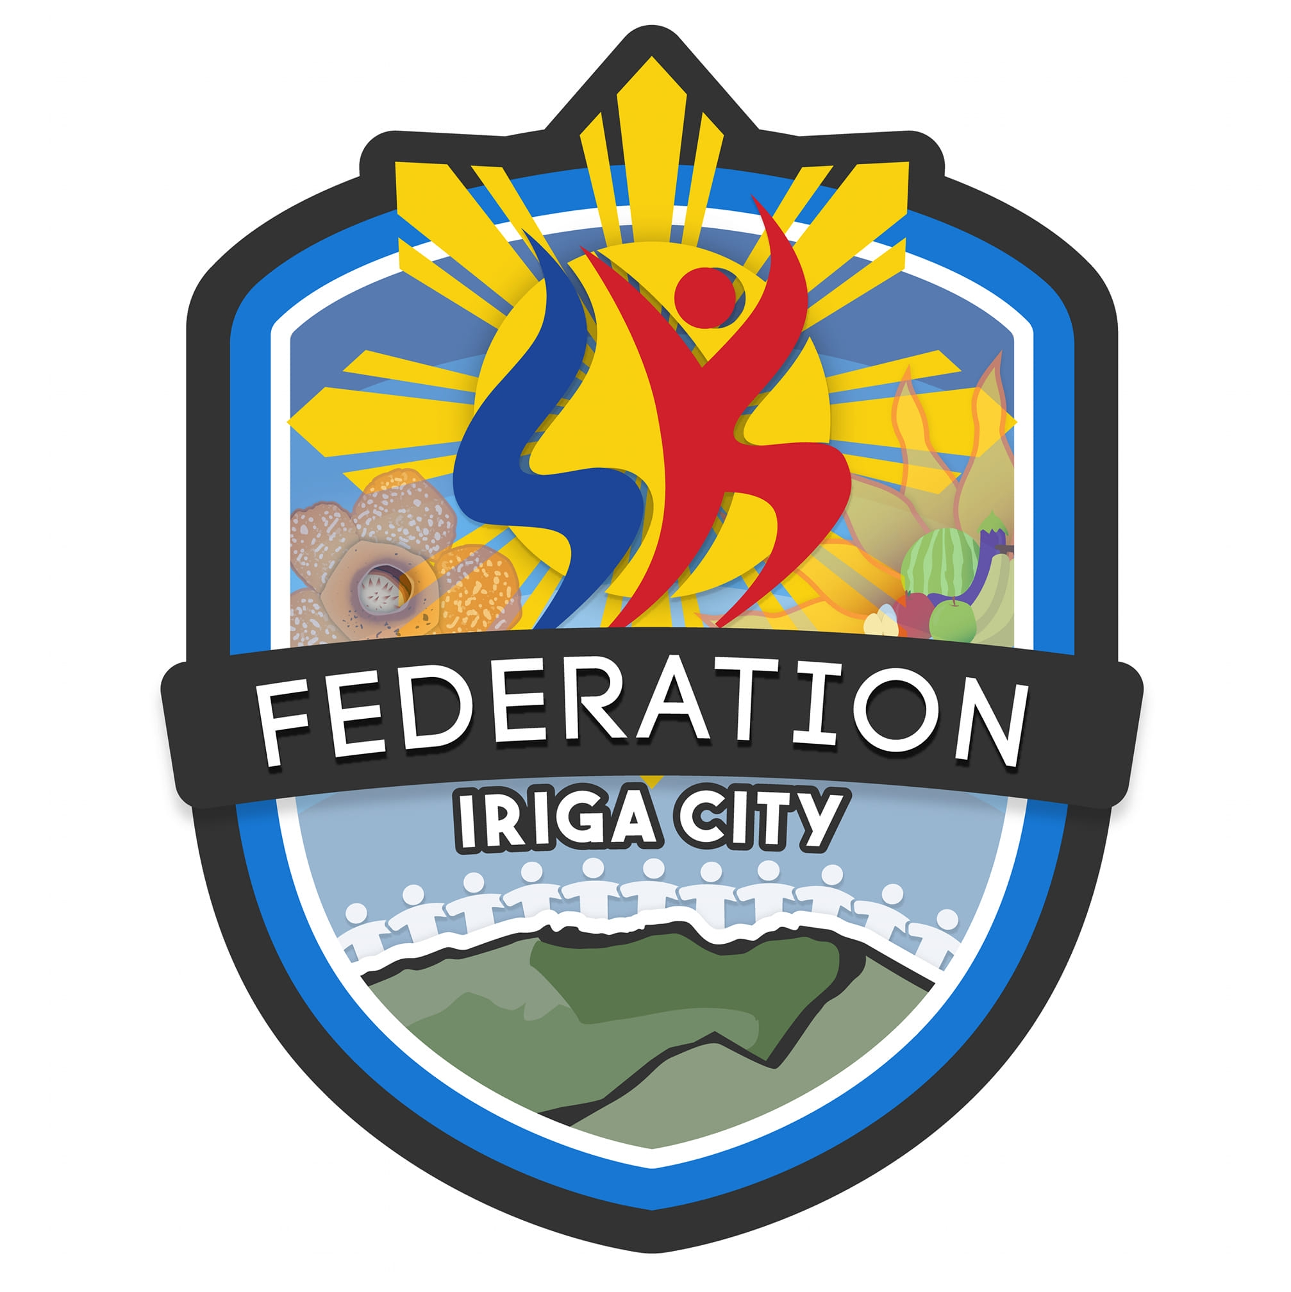 | REPUBLIC OF THE PHILIPPINES  PROVINCE OF CAMARINES SUR  CITY OF IRIGA  PANLUNGSOD NA PEDERASYON NG MGA  SANGGUNIANG KABATAAN | 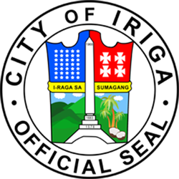

ATTENDANCE REPORT

Event: Youth Peace and Security Forum
Date: September 27, 2025
Time: 8:00 AM - 5:00 PM
Location: Iriga City Multipurpose Gymnasium

No. | KK Number | Name | Zone | AM Time-In | AM Time-Out | AM Status | PM Time-In | PM Time-Out | PM Status
1 | 25-000001 | Luzano, Christian Nico Brizuela | 1 | - | - | Absent | 05:12 PM | - | Present

