 | REPUBLIC OF THE PHILIPPINES  PROVINCE OF CAMARINES SUR  CITY OF IRIGA  PANLUNGSOD NA PEDERASYON NG MGA  SANGGUNIANG KABATAAN NG IRIGA | 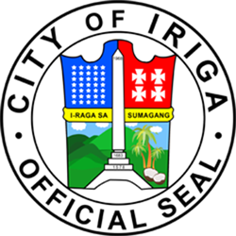

PANLUNGSOD NA PEDERASYON NG MGA KABATAAN
OFFICIAL LIST

User ID | Barangay | Name | Age | Birthday | Sex | Position
25-0000-01 | San Francisco | Lontayao, Dessa Mare Parma | 24 | 07/15/2001 | Female | Pederasyon President
25-0000-00 | San Francisco | Luzano, Christian Nico Brizuela | 21 | 01/22/2004 | Male | Pederasyon Sergeant at Arms

Prepared by:  _________________________  ________________  Pederasyon Secretary | Approved by:  _________________________  Dessa Mare Parma Lontayao  Pederasyon President

