Types of number system

1. Representations
a. Sign Magnitude
- The Most Significant Bit (MSB) indicates the sign (0 for positive, 1 for negative).
- The remaining bits represent the absolute value in binary form.
Example: For a 4-bit representation, +3 is 0011, and -3 is 1011.
Advantages: Intuitive and straightforward for conversion.
Disadvantages: Two representations for zero (0000 and 1000), and addition/subtraction require separate sign handling.
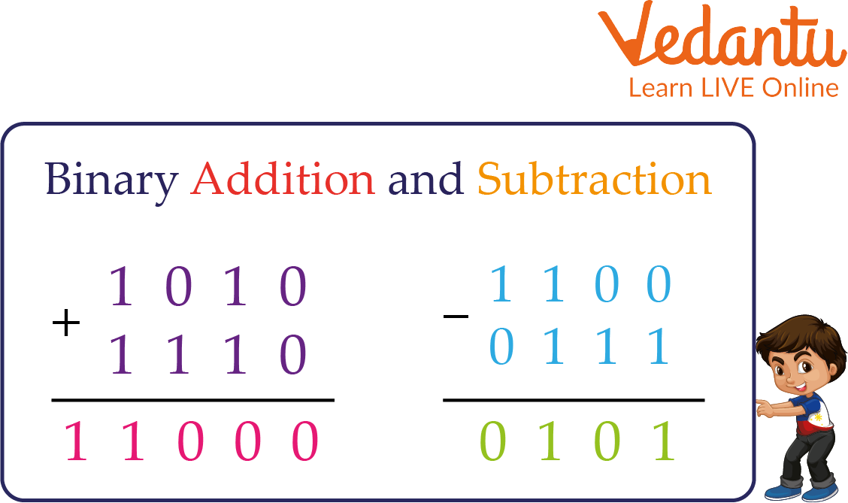
(Schematic of Sign Magnitude Representation)
b. Two’s Complement
- Positive numbers: Standard binary representation (MSB = 0).
- Negative numbers: Obtained by taking the two's complement of the positive counterpart (invert all bits and add 1).
- Unique representation for zero (all bits 0).
- Range for n bits: From −2n−1-2^{n-1}−2n−1 to 2n−1−12^{n-1} - 12n−1−1.
Example: For 4 bits, +3 is 0011; -3 is 1101 (invert 0011 to 1100, then add 1).
Advantages: Simplifies addition and subtraction as operations mimic unsigned arithmetic, without separate sign processing.
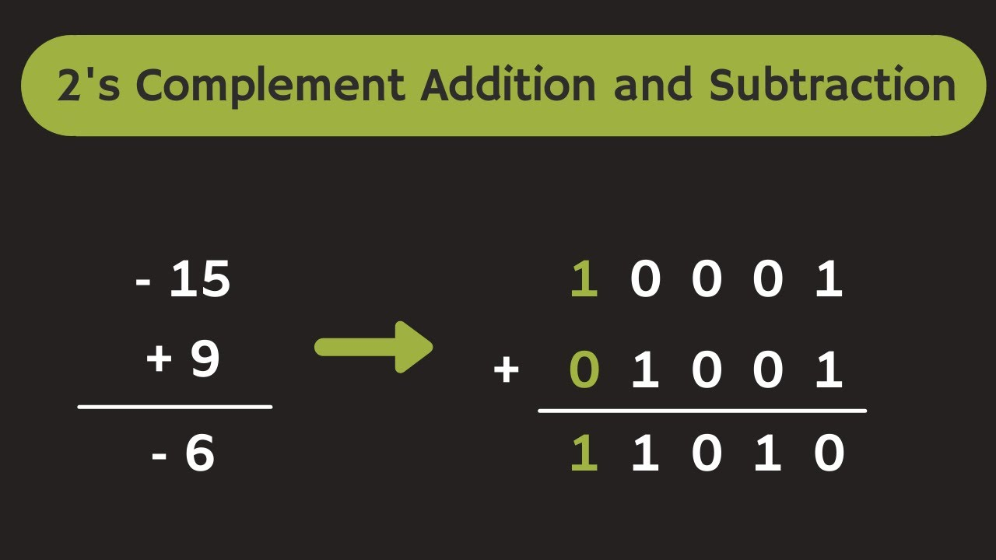
(Schematic of Two’s Complement Representation)
c. Biased (Excess)
- Commonly used for exponents in floating-point representations.
- Actual value = Stored value - bias.
- Bias typically equals 2k−1−12^{k-1} - 12k−1−1, where k is the number of exponent bits (e.g., bias = 127 for 8-bit exponents).
Example: With bias = 127, a stored exponent of 130 represents an actual value of 130 - 127 = 3.
Advantages: Enables unsigned comparisons for exponents.

2. Identifying Negative Numbers
Representation | Identification Method
Sign Magnitude | MSB = 1
Two’s Complement | MSB = 1
Biased | Stored value < bias (indicates negative actual value)

3. Sign-Extension Rule (Two’s Complement)
- When extending from n bits to m bits (where m > n):
  - Fill the additional leftmost bits with the MSB (sign bit) of the original number.
Example: Extending 1011 (4-bit, -5) to 8 bits yields 11111011.

4. Negation in Two’s Complement
- Invert all bits (one's complement).
- Add 1 to the result.
Example: +5 (0101) → Invert to 1010 → Add 1 = 1011 (-5).
5. When Two’s Complement Equals the Original Number
- Occurs when the number is 0 or the minimum representable value
(−2n−1-2^{n-1}−2n−1).
Example: In 4 bits, -8 (1000) negates to itself due to overflow.

6. Distinctions
- Two’s complement representation: The storage format for numbers in memory.
- Two’s complement of a number: The operation to obtain the negation.

7. Why Unsigned Addition Works but Multiplication Does Not
- Addition: Overflow behaves as modulo 2n2^n2n, aligning with two’s complement semantics (carry-out is ignored).
- Multiplication: Results may require up to 2n bits; truncating high bits loses sign and value information.
Example: Multiplying two 8-bit numbers can produce a 16-bit result, but retaining only the lower 8 bits leads to inaccuracies.

8. Four Basic Components of Floating-Point Numbers
- Sign bit (0 for positive, 1 for negative).
- Exponent (biased for representation).
- Significand (mantissa, the fractional part, normalized).
- Base (typically 2).
General Formula:
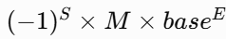, baseEwhere M = 1 + fraction (in normalized form).
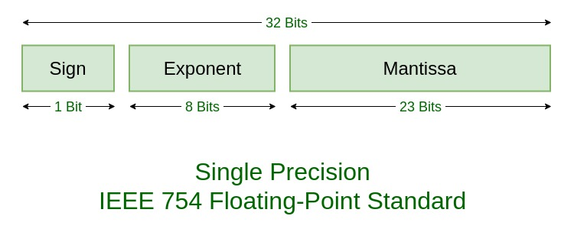
(IEEE 754 Single-Precision Format Diagram)
9. Benefits of Biased Exponents
- Allows exponent comparisons using unsigned arithmetic.
- Avoids negative stored exponents (always non-negative).
- Facilitates sorting and hardware implementation.

10. Distinguishing Overflow Types
- Positive overflow: Result exceeds the maximum positive representable value.
- Exponent overflow: Exponent surpasses limits, yielding ±∞ (per IEEE standards).
- Significand overflow: Mantissa exceeds normalization range, requiring right-shift and exponent increment.

11. Steps for Floating-Point Addition/Subtraction
- Align exponents (shift significand of the smaller exponent).
- Add or subtract significands.
- Normalize the result (shift to 1.xxxx form).
- Round the value.
- Check for overflow/underflow.
Guard Bits: Additional bits (typically 3: guard, round, sticky) to minimize rounding errors during shifts and operations.

12. Four Floating-Point Rounding Methods
- Round to nearest even (IEEE-754 default, ties to even).
- Round toward +∞ (upward).
- Round toward –∞ (downward).
- Round toward 0 (truncation).

13. 16-Bit Representations
+512
- Binary: 512 = 292^929 → 0000001000000000.
Sign-Magnitude (16-bit): 0 followed by 000001000000000 → 0000001000000000.
Two’s Complement: Identical to positive form → 0000001000000000.
–29
- 29 in binary = 0000000000011101.
Sign-Magnitude (16-bit): MSB = 1 → 1000000000011101.
Two’s Complement:
- Start with 0000000000011101.
- Invert → 1111111111100010.
- Add 1 → 1111111111100011.
14. Converting Two’s Complement to Decimal
a) 1101011 (7-bit)
- MSB = 1 (negative).
- Invert: 0010100 (= 20 decimal).
- Add 1: 0010101 (= 21). → Result: -21.
b) 0101101 (7-bit)
- MSB = 0 (positive). = 45 decimal (32 + 8 + 4 + 1).

15. 8-Bit Two’s Complement Operations (Displayed in 8-Bit Binary)
(Illustration of Two’s Complement Addition)
Steps to Solve Problems:
- Convert operands to 8-bit two’s complement if needed (positive: binary; negative: invert positive binary and add 1).
- Perform binary addition, ignoring carry-out beyond 8 bits.
- Interpret result: If MSB = 1, convert to decimal negative; else positive.
- Verify no overflow (result within -128 to 127).
a) 6 + 13
- 6 = 00000110
- 13 = 00001101
- Sum: 00010011 = 19 (decimal).
b) −6 + 13
- −6: Two’s complement of 6 (invert 00000110 → 11111001, add 1 → 11111010).
- 13 = 00001101
- Sum: 00000111 = 7 (decimal).
c) 6 − 13 = 6 + (−13)
- −13: Two’s complement of 13 (invert 00001101 → 11110010, add 1 → 11110011).
- 6 = 00000110
- Sum: 11111001 = -7 (decimal).
d) −6 − 13 = (−6) + (−13)
- −6 = 11111010
- −13 = 11110011
- Sum: 11101101 = -19 (decimal).
(Note: All results fall within -128 to 127, with no overflow.)

16. IEEE 32-Bit Floating-Point to Decimal Conversion
(IEEE 754 Single-Precision Floating-Point Format)
Rule: Value =
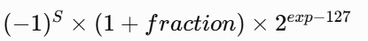
(excluding denormalized, NaN, or infinity cases).

Steps to Solve Problems:
1, Extract sign (S), exponent (exp: 8 bits), and fraction (23 bits).
2, Compute biased exponent: E = exp - 127.
3, Significand = 1 + (fraction / 2232^{23}223).
4, Calculate value using the formula.
5, Handle special cases if applicable (none here).
a) 1 10000011 11000000000000000000000
- S = 1 (negative).
- exp = 10000011 = 131 → E = 131 - 127 = 4.
- Fraction = 110000... = 0.75 (binary 0.11)
→ Significand = 1.75 → Value = -1.75 × 242^424 = -28.
b) 0 01111110 10100000000000000000000
- S = 0 (positive).
- exp = 01111110 = 126 → E = 126 - 127 = -1.
- Fraction = 101000... = 0.625 (binary 0.101)
→ Significand = 1.625 → Value = 1.625 × 2−12^{-1}2−1 = 0.8125.

c) 0 10000000 00000000000000000000000
- S = 0 (positive).
- exp = 10000000 = 128 → E = 128 - 127 = 1.
- Fraction = 000000... = 0
→ Significand = 1.0 → Value = 1.0 × 212^121 = 2.

