Boolean Algebra

- Construct three way (A truth table,Graphical symbol, Boolean equation) for the following Boolean expressions:
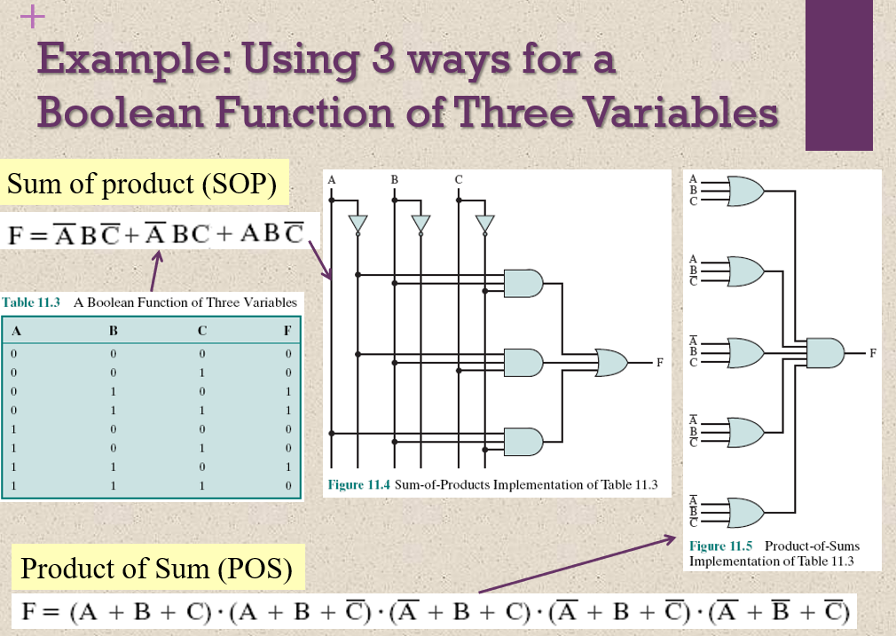
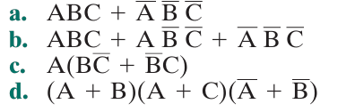
- Construct the operation XOR from the basic Boolean operations AND, OR, and NOT
- Given a NOR gate and NOT gates, draw a logic diagram that will perform the three- input AND function.
- Write the Boolean expression for a four- input NAND gate.

