Boolean Algebra
Answer:

1,Construct three way (A truth table,Graphical symbol, Boolean equation) for the following Boolean expressions:
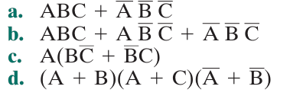

a. F = ABC + A̅B̅C̅
A | B | C | ABC | A̅B̅C̅ | F = ABC + A̅B̅C̅
0 | 0 | 0 | 0 | 1 | 1
0 | 0 | 1 | 0 | 0 | 0
0 | 1 | 0 | 0 | 0 | 0
0 | 1 | 1 | 0 | 0 | 0
1 | 0 | 0 | 0 | 0 | 0
1 | 0 | 1 | 0 | 0 | 0
1 | 1 | 0 | 0 | 0 | 0
1 | 1 | 1 | 1 | 0 | 1

Step to slove problem:
- Boolean Equation: The equation is given in the Sum of Products (SOP) form.
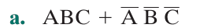
- Truth Table: We create a table with 3 input variables: A, B, and C.
+ The F column will have a value of 1 when A=1, B=1, C=1 (corresponding to ABC) or when A=0, B=0, C=0 (corresponding to A̅B̅C̅).
Logic Gate Diagram:
- You need 3 NOT gates to create A̅, B̅, and C̅.
- You need two 3-input AND gates:
- One gate for the product ABC.
- One gate for the product A̅B̅C̅.
- You need one 2-input OR gate to sum the results from the two AND gates.
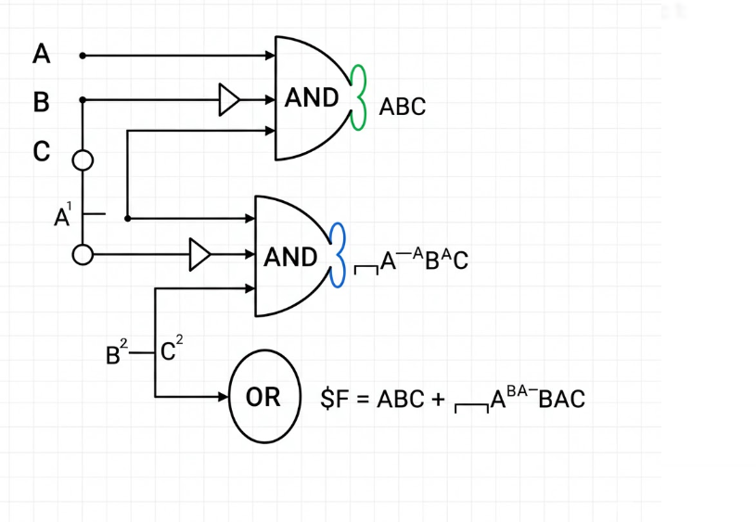
b. F = ABC + AB̅C + A̅BC̅

A | B | C | ABC | AB̅C | A̅BC̅ | F
0 | 0 | 0 | 0 | 0 | 0 | 0
0 | 0 | 1 | 0 | 0 | 0 | 0
0 | 1 | 0 | 0 | 0 | 1 | 1
0 | 1 | 1 | 0 | 0 | 0 | 0
1 | 0 | 0 | 0 | 0 | 0 | 0
1 | 0 | 1 | 0 | 1 | 0 | 1
1 | 1 | 0 | 0 | 0 | 0 | 0
1 | 1 | 1 | 1 | 0 | 0 | 1

Step to solve problem:
- Boolean Equation:
- Truth Table: The F column will have a value of 1 at the rows corresponding to the products: A=1, B=1, C=1 (ABC); A=1, B=0, C=1 (AB̅C); and A=0, B=1, C=0 (A̅BC̅).
-Logic Gate Diagram:
- NOT gates to create A̅, B̅, and C̅.
- Add three 3-input AND gates for each product term.
- Add one 3-input OR gate to sum the results of the 3 AND gates.
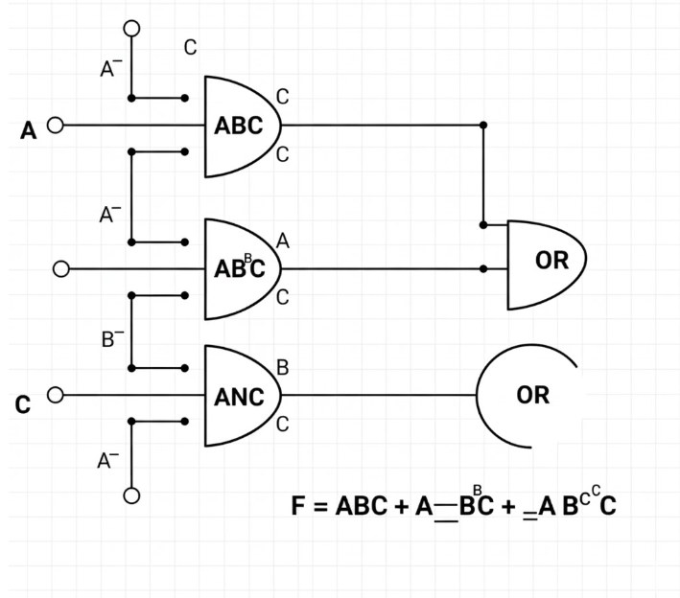

c. F = A(B̅C̅ + BC)
A | B | C | B̅C̅ | BC | X = B̅C̅+BC | F = A · X
0 | 0 | 0 | 1 | 0 | 1 | 0
0 | 0 | 1 | 0 | 0 | 0 | 0
0 | 1 | 0 | 0 | 0 | 0 | 0
0 | 1 | 1 | 0 | 1 | 1 | 0
1 | 0 | 0 | 1 | 0 | 1 | 1
1 | 0 | 1 | 0 | 0 | 0 | 0
1 | 1 | 0 | 0 | 0 | 0 | 0
1 | 1 | 1 | 0 | 1 | 1 | 1

Step to Solve problem:
- Boolean Equation: The equation can be kept as is or expanded into the SOP form:

- Truth Table: We first calculate the value of the expression in the parentheses, X = B̅C̅ + BC, and then calculate F = A · X.
Logic Gate Diagram: This diagram can be drawn in 2 ways corresponding to the two forms of the equation. Below is the method for the original equation:
- NOT gates for B̅ and C̅.
- Two 2-input AND gates (for B̅C̅ and BC).
- One 2-input OR gate to sum the results from the two AND gates.
- One 2-input AND gate to multiply the result of the OR gate with A.
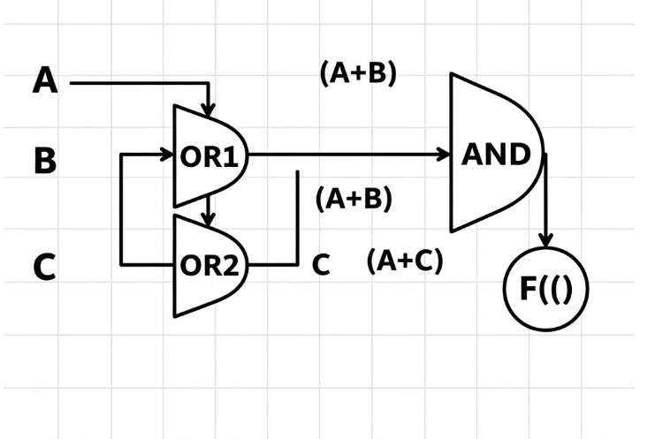

d. F = (A + B)(A + C)(A̅ + B̅)
A | B | C | A+B | A+C | A̅+B̅ | F
0 | 0 | 0 | 0 | 0 | 1 | 0
0 | 0 | 1 | 0 | 1 | 1 | 0
0 | 1 | 0 | 1 | 0 | 1 | 0
0 | 1 | 1 | 1 | 1 | 1 | 1
1 | 0 | 0 | 1 | 1 | 1 | 1
1 | 0 | 1 | 1 | 1 | 1 | 1
1 | 1 | 0 | 1 | 1 | 0 | 0
1 | 1 | 1 | 1 | 1 | 0 | 0

Step to solve problem:
- Boolean Equation: This equation is in the Product of Sums (POS) form.
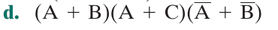
- Truth Table: We calculate the value of each sum in the parentheses, then multiply them together. F will be 0 if any sum in the parentheses is 0.
Logic Gate Diagram:
  - NOT gates for A̅ and B̅.
  - Need three 2-input OR gates:
+ One gate for (A + B).
+ One gate for (A + C).
+ One gate for (A̅ + B̅).
  - Add one 3-input AND gate to multiply the results of the 3 OR gates.

2,Construct the operation XOR from the basic Boolean operations AND, OR, and NOT
- The construct the XOR (Exclusive OR) operation from the three basic Boolean operations (AND, OR, NOT) using a specific formula.
- The logical statement for XOR is "one or the other, but not both." This translates directly into a Boolean expression.
1. Truth Table for XOR
First, let's define what an XOR gate does. The output X is 1 only when the inputs A and B are different.
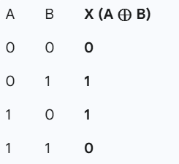
2. Boolean Expression
To build this with basic operations, we look at the rows where the output is 1:
- The output is 1 when A is 0 AND B is 1 (which is A̅B).
- The output is also 1 when A is 1 AND B is 0 (which is AB̅).
Since the output can be true in either of these cases, we combine them with an OR operation.
This gives us the standard Boolean equation for XOR:

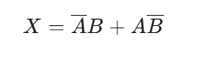
3. Logic Gate Construction
Based on the equation above, you can construct the XOR operation with the following gates:
- Two NOT gates to get A̅ and B̅.
- Two AND gates to get the products A̅B and AB̅.
- One OR gate to add the results of the AND gates together.

3,Given a NOR gate and NOT gates, draw a logic diagram that will perform the three- input AND function.

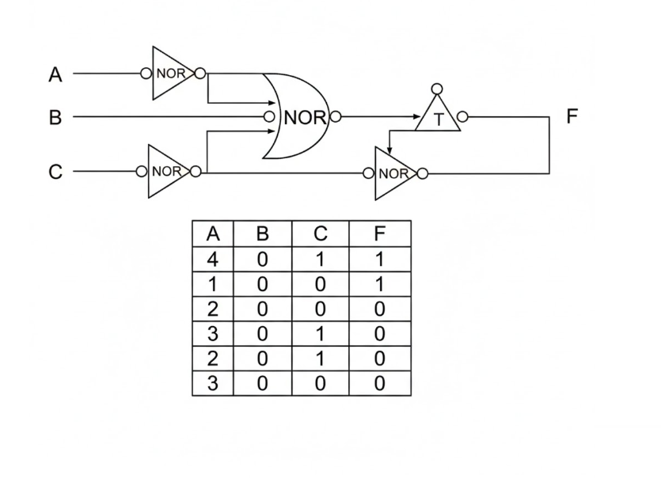

4, Write the Boolean expression for a four- input NAND gate.
The Boolean expression for a four-input NAND gate is the negation of the AND operation on all its inputs.
For a gate with inputs A, B, C, and D, the expression is:
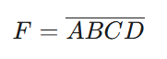
The name NAND is a contraction of "NOT AND". This means the output F is 0 only when all inputs (A, B, C, and D) are 1. For any other combination of inputs, the output will be 1.

Example:
Let's calculate the output F for two different sets of inputs.
Case 1: All inputs are 1
If the inputs are A=1, B=1, C=1, and D=1:
- First, the AND operation is performed: 1 ⋅ 1 ⋅ 1 ⋅ 1 = 1.
- Then, the NOT operation inverts the result: F = 1̅ = 0.
So, the output F is 0.
Case 2: At least one input is 0
If the inputs are A=1, B=1, C=0, and D=1:
- First, the AND operation is performed: 1 ⋅ 1 ⋅ 0 ⋅ 1 = 0.
- Then, the NOT operation inverts the result: F = 0̅ = 1.
So, the output F is 1.

- This demonstrates the core rule of a NAND gate: the output is 0 only when all of its inputs are 1. In every other case, the output is 1.

