Report
- About DMA-Direct Memory Access:
A DMA (Direct Memory Access) controller allows peripherals to read/write data directly from/to system memory without continuous CPU intervention.
Mechanism
- Setup by CPU:
  - CPU programs the DMA controller with source address, destination address, data length, and transfer mode.
  - Example: source = I/O device buffer, destination = RAM.
- Bus Arbitration:
  - When ready, DMA controller requests control of the system bus (via HOLD/HOLDA in Intel 8086 style).
  - CPU suspends bus activity and grants bus control.
- Data Transfer:
  - DMA controller places memory address on the address bus.
  - It asserts control signals (MEMR, MEMW, IOR, IOW) to move data between I/O device and memory.
  - CPU is idle during the actual transfer (except for “cycle stealing” where CPU runs between DMA bursts).
- Completion:
  - After the transfer count reaches zero, DMA controller sends an interrupt to CPU.
  - CPU resumes normal execution.

Memory Diagram (simplified):
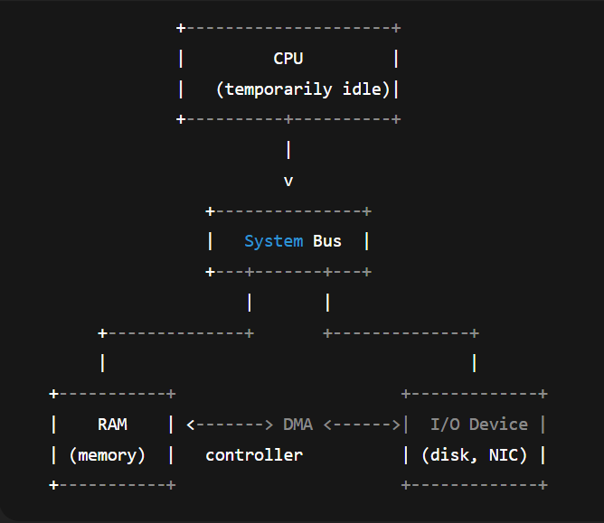
THESE MODELS DMA USING ON PROCESS:
- Burst mode: DMA transfers entire block, CPU halted.
- Cycle stealing: DMA transfers one word per cycle, CPU interleaves execution.
- Transparent mode: DMA works only when CPU is not using the bus.

2. About Comparison: I/O-Mapped I/O vs Memory-Mapped I/O

- I/O-Mapped I/O (Isolated I/O)
+ Separate address space for I/O (different from memory).
+ CPU uses special instructions (IN, OUT).
+ Requires separate control signals (IO/M).
+ Example: Intel 8086 uses ports like 60h for keyboard.
+ Pros: Keeps memory space intact, easy to distinguish between memory and devices.
- Cons: Limited number of I/O ports (256 or 64K), more complex programming (must use IN/OUT), CPU needs extra instructions.

- Memory-Mapped I/O (MMIO)
+ I/O devices share the same address space with memory.
+ CPU uses normal memory instructions (LOAD, STORE, MOV).
+ No need for separate I/O instructions.
+ Example: ARM processors map device registers into RAM space (e.g., 0x3F200000 for GPIO on Raspberry Pi).
- Pros: Full CPU instruction set can be used, easier programming, can use cache and optimization, simpler CPU design.
- Cons: Reduces usable RAM space, may cause address conflicts if not managed, harder to clearly separate memory and devices.

Example simply:
+ I/O-Mapped: “I/O lives in a separate neighborhood with its own gate.”
+ MMIO: “I/O lives in the same city as RAM, just a different street address.”
I/O-Mapped I/O (Isolated I/O)
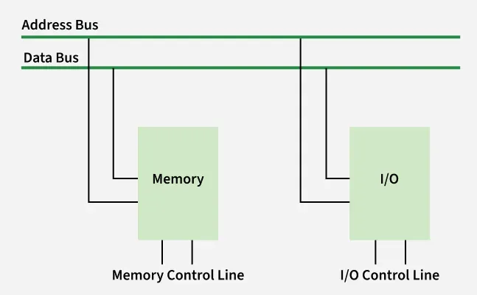
I/O-Mapped I/O (or Isolated I/O) is a communication mechanism between the CPU and peripheral devices in which the I/O address space is separated from the memory address space. This method is used in many traditional computer architectures, especially on the Intel x86 microprocessor line.
Operating principle
+CPU distinguishes two types of space: memory space and I/O space.
+Peripheral devices are assigned port addresses (I/O port).
+CPU accesses devices through specialized instructions (IN, OUT).
+The control bus has its own signal to determine the memory access cycle or I/O.
I/O-Mapped I/O is a clear technical solution in separating memory and peripherals. However, the limited flexibility makes this method less used in modern computer systems. Memory-Mapped I/O has become a more popular choice. 1. Introduction

Memory-Mapped I/O (MMIO)
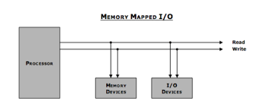
Memory-Mapped I/O (MMIO) is a mechanism that allows the CPU to access peripheral devices by mapping the device's control registers and data areas into the same address space as main memory. This means that the peripheral is treated similarly to RAM or ROM memory areas.
Operating principle
+The CPU treats the device's I/O registers as normal memory cells.
+Memory read/write instructions (MOV, LOAD, STORE, …) are used to communicate with the device.
+The memory address space and I/O share the same space.
+Peripherals are allocated a specific address range in the system memory space
Memory-Mapped I/O is the current popular method of communication between CPU and peripheral devices. Although it occupies memory space, its advantages in performance, programming and scalability make it the standard choice in most modern computer architectures.
Summarise:
- MMIO is standard in most modern RISC architectures (such as ARM in phones and microcontrollers) and is how high-speed devices in today's computers (such as graphics card caches or PCIe bus registers) are accessed.
+ For example: Writing data directly to a graphics card's VRAM (Video RAM) is done with a {MOV} instruction to a mapped memory address.
- In summary, Isolated I/O prioritizes preserving memory address space and simplifying low-level I/O hardware, making it suitable for legacy systems or simple microcontrollers.
- In contrast, MMIO prioritizes programming flexibility and high access speed, making it a popular choice for modern computer systems and microprocessors.

- ABOUT RAID (Redundant Array of Independent/Inexpensive Disks)
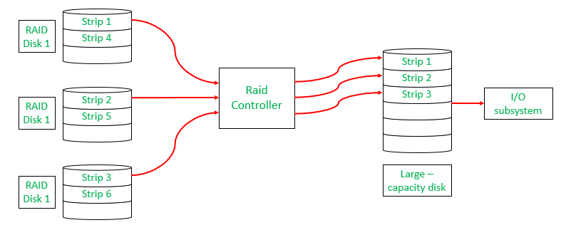
RAID is a data storage virtualization technology that combines multiple physical hard drives into one or more logical units to achieve increased performance, data redundancy, or both.
Principles and objectives
+Disk aggregation: Use ≥2 physical drives to create a single logical block.
+Performance: Improve read/write speed by distributing data across multiple drives, allowing parallel access.
+Fault Tolerance: Protect data against drive failure by copying or storing error checking information (parity).
+Does not replace Backup: RAID only protects against drive failures, does not prevent data loss due to accidental deletion, malware attacks, fire, theft.
Main techniques
Striping (RAID 0)
Mechanism: Divide data into blocks and write sequentially on multiple drives.
Goal: Maximize speed.
Limitations: No redundancy, failure of 1 drive → loss of all data.
Mirroring (RAID 1)
Mechanism: Write identical data to 2 (or more) drives.
Goal: 100% data redundancy.
Limitations: Available capacity = 50% of total drive.
Parity (RAID 5, RAID 6)
Mechanism: Calculate blocks containing error checking information from data and distribute them across drives.
Goal: Provide redundancy with better capacity efficiency than mirroring.
Function: When 1 drive fails, data is recovered from the remaining data + parity. RAID 6 allows simultaneous failure of 2 drives.
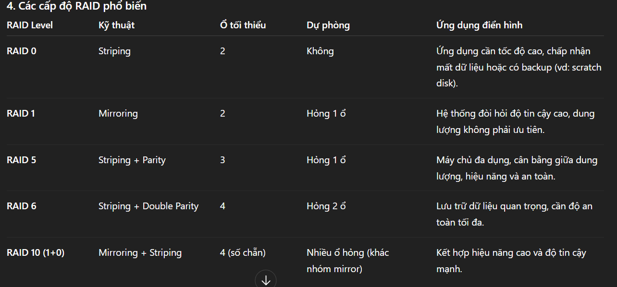
Conclusion
RAID is a storage virtualization solution that combines multiple physical drives into logical units to achieve higher performance, fault tolerance, or both.
- Core techniques include:
+ Striping: focuses on performance, no redundancy (RAID 0).
+ Mirroring: ensures full data safety, but reduces usable capacity (RAID 1).
+ Parity: balances safety and capacity (RAID 5, RAID 6).
- Characteristics of common RAID levels:
+ RAID 0: maximum speed, but high data loss risk.
+ RAID 1: complete redundancy, at the cost of capacity.
+ RAID 5/6: balance between performance, capacity, and reliability.
+ RAID 10: combines striping and mirroring, suited for high-performance, high-reliability systems.
RAID is not a substitute for backup: while it provides protection against hardware failure, it does not prevent data loss caused by accidental deletion, malware, fire, or theft.
The choice of RAID level depends on the system’s requirements (speed, capacity, reliability) and hardware budget. In practice, RAID is often deployed alongside a proper backup strategy to ensure comprehensive data protection.

