Chunyuan Shen

ID:801322013

Homework 2

<https://github.com/cryyin/ECGR5105/tree/main/homework3>

**Problem 1 (40pts):**

Use the cancer dataset to build a Naïve Bayesian model to classify the type of cancer (Malignant vs. benign). Plot your classification accuracy, precision, and recall. Explain and elaborate on your results. Can you compare your results against the logistic regression classifier you did in previous homework.

Naïve Bayesian model：

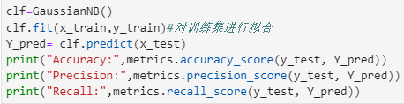

We know that Bayes' theorem is: $\text{P}\left(\text{A} ∣ \text{B}\right)=\frac{\text{P}\left(\text{B} ∣ \text{A}\right)\text{P}\left(\text{A}\right)}{\text{P}\left(\text{B}\right)}$

Use machine learning x, y to replace events A and B to get the formula could be used in machine learning.

Result：

Accuracy: 0.9298245614035088

Precision: 0.9253731343283582

Recall: 0.9538461538461539

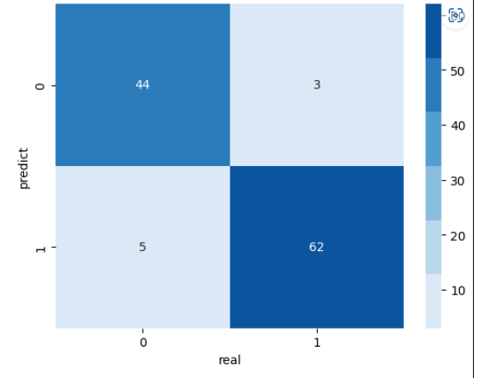

In the previous homework its result is 0.9473684210526315, better than this time’s.

**Problem 2 (40pts):**

Use the cancer dataset to build a logistic regression model to classify the type of cancer (Malignant vs. benign). Use the PCA feature extraction for your training. Perform N number of independent training (N=1, …, K). Identify the optimum number of K, principal components that achieve the highest classification accuracy. Plot your classification accuracy, precision, and recall over a different number of Ks. Explain and elaborate on your results.

 When k=9 it has the best performance:

Accuracy: 0.9736842105263158

Precision: 0.9558823529411765

Recall: 1.0

|  |  |  |  |
| --- | --- | --- | --- |
| k | accuracy | precision | recall |
| 1 | 0.912281 | 0.8985507 | 0.9538462 |
| 3 | 0.9649123 | 0.9692308 | 0.9692308 |
| 5 | 0.9649123 | 0.9552239 | 0.9846154 |
| 7 | 0.9649123 | 0.9552239 | 0.9846154 |
| 9 | 0.9736842 | 0.9558824 | 1 |

But when k=3 it has the best precision, that might because when we going to lower dimensions we will loss some information.

**Problem 3 (20pts):**

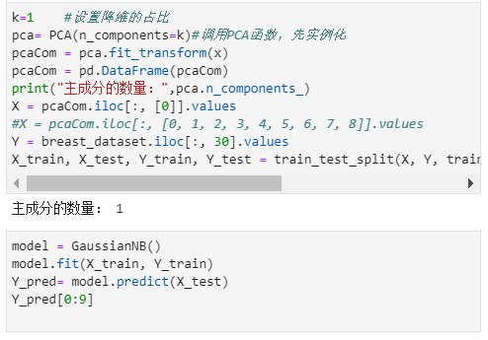Can you repeat problem 2? This time, replace logistic regression with the Bayes classifier. Report your results (classification accuracy, precision, and recall). Compare your results against problem 2.

When k=5 it has the best performance:

Accuracy: 0.9210526315789473

Precision: 0.9

Recall: 0.9692307692307692

|  |  |  |  |
| --- | --- | --- | --- |
| k | accuracy | precision | recall |
| 1 | 0.9122807 | 0.8985507 | 0.9538462 |
| 3 | 0.9122807 | 0.8985507 | 0.9538462 |
| 5 | 0.9210526 | 0.9 | 0.9692308 |
| 7 | 0.9122807 | 0.8873239 | 0.9692308 |
| 9 | 0.9035088 | 0.875 | 0.9692308 |

The results are not as good as previous one, but it reach the best performance at 5.