Report on Web Development

CSY-1018

 

Submitted by:

Deepak Rai

UN ID: 16418513

Date : 7th April, 2017

Contents

Introduction 1

Project development 3

Designing 4

Validation Check 7

Speed Check 9

Work In progress 9

Conclusion 9

# Introduction

This report is about the web development project of 1st term for year 1 students of University of Northampton. The students should design 4 web pages about themselves.

As I had not studied web during my school times, it was hard to design a web page. So, I had looked for web designing pages in the internet which would help me in designing my webpages. W3schools helped me a lot for this assignment. So, after looking through the w3schools pages, I got some idea and started to work on the assignment. I had discussed few things about the webpages with my friends from the college and they also guided me for a better looking design. Altogether, there are 4 web pages.

# Project development

For my 4 webpages that I have designed, it took me about 12 days. For creating the web page, I used Atom. The index page or the home page was made in 6 days. It took me 6 days to create the first page because I had little knowledge about it and I consistently kept changing the background image until I found something that matches with the text. Then, for other pages it took about 2 days most. However, the new content in the new page didn’t match with the background image, so I had to change the background image again. And finally I took a picture and made it the background image of my page. Although, I still have doubts about the background image.

I had to upload the files to github.com. I didn’t know much about GitHub either so, I learned it from YouTube. After that, I uploaded my files to GitHub. The link to my GitHub is: https://github.com/crzymario/keepitsimple_csy1018.git

# Designing

The below are the wireframes of my webpages. 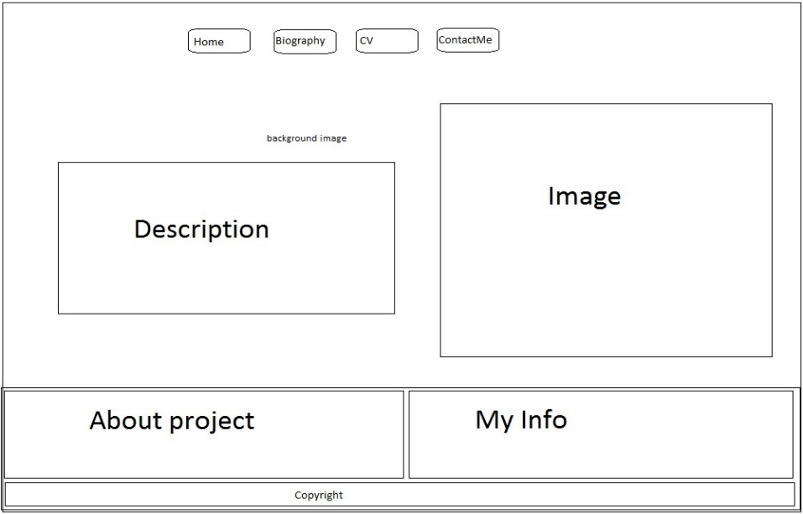

Figure 1(index page)

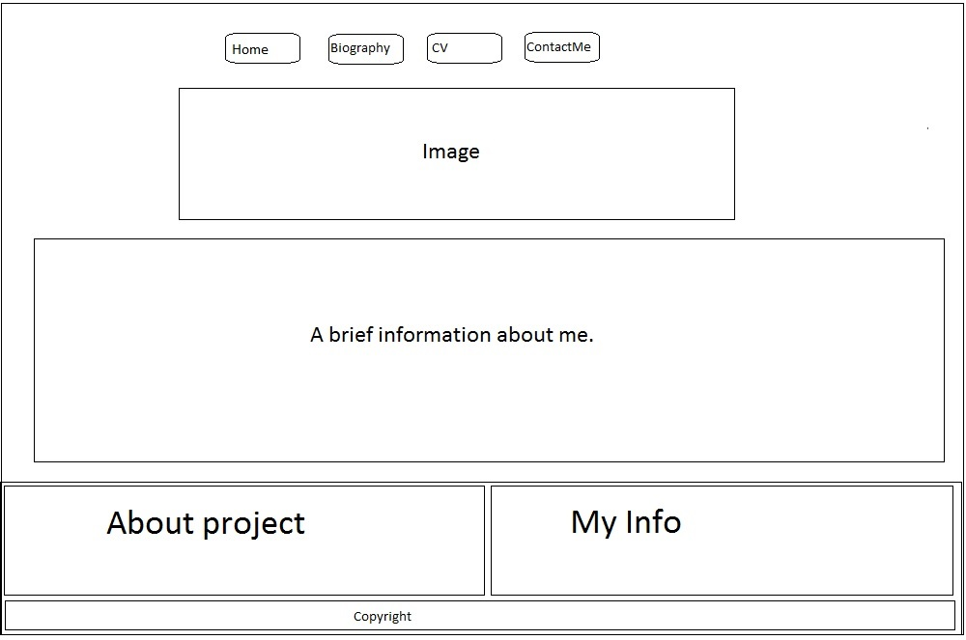

Figure 2(bio page)

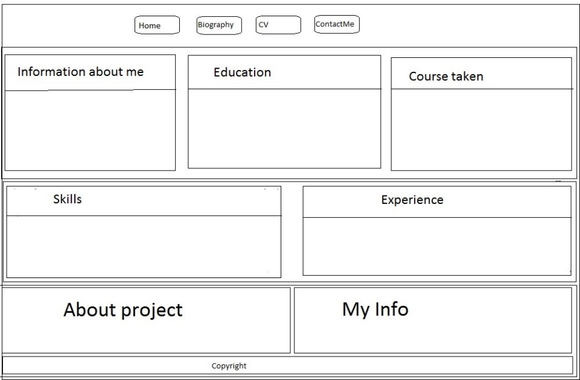

Figure 3(CV page)

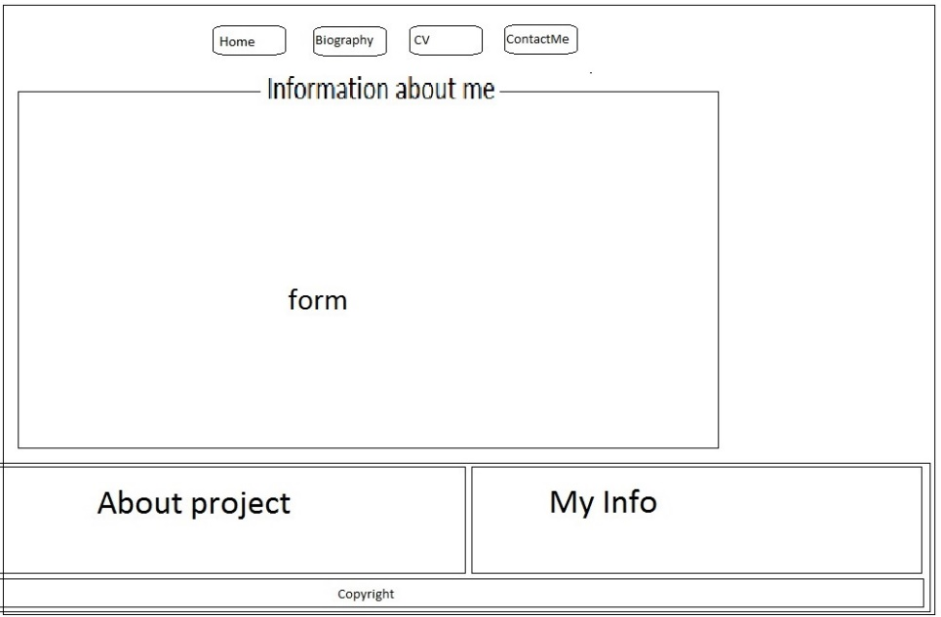

Figure 4(contact page)

And the final designs of my pages are:

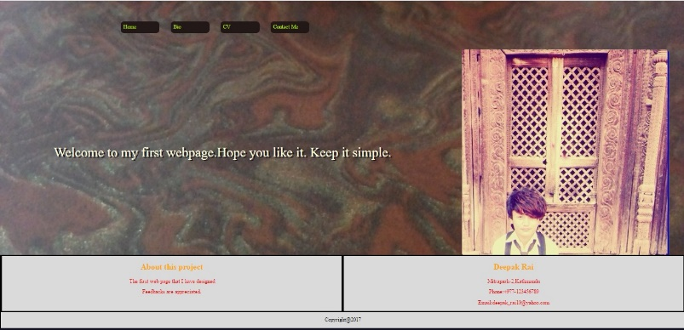

Figure 5(index)

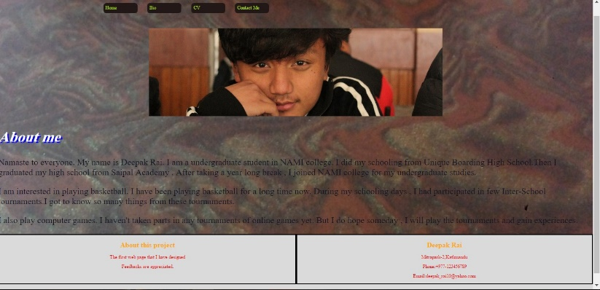

Figure 6(bio)

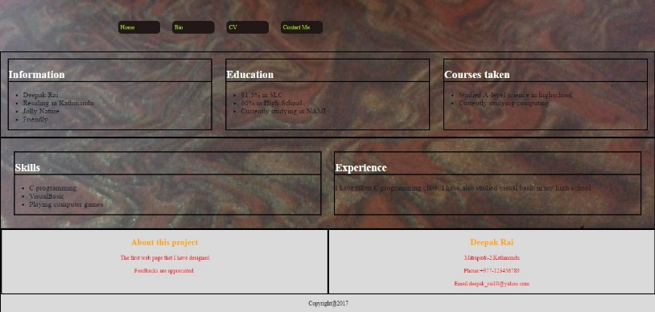

Figure 7(cv)

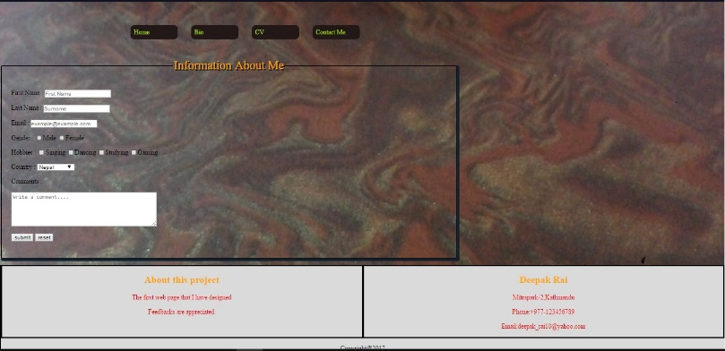

Figure 8(contant)

# Validation Check

I did my validation check on: https:validator.w3.org and found out 3-4 errors in each pages. I solved those errors and rechecked the html pages. There are no errors shown. The screenshots of the validation check are given below:

For index.html file:

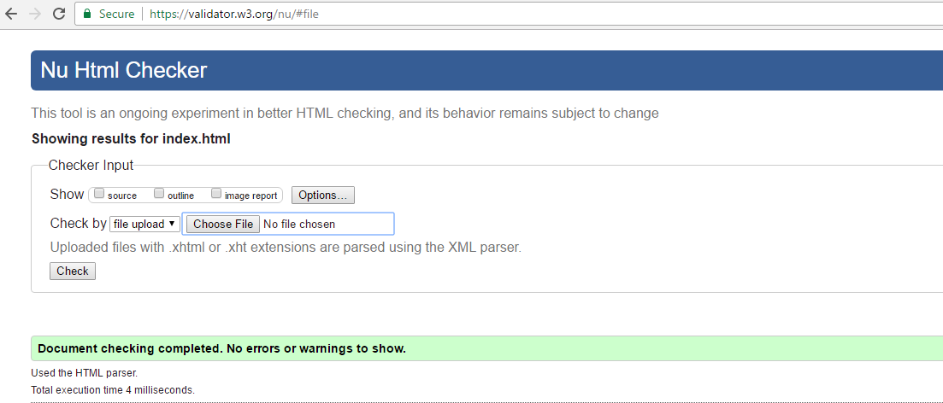

For bio.html file:

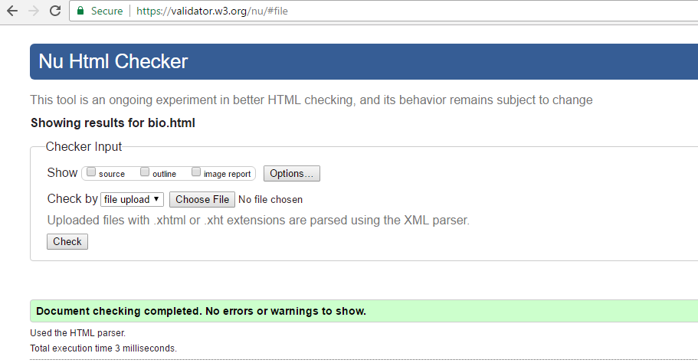

For cv.html file:

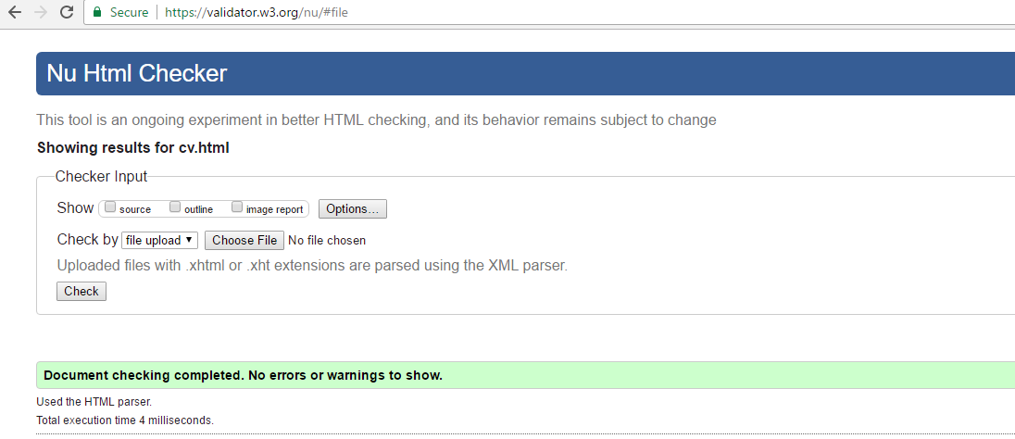

For contact.html file:

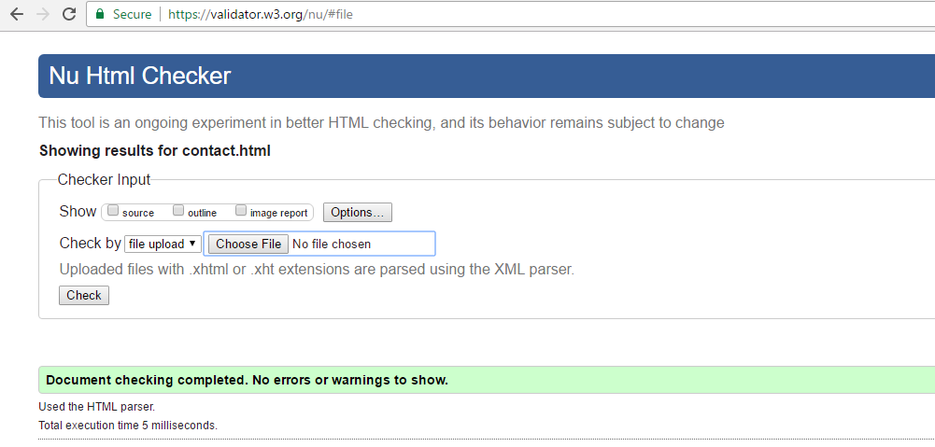

CSS validation check:

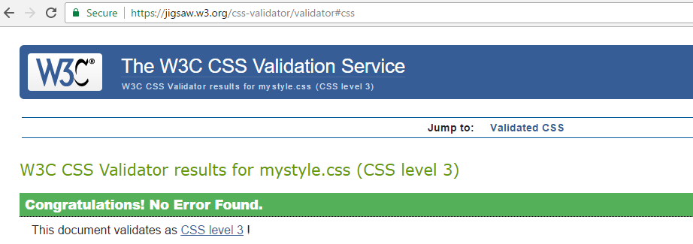

# Speed Check

I also took the speed check of my webpage via https:tools.pingdom.com. The following is the result:

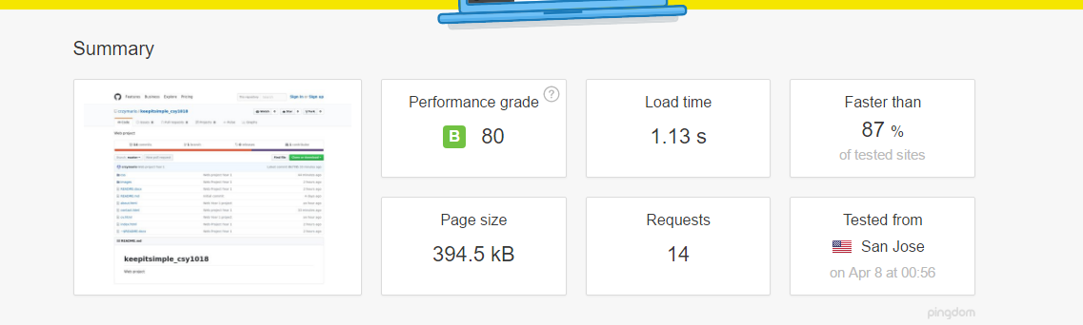

As you can see, the performance grade was B with score 80. It is faster than 87% of tested sites.

# Work In progress

There are many things that I have missed while making these pages. Making it responsive was a very challenging task. I still think the page can be made better. With the current knowledge I have about the web development, this is the page I could design. When I learn more about it, I hope I can add more things to the web page and make it more interesting.

# Conclusion

After two weeks, I finally completed designing my webpages. It was fun making the web pages and I got to learn many things while doing this assignment. I also learned the basics of GitHub and the importance of using it. The webpages are designed as given in the assignment.

## References

* W3schools.com (2017) *CSS Tutorial* [online] Available from: <https://www.w3schools.com/css/default.asp> [Accessed 7th April, 2017]
* c0deporn (2017) *Learn Git in 20 minutes* [online] Available from: <https://www.youtube.com/watch?v=Y9XZQO1n_7c> [Accessed 1st April, 2017]
* W3C (2013) *Markup Validation Service* [online] Available from: <https://validator.w3.org/> [Accessed 7th April, 2017]
* W3C (2009) *CSS Validation Service* [online] Available from: <https://jigsaw.w3.org/css-validator/> [Accessed 7th April, 2017]
* Pingdom (2017) *Pingdom Website Speed Test* [online] Available from: <https://tools.pingdom.com/>