SQL> CREATE TABLE PRODUCT(PID NUMBER(3) PRIMARY KEY,PNAME VARCHAR(4),SUP_NAME VA RCHAR(10),UNIT_PRICE NUMBER(4));

Table created.

SQL> DESC PRODUCT;

Name Null? Type

----------------------------------------- -------- ----------------------------

PID NOT NULL NUMBER(3)

PNAME VARCHAR2(4)

SUP_NAME VARCHAR2(10)

UNIT_PRICE NUMBER(4)

SQL> CREATE TABLE PRODUCT_HIS(PID NUMBER(3) ,PNAME VARCHAR(4),SUP_NAME VARCHAR(10),UNIT_PRICE NUMBER(4));

Table created.

SQL> DESC PRODUCT_HIS;

Name Null? Type

----------------------------------------- -------- ----------------------------

PID NUMBER(3)

PNAME VARCHAR2(4)

SUP_NAME VARCHAR2(10)

UNIT_PRICE NUMBER(4)

INSERT INTO PRODUCT VALUES(101,’A’,’NEHA’,200)

INSERT INTO PRODUCT VALUES(102,’B’,’SUNAINA’,800)

INSERT INTO PRODUCT VALUES(103,’C’,’NISHA’,400)

INSERT INTO PRODUCT VALUES(104,’D’,’AMIT’,400)

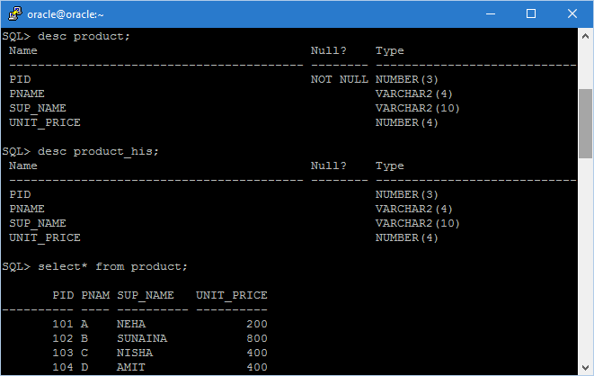

CREATE OR REPLACE TRIGGER PRICE_HIS

BEFORE UPDATE OF UNIT_PRICE ON PRODUCT FOR EACH ROW

BEGIN

INSERT INTO PRODUCT_HIS VALUES(:OLD.PID,:OLD.PNAME,:OLD.SUP_NAME,:OLD.UNIT_PRICE);

END;/

TRIGGER CREATED.

SQL> UPDATE PRODUCT SET UNIT_PRICE=700 WHERE PID=101;

1 ROW UPDATED.

SQL> SELECT* FROM PRODUCT;

PID PNAM SUP_NAME UNIT_PRICE

---------- ---- ---------- ----------

101 A NEHA 700

102 B SUNAINA 800

103 C NISHA 400

104 D AMIT 400

SQL> SELECT * FROM PRODUCT_HIS;

PID PNAM SUP_NAME UNIT_PRICE

---------- ---- ---------- ----------

101 A NEHA 200

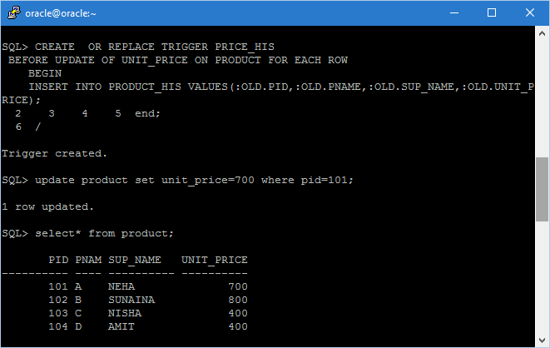

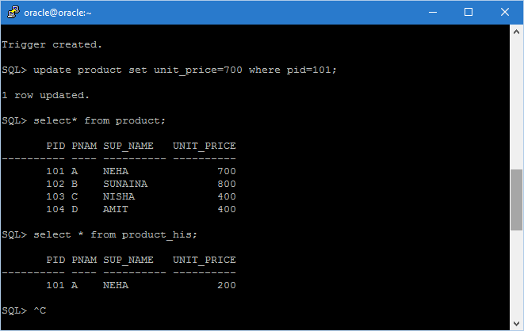

CREATE OR REPLACE TRIGGER NEW_ENTRY

AFTER INSERT ON PRODUCT FOR EACH ROW

BEGIN

INSERT INTO PRODUCT_HIS VALUES(:NEW.PID,:NEW.PNAME,:NEW.SUP_NAME,:NEW.UNIT_PRICE);

END;/

Trigger created.

SQL> INSERT INTO PRODUCT VALUES(105,'E','ANKUR',600);

1 row created.

SQL> SELECT* FROM PRODUCT;

PID PNAM SUP_NAME UNIT_PRICE

---------- ---- ---------- ----------

101 A NEHA 700

102 B SUNAINA 800

103 C NISHA 400

104 D AMIT 400

105 E ANKUR 600

SQL> SELECT * FROM PRODUCT_HIS;

PID PNAM SUP_NAME UNIT_PRICE

---------- ---- ---------- ----------

101 A NEHA 200

105 E ANKUR 600

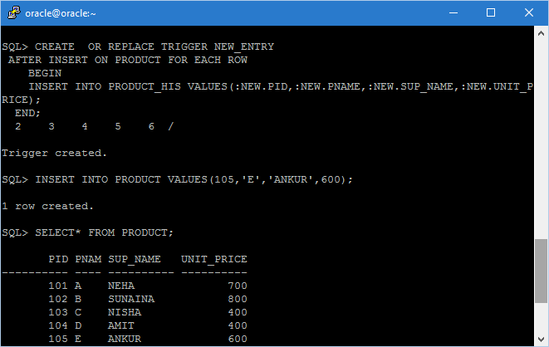

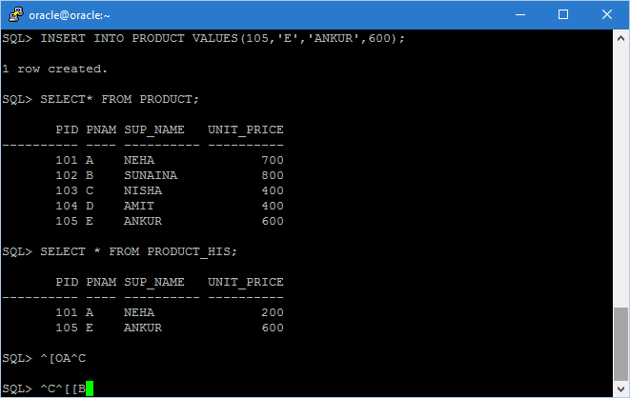

SQL> CREATE OR REPLACE TRIGGER DEL_ENTRY

BEFORE DELETE ON PRODUCT FOR EACH ROW

BEGIN

INSERT INTO PRODUCT_HIS VALUES(:OLD.PID,:OLD.PNAME,:OLD.SUP_NAME,:OLD.UNIT_PRICE);

END;/

Trigger created.

SQL> DELETE FROM PRODUCT WHERE PID=103;

1 row deleted.

SQL> SELECT * FROM PRODUCT;

PID PNAM SUP_NAME UNIT_PRICE

---------- ---- ---------- ----------

101 A NEHA 700

102 B SUNAINA 800

104 D AMIT 400

105 E ANKUR 600

SQL> SELECT * FROM PRODUCT_HIS;

PID PNAM SUP_NAME UNIT_PRICE

---------- ---- ---------- ----------

101 A NEHA 200

105 E ANKUR 600

103 C NISHA 400

