SMART SLEEP ALARM
Machine-learning progress, findings, and guidance request
Purpose: Professor discussion brief
Date: 4 September 2026
Status: Validation evidence available; no final model selected

1. Executive summary
The project aims to identify epochs likely to be light sleep from wearable-style heart-rate and accelerometer data, so a smart alarm can optionally choose a gentler wake moment. The exact user-selected alarm time remains the safety guarantee; the ML component never replaces it.
- The strongest completed held-out result is the causal-time engineered logistic model: test F1 0.6409 and test AUC 0.6067.
- Detailed raw signals alone did not improve the CNN-GRU model. A validation-only raw logistic baseline did retain useful signal.
- The new hybrid model gives a small validation improvement (F1 0.6350 versus 0.6331), but the difference is too small to call a confirmed improvement without the professor's guidance on uncertainty and final evaluation.
- A high-precision alarm policy selected on validation did not generalize to test participants, showing that conservative thresholding alone is not reliable.

2. Data and prediction task
Source: official BIDSleep release 1.0.0. The raw files remain outside the repository; derived artifacts are stored locally under ml/artifacts.
Item | Details
Participants / nights | 47 participants; 253 nights
Usable labelled epochs | 213,387 fixed 30-second epochs
Split (seed 20260821) | 29 train / 9 validation / 9 held-out test participants
Target | Light sleep (N1/N2) = 1; awake, deep, and REM = 0
Raw input | 30 one-second causal bins: acceleration x/y/z + availability; heart rate + availability
Coverage finding | Acceleration is available in about 96% of train bins; heart rate in about 19%

All model fitting and threshold selection use training and validation participants only. The held-out test participants are reserved for a single final evaluation of a candidate selected on validation.

3. What has been tried
Approach | Input / design | Key result | Interpretation
Causal-time logistic | 12 engineered epoch features plus elapsed-session and clock-time encodings | Val F1 0.6331; test F1 0.6409; test AUC 0.6067 | Current completed benchmark
Conservative policy | High threshold chosen to target precision >= 0.70 on validation | Val precision 0.738; test precision 0.486; 107 test triggers | Did not generalize
Rolling engineered | Causal ten-epoch summaries and rolling movement/HR statistics | Val F1 0.6314; test F1 0.6399; test AUC 0.6155 | No F1 gain over baseline
Raw CNN-GRU | Current 30-second raw input, 30 x 6, hidden size 64 | Test F1 0.6234; test AUC 0.5146 | Worse than engineered baseline
Raw logistic diagnostic | Standardized current raw 30 x 6 input | Val F1 0.6175; val AUC 0.6304 | Raw signal has some linear information
Hybrid validation candidate | Current raw 30-second signal + ten-epoch engineered/time context | Val F1 0.6350; val AUC 0.6371 | Promising but unconfirmed

4. Visual comparison
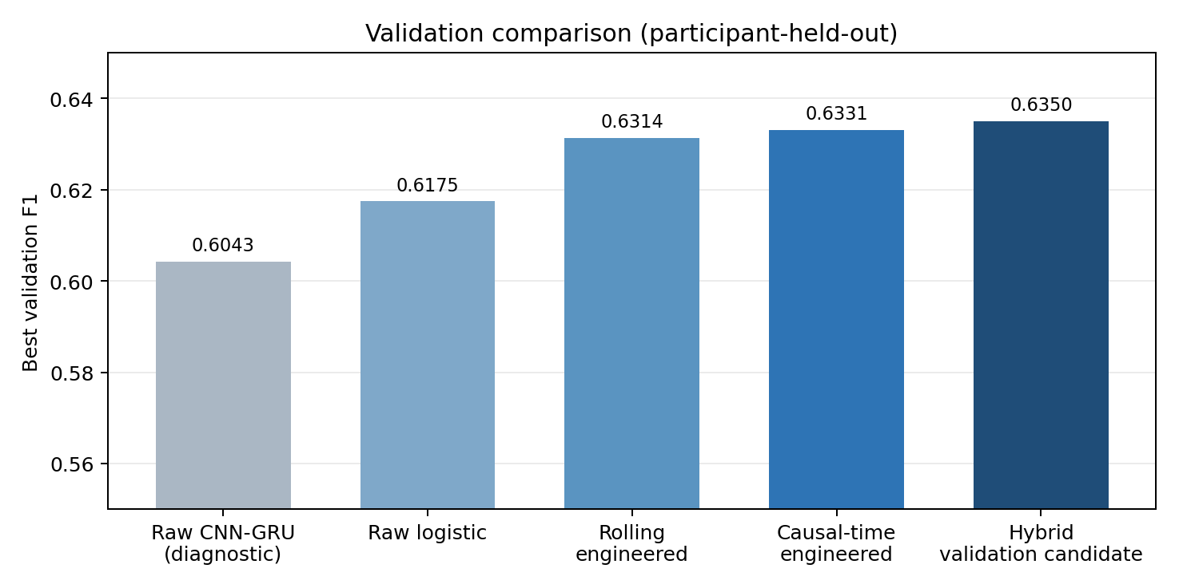
Figure 1. Best F1 selected on validation participants. The hybrid result has not been evaluated on the held-out test split.

5. Diagnostic findings
- Raw-data integrity checks passed: raw labels and participant assignments exactly match the prepared epoch artifact, and sensor timestamps overlap the labelled epochs.
- The raw CNN-GRU learned weakly during the diagnostic run: validation AUC reached 0.5477 after 12 epochs; mean loss changed only from 0.7532 to 0.7493; output probabilities were narrowly concentrated.
- The hybrid candidate uses 303 standardized features: 180 values from the current raw 30-second epoch, 120 engineered values from ten causal epochs, and three causal time features.
- The hybrid's gain over the causal-time baseline is 0.0019 validation F1. It may be real or split-specific variation; it should not be presented as a confirmed improvement yet.

6. Limitations and safety
- The label is sleep stage, not a direct measurement of how refreshed a person feels after waking. The present study measures epoch classification, not wake-window satisfaction.
- BIDSleep participants and wearable sensors may not match the eventual phone/watch user population. External validation is still required.
- Heart-rate availability is sparse in the one-second representation, which may limit raw signal models.
- The exact-time fallback alarm remains mandatory. The model should be advisory and subject to sensor-quality gates.

7. Questions for professor guidance
- Is binary light-versus-other sleep stage an appropriate first proxy for a smart alarm, or should the research target be reframed around a wake-window outcome?
- How should uncertainty be reported for participant-held-out results: participant-level bootstrap intervals, repeated group splits, or another protocol?
- Is the 0.0019 validation-F1 hybrid gain sufficient to justify one final held-out test evaluation, or should more validation-only analysis be required first?
- Would a simpler interpretable model be preferable for this project, given the raw CNN-GRU did not add value?
- What real-user study, safety criteria, and fairness checks would be needed before product claims are appropriate?

8. Proposed next steps
- Perform validation-only participant-level uncertainty and calibration analysis for the causal-time baseline and hybrid candidate.
- After methodological review, choose at most one candidate and evaluate it once on the held-out participants.
- Retain the simple causal-time model if the hybrid advantage is not robust or not worth the added complexity.
- Plan a separate real-world evaluation focused on wake-window experience, sensor quality, and alarm safety.

9. Reproducibility record
Environment: C:\Users\AMIT\anaconda3\envs\fashion-trends\python.exe. Random seed: 20260821. Key derived artifacts: epochs.parquet, raw_sequences.npz, causal_time_features_validation.json, causal_rolling_features_validation.json, conservative_policy_evaluation.json, raw_cnn_gru/metrics.json, raw_cnn_gru_diagnostic.json, and hybrid_raw_engineered_validation.json.
Code added during the raw/hybrid investigation: ml/raw_sequences.py, ml/diagnose_raw.py, and ml/hybrid_candidate.py, with corresponding focused tests. The ML suite passed 31 tests with three pre-existing ONNX tracer warnings at the time of this report.

