分 数：
评卷人：



研究生（数据中心技术）课程论文（报告）

题 目：大禹-在超大规模存储系统中的快速低干扰数据恢复

学 号 M201973389
姓 名 陈逸飞
专 业 计算机技术
课程指导教师 施展、曾令仿
院（系、所） 计算机科学与技术学院

2019年 11月 4日

大禹-在超大规模存储系统中的快速低干扰数据恢复
计算机学院 硕1908班 M201973389 陈逸飞

1 引言
这篇论文主要论述的是在“盘古”中的数据恢复，作者是清华大学的教授。“快速”，很好理解，就是数据恢复时间尽可能短。“低干扰”，意思是数据中心有自己的主业，主业是对外提供在线数据处理服务，而数据恢复是数据中心内部的工作，在进行数据恢复时会占用带宽，要采取措施，对前台应用的干扰最小，这就是低干扰的意思。作者先是介绍大规模存储系统中数据恢复面临哪些挑战，然后观察一个“盘古”的数据中心，得出一些结论，再进一步介绍“大禹”（作者的数据恢复技术），大禹要完成哪些目标，大禹采取的关键技术有哪些，然后对大禹进行评估，最后是介绍一些相关工作。

2背景和观察

2.1盘古的背景
盘古是阿里云的底层存储系统，盘古继承了以前经典的分布式文件系统架构，例如GFS，HDFS，Cosmos，Azure。盘古把文件分割成数据块，把不同的数据块分散存储到文件块服务器中去，大部分文件块是64MB。元数据服务器存储着文件块分布的信息，例如某个文件块在哪里。盘古还有一个根服务器，引导客户连接元数据服务器。
和大多数文件系统一样，盘古为每个文件块复制副本（大多数块有3个副本），这样如果有某个节点宕机，盘古可以从副本引导数据恢复。对于每个需要恢复的文件块，盘古需要选择源服务器和目的地服务器。目前版本的盘古随机选择源和目的地。
盘古在数据恢复的过程中，仍然要对外提供前台应用服务，这样二者可能会竞争有限的带宽（大多数盘古节点配备1Gb或者10Gb以太网）。所以我们要设定数据恢复的速度，不能太慢，也不能太快。我们列出一个公式：
B_{recover}是数据恢复的速度，B_{total}是一个节点的总带宽，B_{foreground}是一个节点的前台带宽，B_{min}是一个节点的人为设置的最小恢复速度(为了防止速度太慢），大禹设置最小恢复速度为30MB/s。α这个参数控制对前台流量的干扰，α越大对前台的干扰越大。因为如果设置α为1表明我们把剩余的带宽全部分配给数据恢复，但是前台带宽是上下波动的，很有可能受到干扰，所以要留一部分带宽作为缓冲。作者设置α为75%，这时p90尾延迟几乎可以忽略不计。如果某些人想要优化到极端的p99尾延迟，他可以再进一步下调α值。
2.2对盘古数据中心的观察
阿里云为作者提供了一个数据中心用来实验，这个数据中心包含超过3500个节点，每个节点配备两个1G网络接口控制器，还有11个2TB硬盘。这些节点主要对外提供在线数据处理服务，包括数据查询和MapReduce。
观察1：每个节点都存储了大量文件块
观察2：平均来说每个节点的前台流量消耗不到一半的总带宽
观察3：前台流量在短期内装载非常不平衡
观察4：对于给定节点文件块的副本在其他节点中分布不均匀
观察5：前台流量一般上下波动占总带宽的14.4%，有时会更大

3 大禹概览
我们把恢复一个数据块叫做一个恢复任务。大禹提出了一个中央调度器，叫做观察者服务器，它执行基于时隙的恢复任务的调度。
大禹假设每个数据服务器周期性地报告他们数据块的放置信息和网络利用率。
为了完成高速高质量的数据恢复，大禹按包来调度任务，一个包就是所有任务的一个子集，一个时隙完成若干个任务。因为每个节点只需完成几十个任务，多包可使每个节点参与到数据恢复任务中来，这充分利用了带宽。
为了充分利用带宽，大禹重叠多个时隙，每个任务的数据传输快要结束时，节点就开始进行下一个任务的相关信息搜集和任务调度。时隙的长度取决于存储系统收集信息的频率。
大禹的目标1：尽可能充分利用可用的带宽。一个时隙可以完成任务的总大小可以用一个公式来表示：
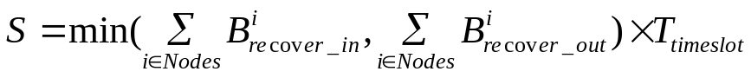
大禹的目标2：在一个时隙中尽可能完成多的任务。
大禹的目标3：使发生掉队者的几率最小化。

4 四项关键技术
4.1选择源和目的地
大禹递归地扫描所有任务为他们选择目的地和源，直到它可以找到足够的任务去填满一个时隙（一个时隙可以完成的任务的总大小见目标1）。大禹从目的地和源的候选者中选取最未被充分利用的节点。如对于某个任务，如果大禹找到的最未被利用的节点都已经饱和了，那么大禹将跳过这个任务，这个任务成为掉队者。
对于寻找数据源，大禹递归查找每一个节点，计算它的恢复时间（对于任务t），一直找到最小的值。因为可以作为数据源的服务器很少，顺序查找最小值是个好办法。
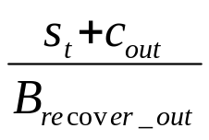
但是可以作为目的地的服务器很多，有成百上千个，顺序查找非常耗时。大禹将每个节点的累计任务大小作为y轴，可用带宽作为x轴，绘制每一个点。在y轴上绘制（0，-S_{t}）这个点，S_{t}是当前任务的大小。（0，-S_{t}）和节点的连线正好是如下公式，是目的地数据接收的时间。为了时间最短，那么就是连线的斜率最小。易知，连线斜率最小的点只能是最外围的节点，而且是下方的节点。作者利用凸包算法找到凸壳，在下凸壳中的一系列节点中，利用二分查找，找出与 （0，-S_{t}）连线斜率最小的点。

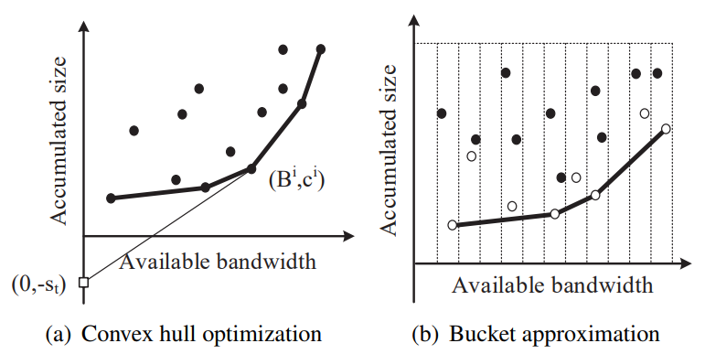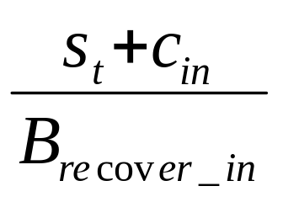

4.2对节点的未利用率排序
作者认为当一个节点拥有高可用的带宽并且自身所含文件块较少时，那么这个节点就是未充分利用的。对于选择文件源和目的地，作者使用贪心算法，可是这里却不能再使用了。举个例子，假设节点A的可用输出带宽为50MB/s，可以作为任务1和任务2的数据源。节点B的可用输出带宽为60MB/s，可作为任务1、2、3、4的数据源。如果采用贪心算法每次都选择带宽最大的节点，那么任务1将分配给B节点。可是最优的调度应是：任务1、2分配给A，任务3、4分配给B。
对此作者建立了两个列表，第一个是按节点的可用带宽降序排序，第二个是按节点拥有的公共文件块总大小升序排序（公共文件块就是可以作为文件源的文件块）。观察者服务器选取这两个列表的前β%的交集。然后从所有任务中选取在这个交集中的任务插入“排过序的队列”，剩下的任务插入“正常队列”。大禹直接使用“排过序的队列”里面的节点作为文件源服务器。
大禹建立两个堆，键是可用带宽和公共文件块大小，值都是节点的编号。抛出10000个节点的前5%仅仅花了几毫秒。所以作者选取β为5%。

4.3为每个任务分配带宽
一个简单粗暴的办法是为每个节点分配带宽。这样会带来两个问题:首先所有任务竞争带宽，某些任务的速度可能过慢，可能会成为掉队者。再次就是如果某些节点作为数据目的地的带宽小于数据源的带宽，这可能会造成网络拥塞，反之亦然。
大禹的办法是采用递归的基于权重的洗牌调度（WSS）。大禹对每个节点维持B^{i}_{remain_in}和B^{i}_{remain_out}值 。这分别代表着每个节点剩余的可用来任务输出和任务输入的带宽。大禹首先找一个节点拥有最大的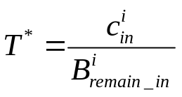或。然后给t任务分配带宽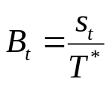。然后更新剩余带宽的值，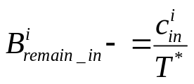，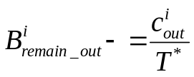。简而言之就是越大的文件块分配到的带宽越大。

4.4对掉队者任务进行再调度
大禹不会把掉队者简单地当做新任务重新调度，因为重新选择目的地将重新传输浪费带宽。
大禹首先需要识别掉队者任务。我们回忆起大禹重叠时隙，在时隙的开始有调度过程，大禹依据这个任务的速度和这个任务的大小，计算它否能在一个时隙内完成，如果不行，那么大禹将把这个任务置入掉队者集。有时预测可能不准确，但是调度时间是远小于时隙的，这点错误是可以接受的。
大禹识别掉队者以后要再调度它们。如果一个任务因为在数据源服务器上输出导致服务器饱和，那么将维持它目的地不变，重新选择数据源和带宽。如果一个任务因为在目的地服务器上输入导致服务器饱和，那么将把这个掉队者当做新任务重新调度。
对比与仅仅把掉队者按原始的方法继续传输，这提升了整体恢复速度的15.6%。

5评估
5.1.1整体性能
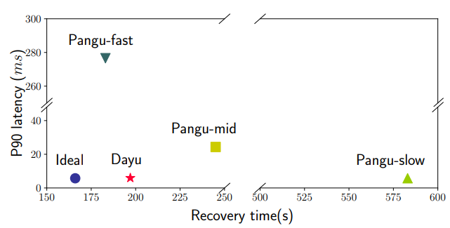
首先在真实的环境中测评。如图显示了各种恢复方法数据恢复时间和p90为延迟。在这个测试中，作者关闭了一个服务器模拟宕机，导致15TB的数据需要恢复，有大约990个服务器参与恢复。大禹完成了最接近理想化的恢复时间和干扰。
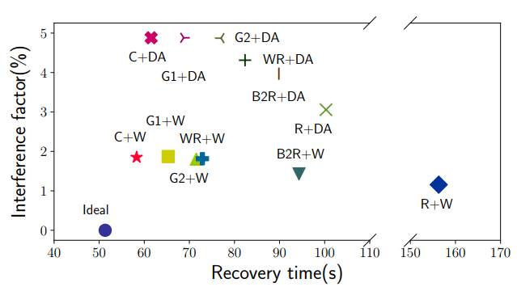
其次是在模拟环境中的数据恢复。大禹使用C+W（凸包算法和递归WSS）来进行调度，此时的干扰因子仅仅为2%。

5.1.2什么是干扰因子
B^{i}_{overload}是每个服务器过载的带宽。
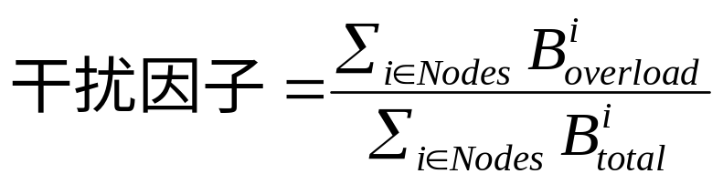
5.2可扩展性
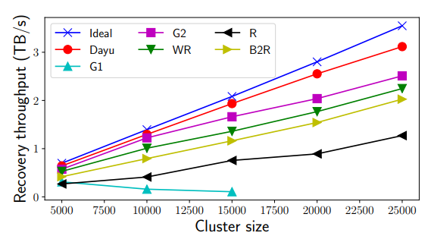
如图所示，大禹可以扩展到25000个节点，性能高于所有算法。作者没有进一步提高扩展，因为那样就离现实太远了，现实是阿里云盘古系统10000个节点。
5.3关键参数的影响
作者计算α分别为85%，80%，75%，70%，65%时的恢复时间和干扰因子，最终选择了75%为最佳值。p90延迟为6ms，干扰因子大约为2.5%，而且数据恢复时间不到60s。
作者分别计算β值为0%，2.5%，5%，7.5%，10%时的干扰因子，最终选择5%为最佳值。

6相关工作
纠删码也是一种数据恢复算法，它把文件分成n块，计算出m块校验块，当着n+m块数据最多有不超过m块损毁时，可以利用剩下的任意n块恢复出原始数据。相比于大禹，这种算法在恢复1块数据时必须利用n块数据，也就是n台服务器，可是大禹只需要利用一个源服务器和一个目的地服务器。所以纠删码对前台流量的影响非常显著，而大禹则可以做到低干扰。

7结论
中心化的调度器有更好的调度质量，尤其是在动态的不平衡的环境中。大禹几乎不会对前台流量造成干扰，干扰因子仅为2.5%。数据恢复的速度主要取决于数据源和目的地的选择速度。大禹在不到200秒的时间内利用990个服务器恢复了15TB的数据。

8致谢
感谢曾老师和施老师这两个月以来的辛苦付出，老师们开阔了我的视野，使我受益匪浅。

参考文献：
[1] Zujie Ren, Weisong Shi, Jian Wan, Feng Cao, and Jiangbin Lin. Realistic and scalable benchmarking cloud file systems: Practices and lessons from alicloud. IEEE Transactions on Parallel and Distributed Systems, 28(3272-3285):1, 2017.
[2] Backblaze. Backblaze Durability is 99.999999999% — And Why It Doesn’t Matter. https://www.backblaze. com/blog/cloud-storage-durability/, 2018. Online; accessed 2018-12-25.
[3] Sanjay Ghemawat, Howard Gobioff, and Shun-Tak Leung. The Google file system. In Proceedings of the 19th ACM Symposium on Operating Systems Principles (SOSP’03), volume 37. ACM, 2003.
[4] Diego Ongaro, Stephen M Rumble, Ryan Stutsman, John Ousterhout, and Mendel Rosenblum. Fast crash recovery in RAMCloud. In Proceedings of the 23rd ACM Symposium on Operating Systems Principles (SOSP’11), pages 29–41. ACM, 2011.
[5] Konstantin Shvachko, Hairong Kuang, Sanjay Radia, and Robert Chansler. The Hadoop distributed file system. In Proceedings of 26th IEEE symposium on Mass storage systems and technologies (MSST’10), pages 1–10. IEEE, 2010.
[6] Ronnie Chaiken, Bob Jenkins, Per-Åke Larson, Bill Ramsey, Darren Shakib, Simon Weaver, and Jingren Zhou. Scope: easy and efficient parallel processing of massive data sets. Proceedings of the VLDB Endowment (VLDB’08), 1(2):1265–1276, 2008.
[7] Brad Calder, Ju Wang, Aaron Ogus, Niranjan Nilakantan, Arild Skjolsvold, Sam McKelvie, Yikang Xu, Shashwat Srivastav, Jiesheng Wu, Huseyin Simitci, et al. Windows Azure Storage: a highly available cloud storage service with strong consistency. In Proceedings of the Twenty-Third ACM Symposium on Operating Systems Principles (SOSP’17), pages 143–157. ACM, 2011.
[8] Fay Chang, Jeffrey Dean, Sanjay Ghemawat, Wilson C Hsieh, Deborah A Wallach, Mike Burrows, Tushar Chandra, Andrew Fikes, and Robert E Gruber. Bigtable: A distributed storage system for structured data. ACM Transactions on Computer Systems (TOCS), 26(2):4, 2008.

[9] Andrea W Richa, M Mitzenmacher, and R Sitaraman. The power of two random choices: A survey of techniques and results. Combinatorial Optimization, 9:255–304, 2001.
[10] Yuchao Zhang, Junchen Jiang, Ke Xu, Xiaohui Nie, Martin J Reed, Haiyang Wang, Guang Yao, Miao Zhang, and Kai Chen. BDS: a centralized near-optimal overlay network for inter- datacenter data replication. In Proceedings of the Thirteenth European Conference on Computer Systems (Eurosys’18), pages 10:1–10:14. ACM, 2018.
[11] Jun Woo Park, Alexey Tumanov, Angela Jiang, Michael A Kozuch, and Gregory R Ganger. 3Sigma: distribution-based cluster scheduling for runtime uncertainty. In Proceedings of the Thirteenth European Conference on Computer Systems (Eurosys’18), page 2. ACM, 2018.
[12] Alexey Tumanov, Timothy Zhu, Jun Woo Park, Michael A Kozuch, Mor Harchol-Balter, and Gregory R Ganger. TetriSched: global rescheduling with adaptive plan-ahead in dynamic heterogeneous clusters. In Proceedings of the Eleventh European Conference on Computer Systems (Eurosys’ 16), page 35. ACM, 2016.
[13] Mark de Berg, Otfried Cheong, Marc van Kreveld, and Mark Overmars. Computational geometry: algorithms and applications. Springer-Verlag TELOS, 2008.
[14] Mosharaf Chowdhury, Matei Zaharia, Justin Ma, Michael I. Jordan, and Ion Stoica. Managing data transfers in computer clusters with Orchestra. In Proceedings of the ACM SIGCOMM 2011 Conference on Applications, technologies, architectures, and protocols for computer communication (SIGCOMM’11), pages 98–109, New York, NY, USA, 2011. ACM.
[15] James C Corbett, Jeffrey Dean, Michael Epstein, Andrew Fikes, Christopher Frost, Jeffrey John Furman, Sanjay Ghemawat, Andrey Gubarev, Christopher Heiser, Peter Hochschild, et al. Spanner: Google’s globally distributed database. ACM Transactions on Computer Systems (TOCS), 31(3):8, 2013.
[16] Apache. HDFS Federation. https://hadoop.apache. org/docs/stable/hadoop-project-dist/hadoop-hdfs/ Federation.html, 2018. Online; accessed 2018-04-16.
[17] Sage A. Weil, Scott A. Brandt, Ethan L. Miller, Darrell D. E. Long, and Carlos Maltzahn. Ceph: A scalable, high-performance distributed file system. In Proceedings of the 7th USENIX Symposium on Operating Systems Design and Implementation (OSDI ’06), pages 307–320, 2006.
[18] Albert Greenberg, James R Hamilton, Navendu Jain, Srikanth Kandula, Changhoon Kim, Parantap Lahiri, David A Maltz, Parveen Patel, and Sudipta Sengupta. VL2: a scalable and flexible data center network. In Proceedings of the ACM SIGCOMM 2009 conference on Applications, technologies, architectures, and protocols for computer communication (SIG- COMM’09), volume 39, pages 51–62. ACM, 2009.
[19] Albert Greenberg, Parantap Lahiri, David A Maltz, Parveen Patel, and Sudipta Sengupta. Towards a next generation data center architecture: scalability and commoditization. In Proceedings of the ACM workshop on Programmable routers for extensible services of tomorrow (PRESTO’08), pages 57–62. ACM, 2008.

[20] Radhika Niranjan Mysore, Andreas Pamboris, Nathan Farrington, Nelson Huang, Pardis Miri, Sivasankar Radhakrishnan, Vikram Subramanya, and Amin Vahdat. Portland: a scalable fault-tolerant layer 2 data center network fabric. In Proceedings of the ACM SIGCOMM 2009 conference on Applications, technologies, architectures, and protocols for computer communication (SIGCOMM’09), volume 39, pages 39–50. ACM, 2009.
[21] Mohammad Al-Fares, Alexander Loukissas, and Amin Vahdat. A scalable, commodity data center network architecture. In Proceedings of the ACM SIGCOMM 2008 conference on Applications, technologies, architectures, and protocols for computer communication (SIGCOMM’08), volume 38, pages 63– 74. ACM, 2008.
[22] Giuseppe DeCandia, Deniz Hastorun, Madan Jampani, Gu- navardhan Kakulapati, Avinash Lakshman, Alex Pilchin, Swaminathan Sivasubramanian, Peter Vosshall, and Werner Vogels. Dynamo: Amazon’s highly available key-value store. In Proceedings of the 21st ACM Symposium on Operating Systems Principles (SOSP’07), volume 41, pages 205–220. ACM, 2007.
[23] Thomas H Cormen, Charles E Leiserson, Ronald L Rivest, and Clifford Stein. Introduction to algorithms. MIT press, 2009.
[24] Jeffrey Dean and Sanjay Ghemawat. MapReduce: simplified data processing on large clusters. Proceedings of the 6th Conference on Symposium on Opearting Systems Design and Implementation (OSDI’04), 51(1):107–113, 2004.
[25] Haryadi S. Gunawi, Riza O. Suminto, Russell Sears, Casey Golliher, Swaminathan Sundararaman, Xing Lin, Tim Emami, Weiguang Sheng, Nematollah Bidokhti, Caitie McCaffrey, Gary Grider, Parks M. Fields, Kevin Harms, Robert B. Ross, Andree Jacobson, Robert Ricci, Kirk Webb, Peter Alvaro, H. Bi- rali Runesha, Mingzhe Hao, and Huaicheng Li. Fail-slow at scale: Evidence of hardware performance faults in large production systems. In 16th USENIX Conference on File and Storage Technologies (FAST’18), pages 1–14, Oakland, CA, 2018. USENIX Association.
[26] Thanh Do, Mingzhe Hao, Tanakorn Leesatapornwongsa, Tiratat Patana-anake, and Haryadi S. Gunawi. Limplock: Understanding the impact of limpware on scale-out cloud systems. In Proceedings of the 4th Annual Symposium on Cloud Computing (SOCC’13), pages 14:1–14:14, New York, NY, USA, 2013. ACM.
[27] Peng Huang, Chuanxiong Guo, Jacob R. Lorch, Lidong Zhou, and Yingnong Dang. Capturing and enhancing in Situ system observability for failure detection. In 13th USENIX Symposium on Operating Systems Design and Implementation (OSDI’18), pages 1–16, Carlsbad, CA, 2018. USENIX Association.

[28] Mosharaf Chowdhury, Srikanth Kandula, and Ion Stoica. Leveraging endpoint flexibility in data-intensive clusters. In Proceedings of the ACM SIGCOMM 2013 Conference on Applications, technologies, architectures, and protocols for computer communication (SIGCOMM’13), volume 43, pages 231–242. ACM,
2013.
[29] Mohammad Al-Fares, Sivasankar Radhakrishnan, Barath Raghavan, Nelson Huang, and Amin Vahdat. Hedera: Dynamic flow scheduling for data center networks. In Proceedings of the 7th USENIX Conference on Networked Systems Design and Implementation (NSDI’10), Berkeley, CA, USA, 2010. USENIX Association.
[30] Chi-Yao Hong, Matthew Caesar, and P Godfrey. Finishing flows quickly with preemptive scheduling. In Proceedings of the ACM SIGCOMM 2012 conference on Applications, technologies, architectures, and protocols for computer communication (SIGCOMM’12), pages 127–138. ACM, 2012.
[31] Zhirong Shen, Jiwu Shu, and Patrick PC Lee. Reconsidering single failure recovery in clustered file systems. In Proceedings of 46th Annual IEEE/IFIP International Conference on Dependable Systems and Networks (DSN ’16), pages 323–334. IEEE, 2016.
[32] Subrata Mitra, Rajesh Panta, Moo-Ryong Ra, and Saurabh Bagchi. Partial-parallel-repair (ppr): a distributed technique for repairing erasure coded storage. In Proceedings of the Eleventh European Conference on Computer Systems (Eu- rosys’16), page 30. ACM, 2016.
[33] Gurobi. Gurobi 8.0. URL:http://www.gurobi.com, 2018. Online; accessed 2018-12-25.
[34] Jake Wires and Andrew Warfield. Mirador: An active control plane for datacenter storage. In Proceedings of 15th USENIX Conference on File and Storage Technologies (FAST’17), pages 213–228, Santa Clara, CA, 2017. USENIX Association.
[35] Pulkit A. Misra, Inigo Goiri, Jason Kace, and Ricardo Bianchini. Scaling distributed file systems in resource-harvesting datacenters. In Proceedings of 2017 USENIX Annual Technical Conference (ATC’17), pages 799–811, Santa Clara, CA, 2017. USENIX Association.
[36] Kay Ousterhout, Patrick Wendell, Matei Zaharia, and Ion Stoica. Sparrow: Distributed, low latency scheduling. In Proceedings of the Twenty-Fourth ACM Symposium on Operating Systems Principles, SOSP ’13, pages 69–84, New York, NY, USA, 2013. ACM.
[37] Ionel Gog, Malte Schwarzkopf, Adam Gleave, Robert N. M. Watson, and Steven Hand. Firmament: Fast, centralized cluster scheduling at scale. In Proceedings of 12th USENIX Symposium on Operating Systems Design and Implementation (OSDI’16), pages 99–115, Savannah, GA, 2016. USENIX Association.

[38] Ryan Scott Stutsman. Durability and crash recovery in distributed in-memory storage systems. PhD thesis, Stanford University, 2013.
[39] Edmund B Nightingale, Jeremy Elson, Jinliang Fan, Owen S Hofmann, Jon Howell, and Yutaka Suzue. Flat datacenter storage. In Proceedings of the 10th USENIX Symposium on Operating Systems Design and Implementation (OSDI’12), pages 1–15, 2012.
[40] Gluster. GlusterFS documention. URL:https://docs. gluster.org/en/latest/, 2018. Online; accessed 2018- 12-25.
[41] Ion Stoica, Robert Morris, David Karger, M Frans Kaashoek, and Hari Balakrishnan. Chord: A scalable peer-to-peer lookup service for internet applications. Proceedings of the ACM SIGCOMM 2001 conference on Applications, technologies, architectures, and protocols for computer communication (SIG- COMM’01), 31(4):149–160, 2001.
[42] Runhui Li, Xiaolu Li, Patrick PC Lee, and Qun Huang. Repair pipelining for erasure-coded storage. In Proceedings of the 2017 USENIX Annual Technical Conference (ATC’17), pages 567–579, 2017.
[43] Subrata Mitra, Rajesh Panta, Moo-Ryong Ra, and Saurabh Bagchi. Partial-parallel-repair (PPR): a distributed technique for repairing erasure coded storage. In Proceedings of the Eleventh European Conference on Computer Systems (Eu- rosys’16), page 30. ACM, 2016.
[44] Alexandros G Dimakis, P Brighten Godfrey, Yunnan Wu, Martin J Wainwright, and Kannan Ramchandran. Network coding for distributed storage systems. IEEE Transactions on Information Theory, 56(9):4539–4551, 2010.
[45] KV Rashmi, Preetum Nakkiran, Jingyan Wang, Nihar B Shah, and Kannan Ramchandran. Having your cake and eating it too: Jointly optimal erasure codes for I/O, storage, and network- bandwidth. In Proceedings of 13th USENIX Conference on File and Storage Technologies (FAST’15), pages 81–94, 2015.
[46] Myna Vajha, Vinayak Ramkumar, Bhagyashree Puranik, Ganesh Kini, Elita Lobo, Birenjith Sasidharan, P Vijay Kumar, Alexandar Barg, Min Ye, Srinivasan Narayanamurthy, et al. Clay codes: Moulding MDS codes to yield an MSR code. In Proceedings of 16th USENIX Conference on File and Storage Technologies (FAST’18), volume 2018, pages 139–154, 2018.
[47] Min Ye and Alexander Barg. Explicit constructions of optimal- access MDS codes with nearly optimal sub-packetization. IEEE Transactions on Information Theory, 63(10):6307–6317, 2017.
[48] Apache. HDFS Balancer Command. URL:https://hadoop. apache.org/docs/r2.7.2/hadoop-project-dist/ hadoop-hdfs/HDFSCommands.html, 2019. Online; accessed 2019-01-10.
[49] Ignacio Cano, Srinivas Aiyar, Varun Arora, Manosiz Bhattacharyya, Akhilesh Chaganti, Chern Cheah, Brent Chun, Karan Gupta, Vinayak Khot, and Arvind Krishnamurthy. Cu- rator: Self-managing storage for enterprise clusters. In Proceedings of 14th USENIX Symposium on Networked Systems Design and Implementation (NSDI’17), pages 51–66, Boston, MA, 2017. USENIX Association.

[50] Dhruba Borthakur, Jonathan Gray, Joydeep Sen Sarma, Kannan Muthukkaruppan, Nicolas Spiegelberg, Hairong Kuang, Karthik Ranganathan, Dmytro Molkov, Aravind Menon, Samuel Rash, et al. Apache hadoop goes realtime at facebook. In Proceedings of the 2011 ACM SIGMOD International Conference on Management of data (SIGMOD’11), pages 1071– 1080. ACM, 2011.
[51] Asaf Cidon, Stephen Rumble, Ryan Stutsman, Sachin Katti, John Ousterhout, and Mendel Rosenblum. Copysets: Reducing the frequency of data loss in cloud storage. In Proceedings of the 2013 USENIX Annual Technical Conference (USENIX ATC’13), pages 37–48, 2013.
[52] Asaf Cidon, Robert Escriva, Sachin Katti, Mendel Rosenblum, and Emin Gun Sirer. Tiered replication: A cost-effective alternative to full cluster geo-replication. In 2015 USENIX Annual Technical Conference (USENIX ATC’15), pages 31–43, 2015.
[53] Michael Isard, Vijayan Prabhakaran, Jon Currey, Udi Wieder, Kunal Talwar, and Andrew Goldberg. Quincy: Fair scheduling for distributed computing clusters. In Proceedings of the ACM SIGOPS 22nd symposium on Operating systems principles (SOSP’09), pages 261–276. ACM, 2009.
[54] Benjamin Hindman, Andy Konwinski, Matei Zaharia, Ali Gh- odsi, Anthony D. Joseph, Randy Katz, Scott Shenker, and IonStoica. Mesos: A platform for fine-grained resource sharing in the data center. In Proceedings of the 8th USENIX Conference on Networked Systems Design and Implementation (NSDI’11), NSDI’11, pages 295–308, Berkeley, CA, USA, 2011. USENIX Association.
[55] Eric Boutin, Jaliya Ekanayake, Wei Lin, Bing Shi, Jingren Zhou, Zhengping Qian, Ming Wu, and Lidong Zhou. Apollo: Scalable and coordinated scheduling for cloud-scale computing. In Proceedings of the 11th USENIX Symposium on Operating Systems Design and Implementation (OSDI’14), pages 285–300, Broomfield, CO, 2014. USENIX Association.
[56] Pamela Delgado, Florin Dinu, Anne-Marie Kermarrec, and Willy Zwaenepoel. Hawk: Hybrid datacenter scheduling. In Proceedings of the 2015 USENIX Annual Technical Conference (ATC’15), pages 499–510, Santa Clara, CA, 2015. USENIX Association.

[57] Charles Reiss, Alexey Tumanov, Gregory R Ganger, Randy H Katz, and Michael A Kozuch. Heterogeneity and dynamicity of clouds at scale: Google trace analysis. In Proceedings of the Third ACM Symposium on Cloud Computing (SOCC’12), page 7. ACM, 2012.
[58] Ionel Corneliu Gog. Flexible and efficient computation in large data centres. PhD thesis, University of Cambridge, 2018.

研究生签字 |  | 陈逸飞

