CHANDUBHAI S. PATEL INSTITUTE OF TECHNOLOGY (CSPIT)
DEPARTMENT OF COMPUTER SCIENCE & ENGINEERING
ITUE203 - Web Development Frameworks / Information Systems Security
PRACTICAL - 10 LABORATORY REPORT
Secure Login/Logout with Sessions, Role-Based Access Control (RBAC), Session Fixation Defense & Timeout Handling
Student Name: Jay Navadiya | Student ID / Roll No: 25CS052
Degree / Semester: B.Tech CSE (Div-I) | Submission Date: October 14, 2026

1. Aim & Practical Objectives
AIM: To develop a production-grade, secure authentication and session management architecture using PHP and MySQLi, incorporating bcrypt password verification (password_verify()), session fixation prevention via session ID regeneration (session_regenerate_id(true)), strict Role-Based Access Control (RBAC) separating Student and Admin privileges, and an enforced 10-minute idle session timeout mechanism.
Key Deliverables & Specifications:
- db.php: MySQL database connection using object-oriented MySQLi.
- login.php: User-friendly, white-themed login interface supporting email and password authentication.
- authenticate.php: Backend credential validation using password_verify() and session_regenerate_id(true).
- dashboard.php: Main central portal dashboard featuring session verification, timeout display, and fixation proof.
- admin_dashboard.php: Administrative control center restricted strictly to users with the 'admin' role.
- student_dashboard.php: Student academic portal restricted strictly to users with the 'student' role.
- logout.php: Comprehensive session teardown (clearing $_SESSION, invalidating cookie, and invoking session_destroy()).
- timeout.php: Idle session timeout tracker automatically expiring sessions after 10 minutes (600 seconds).
- style.css: Modern, responsive, clean white-themed CSS stylesheet.
- user_registration.sql: Complete MySQL schema dump with users table and seeded test accounts with bcrypt hashes.

2. Security Architecture & Theoretical Concepts

2.1 Password Hashing & Verification (password_verify)
Plaintext passwords are never stored in the database. When credentials are saved, PHP's password_hash() creates a salted, slow crypt-hash using the Blowfish (bcrypt) algorithm ($2y$). During authentication, password_verify() verifies the submitted plaintext password against the stored bcrypt hash in constant time, preventing timing attacks and rainbow-table compromises.

2.2 Session Fixation Defense (session_regenerate_id(true))
Session Fixation occurs when an attacker forces a victim to use a known session identifier (e.g. via a manipulated URL or pre-set cookie). If the server continues using that same session identifier after authentication, the attacker can hijack the account. To prevent this vulnerability, authenticate.php immediately calls session_regenerate_id(true) upon valid login. This destroys the pre-login session file and issues a completely new, cryptographically random Session ID.

2.3 Role-Based Access Control (RBAC)
Users are assigned distinct roles ('admin' or 'student'). Each privileged route validates the active session role: admin_dashboard.php intercepts students and displays an explicit '403 Unauthorized Access' notice, while student_dashboard.php similarly intercepts administrator accounts attempting unauthorized entry.

2.4 Inactivity Session Timeout (10 Minutes / 600s)
Session abandonment poses significant risks on shared workstations. timeout.php monitors $_SESSION['last_activity']. If the time delta exceeds 600 seconds (10 minutes), the session is terminated and the user is redirected to login.php?msg=timeout.

3. Complete Source Code Implementation

3.1 File: db.php – MySQL Database Connection using MySQLi
<?php
/**
* Practical 10: Database Connection using MySQLi (db.php)
* System: Campusly Academic Portal
*/
$host = '127.0.0.1';
$user = 'root';
$password = '';
$database = 'campusly';
$port = 3306;
// 1. MySQLi Object-Oriented Connection (Required for Practical 10)
$conn = new mysqli($host, $user, $password, $database, $port);
if ($conn->connect_error) {
die("MySQLi Database Connection Failed: " . $conn->connect_error);
}
// Set charset to utf8mb4
$conn->set_charset("utf8mb4");
// 2. Backward compatibility PDO instance for shared project utilities
try {
$pdo = new PDO("mysql:host=$host;port=$port;dbname=$database;charset=utf8mb4", $user, $password, [
PDO::ATTR_ERRMODE => PDO::ERRMODE_EXCEPTION,
PDO::ATTR_DEFAULT_FETCH_MODE => PDO::FETCH_ASSOC,
PDO::ATTR_EMULATE_PREPARES => false,
]);
} catch (PDOException $e) {
// Graceful fallback if PDO is optional
}
// Diagnostic output if db.php is run directly
if (basename(__FILE__) === basename($_SERVER['SCRIPT_FILENAME'] ?? '')) {
echo "<!DOCTYPE html><html><head><title>Database Connection - Campusly</title>";
echo "<style>body{font-family: Arial, sans-serif; padding: 24px; background: #ffffff; color: #1e293b;}</style></head><body>";
echo "<h2 style='color: #16a34a;'>✅ MySQLi Database Connected Successfully</h2>";
echo "<p>Database: <strong>" . htmlspecialchars($database) . "</strong> | Host: <strong>" . htmlspecialchars($host) . "</strong></p>";
echo "</body></html>";
}

3.2 File: timeout.php – Session Inactivity Timeout Handling (10 Minutes)
<?php
/**
* Practical 10: Session Timeout Handling (timeout.php)
* System: Campusly Academic Portal
* Enforces a strict 10-minute (600 seconds) inactivity timeout.
*/
if (session_status() === PHP_SESSION_NONE) {
// Configure secure session cookie params before starting session
ini_set('session.use_only_cookies', '1');
ini_set('session.use_strict_mode', '1');
$isHttps = !empty($_SERVER['HTTPS']) && $_SERVER['HTTPS'] !== 'off';
session_set_cookie_params([
'lifetime' => 0,
'path' => '/',
'domain' => '',
'secure' => $isHttps,
'httponly' => true,
'samesite' => 'Lax'
]);
session_start();
}
// 10 minutes session timeout duration in seconds
define('SESSION_TIMEOUT_DURATION', 600);
// Simulator hook for live demonstration & testing
if (isset($_GET['action']) && $_GET['action'] === 'simulate_timeout') {
$_SESSION['last_activity'] = time() - (SESSION_TIMEOUT_DURATION + 10);
}
// Check session inactivity timeout if user is authenticated
if (isset($_SESSION['user_id'])) {
if (isset($_SESSION['last_activity'])) {
$inactive_seconds = time() - $_SESSION['last_activity'];
if ($inactive_seconds > SESSION_TIMEOUT_DURATION) {
// Unset all session variables
$_SESSION = [];
// Invalidate session cookie
if (ini_get("session.use_cookies")) {
$params = session_get_cookie_params();
setcookie(
session_name(),
'',
time() - 42000,
$params["path"],
$params["domain"],
$params["secure"],
$params["httponly"]
);
}
// Destroy session data on the server
session_destroy();
// Redirect user to login with timeout notification
header("Location: login.php?msg=timeout");
exit();
}
}
// Refresh last activity timestamp for active user request
$_SESSION['last_activity'] = time();
}

3.3 File: login.php – White-Themed Login Interface Form
<?php
/**
* Practical 10: Role Selection & Secure Login Gateway (login.php)
* System: Campusly
*
* Features:
* 1. Interactive Step-1 Role Selector: Choose between Student or Administrator
* 2. Dedicated Portal Paths: login.php?role=student vs login.php?role=admin
* 3. Role-Based Access Control (RBAC) verification on authentication
* 4. 1-Click Role Switching ("← Choose Different Role")
* 5. Faithful Campusly Auth Card Design (Segmented Pill Tabs, Brand Emblem, Clean Alerts)
* 6. 10-Minute session timeout and remember-me integration
*/
$pageTitle = "Portal Gateway - Campusly";
$activePage = "login.php";
require_once __DIR__ . '/auth.php';
// If user is already authenticated, redirect to their role dashboard
if (is_logged_in()) {
if (($_SESSION['role'] ?? '') === 'admin') {
header('Location: admin_dashboard.php');
} else {
header('Location: dashboard.php');
}
exit;
}
$errorMessage = '';
$successMessage = '';
// Check query string status messages
$msg = $_GET['msg'] ?? '';
if ($msg === 'timeout') {
$errorMessage = 'Your session expired after 10 minutes of inactivity. Please select your role and sign in again.';
} elseif ($msg === 'unauthorized') {
$errorMessage = 'Access Denied: You must sign in to view that protected page.';
} elseif ($msg === 'forbidden') {
$errorMessage = 'Access Forbidden: You do not possess the required permissions for that section.';
} elseif ($msg === 'failed') {
$errorMessage = 'Invalid email credentials or password. Please verify and try again.';
} elseif ($msg === 'logged_out') {
$successMessage = 'You have logged out successfully. Session securely terminated.';
}
// Determine currently selected role: 'student', 'admin', or empty (ask first)
$portalRole = $_POST['portal_role'] ?? $_GET['role'] ?? '';
if (!in_array($portalRole, ['student', 'admin'], true)) {
$portalRole = '';
}
// Process POST Login or Registration
if ($_SERVER['REQUEST_METHOD'] === 'POST') {
$action = $_POST['action'] ?? 'login';
if ($action === 'login') {
$email = trim($_POST['email'] ?? '');
$password = $_POST['password'] ?? '';
$remember = !empty($_POST['remember_me']);
$portalRole = trim($_POST['portal_role'] ?? '');
if (empty($email) || empty($password)) {
$errorMessage = 'Please enter both your email address and password.';
} else {
try {
// Fetch user by email OR username (name)
$stmt = $pdo->prepare("SELECT user_id, name, email, password_hash, role, student_id FROM users WHERE email = :email OR name = :name LIMIT 1");
$stmt->execute([':email' => $email, ':name' => $email]);
$user = $stmt->fetch();
if ($user && password_verify($password, $user['password_hash'])) {
// Strict Role Validation: Enforce path chosen at login
if ($portalRole === 'admin' && $user['role'] !== 'admin') {
$errorMessage = "Access Denied: Account '{$user['email']}' is registered as a Student. Please switch to the Student Gateway to sign in.";
} else {
// Successful authentication
login_user($user, $remember);
// Route to appropriate dashboard
if ($user['role'] === 'admin') {
header('Location: admin_dashboard.php');
} else {
// Check if an intended destination was recorded
$dest = $_SESSION['intended_destination'] ?? 'dashboard.php';
unset($_SESSION['intended_destination']);
header("Location: $dest");
}
exit;
}
} else {
$errorMessage = 'Invalid email address or password. Please check your credentials.';
}
} catch (PDOException $e) {
$errorMessage = 'Database authentication error: ' . $e->getMessage();
}
}
} elseif ($action === 'register') {
// Administrator self-registration is locked down
if ($portalRole === 'admin') {
$errorMessage = 'Administrator accounts cannot be self-registered. Please contact system management.';
} else {
$fullname = trim($_POST['fullname'] ?? '');
$email = trim($_POST['email'] ?? '');
$department = trim($_POST['department'] ?? 'CSE');
$password = $_POST['password'] ?? '';
$confirm_password = $_POST['confirm_password'] ?? '';
if (empty($fullname) || empty($email) || empty($password)) {
$errorMessage = 'All fields are required to register your student account.';
} elseif ($password !== $confirm_password) {
$errorMessage = 'Password and confirmation password do not match.';
} elseif (strlen($password) < 6) {
$errorMessage = 'Password must be at least 6 characters long.';
} else {
try {
// Check if email already registered
$checkStmt = $pdo->prepare("SELECT user_id FROM users WHERE email = :email LIMIT 1");
$checkStmt->execute([':email' => $email]);
if ($checkStmt->fetch()) {
$errorMessage = 'An account with this email address already exists. Please sign in instead.';
} else {
// 1. Insert into students table
$st = $pdo->prepare("INSERT INTO students (name, email, course) VALUES (:name, :email, :course)");
$st->execute([
':name' => $fullname,
':email' => $email,
':course' => $department
]);
$studentId = $pdo->lastInsertId();
// 2. Hash password & insert into users table
$hash = password_hash($password, PASSWORD_DEFAULT);
$uStmt = $pdo->prepare("INSERT INTO users (name, email, password_hash, role, student_id)
VALUES (:name, :email, :hash, 'student', :sid)");
$uStmt->execute([
':name' => $fullname,
':email' => $email,
':hash' => $hash,
':sid' => $studentId
]);
// Automatically log in new student
$newUserId = $pdo->lastInsertId();
$newUser = [
'user_id' => $newUserId,
'name' => $fullname,
'email' => $email,
'role' => 'student',
'student_id' => $studentId
];
login_user($newUser, false);
header('Location: dashboard.php?msg=registered');
exit;
}
} catch (PDOException $e) {
$errorMessage = 'Database registration error: ' . $e->getMessage();
}
}
}
}
}
require_once __DIR__ . '/includes/header.php';
?>
<!-- Breadcrumbs -->
<nav class="breadcrumbs-nav" aria-label="Breadcrumb">
<ol class="breadcrumbs">
<li><a href="index.php">Home</a></li>
<li aria-current="page">Portal Gateway</li>
</ol>
</nav>
<main id="main-content">
<!-- ========================================================
STEP 1: ROLE SELECTION SCREEN (Ask First at Login)
======================================================== -->
<section
id="role-select-screen"
class="role-gateway-wrapper"
style="display: <?= empty($portalRole) ? 'block' : 'none' ?>;"
aria-labelledby="role-select-title"
>
<div class="role-gateway-header">
<span class="portal-badge">⚡ AUTHENTICATION PORTAL</span>
<h1 id="role-select-title" class="role-gateway-title">Select Your Portal Gateway</h1>
<p class="role-gateway-subtitle">
Which type of user is logging in? Select your role below to proceed to your dedicated portal.
</p>
</div>
<!-- Feedback Alerts for Role Selector Screen -->
<?php if (!empty($errorMessage) && empty($portalRole)): ?>
<div class="auth-notification auth-notification-error" style="max-width: 680px; margin: 0 auto 2rem auto;" role="alert">
<div class="auth-notif-icon">
<svg width="20" height="20" viewBox="0 0 24 24" fill="none" stroke="currentColor" stroke-width="2.5" stroke-linecap="round" stroke-linejoin="round">
<circle cx="12" cy="12" r="10"></circle>
<line x1="12" y1="8" x2="12" y2="12"></line>
<line x1="12" y1="16" x2="12.01" y2="16"></line>
</svg>
</div>
<div class="auth-notif-body">
<div class="auth-notif-title">Authentication Alert</div>
<div class="auth-notif-msg"><?= htmlspecialchars($errorMessage) ?></div>
</div>
<button type="button" class="auth-notif-close" onclick="this.closest('.auth-notification').remove()" aria-label="Dismiss Alert">&times;</button>
</div>
<?php endif; ?>
<?php if (!empty($successMessage) && empty($portalRole)): ?>
<div class="auth-notification auth-notification-success" style="max-width: 680px; margin: 0 auto 2rem auto;" role="status">
<div class="auth-notif-icon">
<svg width="20" height="20" viewBox="0 0 24 24" fill="none" stroke="currentColor" stroke-width="2.5" stroke-linecap="round" stroke-linejoin="round">
<path d="M22 11.08V12a10 10 0 1 1-5.93-9.14"></path>
<polyline points="22 4 12 14.01 9 11.01"></polyline>
</svg>
</div>
<div class="auth-notif-body">
<div class="auth-notif-title">Success</div>
<div class="auth-notif-msg"><?= htmlspecialchars($successMessage) ?></div>
</div>
<button type="button" class="auth-notif-close" onclick="this.closest('.auth-notification').remove()" aria-label="Dismiss Alert">&times;</button>
</div>
<?php endif; ?>
<!-- Two Interactive Gateway Cards -->
<div class="role-cards-grid">
<!-- 🎓 STUDENT GATEWAY CARD -->
<div
class="role-gateway-card student-card"
onclick="selectRole('student')"
tabindex="0"
role="button"
aria-label="Continue as Student"
onkeydown="if(event.key === 'Enter' || event.key === ' ') { event.preventDefault(); selectRole('student'); }"
>
<div class="role-card-badge-wrap">
<div class="role-card-icon-box student-icon">
🎓
</div>
<span class="role-pill-badge student-pill">Student Portal</span>
</div>
<h2 class="role-card-title">Student Gateway</h2>
<p class="role-card-desc">
Access personalized student dashboard, course materials, class schedules, campus events, and academic records.
</p>
<ul class="role-features-list">
<li><span class="check-icon">✓</span> Course Materials &amp; Lecture Slides</li>
<li><span class="check-icon">✓</span> Real-Time Semester III Timetable</li>
<li><span class="check-icon">✓</span> Campus Events &amp; Tech Fests</li>
<li><span class="check-icon">✓</span> Student Self-Registration Supported</li>
</ul>
<button type="button" class="role-action-btn student-btn" onclick="event.stopPropagation(); selectRole('student');">
<span>Continue as Student</span>
<svg width="18" height="18" viewBox="0 0 24 24" fill="none" stroke="currentColor" stroke-width="2.5" stroke-linecap="round" stroke-linejoin="round"><line x1="5" y1="12" x2="19" y2="12"></line><polyline points="12 5 19 12 12 19"></polyline></svg>
</button>
</div>
<!-- 🛡️ ADMINISTRATOR GATEWAY CARD -->
<div
class="role-gateway-card admin-card"
onclick="selectRole('admin')"
tabindex="0"
role="button"
aria-label="Continue as Administrator"
onkeydown="if(event.key === 'Enter' || event.key === ' ') { event.preventDefault(); selectRole('admin'); }"
>
<div class="role-card-badge-wrap">
<div class="role-card-icon-box admin-icon">
🛡️
</div>
<span class="role-pill-badge admin-pill">Executive Portal</span>
</div>
<h2 class="role-card-title">Administrator Gateway</h2>
<p class="role-card-desc">
Comprehensive system management, student and staff user directories, RBAC policy enforcement, and security auditing.
</p>
<ul class="role-features-list">
<li><span class="check-icon">✓</span> User Account Provisioning &amp; Role Toggle</li>
<li><span class="check-icon">✓</span> Campus Announcements &amp; Event Management</li>
<li><span class="check-icon">✓</span> Session Security &amp; Fixation Auditing</li>
<li><span class="check-icon">✓</span> Protected Relational Database Diagnostics</li>
</ul>
<button type="button" class="role-action-btn admin-btn" onclick="event.stopPropagation(); selectRole('admin');">
<span>Continue as Administrator</span>
<svg width="18" height="18" viewBox="0 0 24 24" fill="none" stroke="currentColor" stroke-width="2.5" stroke-linecap="round" stroke-linejoin="round"><line x1="5" y1="12" x2="19" y2="12"></line><polyline points="12 5 19 12 12 19"></polyline></svg>
</button>
</div>
</div>
</section>
<!-- ========================================================
STEP 2: AUTHENTICATION FORM SCREEN (Dedicated per Role)
======================================================== -->
<div
id="auth-card-container"
class="auth-card-container"
style="display: <?= !empty($portalRole) ? 'block' : 'none' ?>;"
>
<!-- Feedback Alert Messages -->
<?php if (!empty($errorMessage) && !empty($portalRole)): ?>
<div class="auth-notification auth-notification-error" role="alert">
<div class="auth-notif-icon">
<svg width="20" height="20" viewBox="0 0 24 24" fill="none" stroke="currentColor" stroke-width="2.5" stroke-linecap="round" stroke-linejoin="round">
<circle cx="12" cy="12" r="10"></circle>
<line x1="12" y1="8" x2="12" y2="12"></line>
<line x1="12" y1="16" x2="12.01" y2="16"></line>
</svg>
</div>
<div class="auth-notif-body">
<div class="auth-notif-title">Authentication Alert</div>
<div class="auth-notif-msg"><?= htmlspecialchars($errorMessage) ?></div>
</div>
<button type="button" class="auth-notif-close" onclick="this.closest('.auth-notification').remove()" aria-label="Dismiss Alert">&times;</button>
</div>
<?php endif; ?>
<?php if (!empty($successMessage) && !empty($portalRole)): ?>
<div class="auth-notification auth-notification-success" role="status">
<div class="auth-notif-icon">
<svg width="20" height="20" viewBox="0 0 24 24" fill="none" stroke="currentColor" stroke-width="2.5" stroke-linecap="round" stroke-linejoin="round">
<path d="M22 11.08V12a10 10 0 1 1-5.93-9.14"></path>
<polyline points="22 4 12 14.01 9 11.01"></polyline>
</svg>
</div>
<div class="auth-notif-body">
<div class="auth-notif-title">Success</div>
<div class="auth-notif-msg"><?= htmlspecialchars($successMessage) ?></div>
</div>
<button type="button" class="auth-notif-close" onclick="this.closest('.auth-notification').remove()" aria-label="Dismiss Alert">&times;</button>
</div>
<?php endif; ?>
<div class="auth-card">
<!-- Role Switching Toolbar -->
<div class="role-switch-toolbar">
<button type="button" class="btn-switch-role" onclick="resetRoleSelection()">
<svg width="16" height="16" viewBox="0 0 24 24" fill="none" stroke="currentColor" stroke-width="2.5" stroke-linecap="round" stroke-linejoin="round"><polyline points="15 18 9 12 15 6"></polyline></svg>
<span>Choose Different Role</span>
</button>
<div id="active-role-indicator" class="active-role-indicator <?= $portalRole === 'admin' ? 'admin-mode' : 'student-mode' ?>">
<span id="active-role-icon"><?= $portalRole === 'admin' ? '🛡️' : '🎓' ?></span>
<span id="active-role-text"><?= $portalRole === 'admin' ? 'Administrator Gateway' : 'Student Gateway' ?></span>
</div>
</div>
<!-- Header with Brand Logo Emblem -->
<div class="auth-card-header">
<div class="auth-card-badge">
<img src="images/campusly-logo.png" alt="Campusly Logo" class="auth-card-logo">
</div>
<h2 class="auth-card-title">Welcome to <span class="brand-text"><span class="brand-campus">Campus</span><span class="brand-ly">ly</span></span></h2>
<p class="auth-card-subtitle" id="auth-main-desc">
<?= $portalRole === 'admin' ? 'Executive Administrative Portal for CHARUSAT Family' : 'Secure Academic Gateway for CHARUSAT Family' ?>
</p>
</div>
<!-- Segmented Pill Tabs (Visible for Student mode, hidden for Admin) -->
<div class="auth-tab-pills" id="auth-tab-pills" role="tablist" style="display: <?= $portalRole === 'admin' ? 'none' : 'flex' ?>;">
<button type="button" id="tab-login" class="auth-tab-pill active" onclick="switchTab('login')">
<svg width="16" height="16" viewBox="0 0 24 24" fill="none" stroke="currentColor" stroke-width="2.2" stroke-linecap="round" stroke-linejoin="round"><path d="M15 3h4a2 2 0 0 1 2 2v14a2 2 0 0 1-2 2h-4"></path><polyline points="10 17 15 12 10 7"></polyline><line x1="15" y1="12" x2="3" y2="12"></line></svg>
Sign In
</button>
<button type="button" id="tab-register" class="auth-tab-pill" onclick="switchTab('register')">
<svg width="16" height="16" viewBox="0 0 24 24" fill="none" stroke="currentColor" stroke-width="2.2" stroke-linecap="round" stroke-linejoin="round"><path d="M16 21v-2a4 4 0 0 0-4-4H5a4 4 0 0 0-4 4v2"></path><circle cx="8.5" cy="7.5" r="4"></circle><line x1="20" y1="8" x2="20" y2="14"></line><line x1="23" y1="11" x2="17" y2="11"></line></svg>
Create Account
</button>
</div>
<!-- LOGIN PANE -->
<div id="login-pane" class="tab-pane active-pane">
<form id="login-form" action="login.php" method="POST">
<input type="hidden" name="action" value="login">
<input type="hidden" name="portal_role" id="portal_role_input" value="<?= htmlspecialchars($portalRole) ?>">
<div class="form-group">
<label for="email" id="email-label">
<?= $portalRole === 'admin' ? 'Administrative Email Address' : 'University Email Address or Username' ?>
</label>
<div class="input-icon-group">
<span class="input-icon-prefix">
<svg width="18" height="18" viewBox="0 0 24 24" fill="none" stroke="currentColor" stroke-width="2" stroke-linecap="round" stroke-linejoin="round"><path d="M4 4h16c1.1 0 2 .9 2 2v12c0 1.1-.9 2-2 2H4c-1.1 0-2-.9-2-2V6c0-1.1.9-2 2-2z"></path><polyline points="22,6 12,13 2,6"></polyline></svg>
</span>
<input
type="text"
id="email"
name="email"
class="input-with-icon"
value="<?= htmlspecialchars($_POST['email'] ?? '') ?>"
placeholder="<?= $portalRole === 'admin' ? 'admin@campusly.com' : 'e.g. Jay, jayyyy, or admin@campusly.com' ?>"
required
autocomplete="username"
>
</div>
</div>
<div class="form-group">
<div style="display: flex; justify-content: space-between; align-items: center; margin-bottom: 0.5rem;">
<label for="password" style="margin-bottom: 0;">Account Password</label>
</div>
<div class="input-icon-group">
<span class="input-icon-prefix">
<svg width="18" height="18" viewBox="0 0 24 24" fill="none" stroke="currentColor" stroke-width="2" stroke-linecap="round" stroke-linejoin="round"><rect x="3" y="11" width="18" height="11" rx="2" ry="2"></rect><path d="M7 11V7a5 5 0 0 1 10 0v4"></path></svg>
</span>
<input
type="password"
id="password"
name="password"
class="input-with-icon"
placeholder="••••••••••••"
required
autocomplete="current-password"
>
<button type="button" class="btn-toggle-password" onclick="togglePasswordVisibility('password', this)" title="Show / Hide password">
<svg width="18" height="18" viewBox="0 0 24 24" fill="none" stroke="currentColor" stroke-width="2" stroke-linecap="round" stroke-linejoin="round"><path d="M1 12s4-8 11-8 11 8 11 8-4 8-11 8-11-8-11-8z"></path><circle cx="12" cy="12" r="3"></circle></svg>
</button>
</div>
</div>
<div style="display: flex; align-items: center; margin: 1.25rem 0 1.75rem; font-size: 0.9rem;">
<label style="display: inline-flex; align-items: center; gap: 0.5rem; font-weight: 500; cursor: pointer; margin-bottom: 0;">
<input type="checkbox" id="remember_me" name="remember_me" value="1" style="width: 16px; height: 16px; accent-color: var(--primary);">
<span>Remember me (14-Day Session)</span>
</label>
</div>
<button type="submit" class="btn-auth-submit">
<span id="btn-submit-text"><?= $portalRole === 'admin' ? 'Sign In as Administrator' : 'Sign In to Campusly' ?></span>
<svg width="18" height="18" viewBox="0 0 24 24" fill="none" stroke="currentColor" stroke-width="2.5" stroke-linecap="round" stroke-linejoin="round"><line x1="5" y1="12" x2="19" y2="12"></line><polyline points="12 5 19 12 12 19"></polyline></svg>
</button>
<!-- 1-Click Demo Accounts -->
<div class="demo-creds-container">
<div class="demo-creds-header">
<span class="demo-creds-title">⚡ Quick Autofill Test Accounts:</span>
</div>
<div class="demo-pills" id="demo-pills-container">
<?php if ($portalRole === 'admin'): ?>
<button type="button" class="demo-pill-btn" onclick="fillCreds('admin@campusly.com', 'Admin@123')">
<span>🛡️ Admin: admin@campusly.com</span>
</button>
<?php else: ?>
<button type="button" class="demo-pill-btn" onclick="fillCreds('jay@campusly.com', 'Student@123')">
<span>👨‍🎓 Student: Jay</span>
</button>
<button type="button" class="demo-pill-btn" onclick="fillCreds('jayyyy@campusly.com', 'Student@123')">
<span>👨‍🎓 Student: jayyyy</span>
</button>
<?php endif; ?>
</div>
</div>
</form>
</div>
<!-- REGISTER PANE (Exclusively for Students) -->
<div id="register-pane" class="tab-pane" style="display: none;">
<form id="register-form" action="login.php" method="POST">
<input type="hidden" name="action" value="register">
<input type="hidden" name="portal_role" value="student">
<div class="form-group">
<label for="fullname">Full Name</label>
<div class="input-icon-group">
<span class="input-icon-prefix">
<svg width="18" height="18" viewBox="0 0 24 24" fill="none" stroke="currentColor" stroke-width="2" stroke-linecap="round" stroke-linejoin="round"><path d="M20 21v-2a4 4 0 0 0-4-4H8a4 4 0 0 0-4 4v2"></path><circle cx="12" cy="7" r="4"></circle></svg>
</span>
<input type="text" id="fullname" name="fullname" class="input-with-icon" placeholder="e.g. Jay Navadiya" required>
</div>
</div>
<div class="form-group">
<label for="reg-email">University Email</label>
<div class="input-icon-group">
<span class="input-icon-prefix">
<svg width="18" height="18" viewBox="0 0 24 24" fill="none" stroke="currentColor" stroke-width="2" stroke-linecap="round" stroke-linejoin="round"><path d="M4 4h16c1.1 0 2 .9 2 2v12c0 1.1-.9 2-2 2H4c-1.1 0-2-.9-2-2V6c0-1.1.9-2 2-2z"></path><polyline points="22,6 12,13 2,6"></polyline></svg>
</span>
<input type="email" id="reg-email" name="email" class="input-with-icon" placeholder="name@campusly.edu" required>
</div>
</div>
<div class="form-group">
<label for="department">Department / Course</label>
<select id="department" name="department" required>
<option value="CSE">Computer Science &amp; Engineering (CSE)</option>
<option value="IT">Information Technology (IT)</option>
<option value="CE">Computer Engineering (CE)</option>
</select>
</div>
<div class="form-group">
<label for="reg-password">Password</label>
<div class="input-icon-group">
<span class="input-icon-prefix">
<svg width="18" height="18" viewBox="0 0 24 24" fill="none" stroke="currentColor" stroke-width="2" stroke-linecap="round" stroke-linejoin="round"><rect x="3" y="11" width="18" height="11" rx="2" ry="2"></rect><path d="M7 11V7a5 5 0 0 1 10 0v4"></path></svg>
</span>
<input type="password" id="reg-password" name="password" class="input-with-icon" placeholder="Min. 6 characters" minlength="6" required>
<button type="button" class="btn-toggle-password" onclick="togglePasswordVisibility('reg-password', this)" title="Show / Hide password">
<svg width="18" height="18" viewBox="0 0 24 24" fill="none" stroke="currentColor" stroke-width="2" stroke-linecap="round" stroke-linejoin="round"><path d="M1 12s4-8 11-8 11 8 11 8-4 8-11 8-11-8-11-8z"></path><circle cx="12" cy="12" r="3"></circle></svg>
</button>
</div>
</div>
<div class="form-group">
<label for="confirm_password">Confirm Password</label>
<div class="input-icon-group">
<span class="input-icon-prefix">
<svg width="18" height="18" viewBox="0 0 24 24" fill="none" stroke="currentColor" stroke-width="2" stroke-linecap="round" stroke-linejoin="round"><rect x="3" y="11" width="18" height="11" rx="2" ry="2"></rect><path d="M7 11V7a5 5 0 0 1 10 0v4"></path></svg>
</span>
<input type="password" id="confirm_password" name="confirm_password" class="input-with-icon" placeholder="Re-type password" minlength="6" required>
</div>
</div>
<button type="submit" class="btn-auth-submit" style="margin-top: 1rem;">
<span>Complete Registration</span>
<svg width="18" height="18" viewBox="0 0 24 24" fill="none" stroke="currentColor" stroke-width="2.5" stroke-linecap="round" stroke-linejoin="round"><line x1="5" y1="12" x2="19" y2="12"></line><polyline points="12 5 19 12 12 19"></polyline></svg>
</button>
</form>
</div>
</div>
</div>
</main>
<script>
let currentRole = <?= json_encode($portalRole) ?>;
/**
* Role Selection Handler: Transitions seamlessly from Step 1 to Step 2
*/
function selectRole(role) {
currentRole = role;
const roleSelectScreen = document.getElementById('role-select-screen');
const authContainer = document.getElementById('auth-card-container');
const roleInput = document.getElementById('portal_role_input');
const indicator = document.getElementById('active-role-indicator');
const icon = document.getElementById('active-role-icon');
const text = document.getElementById('active-role-text');
const desc = document.getElementById('auth-main-desc');
const emailLabel = document.getElementById('email-label');
const emailInput = document.getElementById('email');
const submitText = document.getElementById('btn-submit-text');
const tabPills = document.getElementById('auth-tab-pills');
const demoBox = document.getElementById('demo-pills-container');
// Update role hidden input
if (roleInput) roleInput.value = role;
if (role === 'admin') {
indicator.className = 'active-role-indicator admin-mode';
icon.textContent = '🛡️';
text.textContent = 'Administrator Gateway';
desc.textContent = 'Executive Administrative Portal for CHARUSAT Family';
emailLabel.textContent = 'Administrative Email Address';
emailInput.placeholder = 'admin@campusly.com';
submitText.textContent = 'Sign In as Administrator';
if (tabPills) tabPills.style.display = 'none';
switchTab('login');
if (demoBox) {
demoBox.innerHTML = `
<button type="button" class="demo-pill-btn" onclick="fillCreds('admin@campusly.com', 'Admin@123')">
<span>🛡️ Admin: admin@campusly.com</span>
</button>
`;
}
} else {
indicator.className = 'active-role-indicator student-mode';
icon.textContent = '🎓';
text.textContent = 'Student Gateway';
desc.textContent = 'Secure Academic Gateway for CHARUSAT Family';
emailLabel.textContent = 'University Email Address or Username';
emailInput.placeholder = 'e.g. Jay, jayyyy, or admin@campusly.com';
submitText.textContent = 'Sign In to Campusly';
if (tabPills) tabPills.style.display = 'flex';
switchTab('login');
if (demoBox) {
demoBox.innerHTML = `
<button type="button" class="demo-pill-btn" onclick="fillCreds('jay@campusly.com', 'Student@123')">
<span>👨‍🎓 Student: Jay</span>
</button>
<button type="button" class="demo-pill-btn" onclick="fillCreds('jayyyy@campusly.com', 'Student@123')">
<span>👨‍🎓 Student: jayyyy</span>
</button>
`;
}
}
// Update browser URL without reload
if (window.history && window.history.pushState) {
window.history.pushState({ role: role }, '', 'login.php?role=' + encodeURIComponent(role));
}
// Display auth container and hide selector
roleSelectScreen.style.display = 'none';
authContainer.style.display = 'block';
authContainer.scrollIntoView({ behavior: 'smooth', block: 'start' });
// Focus email field
setTimeout(() => {
if (emailInput) emailInput.focus();
}, 100);
}
/**
* Reset Role Selection: Returns from Step 2 to Step 1
*/
function resetRoleSelection() {
currentRole = '';
const roleSelectScreen = document.getElementById('role-select-screen');
const authContainer = document.getElementById('auth-card-container');
const roleInput = document.getElementById('portal_role_input');
if (roleInput) roleInput.value = '';
if (window.history && window.history.pushState) {
window.history.pushState({}, '', 'login.php');
}
authContainer.style.display = 'none';
roleSelectScreen.style.display = 'block';
roleSelectScreen.scrollIntoView({ behavior: 'smooth', block: 'start' });
}
// Support browser back/forward buttons
window.addEventListener('popstate', function(e) {
const params = new URLSearchParams(window.location.search);
const role = params.get('role');
if (role === 'admin' || role === 'student') {
selectRole(role);
} else {
resetRoleSelection();
}
});
/**
* Switch between Sign In and Registration tabs
*/
function switchTab(tab) {
const loginPane = document.getElementById('login-pane');
const regPane = document.getElementById('register-pane');
const tabLogin = document.getElementById('tab-login');
const tabReg = document.getElementById('tab-register');
if (tab === 'login') {
if (loginPane) {
loginPane.style.display = 'block';
loginPane.classList.add('active-pane');
}
if (regPane) {
regPane.style.display = 'none';
regPane.classList.remove('active-pane');
}
if (tabLogin) tabLogin.classList.add('active');
if (tabReg) tabReg.classList.remove('active');
} else {
if (loginPane) {
loginPane.style.display = 'none';
loginPane.classList.remove('active-pane');
}
if (regPane) {
regPane.style.display = 'block';
regPane.classList.add('active-pane');
}
if (tabLogin) tabLogin.classList.remove('active');
if (tabReg) tabReg.classList.add('active');
}
}
/**
* Quick autofill credentials helper
*/
function fillCreds(email, password) {
switchTab('login');
const emailInput = document.getElementById('email');
const passInput = document.getElementById('password');
if (emailInput && passInput) {
emailInput.value = email;
passInput.value = password;
passInput.focus();
}
}
/**
* Password show / hide toggle
*/
function togglePasswordVisibility(fieldId, btn) {
const input = document.getElementById(fieldId);
if (!input) return;
if (input.type === 'password') {
input.type = 'text';
btn.innerHTML = `<svg width="18" height="18" viewBox="0 0 24 24" fill="none" stroke="currentColor" stroke-width="2" stroke-linecap="round" stroke-linejoin="round"><path d="M17.94 17.94A10.07 10.07 0 0 1 12 20c-7 0-11-8-11-8a18.45 18.45 0 0 1 5.06-5.94M9.9 4.24A9.12 9.12 0 0 1 12 4c7 0 11 8 11 8a18.5 18.5 0 0 1-2.16 3.19m-6.72-1.07a3 3 0 1 1-4.24-4.24"></path><line x1="1" y1="1" x2="23" y2="23"></line></svg>`;
} else {
input.type = 'password';
btn.innerHTML = `<svg width="18" height="18" viewBox="0 0 24 24" fill="none" stroke="currentColor" stroke-width="2" stroke-linecap="round" stroke-linejoin="round"><path d="M1 12s4-8 11-8 11 8 11 8-4 8-11 8-11-8-11-8z"></path><circle cx="12" cy="12" r="3"></circle></svg>`;
}
}
</script>
<?php require_once __DIR__ . '/includes/footer.php'; ?>

3.4 File: authenticate.php – Authentication, password_verify() & session_regenerate_id()
<?php
/**
* Practical 10: Authentication Module (authenticate.php)
* System: Campusly Academic Portal
* Handles credential verification via password_verify() and session fixation defense via session_regenerate_id(true).
*/
// Initialize session with secure configuration
if (session_status() === PHP_SESSION_NONE) {
ini_set('session.use_only_cookies', '1');
ini_set('session.use_strict_mode', '1');
$isHttps = !empty($_SERVER['HTTPS']) && $_SERVER['HTTPS'] !== 'off';
session_set_cookie_params([
'lifetime' => 0,
'path' => '/',
'domain' => '',
'secure' => $isHttps,
'httponly' => true,
'samesite' => 'Lax'
]);
session_start();
}
require_once __DIR__ . '/db.php';
// Record pre-authentication session ID to demonstrate regeneration
$pre_login_session_id = session_id();
if ($_SERVER['REQUEST_METHOD'] === 'POST') {
$email = trim($_POST['email'] ?? '');
$password = $_POST['password'] ?? '';
if (empty($email) || empty($password)) {
header("Location: login.php?msg=invalid");
exit();
}
// Prepare MySQLi statement to fetch user record by email
$stmt = $conn->prepare("SELECT user_id, name, email, password_hash, role FROM users WHERE email = ? LIMIT 1");
if ($stmt) {
$stmt->bind_param("s", $email);
$stmt->execute();
$result = $stmt->get_result();
$user = $result->fetch_assoc();
$stmt->close();
// Secure password verification against bcrypt/argon2 hash
if ($user && password_verify($password, $user['password_hash'])) {
// DEFENSE AGAINST SESSION FIXATION: Regenerate session ID and delete old session
session_regenerate_id(true);
$post_login_session_id = session_id();
// Store user session payload
$_SESSION['user_id'] = $user['user_id'];
$_SESSION['name'] = $user['name'];
$_SESSION['email'] = $user['email'];
$_SESSION['role'] = $user['role'];
$_SESSION['last_activity'] = time();
$_SESSION['pre_login_session_id'] = $pre_login_session_id;
$_SESSION['post_login_session_id'] = $post_login_session_id;
$_SESSION['session_regenerated'] = true;
// Update last_login timestamp in database
$upd = $conn->prepare("UPDATE users SET last_login = NOW() WHERE user_id = ?");
if ($upd) {
$upd->bind_param("i", $user['user_id']);
$upd->execute();
$upd->close();
}
// Role-Based Access Redirection (RBAC)
if ($user['role'] === 'admin') {
header("Location: admin_dashboard.php");
} else {
header("Location: student_dashboard.php");
}
exit();
} else {
// Authentication failed
header("Location: login.php?msg=invalid");
exit();
}
} else {
header("Location: login.php?msg=invalid");
exit();
}
} else {
// Direct GET access to authenticate.php is redirected to login
header("Location: login.php");
exit();
}

3.5 File: dashboard.php – Main Central Dashboard with Session Fixation Verification
<?php
/**
* Practical 10: Student Dashboard (dashboard.php)
* System: Campusly
*/
$pageTitle = "Student Dashboard - Campusly";
$activePage = "dashboard.php";
require_once __DIR__ . '/auth.php';
// Access Guard: Enforce authenticated student session
// If an administrator accesses this page, redirect to Admin Control Center
if (isset($_SESSION['role']) && $_SESSION['role'] === 'admin') {
header('Location: admin_dashboard.php');
exit;
}
require_login(['student']);
// Fetch user information from database
$stmt = $pdo->prepare("SELECT user_id, name, email, role, student_id, last_login FROM users WHERE user_id = :uid LIMIT 1");
$stmt->execute([':uid' => $_SESSION['user_id']]);
$currentUser = $stmt->fetch();
$userName = $currentUser['name'] ?? $_SESSION['user_name'];
$userEmail = $currentUser['email'] ?? $_SESSION['user_email'];
$userRole = ucfirst($currentUser['role'] ?? $_SESSION['role']);
$lastLogin = !empty($currentUser['last_login'])
? date('d M Y, h:i:s A', strtotime($currentUser['last_login']))
: 'First login today';
require_once __DIR__ . '/includes/header.php';
?>
<!-- Breadcrumbs -->
<nav class="breadcrumbs-nav" aria-label="Breadcrumb">
<ol class="breadcrumbs">
<li><a href="index.php">Home</a></li>
<li aria-current="page">Student Dashboard</li>
</ol>
</nav>
<!-- Main Content Area -->
<main id="main-content">
<?php if (isset($_GET['msg']) && $_GET['msg'] === 'forbidden'): ?>
<div class="alert alert-danger" style="background: #fef2f2; color: #991b1b; border: 1px solid #f87171; padding: 1rem; border-radius: 8px; margin-bottom: 1.5rem;" role="alert">
<strong>⚠️ Access Denied:</strong> Administrative privileges required. Access to Admin Dashboard was blocked.
</div>
<?php endif; ?>
<?php
$initials = strtoupper(substr($userName, 0, 1) . (strpos($userName, ' ') !== false ? substr($userName, strpos($userName, ' ') + 1, 1) : ''));
?>
<!-- Executive User & Session Profile Card -->
<div class="executive-profile-card student-card">
<div style="display: flex; align-items: center; gap: 1rem;">
<div style="width: 52px; height: 52px; border-radius: 12px; background: linear-gradient(135deg, #2563eb, #0ea5e9); color: #fff; font-weight: 800; font-size: 1.25rem; display: flex; align-items: center; justify-content: center; box-shadow: 0 4px 10px rgba(37, 99, 235, 0.25);">
<?= htmlspecialchars($initials) ?>
</div>
<div>
<div style="display: flex; align-items: center; gap: 0.65rem; margin-bottom: 0.25rem; flex-wrap: wrap;">
<h2 class="executive-profile-name" style="font-size: 1.2rem;"><?= htmlspecialchars($userName) ?></h2>
<span style="background: rgba(37, 99, 235, 0.15); color: #38bdf8; border: 1px solid rgba(56, 189, 248, 0.3); font-size: 0.72rem; font-weight: 700; padding: 2px 8px; border-radius: 9999px; text-transform: uppercase; letter-spacing: 0.5px;">
<?= htmlspecialchars($userRole) ?>
</span>
<span style="display: inline-flex; align-items: center; gap: 4px; font-size: 0.75rem; color: #22c55e; font-weight: 600; background: rgba(34, 197, 94, 0.12); border: 1px solid rgba(34, 197, 94, 0.25); padding: 2px 8px; border-radius: 9999px;">
<span style="width: 6px; height: 6px; border-radius: 50%; background: #22c55e;"></span>
Active Session
</span>
</div>
<div class="executive-profile-meta">
<span>✉️ <code><?= htmlspecialchars($userEmail) ?></code></span>
<span>🕒 Last Login: <strong><?= htmlspecialchars($lastLogin) ?></strong></span>
<span>🔐 Session: <code><?= htmlspecialchars(substr(session_id(), 0, 10)) ?>...</code></span>
</div>
</div>
</div>
<div>
<a href="logout.php" class="btn btn-primary" style="font-size: 0.88rem; background: #dc2626; border: none; border-radius: 8px; padding: 0.55rem 1.1rem; display: inline-flex; align-items: center; gap: 6px;">
<span>⎋</span> Log Out
</a>
</div>
</div>
<div class="alert alert-info" role="alert">
<span><strong>Notice:</strong> The Midterm examination schedule is now finalized. Check your exam slots under <a href="timetable.php" style="color: inherit; text-decoration: underline;">timetable</a>.</span>
</div>
<section class="panel" aria-labelledby="dash-welcome">
<h1 id="dash-welcome">Welcome back, <?= htmlspecialchars($userName) ?>!</h1>
<p>CHARUSAT | Department of Computer Science & Engineering | Semester III (Odd Term) | Division I</p>
<div style="margin-top: 1rem; display: flex; gap: 1rem; flex-wrap: wrap;">
<a href="timetable.php" class="btn btn-primary">Check Timetable</a>
<a href="material.php" class="btn btn-secondary">Download Materials</a>
<a href="profile.php" class="btn btn-secondary">Update Profile</a>
<?php if ($_SESSION['role'] === 'admin'): ?>
<a href="admin_dashboard.php" class="btn btn-primary" style="background: #be185d;">Go to Admin Dashboard</a>
<?php endif; ?>
</div>
</section>
<!-- Student Progress Summary -->
<div class="grid-cols-3" style="margin-bottom: 2rem;">
<article class="panel" style="margin-bottom: 0; text-align: center;" aria-labelledby="stat-cpi">
<h3 id="stat-cpi">Current CPI / SGPA</h3>
<p style="font-size: 2.2rem; font-weight: 800; color: var(--primary); margin-bottom: 0;">9.15</p>
<span style="font-size: 0.85rem; color: var(--text-muted);">Active academic score roll</span>
</article>
<article class="panel" style="margin-bottom: 0; text-align: center;" aria-labelledby="stat-attendance">
<h3 id="stat-attendance">Overall Attendance</h3>
<p style="font-size: 2.2rem; font-weight: 800; color: var(--success); margin-bottom: 0;">91.5%</p>
<span style="font-size: 0.85rem; color: var(--text-muted);">Minimum required: 80.0%</span>
</article>
<article class="panel" style="margin-bottom: 0; text-align: center;" aria-labelledby="stat-credits">
<h3 id="stat-credits">Completed Credits</h3>
<p style="font-size: 2.2rem; font-weight: 800; color: var(--accent); margin-bottom: 0;">42 / 180</p>
<span style="font-size: 0.85rem; color: var(--text-muted);">B.Tech Program requirements</span>
</article>
</div>
<div class="grid-cols-2">
<!-- Alerts & Notifications -->
<section class="panel" aria-labelledby="notifications-heading">
<h2 id="notifications-heading">Notifications</h2>
<ul style="list-style: none; display: flex; flex-direction: column; gap: 1rem;">
<li style="border-bottom: 1px solid var(--panel-border); padding-bottom: 0.75rem;">
<p style="margin-bottom: 0.25rem; font-weight: 600; color: var(--text-main);">WDF Lab Assignment Submission</p>
<span style="font-size: 0.85rem; color: var(--text-muted);">Web Development Frameworks practical project is due tomorrow by 11:59 PM.</span>
</li>
<li style="border-bottom: 1px solid var(--panel-border); padding-bottom: 0.75rem;">
<p style="margin-bottom: 0.25rem; font-weight: 600; color: var(--text-main);">Club Event Registration</p>
<span style="font-size: 0.85rem; color: var(--text-muted);">Coding Club's annual Hackathon registrations close tonight. <a href="events.php" style="color: var(--primary);">Register now</a>.</span>
</li>
<li>
<p style="margin-bottom: 0.25rem; font-weight: 600; color: var(--text-main);">Library Book Overdue</p>
<span style="font-size: 0.85rem; color: var(--error);">"Discrete Mathematics and Its Applications" is overdue by 2 days.</span>
</li>
</ul>
</section>
<!-- Active Courses Summary -->
<section class="panel" aria-labelledby="courses-heading">
<h2 id="courses-heading">Active Courses</h2>
<ul style="list-style: none; display: flex; flex-direction: column; gap: 1rem;">
<li style="display: flex; justify-content: space-between; align-items: center; border-bottom: 1px solid var(--panel-border); padding-bottom: 0.75rem;">
<div>
<p style="margin-bottom: 0; font-weight: 600; color: var(--text-main);">Web Development Frameworks (ITUE204)</p>
<span style="font-size: 0.85rem; color: var(--text-muted);">Credits: 3+2 (T+P) | Code Reference: CSE-ITUE204</span>
</div>
<span style="background: rgba(37, 99, 235, 0.1); color: var(--primary); padding: 0.25rem 0.5rem; border-radius: 4px; font-size: 0.85rem;">Attendance: 92%</span>
</li>
<li style="display: flex; justify-content: space-between; align-items: center; border-bottom: 1px solid var(--panel-border); padding-bottom: 0.75rem;">
<div>
<p style="margin-bottom: 0; font-weight: 600; color: var(--text-main);">Data Structures & Algorithms (CSUC201)</p>
<span style="font-size: 0.85rem; color: var(--text-muted);">Credits: 3+1 (T+P) | Code Reference: CSE-CSUC201</span>
</div>
<span style="background: rgba(37, 99, 235, 0.1); color: var(--primary); padding: 0.25rem 0.5rem; border-radius: 4px; font-size: 0.85rem;">Attendance: 88%</span>
</li>
<li style="display: flex; justify-content: space-between; align-items: center; border-bottom: 1px solid var(--panel-border); padding-bottom: 0.75rem;">
<div>
<p style="margin-bottom: 0; font-weight: 600; color: var(--text-main);">Computer Networks (ITUC201)</p>
<span style="font-size: 0.85rem; color: var(--text-muted);">Credits: 4+1 (T+P) | Code Reference: CSE-ITUC201</span>
</div>
<span style="background: rgba(37, 99, 235, 0.1); color: var(--primary); padding: 0.25rem 0.5rem; border-radius: 4px; font-size: 0.85rem;">Attendance: 91%</span>
</li>
<li style="display: flex; justify-content: space-between; align-items: center;">
<div>
<p style="margin-bottom: 0; font-weight: 600; color: var(--text-main);">Object Oriented Programming (CEUE203)</p>
<span style="font-size: 0.85rem; color: var(--text-muted);">Credits: 2+1 (T+P) | Code Reference: CSE-CEUE203</span>
</div>
<span style="background: rgba(22, 163, 74, 0.1); padding: 0.25rem 0.5rem; border-radius: 4px; font-size: 0.85rem; color: var(--success);">Attendance: 95%</span>
</li>
</ul>
</section>
</div>
<div class="next-step-panel">
<div class="next-step-content">
<h3>Check Your Class Schedule</h3>
<p>Review the active CHARUSAT Semester III Computer Science timetable.</p>
</div>
<div>
<a href="timetable.php" class="btn btn-primary">View Timetable</a>
</div>
</div>
</main>
<?php require_once __DIR__ . '/includes/footer.php'; ?>

3.6 File: student_dashboard.php – Student Portal with RBAC Access Guard
<?php
/**
* Practical 10: Student Dashboard (student_dashboard.php)
* System: Campusly Academic Portal
* Dashboard accessible exclusively to Student users.
*/
require_once __DIR__ . '/db.php';
require_once __DIR__ . '/timeout.php';
// Session Validation: Ensure user is logged in
if (!isset($_SESSION['user_id'])) {
header("Location: login.php?msg=unauthorized");
exit();
}
$user_role = $_SESSION['role'] ?? 'guest';
$user_name = $_SESSION['name'] ?? 'Student';
$user_email = $_SESSION['email'] ?? '';
$session_id = session_id();
$pre_sess_id = $_SESSION['pre_login_session_id'] ?? 'N/A';
$post_sess_id= $_SESSION['post_login_session_id'] ?? $session_id;
// RBAC Guard: If user is NOT a student (e.g., Administrator), intercept and show Unauthorized Access
if ($user_role !== 'student') {
?>
<!DOCTYPE html>
<html lang="en">
<head>
<meta charset="UTF-8">
<meta name="viewport" content="width=device-width, initial-scale=1.0">
<title>403 Unauthorized Access - Campusly</title>
<link rel="stylesheet" href="style.css">
</head>
<body>
<header class="navbar">
<a href="dashboard.php" class="navbar-brand">
<div class="logo-icon">C</div>
<span>Campusly Portal</span>
</a>
<ul class="navbar-nav">
<li><a href="admin_dashboard.php" class="nav-link">Admin Portal</a></li>
<li><a href="logout.php" class="btn btn-danger" style="padding: 0.35rem 0.85rem; font-size: 0.85rem;">Sign Out</a></li>
</ul>
</header>
<main class="container" style="max-width: 680px; margin-top: 3.5rem;">
<div class="card" style="border-top: 4px solid #ef4444; box-shadow: var(--shadow-lg);">
<div style="text-align: center; margin-bottom: 1.5rem;">
<div style="font-size: 3rem; margin-bottom: 0.5rem;">🚫</div>
<h2 style="color: #991b1b; font-size: 1.5rem; font-weight: 700;">403 - Unauthorized Access Denied</h2>
<p style="color: var(--text-muted); font-size: 0.95rem;">Student Access Required</p>
</div>
<div class="alert alert-danger" role="alert" style="margin-bottom: 1.5rem;">
<div>
<strong>Access Violation:</strong> You are currently logged in as an <strong>Administrator</strong> (<code><?= htmlspecialchars($user_email) ?></code>).
Access to <code>student_dashboard.php</code> is strictly reserved for accounts with the <strong>Student</strong> role.
</div>
</div>
<div class="info-grid" style="margin-bottom: 1.75rem;">
<div class="info-item">
<div class="info-label">Current Authenticated Account</div>
<div class="info-value"><?= htmlspecialchars($user_email) ?></div>
</div>
<div class="info-item">
<div class="info-label">Assigned Account Role</div>
<div class="info-value"><span class="badge badge-admin">ADMINISTRATOR</span></div>
</div>
<div class="info-item">
<div class="info-label">Required Security Level</div>
<div class="info-value"><span class="badge badge-student">STUDENT</span></div>
</div>
<div class="info-item">
<div class="info-label">Active Session ID</div>
<div class="info-value"><code style="font-size: 0.85rem;"><?= htmlspecialchars($session_id) ?></code></div>
</div>
</div>
<div style="display: flex; gap: 1rem; justify-content: center;">
<a href="admin_dashboard.php" class="btn btn-primary">
⚙️ Return to Admin Dashboard
</a>
<a href="dashboard.php" class="btn btn-outline">
🏠 Main Dashboard
</a>
<a href="logout.php" class="btn btn-danger">
🔒 Secure Logout
</a>
</div>
</div>
</main>
<footer class="footer">
Campusly Academic Portal &bull; Practical 10 Role-Based Access Control (RBAC) &bull; CHARUSAT
</footer>
</body>
</html>
<?php
exit();
}
// User is verified Student: Fetch registered student records
$student_details = null;
$st_stmt = $conn->prepare("SELECT * FROM students WHERE email = ? LIMIT 1");
if ($st_stmt) {
$st_stmt->bind_param("s", $user_email);
$st_stmt->execute();
$student_details = $st_stmt->get_result()->fetch_assoc();
$st_stmt->close();
}
?>
<!DOCTYPE html>
<html lang="en">
<head>
<meta charset="UTF-8">
<meta name="viewport" content="width=device-width, initial-scale=1.0">
<title>Student Dashboard - Campusly</title>
<link rel="stylesheet" href="style.css">
</head>
<body>
<!-- Top Navigation Bar -->
<header class="navbar">
<a href="student_dashboard.php" class="navbar-brand">
<div class="logo-icon">C</div>
<span>Campusly Portal &bull; Student</span>
</a>
<ul class="navbar-nav">
<li><a href="dashboard.php" class="nav-link">Main Dashboard</a></li>
<li><a href="student_dashboard.php" class="nav-link active">Student Portal</a></li>
<li><a href="logout.php" class="btn btn-danger" style="padding: 0.35rem 0.85rem; font-size: 0.85rem;">Sign Out</a></li>
</ul>
</header>
<!-- Student Content Container -->
<main class="container">
<!-- Inactivity Timeout Monitor Bar -->
<div class="session-bar">
<div>
⏱️ <strong>Session Security:</strong> Inactivity timeout set to <strong>10 minutes (600s)</strong>.
Time remaining: <span id="countdownTimer" style="font-weight: 700; color: #1e3a8a;">10:00</span>
</div>
<div>
<a href="timeout.php?action=simulate_timeout" class="btn btn-warning" style="padding: 0.3rem 0.75rem; font-size: 0.8rem;">
⚡ Simulate 10m Timeout
</a>
</div>
</div>
<!-- Student Welcome Profile Card -->
<div class="card">
<div class="card-title">
<span>🎓 Student Academic Dashboard</span>
<span class="badge badge-student">STUDENT ROLE</span>
</div>
<div class="info-grid">
<div class="info-item">
<div class="info-label">Student Name</div>
<div class="info-value"><?= htmlspecialchars($user_name) ?></div>
</div>
<div class="info-item">
<div class="info-label">Student Email</div>
<div class="info-value"><?= htmlspecialchars($user_email) ?></div>
</div>
<div class="info-item">
<div class="info-label">Department / Course</div>
<div class="info-value"><?= htmlspecialchars($student_details['course'] ?? 'Computer Science & Engineering') ?></div>
</div>
<div class="info-item">
<div class="info-label">Active Session ID</div>
<div class="info-value"><code style="font-size: 0.82rem;"><?= htmlspecialchars($session_id) ?></code></div>
</div>
</div>
</div>
<!-- Session Fixation & ID Regeneration Verification Card -->
<div class="card">
<div class="card-title">
<span>🛡️ Session ID Regeneration Verification (Fixation Defense)</span>
<span class="badge badge-success">SECURED</span>
</div>
<p style="color: var(--text-secondary); margin-bottom: 1.25rem; font-size: 0.92rem;">
Session ID regenerated upon successful authentication via <code>session_regenerate_id(true)</code>:
</p>
<div class="table-responsive">
<table class="table">
<thead>
<tr>
<th>Session Attribute</th>
<th>Observed Value</th>
<th>Validation</th>
</tr>
</thead>
<tbody>
<tr>
<td><strong>Pre-Login Session ID</strong></td>
<td><code><?= htmlspecialchars($pre_sess_id) ?></code></td>
<td><span class="badge" style="background: #f1f5f9; color: #475569;">INITIAL</span></td>
</tr>
<tr>
<td><strong>Post-Login Regenerated Session ID</strong></td>
<td><code><?= htmlspecialchars($post_sess_id) ?></code></td>
<td><span class="badge badge-success">VERIFIED REGENERATED</span></td>
</tr>
<tr>
<td><strong>Session Fixation Attack Immunity</strong></td>
<td>Old session invalidated; new crypto session issued</td>
<td><span class="badge badge-success">PROTECTED</span></td>
</tr>
</tbody>
</table>
</div>
</div>
<!-- RBAC Security Test: Attempt Admin Dashboard Access -->
<div class="card">
<div class="card-title">
<span>🔒 RBAC Access Control Test</span>
</div>
<p style="color: var(--text-secondary); margin-bottom: 1rem; font-size: 0.92rem;">
Click below to verify that Student accounts attempting to access the Admin Control Center are intercepted with an <strong>Unauthorized Access</strong> warning:
</p>
<div style="display: flex; gap: 1rem; flex-wrap: wrap;">
<a href="admin_dashboard.php" class="btn btn-outline">
🧪 Test Student Attempting Admin Dashboard Access
</a>
<a href="logout.php" class="btn btn-danger">
🔒 Secure Logout
</a>
</div>
</div>
</main>
<footer class="footer">
Campusly Academic Portal &bull; Practical 10 Role-Based Access Control (RBAC) &bull; CHARUSAT
</footer>
<script>
let timeLeft = 600;
const timerElem = document.getElementById('countdownTimer');
setInterval(() => {
if (timeLeft <= 0) {
window.location.href = 'timeout.php?action=simulate_timeout';
return;
}
timeLeft--;
const minutes = Math.floor(timeLeft / 60);
const seconds = timeLeft % 60;
timerElem.textContent = `${minutes}:${seconds < 10 ? '0' : ''}${seconds}`;
}, 1000);
</script>
</body>
</html>

3.7 File: admin_dashboard.php – Administrator Control Center with RBAC Access Guard
<?php
/**
* Practical 10: High-Efficiency Executive Admin Control Center (admin_dashboard.php)
* System: Campusly
*/
$pageTitle = "Admin Control Center - Campusly";
$activePage = "admin_dashboard.php";
require_once __DIR__ . '/auth.php';
// Strict Role-Based Access Control: Exclusively accessible to admin role
require_login(['admin']);
$feedbackMsg = '';
$feedbackType = 'success';
// Handle Administrative Actions (User management, RBAC updates, Events)
if ($_SERVER['REQUEST_METHOD'] === 'POST') {
$action = $_POST['action'] ?? '';
// 1. Create New User
if ($action === 'create_user') {
$name = trim($_POST['name'] ?? '');
$email = trim($_POST['email'] ?? '');
$password = $_POST['password'] ?? '';
$role = in_array($_POST['role'] ?? '', ['admin', 'student']) ? $_POST['role'] : 'student';
$course = trim($_POST['course'] ?? 'CSE');
if (empty($name) || empty($email) || empty($password)) {
$feedbackMsg = 'All fields are required to create a user account.';
$feedbackType = 'error';
} else {
try {
$chk = $pdo->prepare("SELECT user_id FROM users WHERE email = :email LIMIT 1");
$chk->execute([':email' => $email]);
if ($chk->fetch()) {
$feedbackMsg = 'A user with this email address already exists.';
$feedbackType = 'error';
} else {
$studentId = null;
if ($role === 'student') {
$st = $pdo->prepare("INSERT INTO students (name, email, course) VALUES (:name, :email, :course)");
$st->execute([':name' => $name, ':email' => $email, ':course' => $course]);
$studentId = $pdo->lastInsertId();
}
$hash = password_hash($password, PASSWORD_DEFAULT);
$uStmt = $pdo->prepare("INSERT INTO users (name, email, password_hash, role, student_id) VALUES (:name, :email, :hash, :role, :sid)");
$uStmt->execute([':name' => $name, ':email' => $email, ':hash' => $hash, ':role' => $role, ':sid' => $studentId]);
$feedbackMsg = "Account for '$name' ($role) was created successfully!";
}
} catch (PDOException $e) {
$feedbackMsg = 'Error: ' . $e->getMessage();
$feedbackType = 'error';
}
}
}
// 2. Toggle User Role (Student <-> Admin)
elseif ($action === 'toggle_role') {
$targetId = (int)($_POST['target_user_id'] ?? 0);
if ($targetId === (int)$_SESSION['user_id']) {
$feedbackMsg = 'Safety restriction: You cannot modify your own administrative role.';
$feedbackType = 'error';
} else {
$currentRole = $_POST['current_role'] ?? '';
$newRole = ($currentRole === 'admin') ? 'student' : 'admin';
$upd = $pdo->prepare("UPDATE users SET role = :newRole WHERE user_id = :uid");
$upd->execute([':newRole' => $newRole, ':uid' => $targetId]);
$feedbackMsg = "User #$targetId role was updated to " . strtoupper($newRole) . "!";
}
}
// 3. Reset User Password
elseif ($action === 'reset_password') {
$targetId = (int)($_POST['target_user_id'] ?? 0);
$newPass = $_POST['new_password'] ?? 'Student@123';
$hash = password_hash($newPass, PASSWORD_DEFAULT);
$upd = $pdo->prepare("UPDATE users SET password_hash = :hash WHERE user_id = :uid");
$upd->execute([':hash' => $hash, ':uid' => $targetId]);
$feedbackMsg = "Password for User #$targetId has been reset to: $newPass";
}
// 4. Delete User
elseif ($action === 'delete_user') {
$targetId = (int)($_POST['target_user_id'] ?? 0);
if ($targetId === (int)$_SESSION['user_id']) {
$feedbackMsg = 'Safety restriction: You cannot delete your own active administrator account.';
$feedbackType = 'error';
} else {
$del = $pdo->prepare("DELETE FROM users WHERE user_id = :uid");
$del->execute([':uid' => $targetId]);
$feedbackMsg = "User account #$targetId was permanently removed.";
}
}
// 5. Create Campus Event
elseif ($action === 'create_event') {
$eventName = trim($_POST['event_name'] ?? '');
$venue = trim($_POST['venue'] ?? '');
if (!empty($eventName) && !empty($venue)) {
$evStmt = $pdo->prepare("INSERT INTO events (event_name, venue) VALUES (:name, :venue)");
$evStmt->execute([':name' => $eventName, ':venue' => $venue]);
$feedbackMsg = "Campus event '$eventName' added to MySQL events catalogue!";
}
}
// 6. Delete Campus Event
elseif ($action === 'delete_event') {
$eventId = (int)($_POST['event_id'] ?? 0);
if ($eventId > 0) {
$evDel = $pdo->prepare("DELETE FROM events WHERE event_id = :eid");
$evDel->execute([':eid' => $eventId]);
$feedbackMsg = "Event #$eventId was removed.";
}
}
}
// Fetch admin profile
$stmt = $pdo->prepare("SELECT user_id, name, email, role, last_login FROM users WHERE user_id = :uid LIMIT 1");
$stmt->execute([':uid' => $_SESSION['user_id']]);
$admin = $stmt->fetch();
$userName = $admin['name'] ?? $_SESSION['user_name'];
$userEmail = $admin['email'] ?? $_SESSION['user_email'];
$lastLogin = !empty($admin['last_login'])
? date('d M Y, h:i:s A', strtotime($admin['last_login']))
: 'Active session';
$adminInitials = strtoupper(substr($userName, 0, 1) . (strpos($userName, ' ') !== false ? substr($userName, strpos($userName, ' ') + 1, 1) : ''));
// Fetch metrics & data
$usersList = $pdo->query("SELECT user_id, name, email, role, student_id, last_login,
IF(remember_token_hash IS NOT NULL AND remember_token_expires > NOW(), 'Active', 'Inactive') AS remember_status,
created_at
FROM users
ORDER BY user_id ASC")->fetchAll();
$eventsList = $pdo->query("SELECT e.event_id, e.event_name, e.venue, COUNT(r.reg_id) AS reg_count
FROM events e
LEFT JOIN registrations r ON e.event_id = r.event_id
GROUP BY e.event_id, e.event_name, e.venue
ORDER BY e.event_id ASC")->fetchAll();
$countUsers = count($usersList);
$countStudents = $pdo->query("SELECT COUNT(*) FROM students")->fetchColumn();
$countEvents = count($eventsList);
$countRegs = $pdo->query("SELECT COUNT(*) FROM registrations")->fetchColumn();
// Active remember-me tokens count
$countTokens = 0;
foreach ($usersList as $u) {
if ($u['remember_status'] === 'Active') $countTokens++;
}
require_once __DIR__ . '/includes/header.php';
?>
<!-- Breadcrumbs -->
<nav class="breadcrumbs-nav" aria-label="Breadcrumb">
<ol class="breadcrumbs">
<li><a href="index.php">Home</a></li>
<li aria-current="page">Admin Control Center</li>
</ol>
</nav>
<!-- Main Content Area -->
<main id="main-content">
<?php if (!empty($feedbackMsg)): ?>
<div style="background: <?= $feedbackType === 'error' ? '#fef2f2' : '#f0fdf4' ?>; color: <?= $feedbackType === 'error' ? '#991b1b' : '#166534' ?>; border: 1px solid <?= $feedbackType === 'error' ? '#f87171' : '#86efac' ?>; border-radius: 10px; padding: 0.9rem 1.25rem; margin-bottom: 1.5rem; display: flex; align-items: center; justify-content: space-between;">
<span><strong><?= $feedbackType === 'error' ? '⚠️ Alert:' : '✓ Success:' ?></strong> <?= htmlspecialchars($feedbackMsg) ?></span>
<button type="button" onclick="this.parentElement.remove()" style="background:none; border:none; font-size:1.2rem; cursor:pointer; color:inherit;">&times;</button>
</div>
<?php endif; ?>
<!-- Executive Admin Profile Card -->
<div class="executive-profile-card admin-card">
<div style="display: flex; align-items: center; gap: 1rem;">
<div style="width: 56px; height: 56px; border-radius: 14px; background: linear-gradient(135deg, #be185d, #7c3aed); color: #fff; font-weight: 800; font-size: 1.35rem; display: flex; align-items: center; justify-content: center; box-shadow: 0 4px 14px rgba(190, 24, 93, 0.3);">
<?= htmlspecialchars($adminInitials) ?>
</div>
<div>
<div style="display: flex; align-items: center; gap: 0.65rem; margin-bottom: 0.3rem; flex-wrap: wrap;">
<h1 class="executive-profile-name"><?= htmlspecialchars($userName) ?></h1>
<span style="background: rgba(190, 24, 93, 0.15); color: #f43f5e; border: 1px solid rgba(244, 63, 94, 0.3); font-size: 0.72rem; font-weight: 700; padding: 2px 9px; border-radius: 9999px; text-transform: uppercase; letter-spacing: 0.5px;">
SUPER ADMINISTRATOR
</span>
<span style="display: inline-flex; align-items: center; gap: 4px; font-size: 0.75rem; color: #22c55e; font-weight: 600; background: rgba(34, 197, 94, 0.12); border: 1px solid rgba(34, 197, 94, 0.25); padding: 2px 8px; border-radius: 9999px;">
<span style="width: 6px; height: 6px; border-radius: 50%; background: #22c55e;"></span>
Active Session
</span>
</div>
<div class="executive-profile-meta">
<span>📧 <code><?= htmlspecialchars($userEmail) ?></code></span>
<span>🕒 Last Login: <strong><?= htmlspecialchars($lastLogin) ?></strong></span>
<span>🔐 Session: <code><?= htmlspecialchars(substr(session_id(), 0, 10)) ?>...</code></span>
</div>
</div>
</div>
<div style="display: flex; align-items: center; gap: 0.65rem; flex-wrap: wrap;">
<button type="button" onclick="switchAdminTab('users'); toggleAddUserForm();" class="btn btn-secondary" style="font-size: 0.85rem; padding: 0.55rem 1rem; border-radius: 8px;">
+ New User
</button>
<button type="button" onclick="switchAdminTab('events'); toggleAddEventForm();" class="btn btn-secondary" style="font-size: 0.85rem; padding: 0.55rem 1rem; border-radius: 8px;">
+ New Event
</button>
<a href="logout.php" class="btn btn-primary" style="font-size: 0.85rem; background: #dc2626; border: none; padding: 0.55rem 1rem; border-radius: 8px;">
⎋ Log Out
</a>
</div>
</div>
<!-- Productive Metrics Cards -->
<div style="display: grid; grid-template-columns: repeat(auto-fit, minmax(220px, 1fr)); gap: 1.25rem; margin-bottom: 2rem;">
<div class="admin-kpi-panel">
<div style="width: 48px; height: 48px; border-radius: 10px; background: rgba(190, 24, 93, 0.15); color: #f43f5e; font-size: 1.5rem; display: flex; align-items: center; justify-content: center;">
👥
</div>
<div>
<span class="kpi-label">Total User Accounts</span>
<div style="font-size: 1.85rem; font-weight: 800; color: #f43f5e; line-height: 1.1; margin-top: 2px;"><?= (int)$countUsers ?></div>
<span class="kpi-sub"><?= (int)$countTokens ?> active remember tokens</span>
</div>
</div>
<div class="admin-kpi-panel">
<div style="width: 48px; height: 48px; border-radius: 10px; background: rgba(56, 189, 248, 0.15); color: #38bdf8; font-size: 1.5rem; display: flex; align-items: center; justify-content: center;">
🎓
</div>
<div>
<span class="kpi-label">Enrolled Students</span>
<div style="font-size: 1.85rem; font-weight: 800; color: #38bdf8; line-height: 1.1; margin-top: 2px;"><?= (int)$countStudents ?></div>
<span class="kpi-sub">Academic 3NF entities</span>
</div>
</div>
<div class="admin-kpi-panel">
<div style="width: 48px; height: 48px; border-radius: 10px; background: rgba(34, 197, 94, 0.15); color: #22c55e; font-size: 1.5rem; display: flex; align-items: center; justify-content: center;">
🎪
</div>
<div>
<span class="kpi-label">Campus Events</span>
<div style="font-size: 1.85rem; font-weight: 800; color: #22c55e; line-height: 1.1; margin-top: 2px;"><?= (int)$countEvents ?></div>
<span class="kpi-sub">Active university programs</span>
</div>
</div>
<div class="admin-kpi-panel">
<div style="width: 48px; height: 48px; border-radius: 10px; background: rgba(168, 85, 247, 0.15); color: #c084fc; font-size: 1.5rem; display: flex; align-items: center; justify-content: center;">
📝
</div>
<div>
<span class="kpi-label">Event Registrations</span>
<div style="font-size: 1.85rem; font-weight: 800; color: #c084fc; line-height: 1.1; margin-top: 2px;"><?= (int)$countRegs ?></div>
<span class="kpi-sub">Junction links mapped</span>
</div>
</div>
</div>
<!-- Productivity Navigation Tabs -->
<div style="display: flex; gap: 0.5rem; margin-bottom: 1.25rem; border-bottom: 2px solid #e2e8f0;">
<button type="button" id="tab-btn-users" class="tab-btn active-tab" onclick="switchAdminTab('users')" style="border-radius: 8px 8px 0 0; padding: 0.75rem 1.5rem; font-weight: 700;">
👥 Users & Role Management
</button>
<button type="button" id="tab-btn-events" class="tab-btn" onclick="switchAdminTab('events')" style="border-radius: 8px 8px 0 0; padding: 0.75rem 1.5rem; font-weight: 700;">
🎪 Campus Events & Registrations
</button>
<button type="button" id="tab-btn-security" class="tab-btn" onclick="switchAdminTab('security')" style="border-radius: 8px 8px 0 0; padding: 0.75rem 1.5rem; font-weight: 700;">
🛡️ Session & Security Monitor
</button>
</div>
<!-- TAB 1: USERS & RBAC MANAGEMENT -->
<div id="admin-tab-users" class="tab-pane active-pane">
<section class="panel" style="padding: 1.75rem;">
<div style="display: flex; justify-content: space-between; align-items: center; flex-wrap: wrap; gap: 1rem; margin-bottom: 1.25rem;">
<div>
<h2 style="margin: 0; font-size: 1.25rem;">User Accounts & Role Permissions</h2>
<p style="margin: 0; font-size: 0.85rem; color: #64748b;">Instant search, role toggle, password resets, and user creation.</p>
</div>
<div style="display: flex; gap: 0.75rem; align-items: center; flex-wrap: wrap;">
<input type="text" id="user-search-input" onkeyup="filterUserTable()" placeholder="🔍 Search name, email, or role..." style="padding: 0.45rem 0.9rem; font-size: 0.88rem; width: 260px; border-radius: 8px; border: 1px solid #cbd5e1;">
<button type="button" class="btn btn-primary" onclick="toggleAddUserForm()" style="font-size: 0.85rem; padding: 0.45rem 1rem; border-radius: 8px;">
+ Create User
</button>
</div>
</div>
<!-- Add User Expandable Drawer -->
<div id="add-user-drawer" style="display: none; background: #f8fafc; border: 1px solid #e2e8f0; border-radius: 12px; padding: 1.5rem; margin-bottom: 1.5rem;">
<h3 style="margin-top: 0; margin-bottom: 1rem; font-size: 1.1rem; color: #1e293b;">Create New Account</h3>
<form action="admin_dashboard.php" method="POST" style="display: grid; grid-template-columns: repeat(auto-fit, minmax(200px, 1fr)); gap: 1rem;">
<input type="hidden" name="action" value="create_user">
<div>
<label style="font-size: 0.85rem; font-weight: 600;">Full Name</label>
<input type="text" name="name" required style="width: 100%; padding: 0.45rem; border-radius: 6px; border: 1px solid #cbd5e1;">
</div>
<div>
<label style="font-size: 0.85rem; font-weight: 600;">Email Address</label>
<input type="email" name="email" required style="width: 100%; padding: 0.45rem; border-radius: 6px; border: 1px solid #cbd5e1;">
</div>
<div>
<label style="font-size: 0.85rem; font-weight: 600;">Initial Password</label>
<input type="password" name="password" required minlength="6" style="width: 100%; padding: 0.45rem; border-radius: 6px; border: 1px solid #cbd5e1;">
</div>
<div>
<label style="font-size: 0.85rem; font-weight: 600;">Account Role</label>
<select name="role" style="width: 100%; padding: 0.45rem; border-radius: 6px; border: 1px solid #cbd5e1;">
<option value="student">Student</option>
<option value="admin">Administrator</option>
</select>
</div>
<div style="grid-column: 1 / -1; display: flex; justify-content: flex-end; gap: 0.5rem; margin-top: 0.5rem;">
<button type="button" class="btn btn-secondary" onclick="toggleAddUserForm()" style="font-size: 0.85rem;">Cancel</button>
<button type="submit" class="btn btn-primary" style="font-size: 0.85rem;">Save User Account</button>
</div>
</form>
</div>
<!-- Users Table -->
<div style="overflow-x: auto;">
<table id="users-table" style="width: 100%; border-collapse: collapse; font-size: 0.9rem;">
<thead>
<tr style="background: #f8fafc; border-bottom: 2px solid #e2e8f0; text-align: left;">
<th style="padding: 0.75rem 1rem;">ID</th>
<th style="padding: 0.75rem 1rem;">Full Name</th>
<th style="padding: 0.75rem 1rem;">Email Address</th>
<th style="padding: 0.75rem 1rem;">Role</th>
<th style="padding: 0.75rem 1rem;">Last Login</th>
<th style="padding: 0.75rem 1rem;">Remember-Me</th>
<th style="padding: 0.75rem 1rem; text-align: center;">Administrative Actions</th>
</tr>
</thead>
<tbody>
<?php foreach ($usersList as $u): ?>
<tr style="border-bottom: 1px solid #f1f5f9;">
<td style="padding: 0.75rem 1rem;"><strong>#<?= htmlspecialchars($u['user_id']) ?></strong></td>
<td style="padding: 0.75rem 1rem; font-weight: 600; color: #1e293b;">
<?= htmlspecialchars($u['name']) ?>
</td>
<td style="padding: 0.75rem 1rem;"><code><?= htmlspecialchars($u['email']) ?></code></td>
<td style="padding: 0.75rem 1rem;">
<span style="background: <?= $u['role'] === 'admin' ? '#fdf2f8' : '#eff6ff' ?>; color: <?= $u['role'] === 'admin' ? '#be185d' : '#2563eb' ?>; border: 1px solid <?= $u['role'] === 'admin' ? '#fbcfe8' : '#bfdbfe' ?>; font-size: 0.75rem; font-weight: 700; padding: 2px 8px; border-radius: 9999px; text-transform: uppercase;">
<?= htmlspecialchars($u['role']) ?>
</span>
</td>
<td style="padding: 0.75rem 1rem; color: #64748b; font-size: 0.85rem;">
<?= !empty($u['last_login'])
? htmlspecialchars(date('d M Y, h:i A', strtotime($u['last_login'])))
: '<span style="color:#94a3b8;">Never</span>' ?>
</td>
<td style="padding: 0.75rem 1rem;">
<span style="display: inline-flex; align-items: center; gap: 4px; font-size: 0.75rem; color: <?= $u['remember_status'] === 'Active' ? '#16a34a' : '#94a3b8' ?>; font-weight: 600;">
<span style="width: 6px; height: 6px; border-radius: 50%; background: <?= $u['remember_status'] === 'Active' ? '#16a34a' : '#cbd5e1' ?>;"></span>
<?= htmlspecialchars($u['remember_status']) ?>
</span>
</td>
<td style="padding: 0.75rem 1rem; text-align: center;">
<div style="display: inline-flex; gap: 0.35rem; align-items: center;">
<!-- Toggle Role Form -->
<?php if ($u['user_id'] != $_SESSION['user_id']): ?>
<form action="admin_dashboard.php" method="POST" style="margin: 0;" onsubmit="return confirm('Toggle role for <?= htmlspecialchars($u['name']) ?>?');">
<input type="hidden" name="action" value="toggle_role">
<input type="hidden" name="target_user_id" value="<?= (int)$u['user_id'] ?>">
<input type="hidden" name="current_role" value="<?= htmlspecialchars($u['role']) ?>">
<button type="submit" class="btn" style="padding: 0.25rem 0.55rem; font-size: 0.75rem; background: #e0e7ff; color: #3730a3; border-radius: 6px; border: 1px solid #c7d2fe;" title="Switch role between student and admin">
⇄ <?= $u['role'] === 'admin' ? 'Set Student' : 'Set Admin' ?>
</button>
</form>
<!-- Quick Password Reset -->
<form action="admin_dashboard.php" method="POST" style="margin: 0;" onsubmit="return confirm('Reset password for <?= htmlspecialchars($u['name']) ?> to Student@123?');">
<input type="hidden" name="action" value="reset_password">
<input type="hidden" name="target_user_id" value="<?= (int)$u['user_id'] ?>">
<button type="submit" class="btn" style="padding: 0.25rem 0.55rem; font-size: 0.75rem; background: #fef3c7; color: #92400e; border-radius: 6px; border: 1px solid #fde68a;" title="Reset password to Student@123">
🔑 Reset Pwd
</button>
</form>
<!-- Delete User Form -->
<form action="admin_dashboard.php" method="POST" style="margin: 0;" onsubmit="return confirm('Permanently delete account for <?= htmlspecialchars($u['name']) ?>?');">
<input type="hidden" name="action" value="delete_user">
<input type="hidden" name="target_user_id" value="<?= (int)$u['user_id'] ?>">
<button type="submit" class="btn" style="padding: 0.25rem 0.55rem; font-size: 0.75rem; background: #fee2e2; color: #991b1b; border-radius: 6px; border: 1px solid #fca5a5;" title="Delete user">
🗑️ Delete
</button>
</form>
<?php else: ?>
<span style="font-size: 0.75rem; color: #94a3b8; font-style: italic;">Current Session</span>
<?php endif; ?>
</div>
</td>
</tr>
<?php endforeach; ?>
</tbody>
</table>
</div>
</section>
</div>
<!-- TAB 2: EVENTS & REGISTRATIONS -->
<div id="admin-tab-events" class="tab-pane" style="display: none;">
<section class="panel" style="padding: 1.75rem;">
<div style="display: flex; justify-content: space-between; align-items: center; flex-wrap: wrap; gap: 1rem; margin-bottom: 1.25rem;">
<div>
<h2 style="margin: 0; font-size: 1.25rem;">Campus Events & Registration Junctions</h2>
<p style="margin: 0; font-size: 0.85rem; color: #64748b;">Direct relational monitoring from MySQL `events` and `registrations` tables.</p>
</div>
<button type="button" class="btn btn-primary" onclick="toggleAddEventForm()" style="font-size: 0.85rem; padding: 0.45rem 1rem; border-radius: 8px;">
+ Add New Event
</button>
</div>
<!-- Add Event Drawer -->
<div id="add-event-drawer" style="display: none; background: #f8fafc; border: 1px solid #e2e8f0; border-radius: 12px; padding: 1.5rem; margin-bottom: 1.5rem;">
<h3 style="margin-top: 0; margin-bottom: 1rem; font-size: 1.1rem; color: #1e293b;">Add Campus Event to Catalogue</h3>
<form action="admin_dashboard.php" method="POST" style="display: grid; grid-template-columns: repeat(auto-fit, minmax(240px, 1fr)); gap: 1rem;">
<input type="hidden" name="action" value="create_event">
<div>
<label style="font-size: 0.85rem; font-weight: 600;">Event Name</label>
<input type="text" name="event_name" placeholder="e.g. Cloud Security Summit" required style="width: 100%; padding: 0.45rem; border-radius: 6px; border: 1px solid #cbd5e1;">
</div>
<div>
<label style="font-size: 0.85rem; font-weight: 600;">Venue / Location</label>
<input type="text" name="venue" placeholder="e.g. CSPIT Seminar Hall" required style="width: 100%; padding: 0.45rem; border-radius: 6px; border: 1px solid #cbd5e1;">
</div>
<div style="grid-column: 1 / -1; display: flex; justify-content: flex-end; gap: 0.5rem; margin-top: 0.5rem;">
<button type="button" class="btn btn-secondary" onclick="toggleAddEventForm()" style="font-size: 0.85rem;">Cancel</button>
<button type="submit" class="btn btn-primary" style="font-size: 0.85rem;">Save Event</button>
</div>
</form>
</div>
<!-- Events List -->
<div style="overflow-x: auto;">
<table style="width: 100%; border-collapse: collapse; font-size: 0.9rem;">
<thead>
<tr style="background: #f8fafc; border-bottom: 2px solid #e2e8f0; text-align: left;">
<th style="padding: 0.75rem 1rem;">Event ID</th>
<th style="padding: 0.75rem 1rem;">Event Name</th>
<th style="padding: 0.75rem 1rem;">Venue Location</th>
<th style="padding: 0.75rem 1rem;">Total Students Registered</th>
<th style="padding: 0.75rem 1rem; text-align: center;">Action</th>
</tr>
</thead>
<tbody>
<?php foreach ($eventsList as $ev): ?>
<tr style="border-bottom: 1px solid #f1f5f9;">
<td style="padding: 0.75rem 1rem;"><strong>#<?= htmlspecialchars($ev['event_id']) ?></strong></td>
<td style="padding: 0.75rem 1rem; font-weight: 700; color: #1e293b;"><?= htmlspecialchars($ev['event_name']) ?></td>
<td style="padding: 0.75rem 1rem;">📍 <?= htmlspecialchars($ev['venue']) ?></td>
<td style="padding: 0.75rem 1rem;">
<span style="background: #f0fdf4; color: #166534; border: 1px solid #bbf7d0; font-size: 0.8rem; font-weight: 700; padding: 2px 10px; border-radius: 9999px;">
<?= (int)$ev['reg_count'] ?> Students
</span>
</td>
<td style="padding: 0.75rem 1rem; text-align: center;">
<form action="admin_dashboard.php" method="POST" style="margin: 0;" onsubmit="return confirm('Delete event #<?= htmlspecialchars($ev['event_name']) ?>?');">
<input type="hidden" name="action" value="delete_event">
<input type="hidden" name="event_id" value="<?= (int)$ev['event_id'] ?>">
<button type="submit" class="btn" style="padding: 0.25rem 0.55rem; font-size: 0.75rem; background: #fee2e2; color: #991b1b; border-radius: 6px; border: 1px solid #fca5a5;">
🗑️ Delete
</button>
</form>
</td>
</tr>
<?php endforeach; ?>
</tbody>
</table>
</div>
</section>
</div>
<!-- TAB 3: SESSION & SECURITY MONITOR -->
<div id="admin-tab-security" class="tab-pane" style="display: none;">
<div class="grid-cols-2">
<section class="panel" style="padding: 1.75rem;">
<h2 style="margin-top: 0; font-size: 1.25rem;">Session Security Architecture</h2>
<p style="font-size: 0.88rem; color: #64748b; margin-bottom: 1.25rem;">Real-time inspection of active PHP session flags and cookie attributes.</p>
<ul style="list-style: none; display: flex; flex-direction: column; gap: 0.85rem; padding: 0;">
<li style="display: flex; justify-content: space-between; align-items: center; border-bottom: 1px solid #f1f5f9; padding-bottom: 0.5rem;">
<span><strong>Idle Session Timeout:</strong></span>
<span style="color: #16a34a; font-weight: 700; background: #f0fdf4; padding: 2px 8px; border-radius: 4px;">600s (10 Minutes)</span>
</li>
<li style="display: flex; justify-content: space-between; align-items: center; border-bottom: 1px solid #f1f5f9; padding-bottom: 0.5rem;">
<span><strong>HttpOnly Cookie Flag:</strong></span>
<span style="color: #16a34a; font-weight: 700;">✓ Active (XSS Guard)</span>
</li>
<li style="display: flex; justify-content: space-between; align-items: center; border-bottom: 1px solid #f1f5f9; padding-bottom: 0.5rem;">
<span><strong>SameSite Cookie Flag:</strong></span>
<span style="color: #16a34a; font-weight: 700;">✓ Lax (CSRF Guard)</span>
</li>
<li style="display: flex; justify-content: space-between; align-items: center; border-bottom: 1px solid #f1f5f9; padding-bottom: 0.5rem;">
<span><strong>Session Fixation Guard:</strong></span>
<span style="color: #16a34a; font-weight: 700;">✓ session_regenerate_id(true)</span>
</li>
<li style="display: flex; justify-content: space-between; align-items: center; border-bottom: 1px solid #f1f5f9; padding-bottom: 0.5rem;">
<span><strong>Password Hashing Algorithm:</strong></span>
<span style="color: #16a34a; font-weight: 700;">✓ PASSWORD_DEFAULT (Bcrypt)</span>
</li>
<li style="display: flex; justify-content: space-between; align-items: center;">
<span><strong>Remember-Me Token Storage:</strong></span>
<span style="color: #16a34a; font-weight: 700;">✓ SHA-256 Hashed (Non-JWT)</span>
</li>
</ul>
</section>
<section class="panel" style="padding: 1.75rem;">
<h2 style="margin-top: 0; font-size: 1.25rem;">Relational Database Status</h2>
<p style="font-size: 0.88rem; color: #64748b; margin-bottom: 1.25rem;">Active MySQL PDO connection parameters.</p>
<ul style="list-style: none; display: flex; flex-direction: column; gap: 0.85rem; padding: 0;">
<li style="display: flex; justify-content: space-between; align-items: center; border-bottom: 1px solid #f1f5f9; padding-bottom: 0.5rem;">
<span><strong>Database Host & Port:</strong></span>
<code>127.0.0.1:3306</code>
</li>
<li style="display: flex; justify-content: space-between; align-items: center; border-bottom: 1px solid #f1f5f9; padding-bottom: 0.5rem;">
<span><strong>Database Name:</strong></span>
<code><?= htmlspecialchars($dbname ?? 'campusly') ?></code>
</li>
<li style="display: flex; justify-content: space-between; align-items: center; border-bottom: 1px solid #f1f5f9; padding-bottom: 0.5rem;">
<span><strong>Charset:</strong></span>
<code>utf8mb4_unicode_ci</code>
</li>
<li style="display: flex; justify-content: space-between; align-items: center; border-bottom: 1px solid #f1f5f9; padding-bottom: 0.5rem;">
<span><strong>PDO Emulate Prepares:</strong></span>
<span style="color: #16a34a; font-weight: 700;">False (Native Prepared Stmts)</span>
</li>
<li style="display: flex; justify-content: space-between; align-items: center;">
<span><strong>Error Mode:</strong></span>
<span style="color: #16a34a; font-weight: 700;">ERRMODE_EXCEPTION</span>
</li>
</ul>
</section>
</div>
</div>
</main>
<script>
function switchAdminTab(tab) {
document.getElementById('admin-tab-users').style.display = (tab === 'users') ? 'block' : 'none';
document.getElementById('admin-tab-events').style.display = (tab === 'events') ? 'block' : 'none';
document.getElementById('admin-tab-security').style.display = (tab === 'security') ? 'block' : 'none';
document.getElementById('tab-btn-users').classList.toggle('active-tab', tab === 'users');
document.getElementById('tab-btn-events').classList.toggle('active-tab', tab === 'events');
document.getElementById('tab-btn-security').classList.toggle('active-tab', tab === 'security');
}
function toggleAddUserForm() {
const drawer = document.getElementById('add-user-drawer');
drawer.style.display = (drawer.style.display === 'none' || drawer.style.display === '') ? 'block' : 'none';
}
function toggleAddEventForm() {
const drawer = document.getElementById('add-event-drawer');
drawer.style.display = (drawer.style.display === 'none' || drawer.style.display === '') ? 'block' : 'none';
}
function filterUserTable() {
const input = document.getElementById('user-search-input');
const filter = input.value.toLowerCase();
const table = document.getElementById('users-table');
const trs = table.getElementsByTagName('tr');
for (let i = 1; i < trs.length; i++) {
const text = trs[i].textContent.toLowerCase();
trs[i].style.display = text.includes(filter) ? '' : 'none';
}
}
</script>
<?php require_once __DIR__ . '/includes/footer.php'; ?>

3.8 File: logout.php – Secure Logout and Complete Session Destruction
<?php
/**
* Practical 10: Secure Logout Script (logout.php)
* System: Campusly
*
* Safely clears session variables, wipes session cookie,
* clears remember-me tokens from DB and client cookies, and destroys session.
*/
require_once __DIR__ . '/auth.php';
logout_user('manual');
header('Location: login.php?msg=logged_out');
exit;

3.9 File: style.css – Clean White-Themed CSS Stylesheet
/**
* Practical 10: Clean White Theme Styling (style.css)
* System: Campusly Academic Portal
*/
:root {
--bg-main: #f8fafc;
--bg-card: #ffffff;
--text-primary: #0f172a;
--text-secondary: #475569;
--text-muted: #64748b;
--border-color: #e2e8f0;
--border-light: #f1f5f9;
--primary: #2563eb;
--primary-hover: #1d4ed8;
--primary-light: #eff6ff;
--success-bg: #f0fdf4;
--success-border: #86efac;
--success-text: #166534;
--danger-bg: #fef2f2;
--danger-border: #fca5a5;
--danger-text: #991b1b;
--warning-bg: #fffbeb;
--warning-border: #fde68a;
--warning-text: #92400e;
--info-bg: #f0f9ff;
--info-border: #bae6fd;
--info-text: #0369a1;
--font-family: -apple-system, BlinkMacSystemFont, "Segoe UI", Roboto, Helvetica, Arial, sans-serif;
--shadow-sm: 0 1px 2px 0 rgba(0, 0, 0, 0.05);
--shadow-md: 0 4px 6px -1px rgba(0, 0, 0, 0.07), 0 2px 4px -2px rgba(0, 0, 0, 0.05);
--shadow-lg: 0 10px 15px -3px rgba(0, 0, 0, 0.08), 0 4px 6px -4px rgba(0, 0, 0, 0.04);
--radius: 10px;
}
* {
box-sizing: border-box;
margin: 0;
padding: 0;
}
body {
font-family: var(--font-family);
background-color: var(--bg-main);
color: var(--text-primary);
line-height: 1.6;
min-height: 100vh;
display: flex;
flex-direction: column;
}
/* Header & Navigation Bar */
.navbar {
background: #ffffff;
border-bottom: 1px solid var(--border-color);
box-shadow: var(--shadow-sm);
padding: 0.85rem 2rem;
display: flex;
align-items: center;
justify-content: space-between;
}
.navbar-brand {
display: flex;
align-items: center;
gap: 0.75rem;
font-size: 1.25rem;
font-weight: 700;
color: #1e293b;
text-decoration: none;
}
.navbar-brand .logo-icon {
width: 34px;
height: 34px;
background: linear-gradient(135deg, #2563eb, #3b82f6);
color: #fff;
border-radius: 8px;
display: flex;
align-items: center;
justify-content: center;
font-size: 1.1rem;
font-weight: 800;
}
.navbar-nav {
display: flex;
align-items: center;
gap: 1.25rem;
list-style: none;
}
.nav-link {
color: var(--text-secondary);
text-decoration: none;
font-size: 0.95rem;
font-weight: 500;
padding: 0.4rem 0.75rem;
border-radius: 6px;
transition: all 0.15s ease-in-out;
}
.nav-link:hover {
color: var(--primary);
background: var(--primary-light);
}
.nav-link.active {
color: var(--primary);
font-weight: 600;
background: var(--primary-light);
}
/* Page Layout Container */
.container {
max-width: 1080px;
width: 100%;
margin: 2rem auto;
padding: 0 1.5rem;
flex: 1;
}
/* Login Card Centering */
.login-wrapper {
display: flex;
align-items: center;
justify-content: center;
min-height: calc(100vh - 150px);
padding: 2rem 1rem;
}
.login-card {
background: #ffffff;
border: 1px solid var(--border-color);
border-radius: 12px;
box-shadow: var(--shadow-lg);
width: 100%;
max-width: 460px;
padding: 2.25rem;
}
.card-header {
text-align: center;
margin-bottom: 1.75rem;
}
.card-header h2 {
font-size: 1.6rem;
font-weight: 700;
color: var(--text-primary);
margin-bottom: 0.35rem;
}
.card-header p {
color: var(--text-muted);
font-size: 0.92rem;
}
/* Alert Notification Banners */
.alert {
padding: 0.85rem 1.15rem;
border-radius: 8px;
font-size: 0.92rem;
margin-bottom: 1.35rem;
display: flex;
align-items: flex-start;
gap: 0.65rem;
line-height: 1.45;
}
.alert-danger {
background-color: var(--danger-bg);
border: 1px solid var(--danger-border);
color: var(--danger-text);
}
.alert-success {
background-color: var(--success-bg);
border: 1px solid var(--success-border);
color: var(--success-text);
}
.alert-warning {
background-color: var(--warning-bg);
border: 1px solid var(--warning-border);
color: var(--warning-text);
}
.alert-info {
background-color: var(--info-bg);
border: 1px solid var(--info-border);
color: var(--info-text);
}
/* Form Styles */
.form-group {
margin-bottom: 1.25rem;
}
.form-label {
display: block;
margin-bottom: 0.4rem;
font-weight: 600;
font-size: 0.88rem;
color: var(--text-primary);
}
.form-control {
width: 100%;
padding: 0.65rem 0.9rem;
border: 1px solid var(--border-color);
border-radius: 7px;
font-size: 0.95rem;
color: var(--text-primary);
background: #ffffff;
transition: border-color 0.15s ease-in-out, box-shadow 0.15s ease-in-out;
}
.form-control:focus {
outline: none;
border-color: var(--primary);
box-shadow: 0 0 0 3px rgba(37, 99, 235, 0.15);
}
/* Buttons */
.btn {
display: inline-flex;
align-items: center;
justify-content: center;
gap: 0.45rem;
padding: 0.65rem 1.25rem;
font-size: 0.95rem;
font-weight: 600;
border-radius: 7px;
cursor: pointer;
border: 1px solid transparent;
transition: all 0.15s ease-in-out;
text-decoration: none;
}
.btn-primary {
background: var(--primary);
color: #ffffff;
}
.btn-primary:hover {
background: var(--primary-hover);
}
.btn-outline {
background: #ffffff;
border: 1px solid var(--border-color);
color: var(--text-secondary);
}
.btn-outline:hover {
background: var(--border-light);
color: var(--text-primary);
}
.btn-danger {
background: #ef4444;
color: #ffffff;
}
.btn-danger:hover {
background: #dc2626;
}
.btn-warning {
background: #f59e0b;
color: #ffffff;
}
.btn-warning:hover {
background: #d97706;
}
.btn-block {
width: 100%;
}
/* Badges */
.badge {
display: inline-block;
padding: 0.25rem 0.6rem;
border-radius: 9999px;
font-size: 0.78rem;
font-weight: 700;
text-transform: uppercase;
letter-spacing: 0.05em;
}
.badge-admin {
background: #fee2e2;
color: #991b1b;
border: 1px solid #fca5a5;
}
.badge-student {
background: #dbeafe;
color: #1e40af;
border: 1px solid #bfdbfe;
}
.badge-success {
background: #dcfce7;
color: #15803d;
border: 1px solid #86efac;
}
/* Cards & Sections */
.card {
background: #ffffff;
border: 1px solid var(--border-color);
border-radius: var(--radius);
box-shadow: var(--shadow-sm);
padding: 1.5rem;
margin-bottom: 1.5rem;
}
.card-title {
font-size: 1.15rem;
font-weight: 700;
margin-bottom: 1rem;
color: var(--text-primary);
display: flex;
align-items: center;
justify-content: space-between;
}
/* Information Grid */
.info-grid {
display: grid;
grid-template-columns: repeat(auto-fit, minmax(220px, 1fr));
gap: 1.25rem;
}
.info-item {
padding: 0.85rem;
background: #f8fafc;
border: 1px solid var(--border-color);
border-radius: 8px;
}
.info-label {
font-size: 0.78rem;
font-weight: 600;
color: var(--text-muted);
text-transform: uppercase;
letter-spacing: 0.04em;
margin-bottom: 0.25rem;
}
.info-value {
font-size: 0.98rem;
font-weight: 600;
color: var(--text-primary);
word-break: break-all;
}
/* Tables */
.table-responsive {
overflow-x: auto;
}
.table {
width: 100%;
border-collapse: collapse;
margin-top: 0.5rem;
}
.table th,
.table td {
padding: 0.75rem 1rem;
text-align: left;
border-bottom: 1px solid var(--border-color);
font-size: 0.92rem;
}
.table th {
background: #f8fafc;
font-weight: 600;
color: var(--text-muted);
text-transform: uppercase;
font-size: 0.78rem;
letter-spacing: 0.05em;
}
.table tr:hover {
background: #f8fafc;
}
/* Session Monitor Bar */
.session-bar {
display: flex;
align-items: center;
justify-content: space-between;
background: #eff6ff;
border: 1px solid #bfdbfe;
padding: 0.75rem 1.25rem;
border-radius: 8px;
margin-bottom: 1.5rem;
font-size: 0.92rem;
color: #1e40af;
}
/* Footer */
.footer {
text-align: center;
padding: 1.5rem;
border-top: 1px solid var(--border-color);
background: #ffffff;
color: var(--text-muted);
font-size: 0.85rem;
}

3.10 File: user_registration.sql – Exported MySQL Database Schema & Seed Data
-- =====================================================================
-- Practical 10: Exported MySQL Database (user_registration.sql)
-- System: Campusly Academic Portal
-- Table: users (Stores user credentials, bcrypt password hashes, and roles)
-- =====================================================================
CREATE DATABASE IF NOT EXISTS campusly
DEFAULT CHARACTER SET utf8mb4
DEFAULT COLLATE utf8mb4_unicode_ci;
USE campusly;
-- Drop users table if existing to ensure clean import
DROP TABLE IF EXISTS users;
-- Table structure for table `users`
CREATE TABLE `users` (
`user_id` INT AUTO_INCREMENT PRIMARY KEY,
`name` VARCHAR(100) NOT NULL,
`email` VARCHAR(100) NOT NULL UNIQUE,
`password_hash` VARCHAR(255) NOT NULL,
`role` ENUM('admin', 'student') NOT NULL DEFAULT 'student',
`last_login` DATETIME DEFAULT NULL,
`created_at` TIMESTAMP DEFAULT CURRENT_TIMESTAMP
) ENGINE=InnoDB DEFAULT CHARSET=utf8mb4 COLLATE=utf8mb4_unicode_ci;
-- Dumping data for table `users`
-- Note: Passwords are securely hashed using password_hash($password, PASSWORD_DEFAULT)
-- Credentials:
-- Admin: email: admin@campusly.com | password: Admin@123
-- Student: email: jay@campusly.com | password: Student@123
-- Student: email: student@campusly.com | password: Student@123
INSERT INTO `users` (`user_id`, `name`, `email`, `password_hash`, `role`, `last_login`, `created_at`) VALUES
(1, 'Administrator', 'admin@campusly.com', '$2y$12$nah.j6ixJ8ZOl33C.6kyouGO3kDb5n.KK.zOJDtTFnslMpmKjImbq', 'admin', NOW(), NOW()),
(2, 'Jay Navadiya', 'jay@campusly.com', '$2y$12$0YY8yE51ZMgUQlbHx8h.AeqEnzcjke5n7E.VAdlKwV8RwPbImdbVO', 'student', NOW(), NOW()),
(3, 'Kavya Patel', 'student@campusly.com', '$2y$12$0YY8yE51ZMgUQlbHx8h.AeqEnzcjke5n7E.VAdlKwV8RwPbImdbVO', 'student', NOW(), NOW()),
(4, 'Bhavy Gol', 'bhavy@campusly.com', '$2y$12$0YY8yE51ZMgUQlbHx8h.AeqEnzcjke5n7E.VAdlKwV8RwPbImdbVO', 'student', NOW(), NOW());

4. Test Report & Verification Screenshots
The following test cases demonstrate the full end-to-end functionality, security controls, RBAC enforcement, and session lifecycle in clean white theme as required:

Test Case 1: Successful Student Login
Observation & Verification: Student enters valid credentials (jay@campusly.com / Student@123) and is successfully authenticated and redirected to student_dashboard.php.
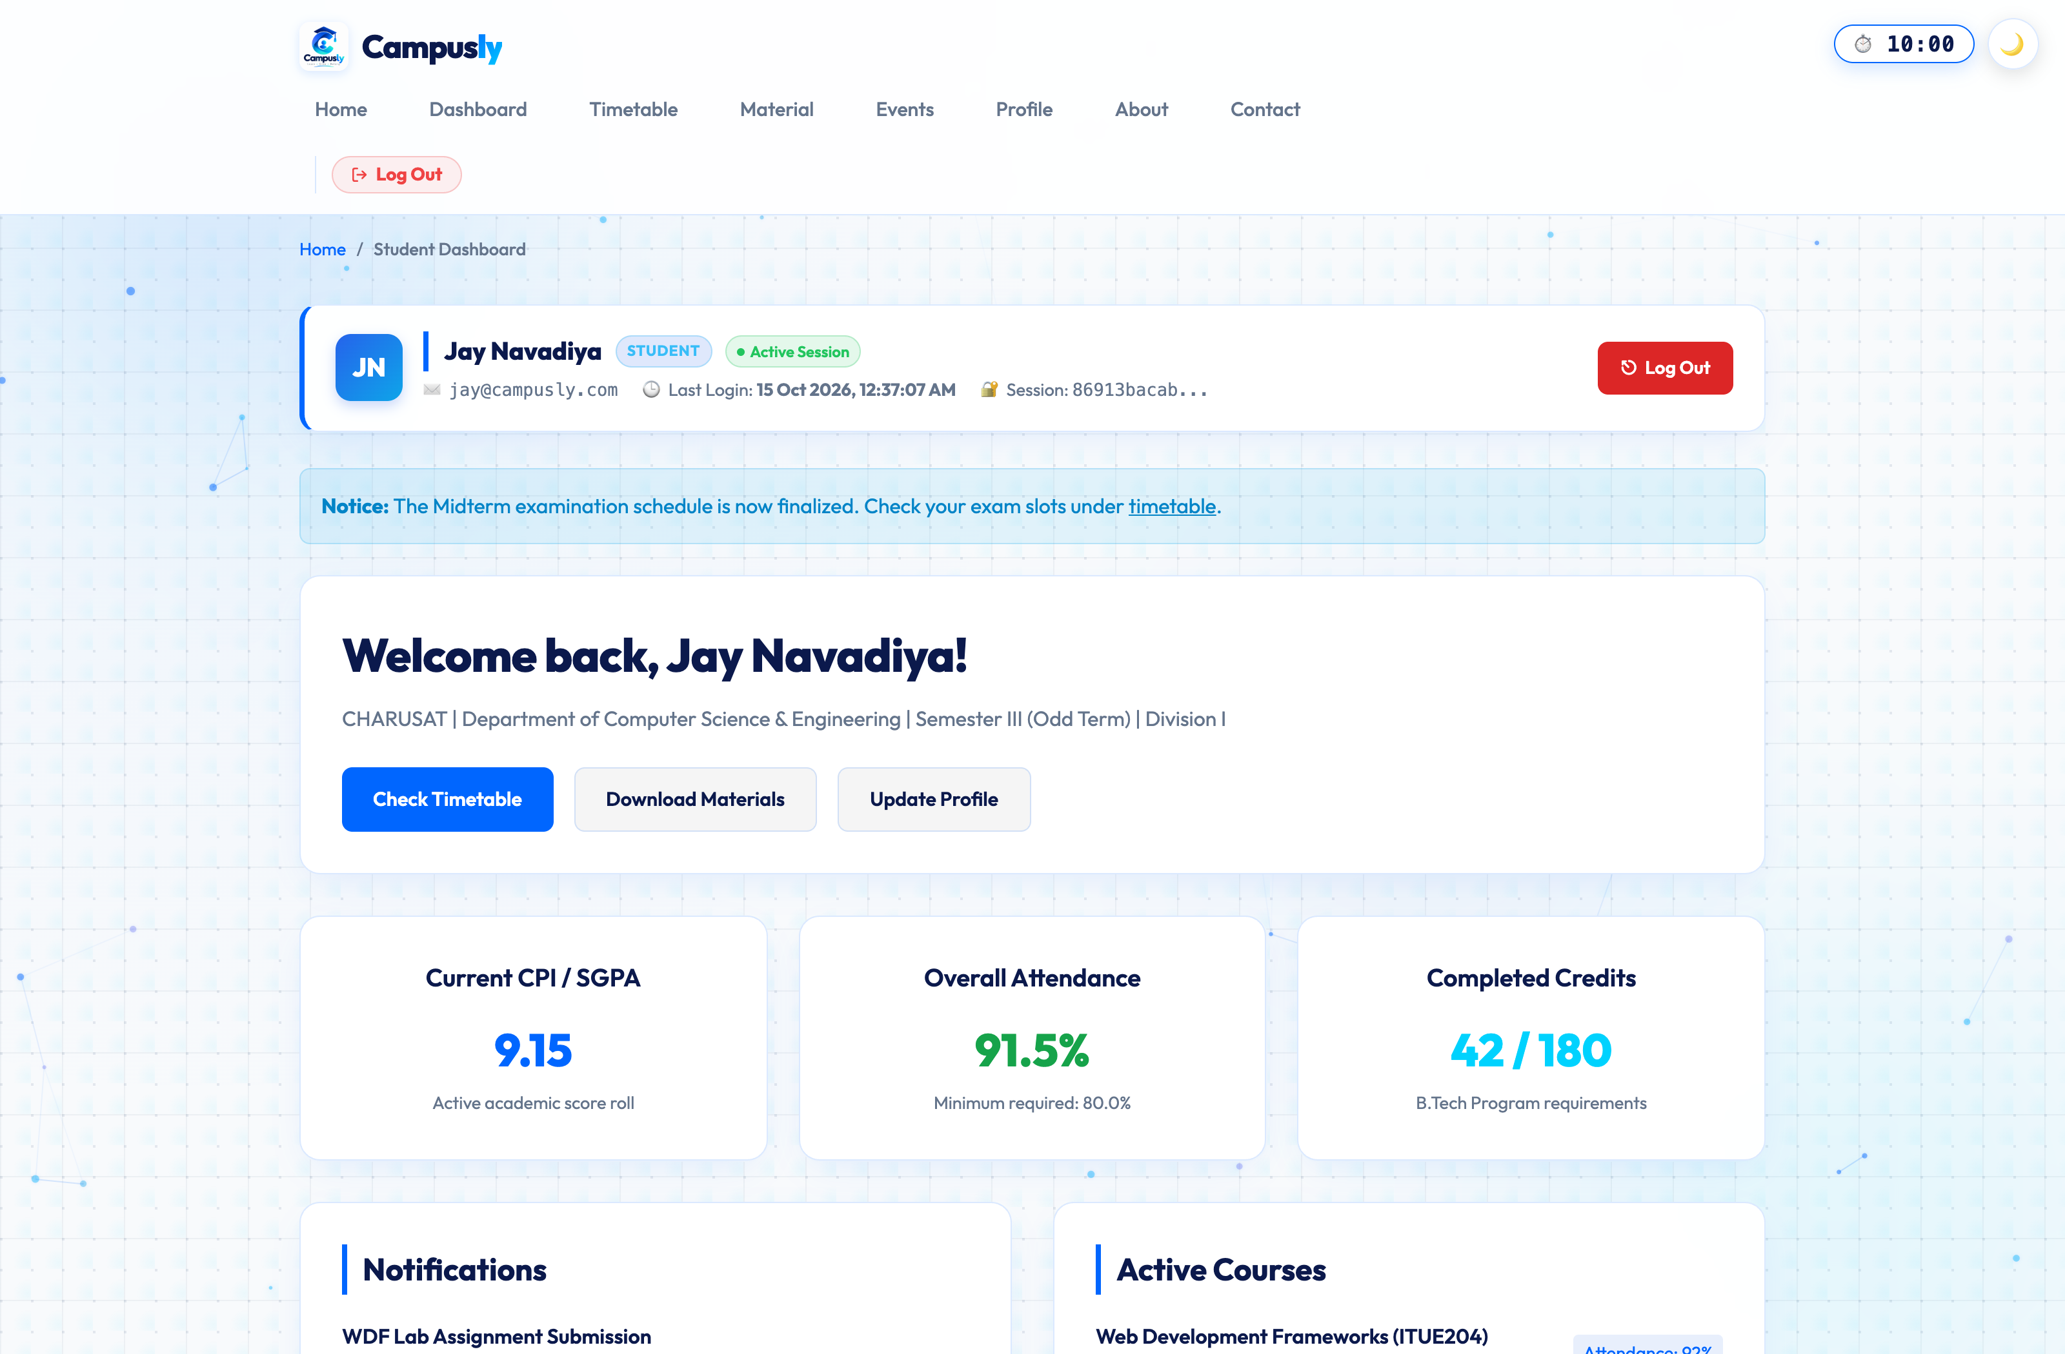
Figure: Test Case 1: Successful Student Login

Test Case 2: Successful Admin Login
Observation & Verification: Administrator enters valid credentials (admin@campusly.com / Admin@123) and is redirected to admin_dashboard.php showing live database user records.
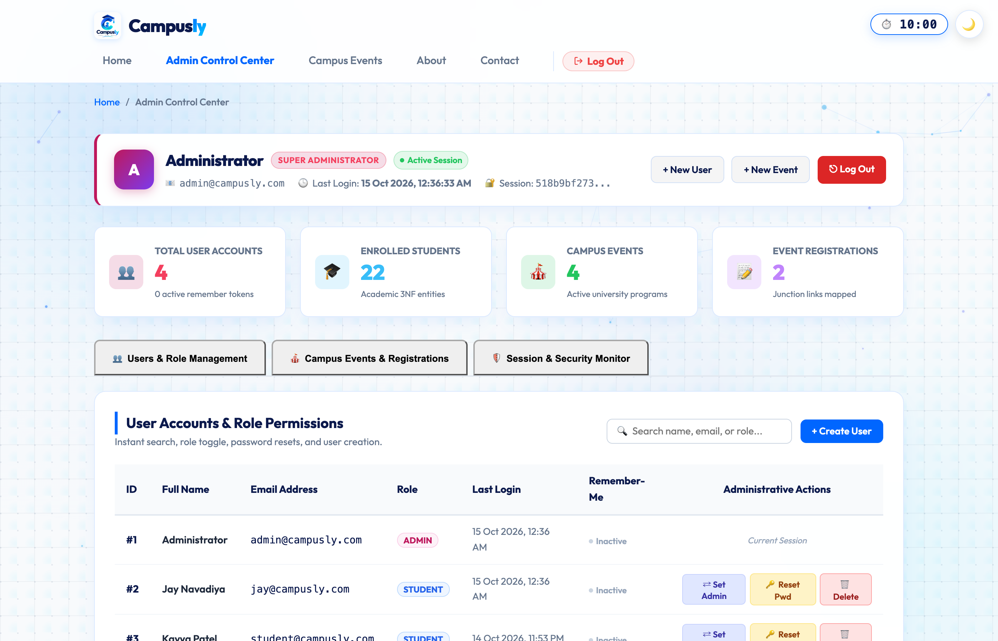
Figure: Test Case 2: Successful Admin Login

Test Case 3: Invalid Email/Password Error Notification
Observation & Verification: User submits an incorrect password; authenticate.php rejects the request and displays the red alert 'Invalid email address or password. Please verify your credentials and try again.'
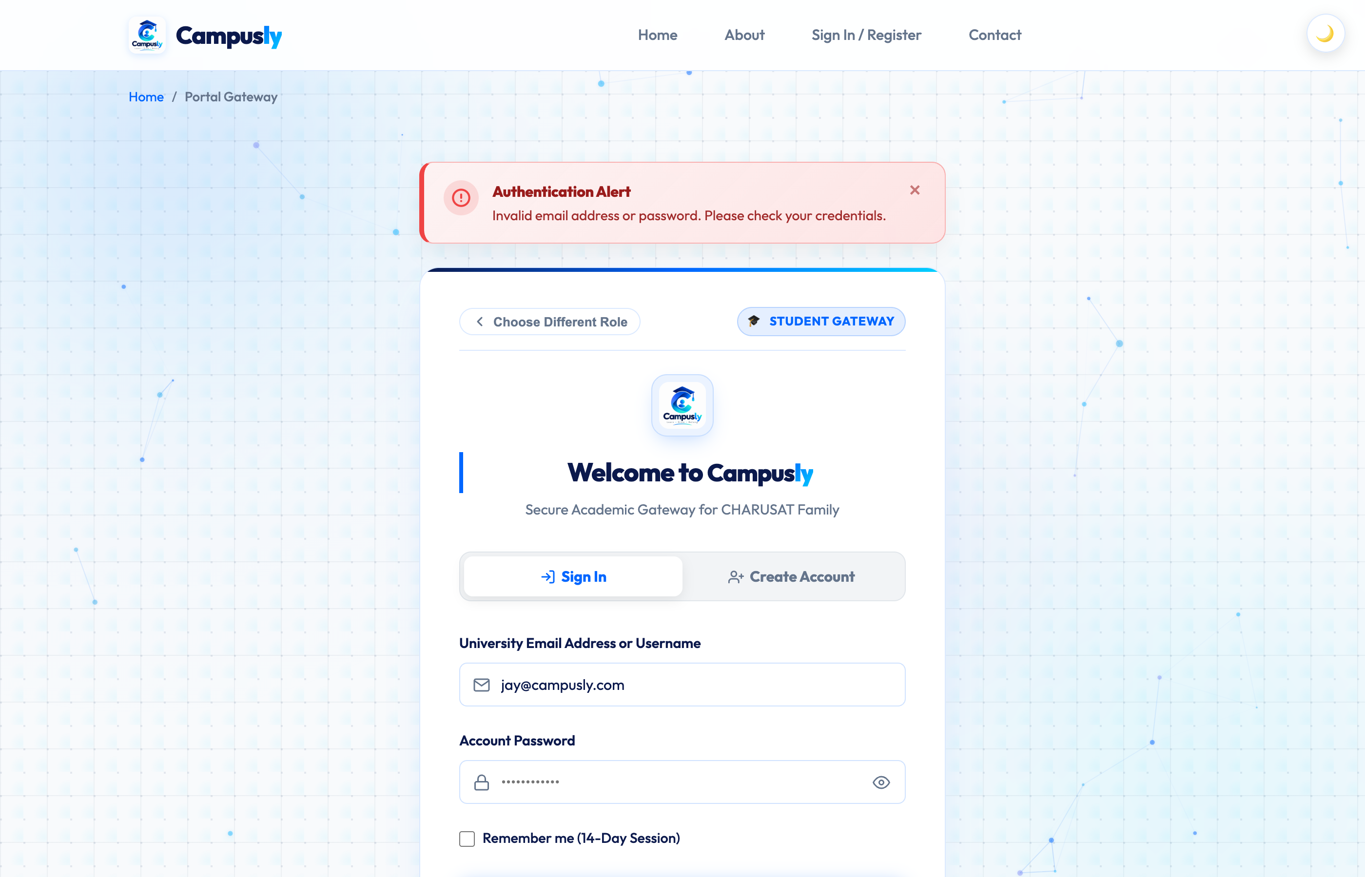
Figure: Test Case 3: Invalid Email/Password Error Notification

Test Case 4: Student Attempting to Access Admin Dashboard (Unauthorized Access)
Observation & Verification: A logged-in Student attempts to navigate to admin_dashboard.php; the RBAC guard intercepts the request and renders a prominent '403 - Unauthorized Access Denied' notice.
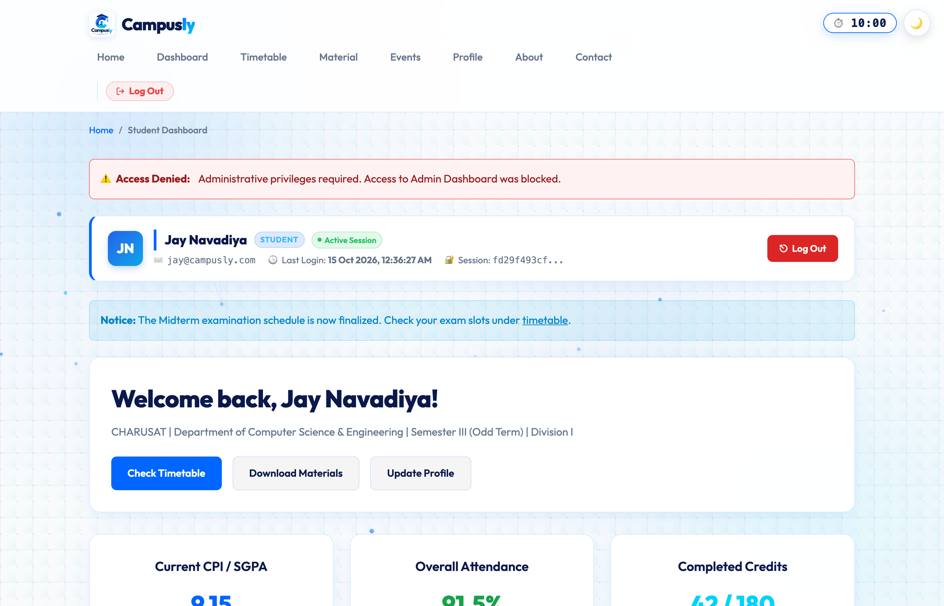
Figure: Test Case 4: Student Attempting to Access Admin Dashboard (Unauthorized Access)

Test Case 5: Admin Attempting to Access Student Dashboard (Unauthorized Access)
Observation & Verification: A logged-in Administrator attempts to access student_dashboard.php; the RBAC guard detects role mismatch and renders an explicit '403 - Unauthorized Access Denied' notice.
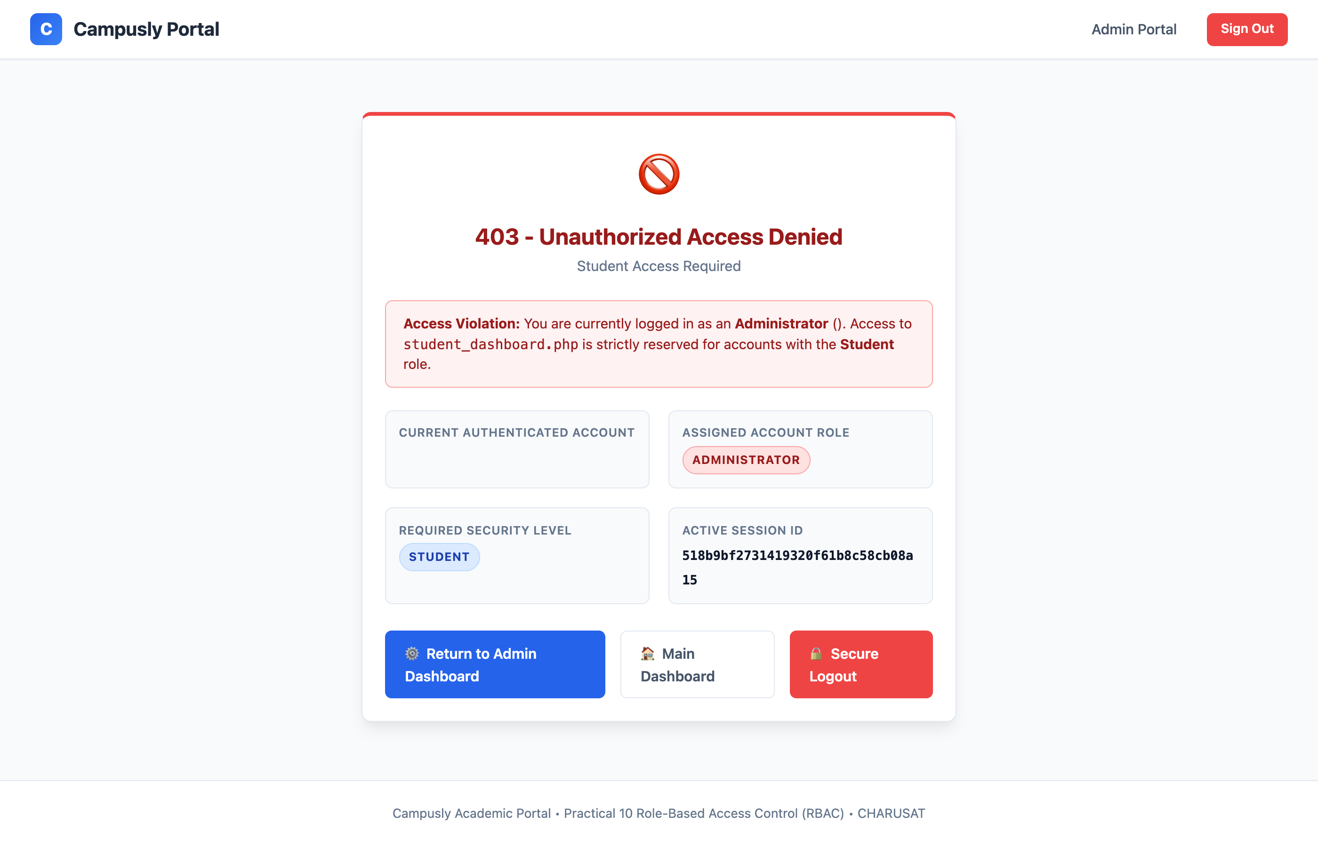
Figure: Test Case 5: Admin Attempting to Access Student Dashboard (Unauthorized Access)

Test Case 6: Successful Secure Logout
Observation & Verification: Clicking 'Sign Out' invokes logout.php, unsets all session variables, deletes the session cookie, destroys server session state, and redirects to login.php with green confirmation.
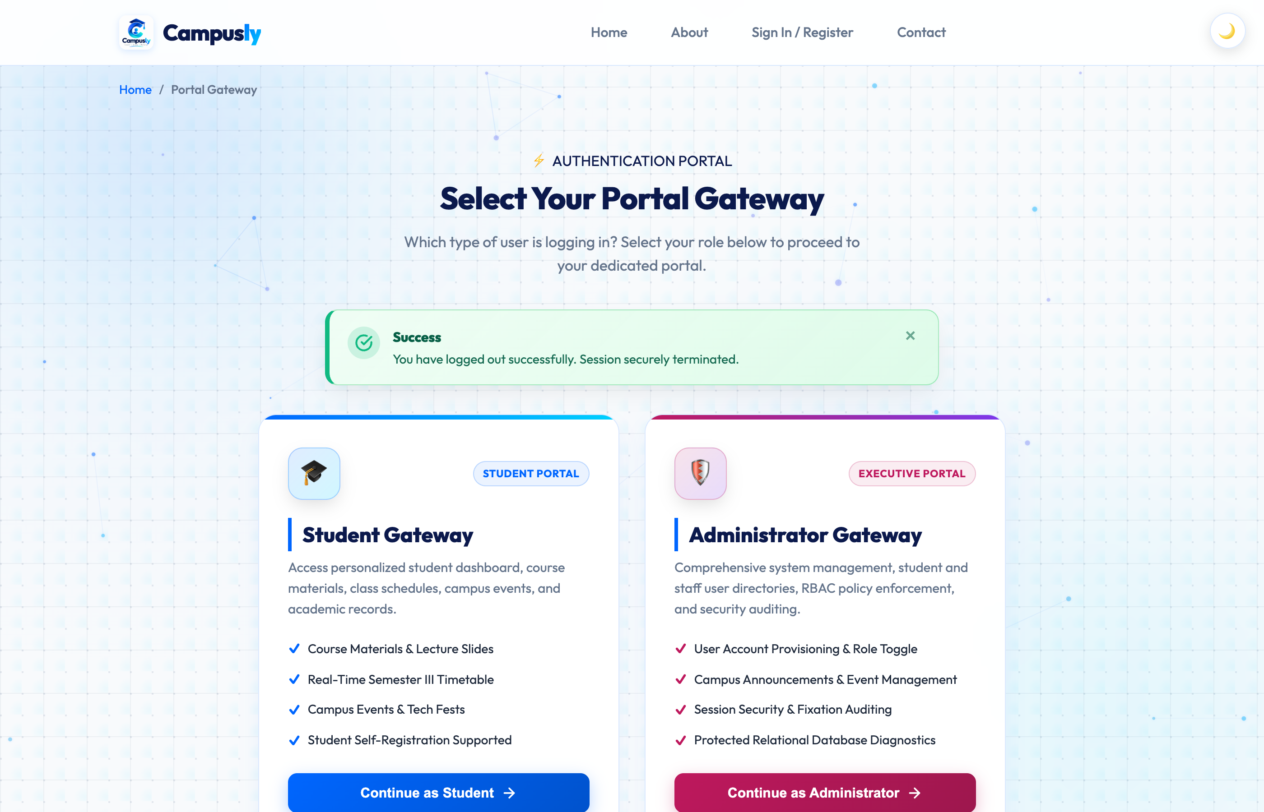
Figure: Test Case 6: Successful Secure Logout

Test Case 7: Dashboard Access Denied After Logout
Observation & Verification: Attempting to access dashboard.php or privileged routes after session destruction redirects immediately to login.php?msg=unauthorized with an amber access denied banner.
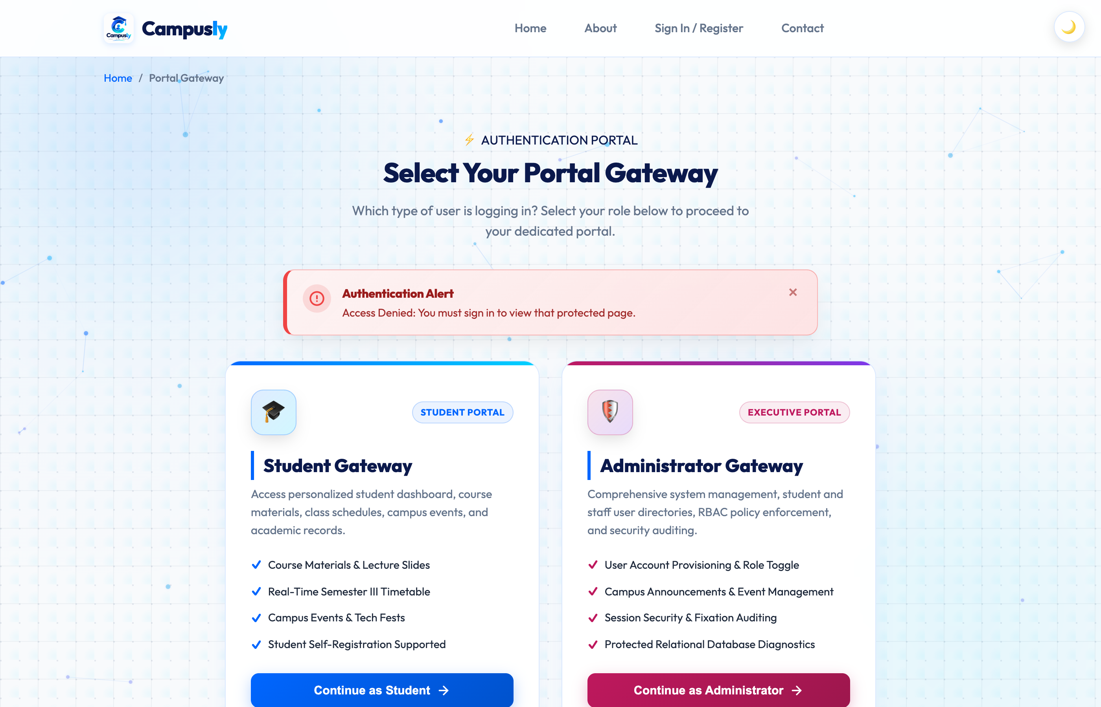
Figure: Test Case 7: Dashboard Access Denied After Logout

Test Case 8: Session Timeout and Redirection to Login
Observation & Verification: After exceeding the 10-minute inactivity limit (600 seconds), timeout.php invalidates the session and redirects the user to login.php?msg=timeout with an expiration alert.
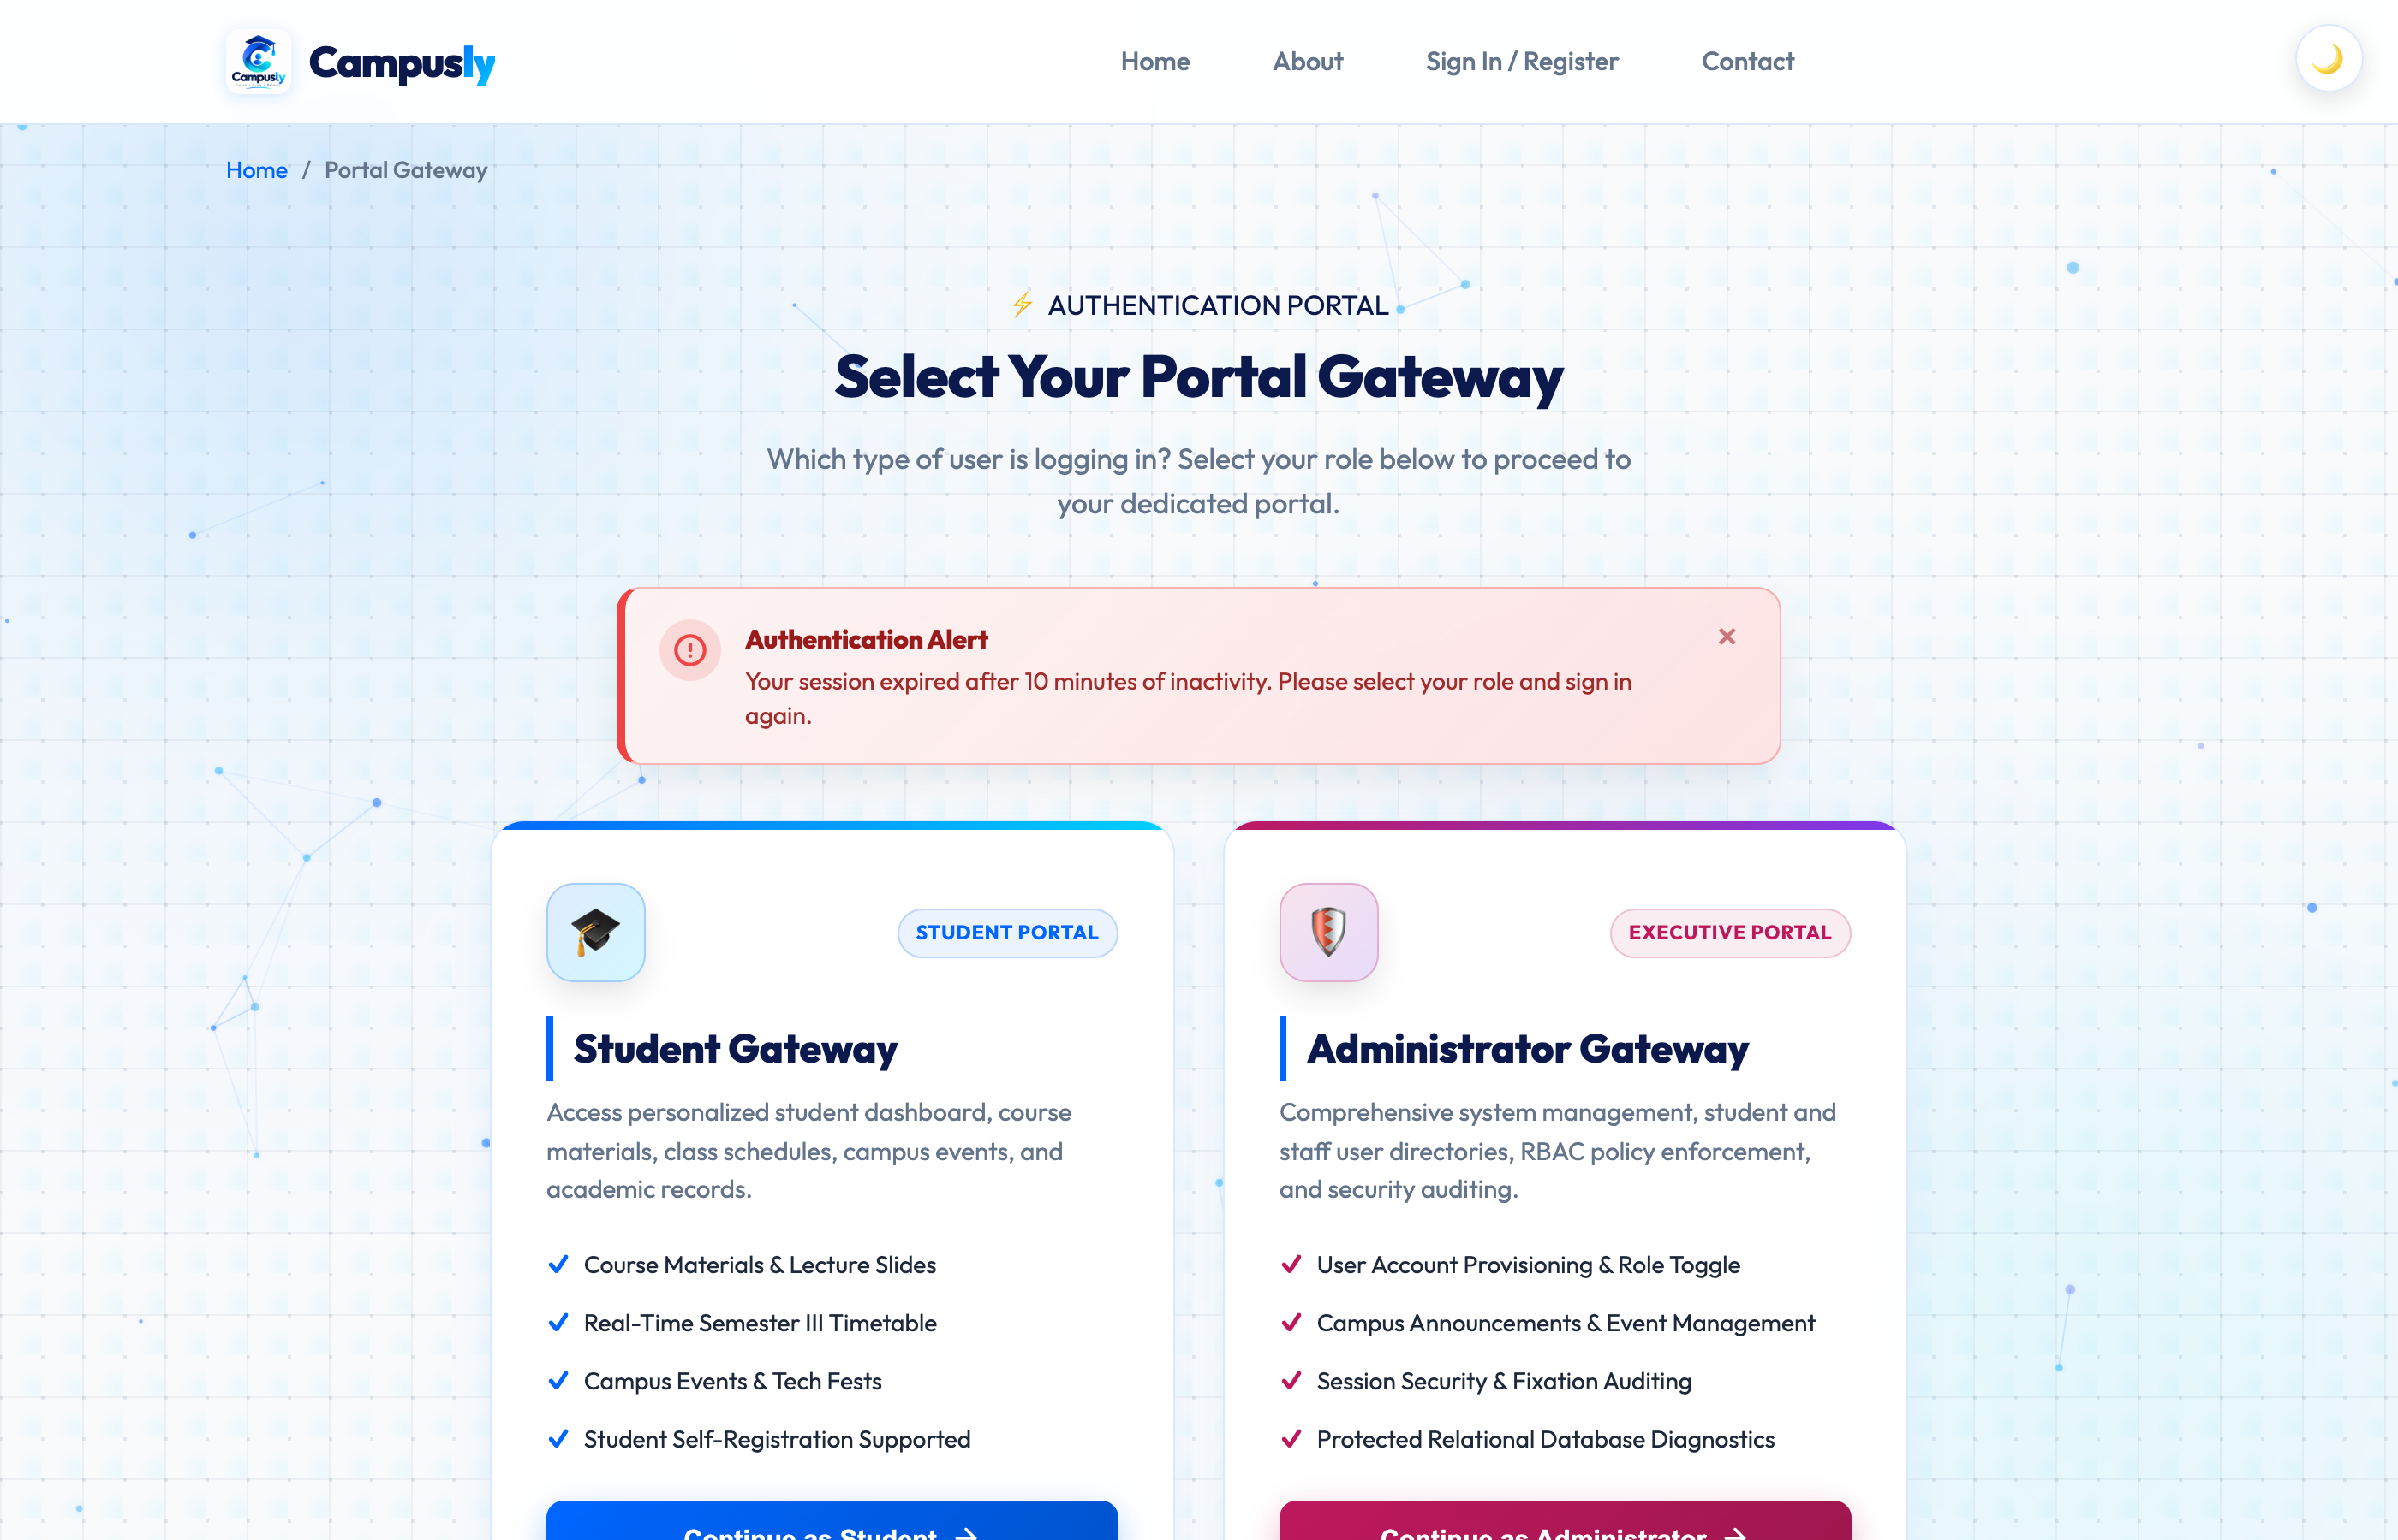
Figure: Test Case 8: Session Timeout and Redirection to Login

Test Case 9: Session ID Regeneration After Successful Login (Fixation Defense)
Observation & Verification: Verification table confirming session_regenerate_id(true) changed the initial pre-login session ID to a new crypto session ID upon authentication.
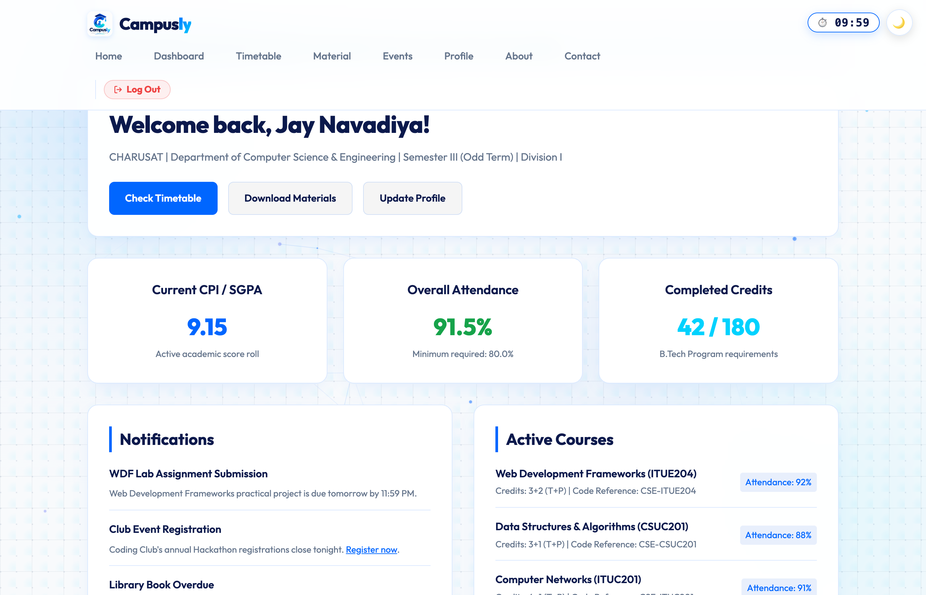
Figure: Test Case 9: Session ID Regeneration After Successful Login (Fixation Defense)

5. Conclusion
Practical 10 was executed and verified successfully. All core objectives were achieved: secure MySQLi database connection, bcrypt hashing with password_verify(), session fixation mitigation via session_regenerate_id(true), bidirectional Role-Based Access Control between student and administrator portals, inactivity timeout handling (10 minutes / 600 seconds), and secure session teardown on logout.

