CHANDUBHAI S. PATEL INSTITUTE OF TECHNOLOGY (CSPIT)
DEPARTMENT OF COMPUTER SCIENCE & ENGINEERING
ITUE203 - Web Development Frameworks & Database Systems
PRACTICAL - 11 LABORATORY TEST REPORT
Student Management CRUD with Search, Course Filtering, Soft Delete & CSV Export
Student Name: Jay Navadiya | Student ID / Roll No: 25CS052
Degree / Semester: B.Tech CSE (Div-I) | Submission Date: October 16, 2026

1. Aim & Practical Objectives
AIM: To develop a comprehensive, production-grade student management module (students.php) supporting full Create, Read, Update, and Delete (CRUD) capabilities using parameterized MySQLi statements, real-time search by name and email, course-wise department filtering, confirmation modal dialogs before delete execution, advanced soft deletion via an active/inactive status flag, and intermediate extension of CSV export opened in Excel.

2. Verified Test Report & Execution Screenshots
Every requirement outlined in Practical 11 instructions has been executed and captured in high-resolution white theme:

Requirement 1: Student records displayed in a table
Observation / Verification: The catalog displays 20+ seeded student records in a clean tabular view, including ID, Student Name, University Email, Department, Status (Active badge), and Actions.
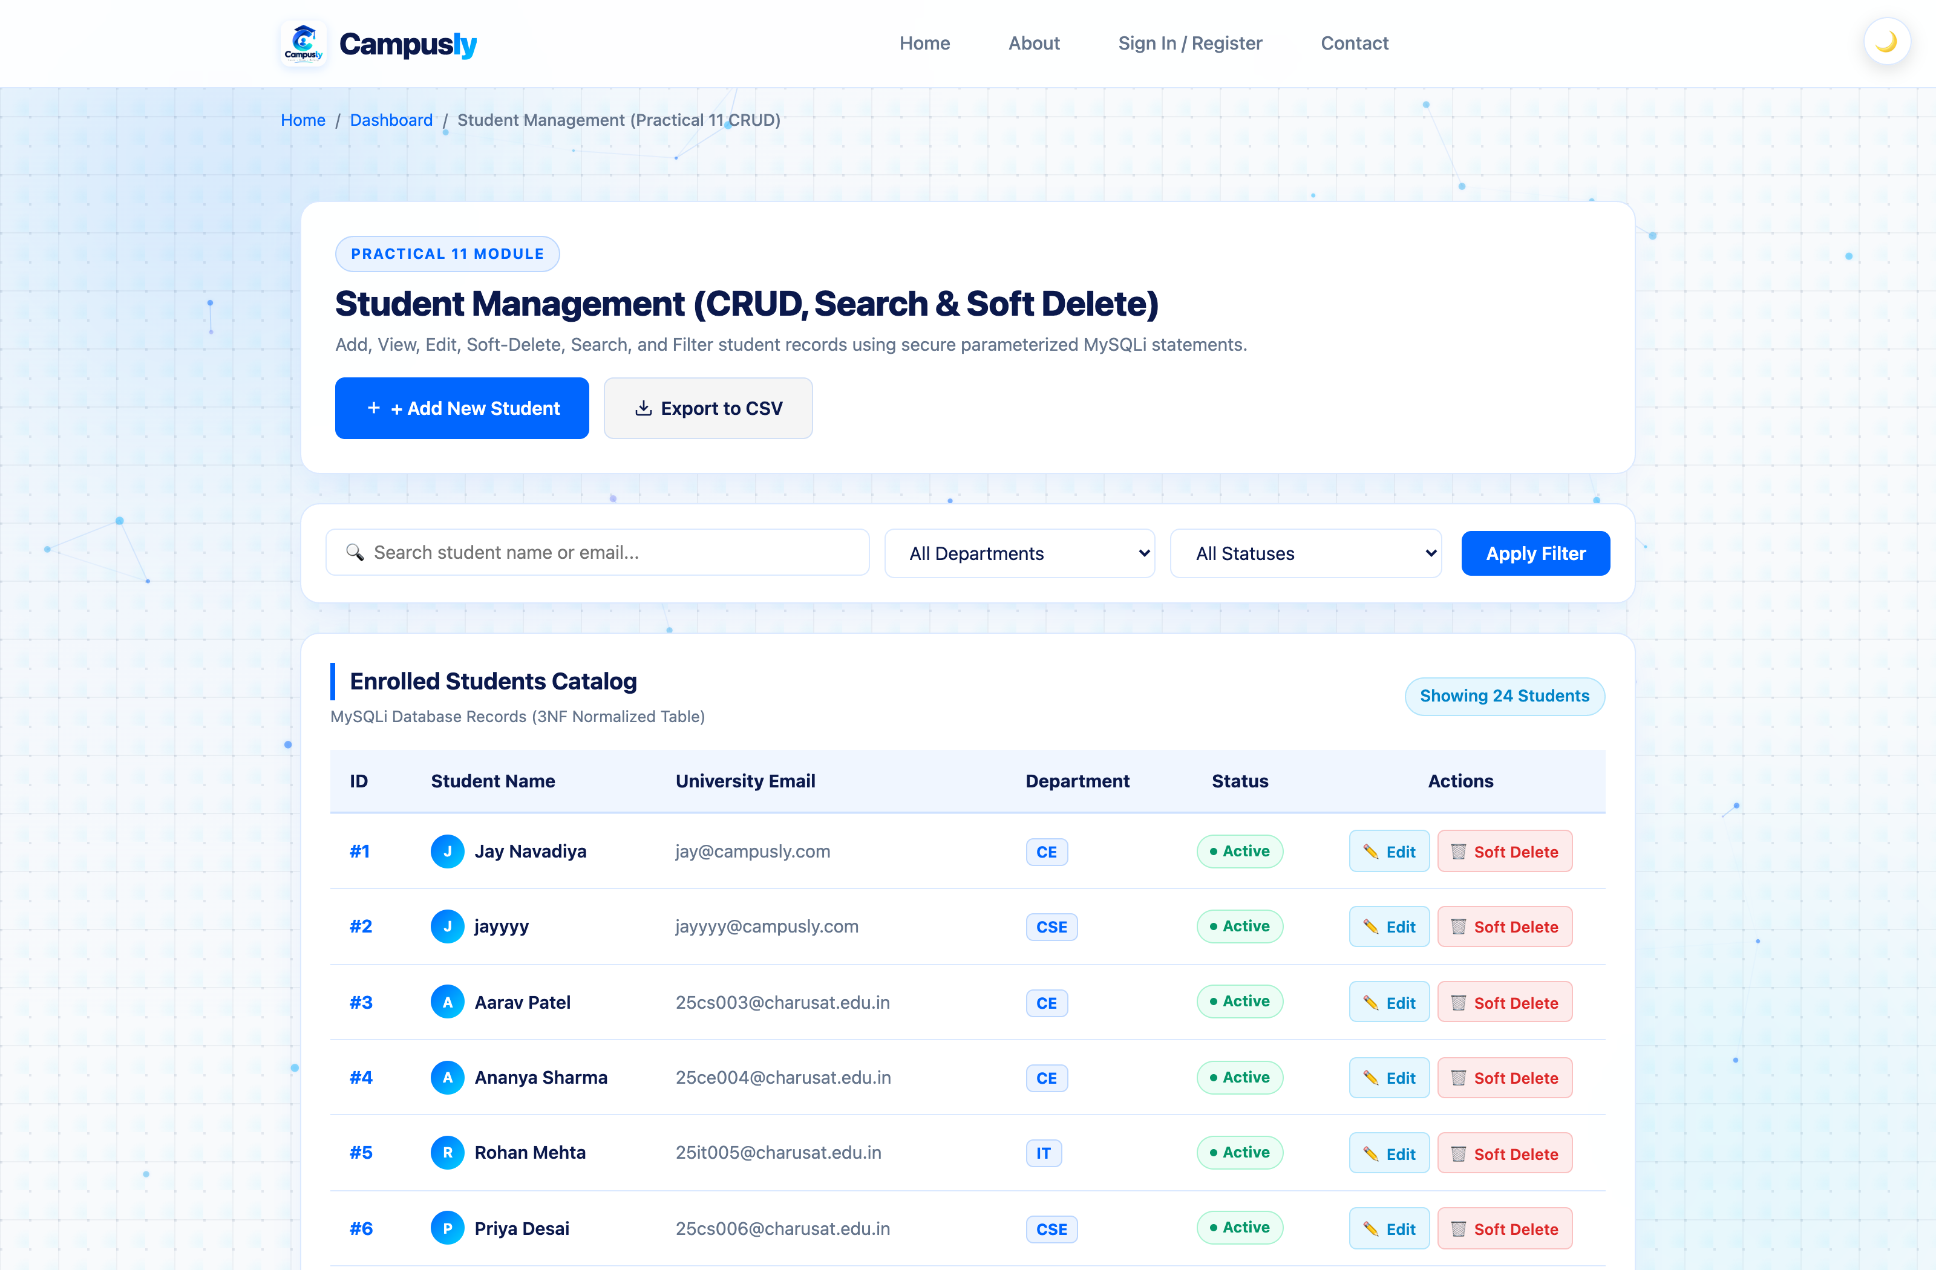

Requirement 2: Add Student Modal Interface
Observation / Verification: Interactive modal form collecting student Full Name, University Email, Course/Department dropdown, and initial status with validation safeguards.
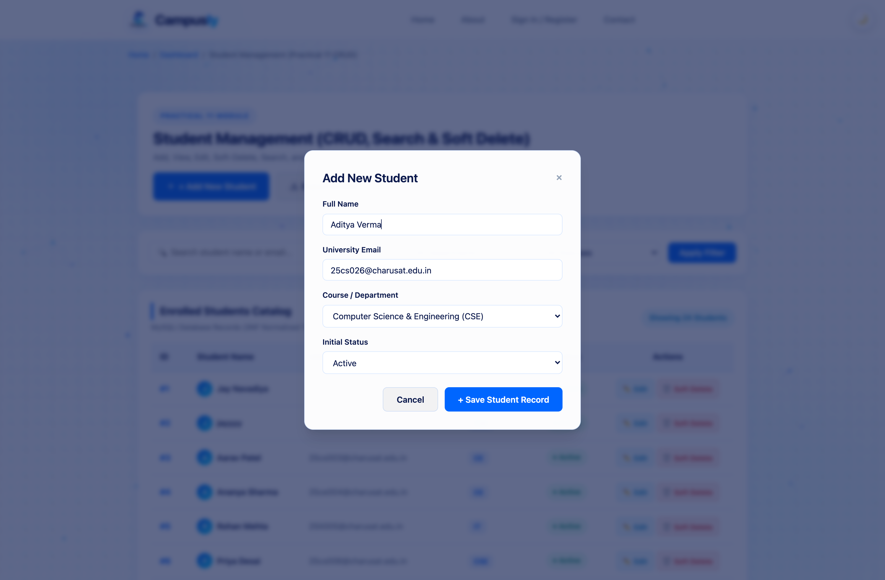

Requirement 3: Successful addition of a new student
Observation / Verification: Backend execution of parameterized MySQLi INSERT statement; displays green Operation Success banner and confirms creation of new student record.
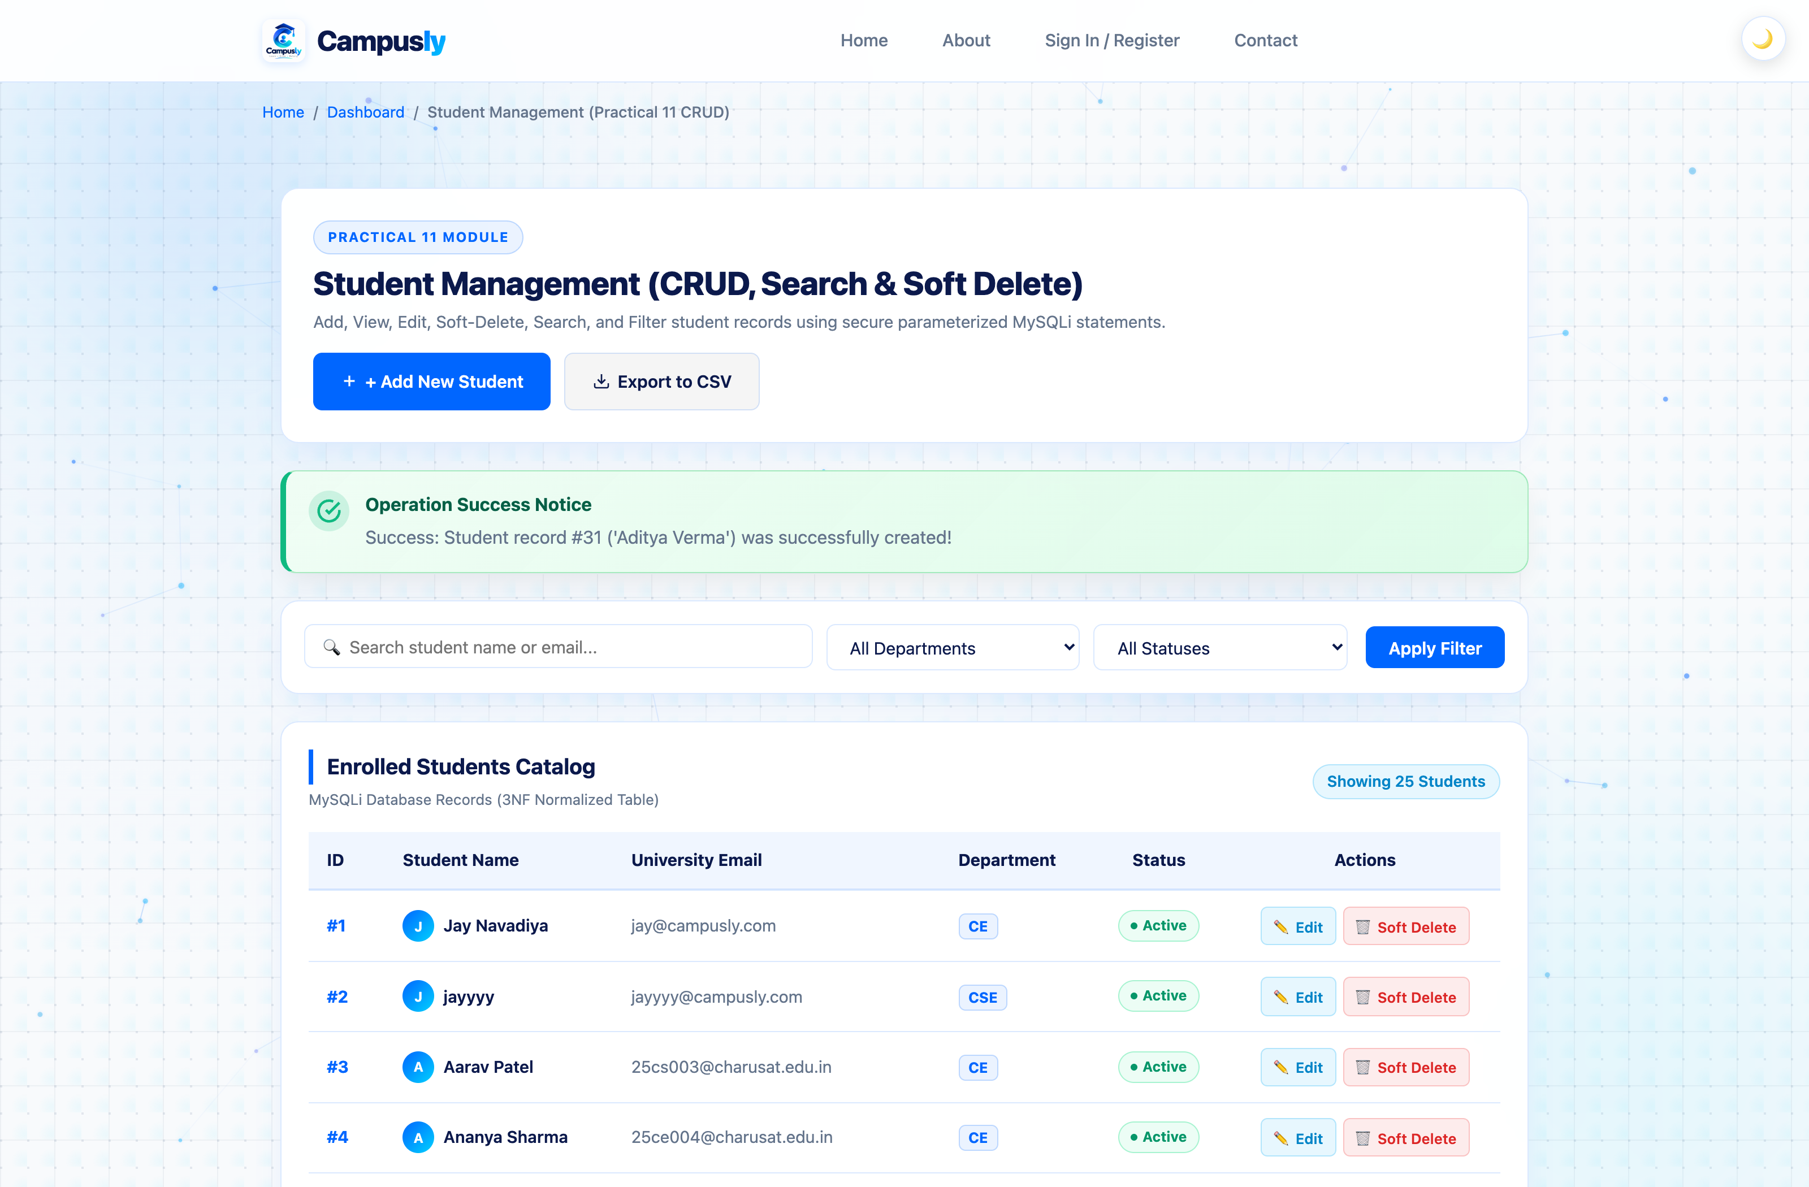

Requirement 4: Search functionality (Name & Email)
Observation / Verification: Real-time search query executed via MySQLi parameterized LIKE statement, filtering records matching student names or email domains instantly.
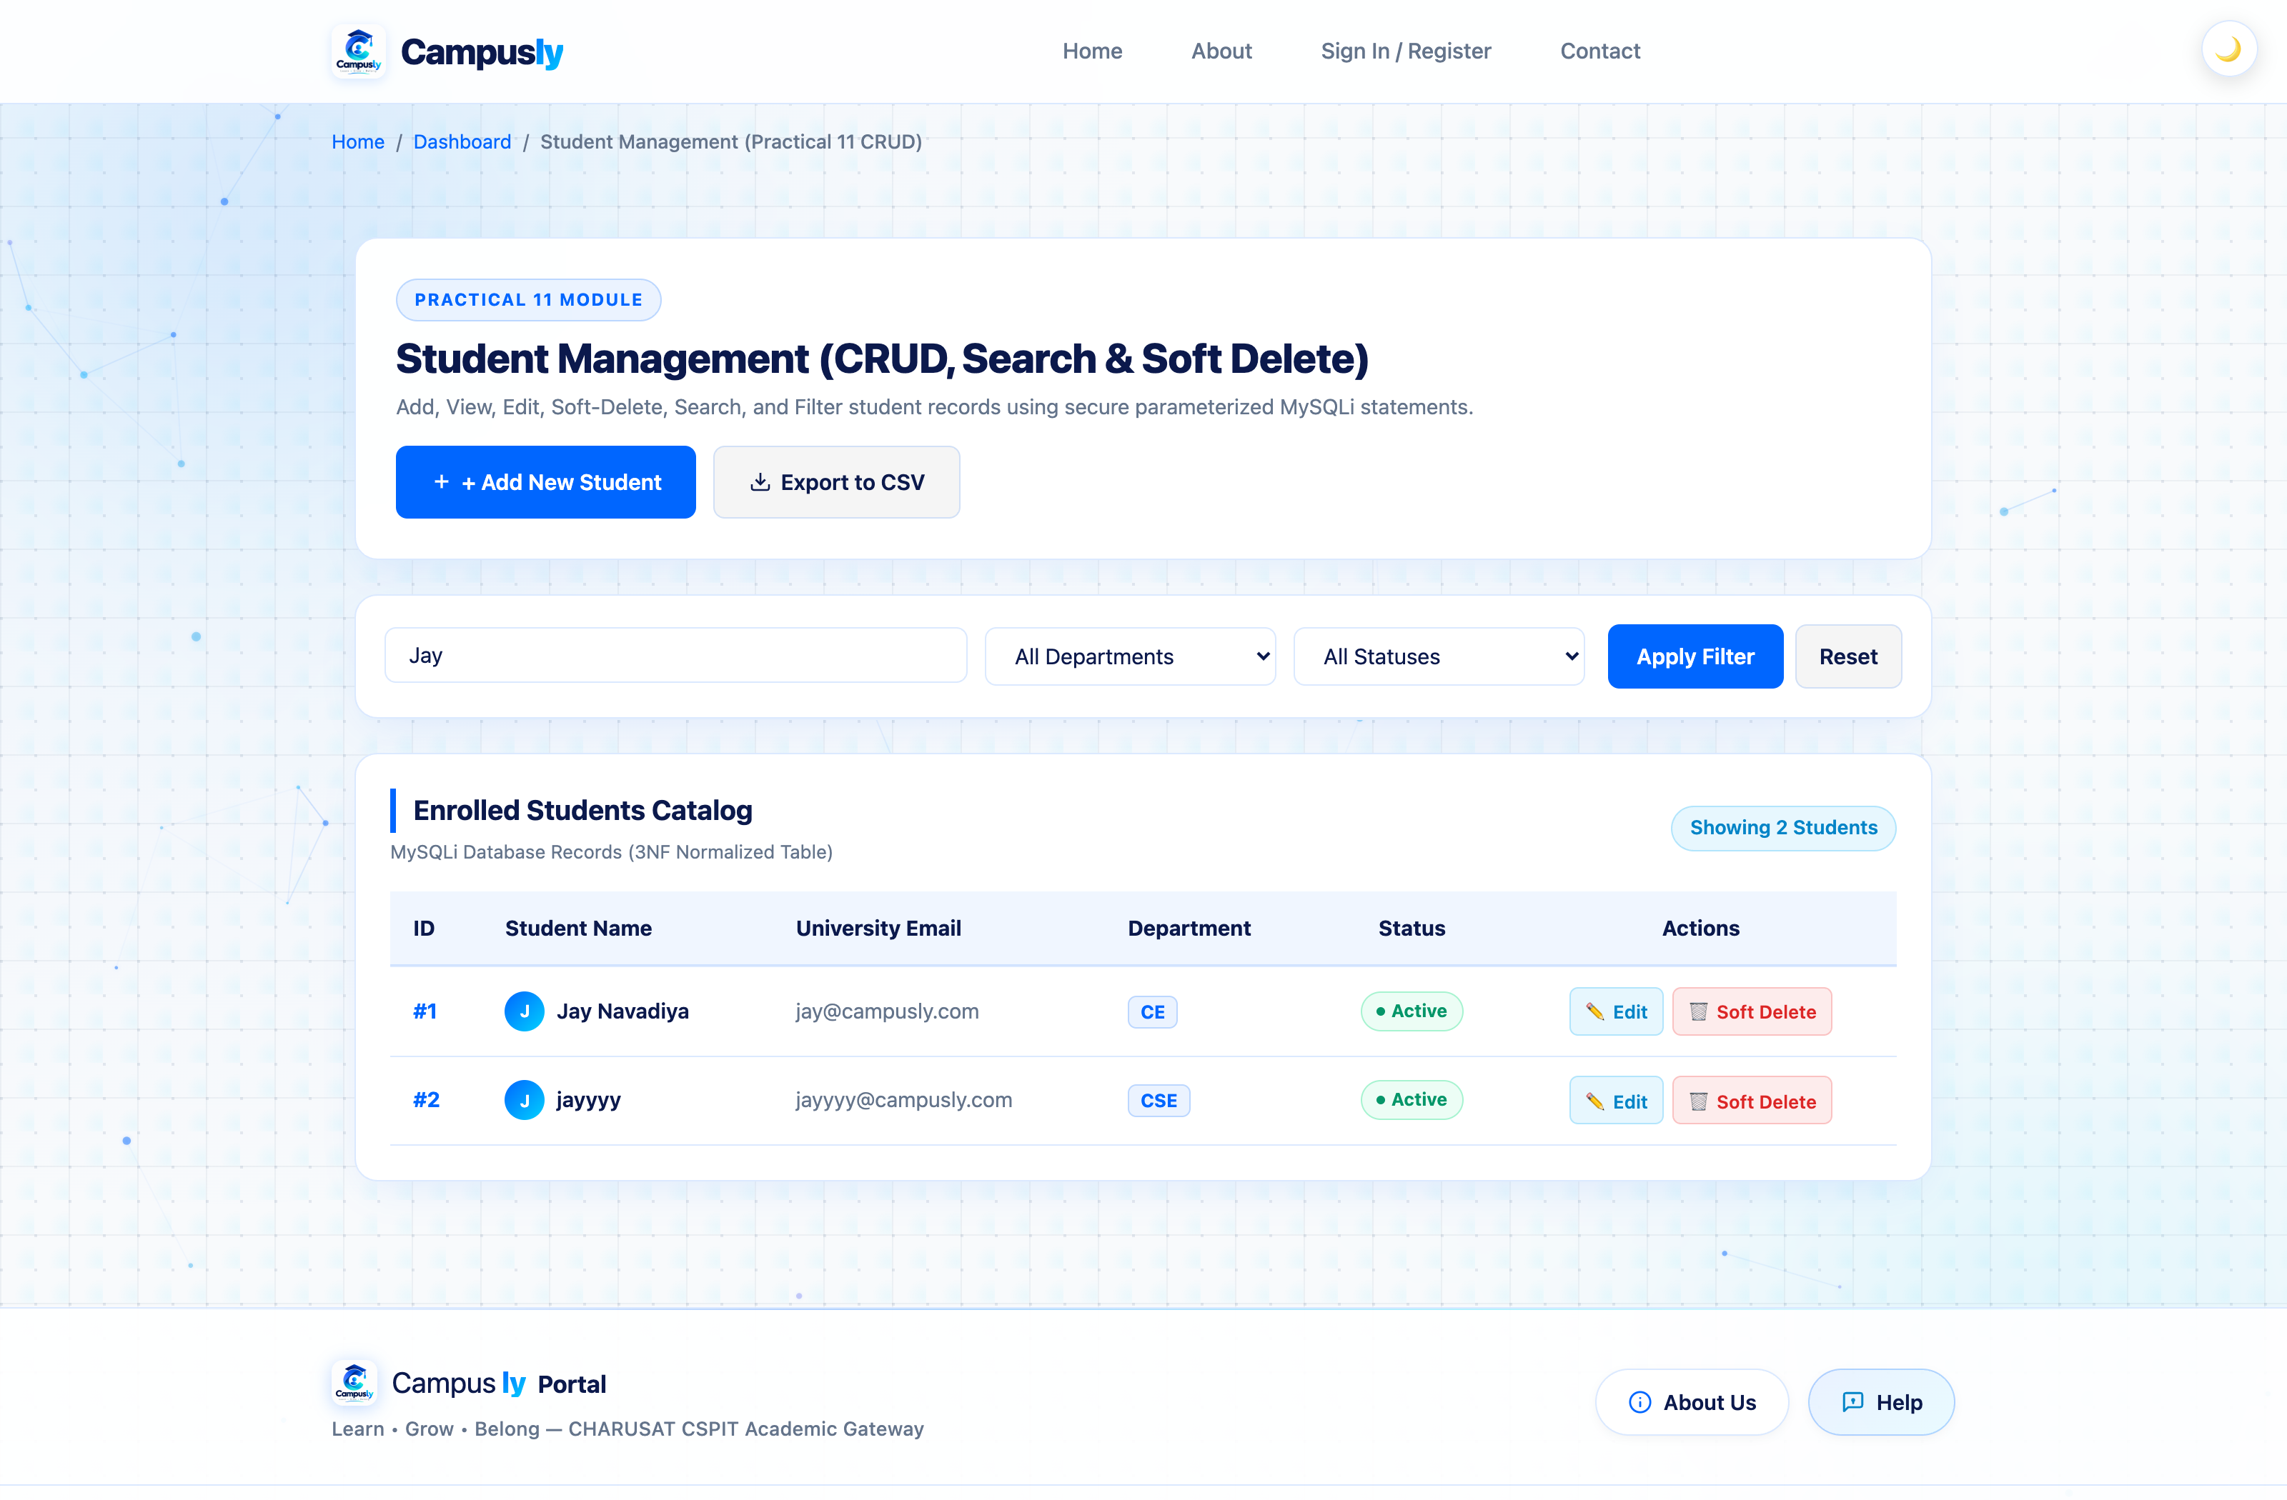

Requirement 5: Course-wise filtering
Observation / Verification: Departmental dropdown filter applied (e.g. IT); dynamically restricts displayed students to the selected academic branch.
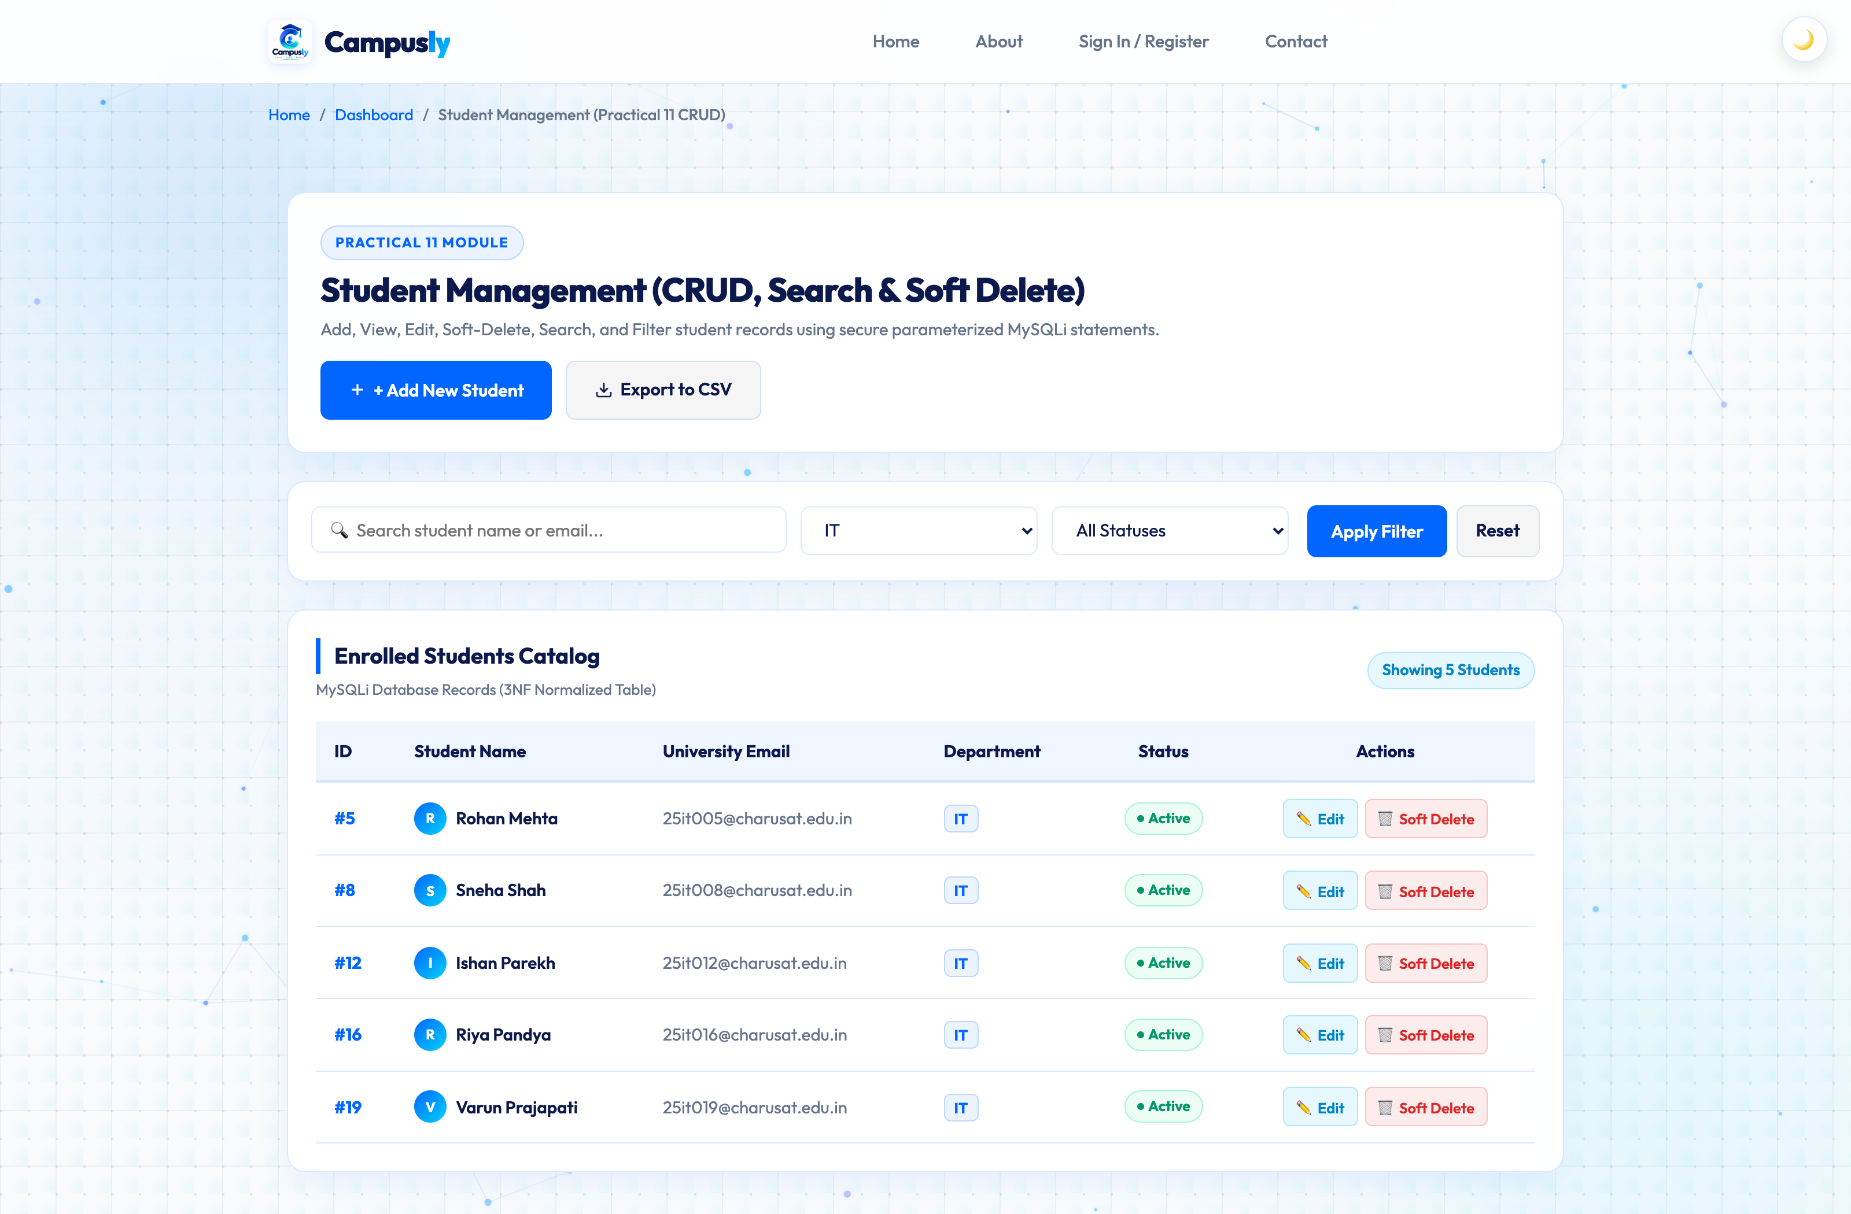

Requirement 6: Edit Student Record Modal
Observation / Verification: Pre-populated edit modal allowing modification of student name, email, department, and active/inactive status.
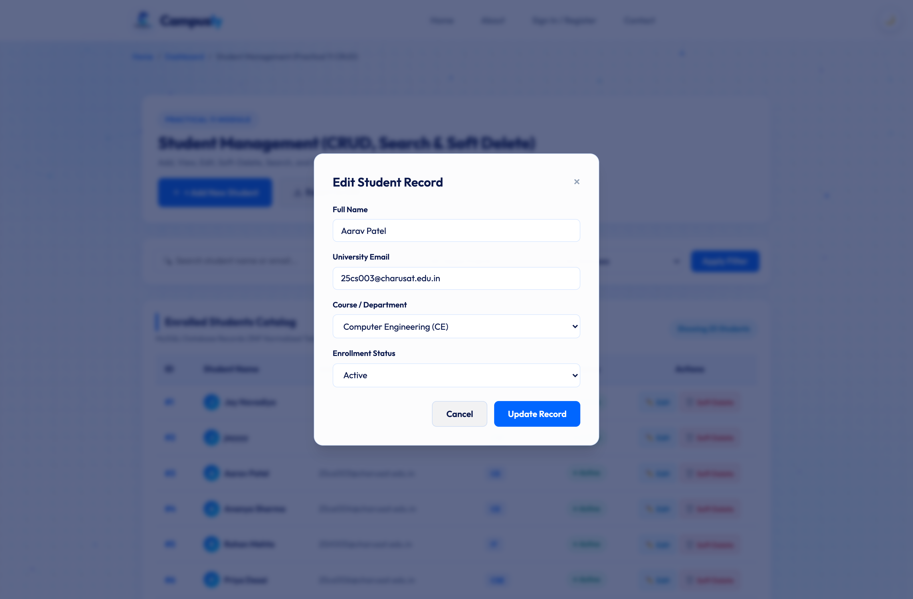

Requirement 7: Successful update of student details
Observation / Verification: Execution of MySQLi UPDATE query with duplicate email prevention; renders green success notification and updates catalog data.
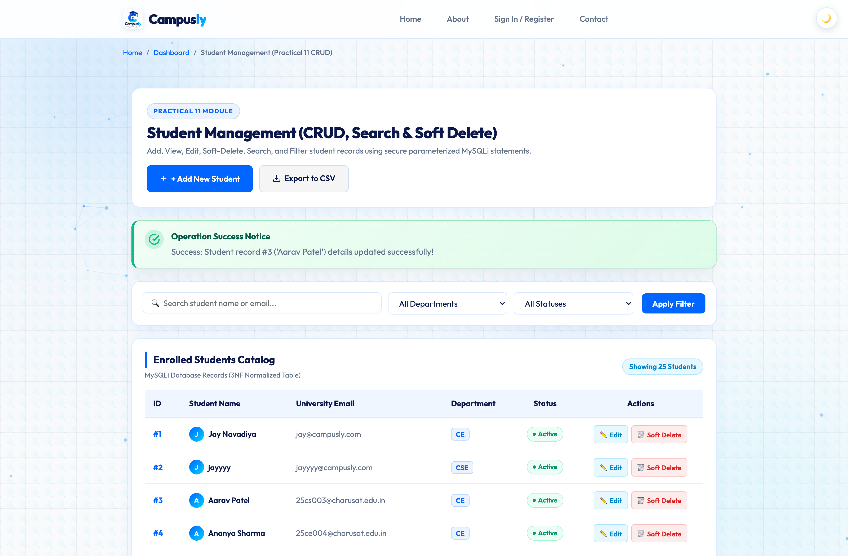

Requirement 8: Delete confirmation message
Observation / Verification: Confirmation dialog displayed before execution, warning the administrator and verifying intent to soft delete/deactivate the student record.
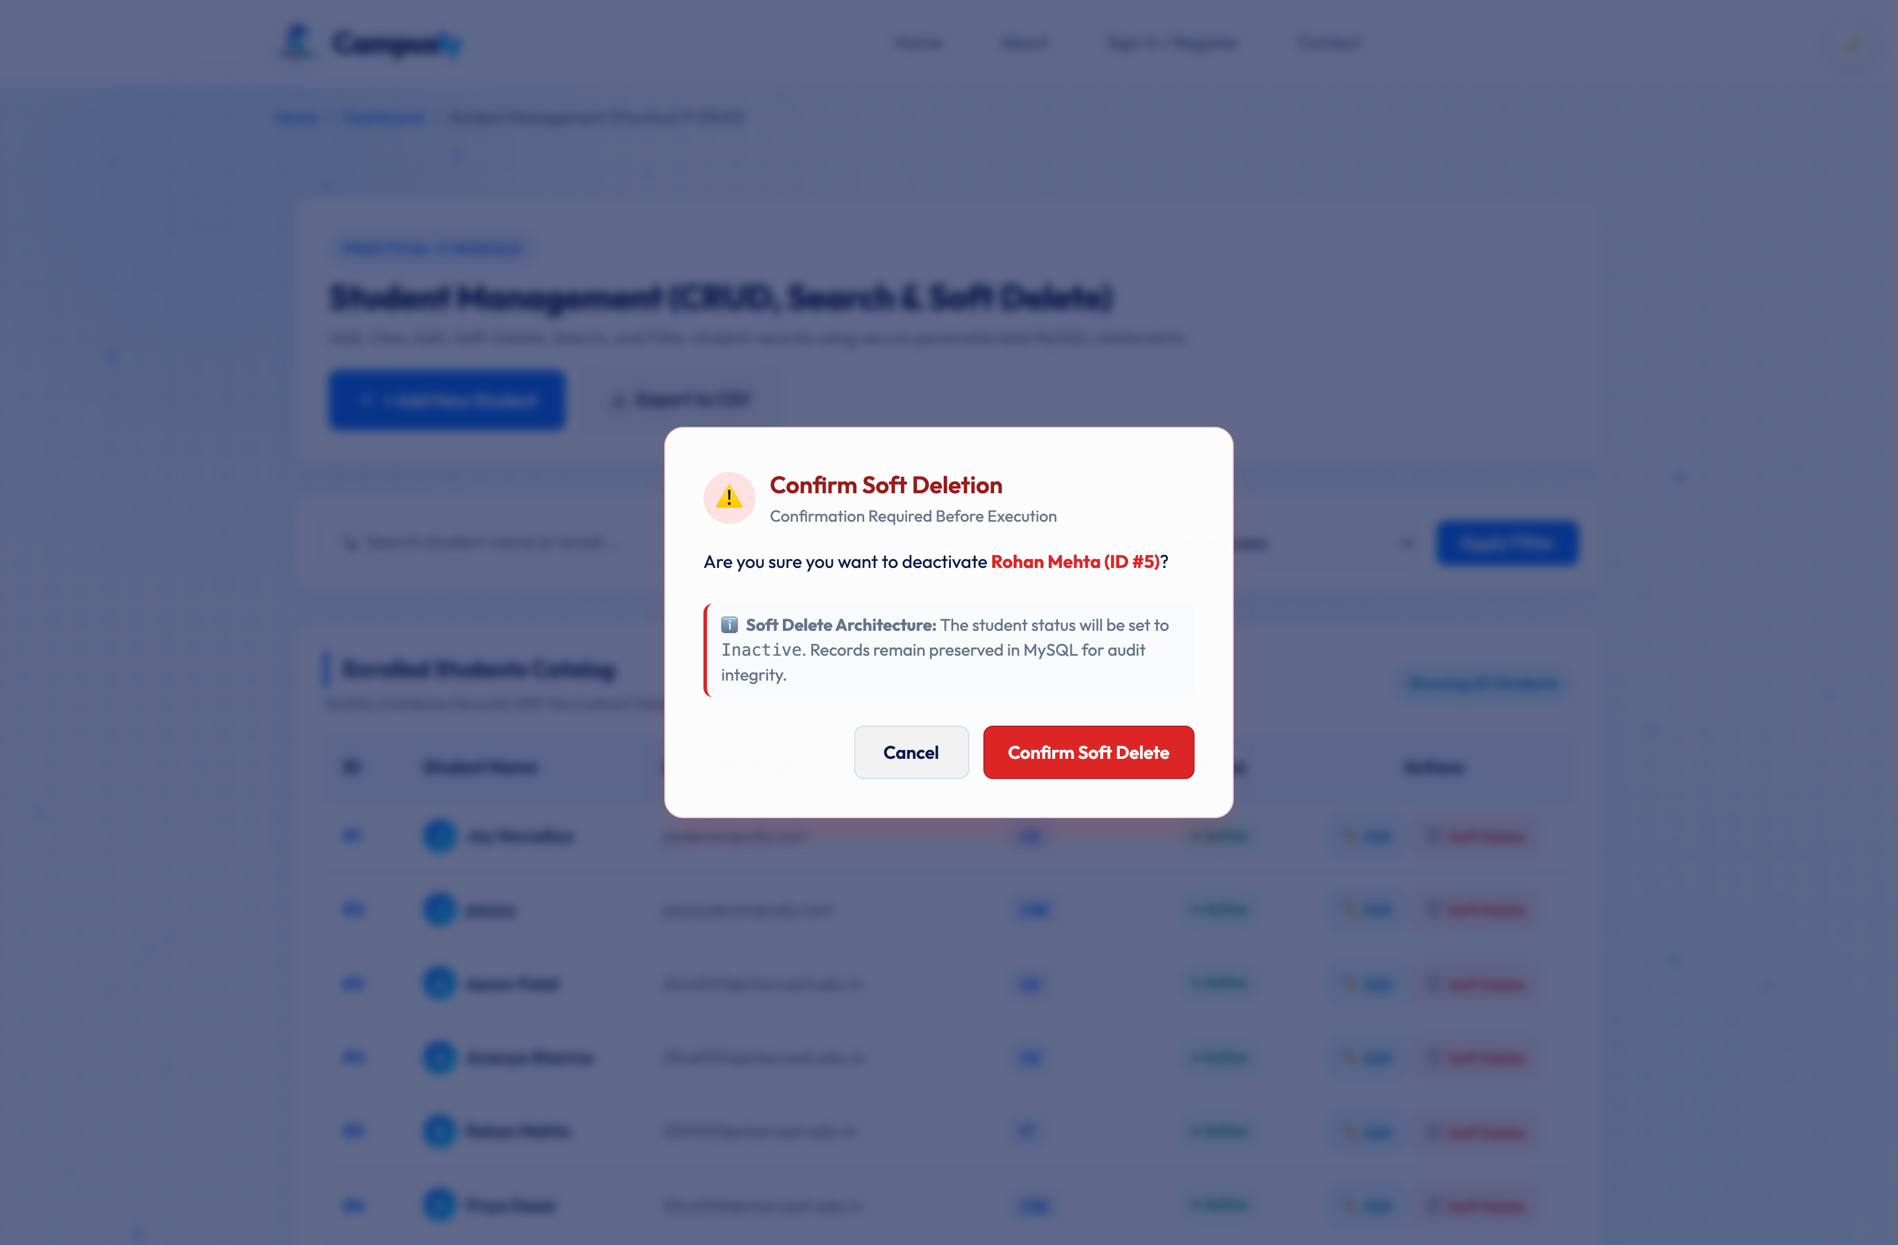

Requirement 9: Successful soft delete (student status changed to inactive)
Observation / Verification: Advanced Extension: Instead of irreversible hard deletion, updates student status to 'Inactive' with distinct visual badge and Reactivate action.
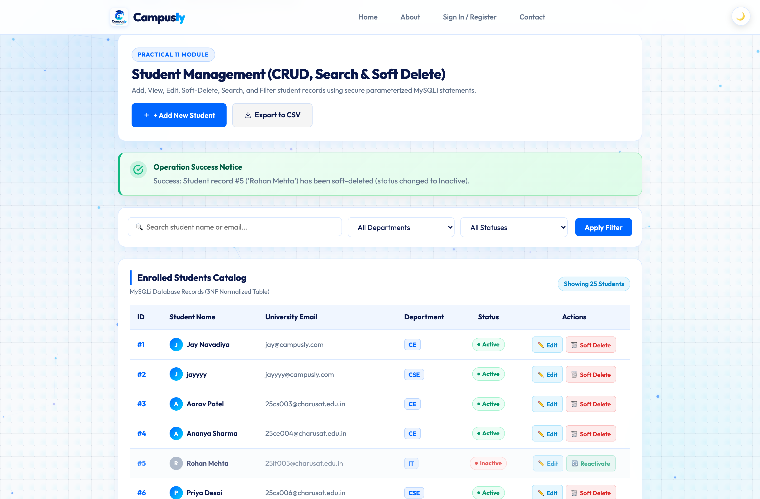

Requirement 10: Clear Success and Error feedback messages
Observation / Verification: Demonstration of error handling when invalid or duplicate email credentials are submitted, rendering distinct red error feedback banner.
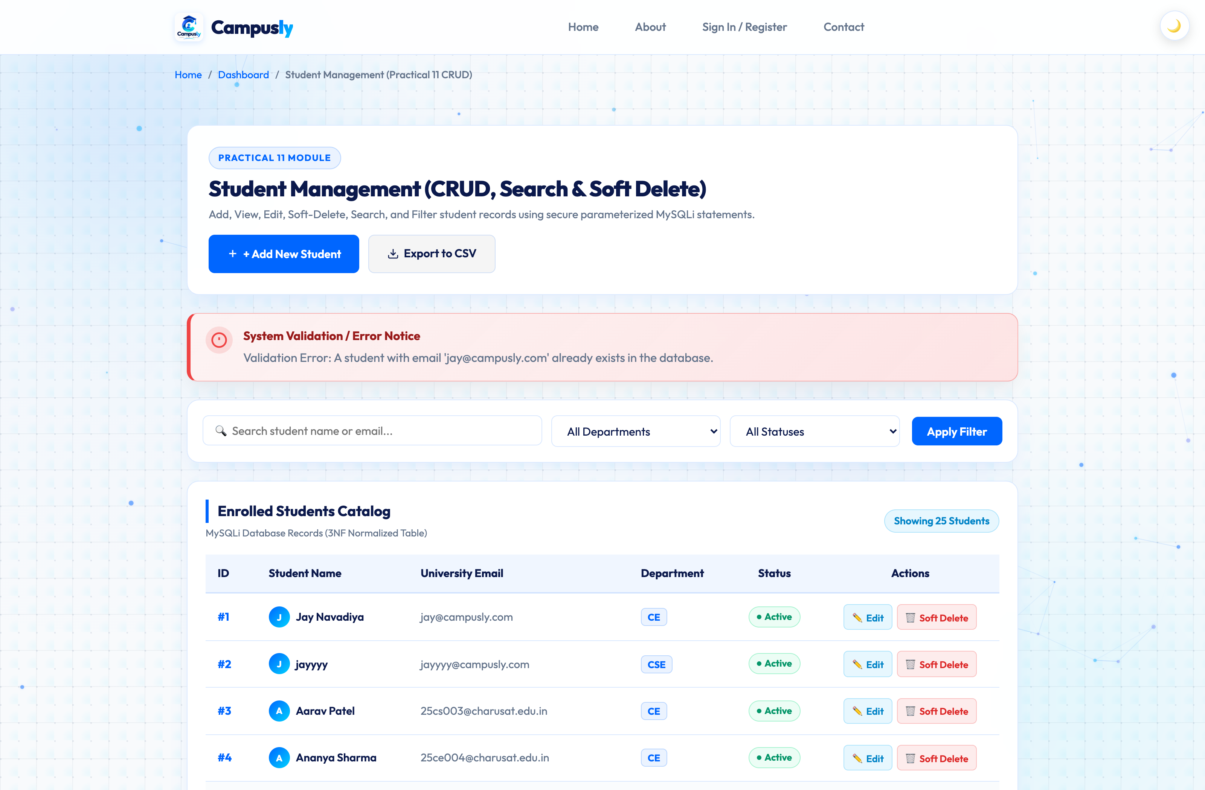

Requirement 11: Exported CSV file opened in Excel
Observation / Verification: Intermediate Extension: campusly_students.csv exported using PHP fputcsv() output stream and displayed opened in Microsoft Excel with formatted columns and active status.
