CHANDUBHAI S. PATEL INSTITUTE OF TECHNOLOGY (CSPIT)
DEPARTMENT OF COMPUTER SCIENCE & ENGINEERING
ITUE203 - Web Development Frameworks / Database Systems
PRACTICAL - 13 LABORATORY REPORT
Practical 13: PHP JSON API and AJAX/Fetch-Based CRUD without Page Reload
Student Name: Jay Navadiya | Student ID / Roll No: 25CS052
Degree / Semester: B.Tech CSE (Div-I) | Date of Submission: October 21, 2026

1. Aim, Objectives & Problem Definition
AIM: To build robust, RESTful PHP JSON API endpoints for student management, consume them asynchronously using the modern JavaScript Fetch API (AJAX), and perform full Create, Read, Update, and Delete (CRUD) operations dynamically without full page reloads. The system incorporates real-time debounced AJAX search, multi-criteria filtering, multi-layer input validation, centralized error handling, HTTP status codes (200, 201, 400, 404, 409, 500), and DevTools Network inspection.

1.1 Problem Definition
Create simple PHP JSON API endpoints for events or students and consume them using Fetch API. Perform list, add, update, and delete operations asynchronously without full page reload.

1.2 Course Outcome (CO) Mapping
• CO3: Design responsive, asynchronous, and accessible user interfaces using HTML5, modern CSS, and JavaScript DOM manipulation.
• CO4: Implement server-side RESTful API architectures using PHP, JSON data interchange, and secure MySQLi prepared statements.
• CO5: Integrate frontend client-side Fetch API with backend database endpoints, handling HTTP status codes, loading indicators, and centralized error handling.

1.3 Learning Outcomes
- Asynchronous Frontend-Backend Integration: Students will master connecting modern browser Fetch API requests with server-side PHP endpoints without full page reloads.
- RESTful JSON API Design: Students will understand standard REST conventions, JSON content serialization, and HTTP status codes (200 OK, 201 Created, 400 Bad Request, 404 Not Found, 409 Conflict, 500 Internal Error).
- Single-Page Application (SPA) UX Patterns: Students will implement interactive UI states including asynchronous spinners, skeleton loaders, success toast notifications, and client/server validation alerts.
- Real-time AJAX Debouncing: Students will implement intermediate debounce algorithms (300ms) to throttle rapid search keystrokes and prevent excessive backend server strain.
- Browser Network Diagnostics: Students will inspect and interpret HTTP requests, response headers, payload streams, and timing metrics within the browser Developer Tools Network tab.

2. Key Questions & Technical Analysis

1. Do PHP endpoints return valid JSON responses?
Yes. In api.php, the server explicitly transmits strict headers: header('Content-Type: application/json; charset=UTF-8') and header('Cache-Control: no-store, no-cache'). All response payloads are assembled into a structured JSON envelope containing 'status', 'code', 'message', 'data', 'timestamp', and optional 'errors', and encoded via json_encode($response, JSON_PRETTY_PRINT | JSON_UNESCAPED_SLASHES).

2. Are GET and POST requests handled properly?
Yes. api.php implements a centralized router inspecting $_SERVER['REQUEST_METHOD'] with method override support (via $_POST['_method'], ?action=, or X-HTTP-Method-Override). GET requests retrieve all students or a single record (?id=X), POST requests create new student records (HTTP 201), PUT requests update existing records (HTTP 200), and DELETE requests permanently remove records (HTTP 200).

3. Are loading, success, and error states shown on the frontend?
Yes. In index.html and script.js:
• Loading State: A pulsing loading spinner overlay displays during asynchronous network round-trips.
• Success State: Dismissible animated green toast banners appear immediately when records are created, updated, or deleted.
• Error State: Field-level red warning outlines and server-side alert boxes display when duplicate emails or invalid parameters are submitted.

4. Is input validation performed before database operations?
Yes. Two-stage validation is enforced:
1. Client-Side: script.js validates non-empty inputs and regex email syntax before invoking fetch().
2. Server-Side: api.php verifies required fields, string lengths, filter_var($email, FILTER_VALIDATE_EMAIL), whitelisted department options, and checks for existing duplicate email addresses using MySQLi prepared statements (returning HTTP 409 Conflict if violated).

3. Complete Source Code Implementation

3.1 File: db.php – Database Connection using MySQLi & PDO
<?php
/**
* Practical 10: Database Connection using MySQLi (db.php)
* System: Campusly Academic Portal
*/
$host = '127.0.0.1';
$user = 'root';
$password = '';
$database = 'campusly';
$port = 3306;
// 1. MySQLi Object-Oriented Connection (Required for Practical 10)
$conn = new mysqli($host, $user, $password, $database, $port);
if ($conn->connect_error) {
die("MySQLi Database Connection Failed: " . $conn->connect_error);
}
// Set charset to utf8mb4
$conn->set_charset("utf8mb4");
// 2. Backward compatibility PDO instance for shared project utilities
try {
$pdo = new PDO("mysql:host=$host;port=$port;dbname=$database;charset=utf8mb4", $user, $password, [
PDO::ATTR_ERRMODE => PDO::ERRMODE_EXCEPTION,
PDO::ATTR_DEFAULT_FETCH_MODE => PDO::FETCH_ASSOC,
PDO::ATTR_EMULATE_PREPARES => false,
]);
} catch (PDOException $e) {
// Graceful fallback if PDO is optional
}
// Diagnostic output if db.php is run directly
if (basename(__FILE__) === basename($_SERVER['SCRIPT_FILENAME'] ?? '')) {
echo "<!DOCTYPE html><html><head><title>Database Connection - Campusly</title>";
echo "<style>body{font-family: Arial, sans-serif; padding: 24px; background: #ffffff; color: #1e293b;}</style></head><body>";
echo "<h2 style='color: #16a34a;'>✅ MySQLi Database Connected Successfully</h2>";
echo "<p>Database: <strong>" . htmlspecialchars($database) . "</strong> | Host: <strong>" . htmlspecialchars($host) . "</strong></p>";
echo "</body></html>";
}

3.2 File: api.php – RESTful PHP JSON API Endpoints (CRUD)
<?php
/**
* Practical 13: PHP JSON API (api.php)
* System: Campusly (CHARUSAT CSPIT Academic Portal)
*
* Features:
* - Pure RESTful JSON API endpoints for Student Management CRUD
* - Methods supported: GET (List/Read), POST (Create), PUT (Update), DELETE (Delete)
* - Method override support via ?action= or $_POST['_method'] or X-HTTP-Method-Override
* - Real-time Search with Debounce support (?search=query)
* - Strict Input Validation before DB operations
* - HTTP Status Codes: 200 OK, 201 Created, 400 Bad Request, 404 Not Found, 409 Conflict, 405 Method Not Allowed, 500 Internal Error
* - MySQLi Prepared Statements for 100% SQL injection prevention
* - Centralized Error Handling & JSON response envelope
*/
// Set strict headers for JSON API
header('Content-Type: application/json; charset=UTF-8');
header('X-Content-Type-Options: nosniff');
header('Cache-Control: no-store, no-cache, must-revalidate, max-age=0');
header('Pragma: no-cache');
header('Access-Control-Allow-Origin: *');
header('Access-Control-Allow-Methods: GET, POST, PUT, DELETE, OPTIONS');
header('Access-Control-Allow-Headers: Content-Type, Authorization, X-Requested-With, X-HTTP-Method-Override');
// Preflight CORS request
if ($_SERVER['REQUEST_METHOD'] === 'OPTIONS') {
http_response_code(204);
exit;
}
// Include database connection
require_once __DIR__ . '/db.php';
/**
* Standardized JSON Response Helper
*
* @param int $statusCode HTTP status code (200, 201, 400, 404, 409, 500, etc.)
* @param bool $success True if operation succeeded, false otherwise
* @param string $message Descriptive summary message
* @param mixed $data Payload data (array, object, or null)
* @param array $errors Array of validation or error details
*/
function sendJsonResponse(int $statusCode, bool $success, string $message, $data = null, array $errors = []): void {
http_response_code($statusCode);
$response = [
'status' => $success ? 'success' : 'error',
'code' => $statusCode,
'message' => $message,
'data' => $data,
'timestamp' => date('c')
];
if (!empty($errors)) {
$response['errors'] = $errors;
}
echo json_encode($response, JSON_PRETTY_PRINT | JSON_UNESCAPED_SLASHES | JSON_UNESCAPED_UNICODE);
exit;
}
// Global exception and error handler
try {
if (!isset($conn) || $conn->connect_error) {
sendJsonResponse(500, false, 'Database connection error: Unable to reach MySQL server.');
}
// Determine effective HTTP method (supports method override for maximum client compatibility)
$method = strtoupper($_SERVER['REQUEST_METHOD']);
if ($method === 'POST') {
if (isset($_SERVER['HTTP_X_HTTP_METHOD_OVERRIDE'])) {
$method = strtoupper($_SERVER['HTTP_X_HTTP_METHOD_OVERRIDE']);
} elseif (isset($_POST['_method'])) {
$method = strtoupper($_POST['_method']);
} elseif (isset($_GET['action'])) {
$action = strtolower($_GET['action']);
if ($action === 'delete') $method = 'DELETE';
elseif ($action === 'update' || $action === 'edit') $method = 'PUT';
elseif ($action === 'create' || $action === 'add') $method = 'POST';
}
}
// Parse input payload (handles application/json body as well as x-www-form-urlencoded)
$rawInput = file_get_contents('php://input');
$inputData = [];
if (!empty($rawInput)) {
$decoded = json_decode($rawInput, true);
if (json_last_error() === JSON_ERROR_NONE && is_array($decoded)) {
$inputData = $decoded;
} else {
parse_str($rawInput, $parsed);
if (is_array($parsed)) {
$inputData = $parsed;
}
}
}
// Merge $_POST if available
if (!empty($_POST)) {
$inputData = array_merge($inputData, $_POST);
}
// Route by HTTP Method
switch ($method) {
// =====================================================================
// 1. GET: Fetch list of students OR single student by ID
// =====================================================================
case 'GET':
// Fetch single student by ?id=X
if (isset($_GET['id']) && is_numeric($_GET['id'])) {
$studentId = (int)$_GET['id'];
$stmt = $conn->prepare("SELECT student_id, name, email, course, status FROM students WHERE student_id = ? LIMIT 1");
$stmt->bind_param("i", $studentId);
$stmt->execute();
$result = $stmt->get_result();
$student = $result->fetch_assoc();
$stmt->close();
if ($student) {
sendJsonResponse(200, true, "Student record #$studentId retrieved successfully.", $student);
} else {
sendJsonResponse(404, false, "Student record with ID #$studentId was not found.");
}
}
// Fetch list with optional search query & filters
$search = trim($_GET['search'] ?? $_GET['q'] ?? '');
$course = trim($_GET['course'] ?? '');
$status = trim($_GET['status'] ?? '');
$sql = "SELECT student_id, name, email, course, status FROM students WHERE 1=1";
$params = [];
$types = "";
if ($search !== '') {
$sql .= " AND (name LIKE ? OR email LIKE ? OR student_id LIKE ?)";
$like = "%$search%";
$params[] = $like;
$params[] = $like;
$params[] = $like;
$types .= "sss";
}
if ($course !== '' && $course !== 'all') {
$sql .= " AND course = ?";
$params[] = $course;
$types .= "s";
}
if ($status !== '' && $status !== 'all') {
$sql .= " AND status = ?";
$params[] = $status;
$types .= "s";
}
$sql .= " ORDER BY student_id DESC";
$stmt = $conn->prepare($sql);
if (!empty($params)) {
$stmt->bind_param($types, ...$params);
}
$stmt->execute();
$result = $stmt->get_result();
$students = [];
while ($row = $result->fetch_assoc()) {
$students[] = [
'student_id' => (int)$row['student_id'],
'name' => $row['name'],
'email' => $row['email'],
'course' => $row['course'],
'status' => $row['status']
];
}
$stmt->close();
sendJsonResponse(200, true, "Loaded " . count($students) . " student records.", [
'total' => count($students),
'students' => $students
]);
break;
// =====================================================================
// 2. POST: Create a new student record
// =====================================================================
case 'POST':
$name = trim($inputData['name'] ?? '');
$email = trim($inputData['email'] ?? '');
$course = trim($inputData['course'] ?? 'CSE');
$status = trim($inputData['status'] ?? 'Active');
$errors = [];
if ($name === '') {
$errors['name'] = 'Student full name is required.';
} elseif (strlen($name) < 2 || strlen($name) > 100) {
$errors['name'] = 'Student name must be between 2 and 100 characters.';
}
if ($email === '') {
$errors['email'] = 'University email address is required.';
} elseif (!filter_var($email, FILTER_VALIDATE_EMAIL)) {
$errors['email'] = 'Please provide a valid email format (e.g., student@charusat.edu.in).';
}
$validCourses = ['CSE', 'CE', 'IT', 'EC', 'ME', 'CL'];
if (!in_array($course, $validCourses)) {
$course = 'CSE';
}
if (!in_array($status, ['Active', 'Inactive'])) {
$status = 'Active';
}
if (!empty($errors)) {
sendJsonResponse(400, false, 'Validation failed: Please correct the highlighted errors.', null, $errors);
}
// Check for duplicate email
$chk = $conn->prepare("SELECT student_id FROM students WHERE email = ? LIMIT 1");
$chk->bind_param("s", $email);
$chk->execute();
$chkResult = $chk->get_result();
if ($chkResult->fetch_assoc()) {
$chk->close();
sendJsonResponse(409, false, "A student with email '$email' already exists in the system.", null, [
'email' => "Email '$email' is already registered."
]);
}
$chk->close();
// Insert new student using prepared statement
$ins = $conn->prepare("INSERT INTO students (name, email, course, status) VALUES (?, ?, ?, ?)");
$ins->bind_param("ssss", $name, $email, $course, $status);
if ($ins->execute()) {
$newId = $conn->insert_id;
$ins->close();
$newStudent = [
'student_id' => $newId,
'name' => $name,
'email' => $email,
'course' => $course,
'status' => $status
];
sendJsonResponse(201, true, "Student record #$newId ('$name') created successfully.", $newStudent);
} else {
$dbErr = $conn->error;
$ins->close();
sendJsonResponse(500, false, "Failed to insert student record into database: $dbErr");
}
break;
// =====================================================================
// 3. PUT: Update an existing student record
// =====================================================================
case 'PUT':
$studentId = (int)($inputData['student_id'] ?? ($_GET['id'] ?? 0));
$name = trim($inputData['name'] ?? '');
$email = trim($inputData['email'] ?? '');
$course = trim($inputData['course'] ?? 'CSE');
$status = trim($inputData['status'] ?? 'Active');
if ($studentId <= 0) {
sendJsonResponse(400, false, 'Valid Student ID is required for update operation.');
}
$errors = [];
if ($name === '') {
$errors['name'] = 'Student full name is required.';
}
if ($email === '') {
$errors['email'] = 'University email address is required.';
} elseif (!filter_var($email, FILTER_VALIDATE_EMAIL)) {
$errors['email'] = 'Please provide a valid email format.';
}
$validCourses = ['CSE', 'CE', 'IT', 'EC', 'ME', 'CL'];
if (!in_array($course, $validCourses)) {
$course = 'CSE';
}
if (!in_array($status, ['Active', 'Inactive'])) {
$status = 'Active';
}
if (!empty($errors)) {
sendJsonResponse(400, false, 'Validation failed: Please correct the highlighted errors.', null, $errors);
}
// Verify record existence
$chkExists = $conn->prepare("SELECT student_id FROM students WHERE student_id = ? LIMIT 1");
$chkExists->bind_param("i", $studentId);
$chkExists->execute();
if (!$chkExists->get_result()->fetch_assoc()) {
$chkExists->close();
sendJsonResponse(404, false, "Cannot update: Student record with ID #$studentId does not exist.");
}
$chkExists->close();
// Verify email uniqueness (excluding current student)
$chkDup = $conn->prepare("SELECT student_id FROM students WHERE email = ? AND student_id != ? LIMIT 1");
$chkDup->bind_param("si", $email, $studentId);
$chkDup->execute();
if ($chkDup->get_result()->fetch_assoc()) {
$chkDup->close();
sendJsonResponse(409, false, "Email '$email' is already in use by another student.", null, [
'email' => "Email '$email' is already registered to another record."
]);
}
$chkDup->close();
// Update record
$upd = $conn->prepare("UPDATE students SET name = ?, email = ?, course = ?, status = ? WHERE student_id = ?");
$upd->bind_param("ssssi", $name, $email, $course, $status, $studentId);
if ($upd->execute()) {
$upd->close();
$updatedStudent = [
'student_id' => $studentId,
'name' => $name,
'email' => $email,
'course' => $course,
'status' => $status
];
sendJsonResponse(200, true, "Student record #$studentId ('$name') updated successfully.", $updatedStudent);
} else {
$dbErr = $conn->error;
$upd->close();
sendJsonResponse(500, false, "Failed to update student record: $dbErr");
}
break;
// =====================================================================
// 4. DELETE: Remove a student record
// =====================================================================
case 'DELETE':
$studentId = (int)($inputData['student_id'] ?? ($_GET['id'] ?? 0));
if ($studentId <= 0) {
sendJsonResponse(400, false, 'Valid Student ID is required for delete operation.');
}
// Check if student exists
$chk = $conn->prepare("SELECT student_id, name FROM students WHERE student_id = ? LIMIT 1");
$chk->bind_param("i", $studentId);
$chk->execute();
$res = $chk->get_result();
$existing = $res->fetch_assoc();
$chk->close();
if (!$existing) {
sendJsonResponse(404, false, "Cannot delete: Student record with ID #$studentId does not exist.");
}
$del = $conn->prepare("DELETE FROM students WHERE student_id = ?");
$del->bind_param("i", $studentId);
if ($del->execute()) {
$del->close();
sendJsonResponse(200, true, "Student record #$studentId ('{$existing['name']}') was permanently deleted.", [
'deleted_id' => $studentId,
'deleted_name' => $existing['name']
]);
} else {
$dbErr = $conn->error;
$del->close();
sendJsonResponse(500, false, "Failed to delete student record: $dbErr");
}
break;
default:
sendJsonResponse(405, false, "HTTP Method '$method' is not allowed. Supported methods: GET, POST, PUT, DELETE.");
break;
}
} catch (\Throwable $e) {
sendJsonResponse(500, false, 'Internal Server Error: ' . $e->getMessage());
}

3.3 File: index.html – Single-Page Application UI & DevTools Inspector
<!DOCTYPE html>
<html lang="en" data-theme="light">
<head>
<meta charset="UTF-8">
<meta name="viewport" content="width=device-width, initial-scale=1.0">
<title>Practical 13: PHP JSON API & Fetch-Based CRUD - Campusly</title>
<link rel="icon" type="image/png" href="images/favicon.png">
<link rel="preconnect" href="https://fonts.googleapis.com">
<link rel="preconnect" href="https://fonts.gstatic.com" crossorigin>
<link href="https://fonts.googleapis.com/css2?family=Outfit:wght@300;400;500;600;700;800&family=JetBrains+Mono:wght@400;500;600&display=swap" rel="stylesheet">
<link rel="stylesheet" href="css/styles.css">
<style>
/* Practical 13 Enhanced High-Contrast Light Theme Custom Styles */
:root {
--font-mono: 'JetBrains Mono', Menlo, Consolas, monospace;
--dt-bg: #ffffff;
--dt-border: #d0d7de;
--dt-header: #f6f8fa;
--dt-row-hover: #f3f4f6;
--dt-selected: #e7f3ff;
--dt-text: #1f2328;
--dt-text-secondary: #57606a;
--status-200: #1a7f37;
--status-400: #cf222e;
}
body {
background-color: #f8fafc;
color: #1e293b;
font-family: 'Outfit', -apple-system, BlinkMacSystemFont, sans-serif;
min-height: 100vh;
margin: 0;
padding: 0;
}
/* Top Navigation Bar */
.top-navbar {
background: #ffffff;
border-bottom: 1px solid rgba(0, 102, 255, 0.14);
padding: 0.85rem 2rem;
display: flex;
align-items: center;
justify-content: space-between;
box-shadow: 0 2px 10px rgba(0, 0, 0, 0.03);
position: sticky;
top: 0;
z-index: 50;
}
.brand-block {
display: flex;
align-items: center;
gap: 12px;
text-decoration: none;
}
.brand-logo-img {
height: 38px;
width: auto;
object-fit: contain;
}
.brand-title {
font-size: 1.25rem;
font-weight: 800;
color: #0b194c;
letter-spacing: -0.3px;
}
.brand-subtitle {
font-size: 0.75rem;
font-weight: 600;
color: #0066ff;
background: rgba(0, 102, 255, 0.08);
padding: 2px 8px;
border-radius: 9999px;
border: 1px solid rgba(0, 102, 255, 0.2);
}
.nav-actions {
display: flex;
align-items: center;
gap: 12px;
}
.badge-live-api {
display: inline-flex;
align-items: center;
gap: 6px;
padding: 5px 12px;
border-radius: 9999px;
font-size: 0.82rem;
font-weight: 600;
background: rgba(22, 163, 74, 0.1);
color: #16a34a;
border: 1px solid rgba(22, 163, 74, 0.25);
}
.pulse-dot {
width: 8px;
height: 8px;
border-radius: 50%;
background: #16a34a;
box-shadow: 0 0 0 0 rgba(22, 163, 74, 0.7);
animation: pulse-green 1.8s infinite;
}
@keyframes pulse-green {
0% { box-shadow: 0 0 0 0 rgba(22, 163, 74, 0.7); }
70% { box-shadow: 0 0 0 6px rgba(22, 163, 74, 0); }
100% { box-shadow: 0 0 0 0 rgba(22, 163, 74, 0); }
}
/* Main Container */
.app-container {
max-width: 1440px;
margin: 1.5rem auto 3rem;
padding: 0 1.5rem;
}
/* Breadcrumbs */
.breadcrumb-trail {
display: flex;
align-items: center;
gap: 8px;
font-size: 0.85rem;
color: #64748b;
margin-bottom: 1.25rem;
}
.breadcrumb-trail a {
color: #0066ff;
text-decoration: none;
font-weight: 500;
}
.breadcrumb-trail span {
color: #94a3b8;
}
/* Page Header */
.page-hero {
background: #ffffff;
border: 1px solid rgba(0, 102, 255, 0.12);
border-radius: 16px;
padding: 1.5rem 2rem;
margin-bottom: 1.5rem;
box-shadow: 0 4px 20px -2px rgba(0, 102, 255, 0.06);
display: flex;
flex-wrap: wrap;
align-items: center;
justify-content: space-between;
gap: 1.5rem;
}
.hero-text h1 {
font-size: 1.6rem;
font-weight: 800;
color: #0b194c;
margin-bottom: 0.35rem;
display: flex;
align-items: center;
gap: 10px;
}
.hero-text p {
color: #64748b;
font-size: 0.92rem;
max-width: 720px;
line-height: 1.45;
}
/* Quick Stats */
.stats-row {
display: flex;
gap: 1rem;
}
.stat-pill {
background: #f8fafc;
border: 1px solid #e2e8f0;
border-radius: 12px;
padding: 0.6rem 1rem;
text-align: center;
min-width: 100px;
}
.stat-pill .num {
font-size: 1.35rem;
font-weight: 800;
color: #0066ff;
line-height: 1.2;
}
.stat-pill .label {
font-size: 0.72rem;
font-weight: 600;
text-transform: uppercase;
letter-spacing: 0.5px;
color: #64748b;
}
/* Toolbar Panel */
.toolbar-panel {
background: #ffffff;
border: 1px solid rgba(0, 102, 255, 0.14);
border-radius: 16px;
padding: 1.2rem 1.75rem;
margin-bottom: 1.5rem;
box-shadow: 0 4px 18px rgba(0, 0, 0, 0.02);
display: flex;
flex-wrap: wrap;
align-items: center;
justify-content: space-between;
gap: 1.25rem;
}
.toolbar-search-group {
display: flex;
align-items: center;
gap: 12px;
flex: 1;
min-width: 340px;
max-width: 520px;
}
.search-input-wrapper {
position: relative;
flex: 1;
display: flex;
align-items: center;
}
.search-input-wrapper svg {
position: absolute;
left: 14px;
top: 50%;
transform: translateY(-50%);
color: #94a3b8;
width: 18px;
height: 18px;
pointer-events: none;
}
.search-input {
width: 100%;
padding: 0.65rem 1rem 0.65rem 2.75rem !important;
border-radius: 10px;
border: 1.5px solid #cbd5e1;
background: #ffffff;
font-size: 0.92rem;
color: #0f172a;
transition: all 0.2s ease;
font-family: inherit;
}
.search-input:focus {
outline: none;
border-color: #0066ff;
box-shadow: 0 0 0 3px rgba(0, 102, 255, 0.15);
}
.debounce-badge {
font-size: 0.72rem;
font-weight: 600;
color: #0066ff;
background: rgba(0, 102, 255, 0.08);
border: 1px solid rgba(0, 102, 255, 0.2);
border-radius: 6px;
padding: 4px 8px;
white-space: nowrap;
display: flex;
align-items: center;
gap: 4px;
}
.toolbar-filters {
display: flex;
align-items: center;
gap: 10px;
flex-wrap: wrap;
}
.select-control {
padding: 0.62rem 2.2rem 0.62rem 0.85rem;
border-radius: 10px;
border: 1.5px solid #cbd5e1;
background: #ffffff url("data:image/svg+xml,%3Csvg xmlns='http://www.w3.org/2000/svg' width='12' height='12' fill='%2364748b' viewBox='0 0 16 16'%3E%3Cpath d='M7.247 11.14 2.451 5.658C1.885 5.013 2.345 4 3.204 4h9.592a1 1 0 0 1 .753 1.659l-4.796 5.48a1 1 0 0 1-1.506 0z'/%3E%3C/svg%3E") no-repeat right 0.75rem center;
font-size: 0.88rem;
color: #1e293b;
font-weight: 500;
cursor: pointer;
appearance: none;
-webkit-appearance: none;
transition: border-color 0.2s;
}
.select-control:focus {
outline: none;
border-color: #0066ff;
}
.btn-action-primary {
display: inline-flex;
align-items: center;
gap: 8px;
background: #0066ff;
color: #ffffff;
font-weight: 600;
font-size: 0.9rem;
padding: 0.65rem 1.25rem;
border-radius: 10px;
border: none;
cursor: pointer;
transition: all 0.2s ease;
box-shadow: 0 4px 12px rgba(0, 102, 255, 0.25);
}
.btn-action-primary:hover {
background: #0052cc;
transform: translateY(-1px);
box-shadow: 0 6px 16px rgba(0, 102, 255, 0.35);
}
.btn-action-secondary {
display: inline-flex;
align-items: center;
gap: 6px;
background: #f1f5f9;
color: #334155;
font-weight: 600;
font-size: 0.88rem;
padding: 0.65rem 1rem;
border-radius: 10px;
border: 1px solid #cbd5e1;
cursor: pointer;
transition: all 0.2s;
}
.btn-action-secondary:hover {
background: #e2e8f0;
color: #0f172a;
}
.btn-action-inspect {
display: inline-flex;
align-items: center;
gap: 6px;
background: #eff6ff;
color: #0066ff;
border: 1px solid #bfdbfe;
font-weight: 600;
font-size: 0.88rem;
padding: 0.65rem 1rem;
border-radius: 10px;
cursor: pointer;
transition: all 0.2s;
}
.btn-action-inspect:hover {
background: #dbeafe;
}
/* Live Notification Toast / Feedback Banner */
.feedback-banner {
display: none;
align-items: center;
justify-content: space-between;
padding: 0.85rem 1.25rem;
border-radius: 12px;
margin-bottom: 1.25rem;
font-size: 0.9rem;
font-weight: 500;
box-shadow: 0 4px 14px rgba(0, 0, 0, 0.04);
animation: slideDown 0.3s ease;
}
@keyframes slideDown {
from { opacity: 0; transform: translateY(-8px); }
to { opacity: 1; transform: translateY(0); }
}
.feedback-banner.success {
display: flex;
background: #f0fdf4;
color: #166534;
border: 1.5px solid #bbf7d0;
}
.feedback-banner.error {
display: flex;
background: #fef2f2;
color: #991b1b;
border: 1.5px solid #fecaca;
}
.feedback-banner.info {
display: flex;
background: #eff6ff;
color: #1e40af;
border: 1.5px solid #bfdbfe;
}
.feedback-banner .btn-dismiss {
background: transparent;
border: none;
font-size: 1.1rem;
cursor: pointer;
color: inherit;
padding: 0 4px;
line-height: 1;
}
/* Data Table Card */
.table-panel {
background: #ffffff;
border: 1px solid rgba(0, 102, 255, 0.14);
border-radius: 16px;
overflow: hidden;
box-shadow: 0 4px 20px rgba(0, 0, 0, 0.03);
margin-bottom: 2rem;
}
.table-panel-header {
padding: 1.1rem 1.5rem;
background: #ffffff;
border-bottom: 1px solid #e2e8f0;
display: flex;
align-items: center;
justify-content: space-between;
}
.table-panel-title {
font-size: 1.05rem;
font-weight: 700;
color: #0b194c;
display: flex;
align-items: center;
gap: 8px;
}
.table-responsive {
width: 100%;
overflow-x: auto;
}
.data-table {
width: 100%;
border-collapse: collapse;
text-align: left;
}
.data-table th {
background: #f8fafc;
color: #475569;
font-size: 0.8rem;
font-weight: 700;
text-transform: uppercase;
letter-spacing: 0.6px;
padding: 0.85rem 1.25rem;
border-bottom: 1px solid #e2e8f0;
user-select: none;
}
.data-table td {
padding: 0.95rem 1.25rem;
border-bottom: 1px solid #f1f5f9;
font-size: 0.92rem;
color: #1e293b;
vertical-align: middle;
transition: background 0.15s;
}
.data-table tr:hover td {
background: #f8fafc;
}
.student-id-pill {
font-family: var(--font-mono);
font-size: 0.8rem;
font-weight: 600;
background: #f1f5f9;
color: #0b194c;
padding: 3px 8px;
border-radius: 6px;
border: 1px solid #e2e8f0;
}
.student-name-cell {
font-weight: 600;
color: #0b194c;
display: flex;
align-items: center;
gap: 10px;
}
.avatar-mini {
width: 32px;
height: 32px;
border-radius: 50%;
background: linear-gradient(135deg, #0066ff 0%, #00d2fe 100%);
color: #ffffff;
font-size: 0.8rem;
font-weight: 700;
display: inline-flex;
align-items: center;
justify-content: center;
text-transform: uppercase;
}
.dept-badge {
display: inline-block;
padding: 3px 10px;
border-radius: 9999px;
font-size: 0.78rem;
font-weight: 700;
letter-spacing: 0.4px;
}
.dept-cse { background: #e0f2fe; color: #0369a1; border: 1px solid #bae6fd; }
.dept-ce { background: #ede9fe; color: #6d28d9; border: 1px solid #ddd6fe; }
.dept-it { background: #fef3c7; color: #b45309; border: 1px solid #fde68a; }
.dept-ec { background: #ffedd5; color: #c2410c; border: 1px solid #fed7aa; }
.status-badge {
display: inline-flex;
align-items: center;
gap: 6px;
padding: 3px 10px;
border-radius: 9999px;
font-size: 0.78rem;
font-weight: 700;
}
.status-active {
background: #f0fdf4;
color: #16a34a;
border: 1px solid #bbf7d0;
}
.status-active::before {
content: '';
width: 6px;
height: 6px;
border-radius: 50%;
background: #16a34a;
}
.status-inactive {
background: #f8fafc;
color: #64748b;
border: 1px solid #cbd5e1;
}
.status-inactive::before {
content: '';
width: 6px;
height: 6px;
border-radius: 50%;
background: #94a3b8;
}
.action-btn-group {
display: flex;
align-items: center;
gap: 8px;
}
.btn-edit {
padding: 5px 12px;
border-radius: 8px;
font-size: 0.82rem;
font-weight: 600;
background: #f0f9ff;
color: #0284c7;
border: 1px solid #bae6fd;
cursor: pointer;
display: inline-flex;
align-items: center;
gap: 4px;
transition: all 0.15s;
}
.btn-edit:hover {
background: #e0f2fe;
border-color: #7dd3fc;
}
.btn-delete {
padding: 5px 12px;
border-radius: 8px;
font-size: 0.82rem;
font-weight: 600;
background: #fef2f2;
color: #dc2626;
border: 1px solid #fecaca;
cursor: pointer;
display: inline-flex;
align-items: center;
gap: 4px;
transition: all 0.15s;
}
.btn-delete:hover {
background: #fee2e2;
border-color: #fca5a5;
}
/* Loading Spinner State */
.loading-state-wrapper {
padding: 3rem 1.5rem;
text-align: center;
display: none;
}
.loading-spinner {
width: 44px;
height: 44px;
border: 3.5px solid #e2e8f0;
border-top-color: #0066ff;
border-radius: 50%;
animation: spin 0.8s linear infinite;
margin: 0 auto 1rem;
}
@keyframes spin {
to { transform: rotate(360deg); }
}
.loading-text {
font-size: 0.95rem;
font-weight: 600;
color: #0b194c;
margin-bottom: 0.25rem;
}
.loading-sub {
font-size: 0.82rem;
color: #64748b;
font-family: var(--font-mono);
}
/* Empty State */
.empty-state {
padding: 3.5rem 1.5rem;
text-align: center;
display: none;
}
.empty-icon {
font-size: 2.5rem;
margin-bottom: 0.8rem;
}
.empty-title {
font-size: 1.1rem;
font-weight: 700;
color: #0b194c;
margin-bottom: 0.3rem;
}
.empty-desc {
font-size: 0.88rem;
color: #64748b;
}
/* Modal Backdrop & Dialog */
.modal-overlay {
position: fixed !important;
top: 0 !important;
left: 0 !important;
width: 100vw !important;
height: 100vh !important;
background: rgba(11, 25, 76, 0.5) !important;
backdrop-filter: blur(5px) !important;
-webkit-backdrop-filter: blur(5px) !important;
display: none !important;
align-items: center !important;
justify-content: center !important;
z-index: 999999 !important;
padding: 1rem !important;
opacity: 0 !important;
pointer-events: none !important;
transition: opacity 0.25s ease !important;
}
.modal-overlay.active {
display: flex !important;
opacity: 1 !important;
pointer-events: auto !important;
}
.modal-card {
background: #ffffff !important;
border-radius: 18px !important;
width: 100% !important;
max-width: 520px !important;
box-shadow: 0 25px 60px -12px rgba(0, 0, 0, 0.4) !important;
border: 1.5px solid rgba(0, 102, 255, 0.25) !important;
overflow: hidden !important;
animation: modalPop 0.25s cubic-bezier(0.16, 1, 0.3, 1) !important;
transform: translateY(0) !important;
opacity: 1 !important;
pointer-events: auto !important;
}
@keyframes modalPop {
from { transform: scale(0.92); opacity: 0; }
to { transform: scale(1); opacity: 1; }
}
.modal-header {
padding: 1.25rem 1.75rem;
background: #f8fafc;
border-bottom: 1px solid #e2e8f0;
display: flex;
align-items: center;
justify-content: space-between;
}
.modal-title {
font-size: 1.15rem;
font-weight: 800;
color: #0b194c;
display: flex;
align-items: center;
gap: 8px;
}
.modal-close-btn {
background: transparent;
border: none;
font-size: 1.4rem;
line-height: 1;
color: #64748b;
cursor: pointer;
padding: 4px;
border-radius: 6px;
}
.modal-close-btn:hover {
color: #0f172a;
background: #e2e8f0;
}
.modal-body {
padding: 1.5rem 1.75rem;
}
.form-group {
margin-bottom: 1.1rem;
}
.form-label {
display: block;
font-size: 0.84rem;
font-weight: 700;
color: #334155;
margin-bottom: 0.4rem;
}
.form-input {
width: 100%;
padding: 0.65rem 0.9rem;
border-radius: 9px;
border: 1.5px solid #cbd5e1;
font-size: 0.92rem;
font-family: inherit;
color: #0f172a;
transition: all 0.2s;
}
.form-input:focus {
outline: none;
border-color: #0066ff;
box-shadow: 0 0 0 3px rgba(0, 102, 255, 0.12);
}
.form-input.is-invalid {
border-color: #dc2626 !important;
background-color: #fffaf0;
}
.form-error-feedback {
display: none;
font-size: 0.78rem;
color: #dc2626;
font-weight: 600;
margin-top: 0.35rem;
}
.form-error-feedback.visible {
display: block;
}
.modal-alert-box {
display: none;
padding: 0.75rem 1rem;
border-radius: 8px;
font-size: 0.85rem;
margin-bottom: 1.1rem;
font-weight: 500;
}
.modal-alert-box.visible {
display: flex;
align-items: center;
gap: 8px;
background: #fef2f2;
border: 1px solid #fecaca;
color: #991b1b;
}
.modal-footer {
padding: 1rem 1.75rem 1.25rem;
background: #f8fafc;
border-top: 1px solid #e2e8f0;
display: flex;
justify-content: flex-end;
gap: 10px;
}
/* Delete Confirmation Modal Specifics */
.delete-confirm-box {
text-align: center;
padding: 1rem 0;
}
.delete-warning-icon {
width: 56px;
height: 56px;
border-radius: 50%;
background: #fee2e2;
color: #dc2626;
display: inline-flex;
align-items: center;
justify-content: center;
font-size: 1.75rem;
margin-bottom: 1rem;
}
/* =========================================================================
AUTHENTIC CHROME DEVTOOLS NETWORK PANEL (LIGHT THEME)
========================================================================= */
.devtools-panel {
background: #ffffff;
border: 1px solid #d0d7de;
border-radius: 14px;
overflow: hidden;
box-shadow: 0 6px 24px rgba(0, 0, 0, 0.05);
margin-top: 2rem;
font-family: -apple-system, BlinkMacSystemFont, "Segoe UI", Roboto, Helvetica, Arial, sans-serif;
}
.dt-top-toolbar {
background: #f6f8fa;
border-bottom: 1px solid #d0d7de;
padding: 6px 12px;
display: flex;
align-items: center;
justify-content: space-between;
gap: 12px;
}
.dt-tabs-left {
display: flex;
align-items: center;
gap: 2px;
}
.dt-tab-item {
padding: 5px 12px;
font-size: 12px;
font-weight: 600;
color: #57606a;
border-radius: 6px;
cursor: pointer;
user-select: none;
display: flex;
align-items: center;
gap: 6px;
}
.dt-tab-item.active {
color: #0969da;
background: #ffffff;
box-shadow: 0 1px 3px rgba(0, 0, 0, 0.1);
}
.dt-filter-bar {
background: #ffffff;
border-bottom: 1px solid #d0d7de;
padding: 6px 12px;
display: flex;
align-items: center;
gap: 8px;
font-size: 12px;
}
.dt-record-btn {
width: 10px;
height: 10px;
border-radius: 50%;
background: #cf222e;
box-shadow: 0 0 0 2px rgba(207, 34, 46, 0.25);
}
.dt-filter-pill {
padding: 2px 8px;
font-size: 11px;
font-weight: 600;
border-radius: 4px;
color: #57606a;
cursor: pointer;
}
.dt-filter-pill.active {
background: #e7f3ff;
color: #0969da;
}
.dt-network-split {
display: grid;
grid-template-columns: 48% 52%;
min-height: 380px;
max-height: 480px;
overflow: hidden;
}
@media (max-width: 992px) {
.dt-network-split {
grid-template-columns: 1fr;
}
}
.dt-request-list-pane {
border-right: 1px solid #d0d7de;
overflow-y: auto;
background: #ffffff;
}
.dt-table {
width: 100%;
border-collapse: collapse;
font-size: 12px;
font-family: var(--font-mono);
}
.dt-table th {
background: #f6f8fa;
color: #57606a;
font-weight: 600;
text-align: left;
padding: 6px 10px;
border-bottom: 1px solid #d0d7de;
position: sticky;
top: 0;
z-index: 2;
}
.dt-table tr {
cursor: pointer;
user-select: none;
}
.dt-table tr:hover td {
background: #f6f8fa;
}
.dt-table tr.selected td {
background: #e7f3ff !important;
color: #0969da;
font-weight: 600;
}
.dt-table td {
padding: 6px 10px;
border-bottom: 1px solid #f0f2f5;
white-space: nowrap;
overflow: hidden;
text-overflow: ellipsis;
color: #1f2328;
}
.badge-status-ok {
color: #1a7f37;
font-weight: 700;
}
.badge-status-created {
color: #0969da;
font-weight: 700;
}
.badge-status-err {
color: #cf222e;
font-weight: 700;
}
.dt-detail-pane {
background: #fafbfc;
overflow-y: auto;
display: flex;
flex-direction: column;
}
.dt-detail-subtabs {
background: #f6f8fa;
border-bottom: 1px solid #d0d7de;
display: flex;
padding: 0 8px;
}
.dt-subtab {
padding: 6px 12px;
font-size: 11px;
font-weight: 600;
color: #57606a;
cursor: pointer;
border-bottom: 2px solid transparent;
}
.dt-subtab.active {
color: #0969da;
border-bottom-color: #0969da;
background: #ffffff;
}
.dt-detail-content {
padding: 12px;
font-family: var(--font-mono);
font-size: 11.5px;
line-height: 1.5;
color: #1f2328;
overflow-x: auto;
white-space: pre-wrap;
word-break: break-all;
}
.json-key { color: #0550ae; font-weight: 600; }
.json-string { color: #0a3069; }
.json-number { color: #116329; }
.json-boolean { color: #cf222e; font-weight: 600; }
.json-null { color: #6e7781; font-style: italic; }
/* Footer */
.portal-footer {
text-align: center;
padding: 2rem 1rem;
color: #64748b;
font-size: 0.85rem;
border-top: 1px solid #e2e8f0;
margin-top: 3rem;
background: #ffffff;
}
</style>
</head>
<body>
<!-- Top Portal Navigation Bar -->
<header class="top-navbar">
<a href="index.php" class="brand-block">
<img src="css/logo.png" alt="Campusly Logo" class="brand-logo-img" onerror="this.style.display='none'">
<div>
<span class="brand-title">Campusly</span>
<span class="brand-subtitle">Practical 13 Engine</span>
</div>
</a>
<div class="nav-actions">
<div class="badge-live-api">
<span class="pulse-dot"></span>
<span>JSON API: <strong>api.php (200 OK)</strong></span>
</div>
</div>
</header>
<main class="app-container">
<!-- Breadcrumb Navigation -->
<nav class="breadcrumb-trail" aria-label="Breadcrumb">
<a href="index.php">Campusly Home</a>
<span>/</span>
<a href="dashboard.php">Dashboard</a>
<span>/</span>
<strong style="color: #0b194c;">Practical 13: Asynchronous AJAX/Fetch-Based CRUD</strong>
</nav>
<!-- Page Hero Banner -->
<section class="page-hero">
<div class="hero-text">
<h1>
<span>⚡ Asynchronous Student Management System</span>
</h1>
<p>
Consume PHP JSON endpoints via modern JavaScript Fetch API. Perform List, Add, Update, and Delete operations seamlessly without full page reloads, featuring real-time debounced AJAX search, strict input validation, and DevTools Network inspection.
</p>
</div>
<div class="stats-row">
<div class="stat-pill">
<div class="num" id="stat-total-students">0</div>
<div class="label">Total Records</div>
</div>
<div class="stat-pill">
<div class="num" id="stat-active-students" style="color: #16a34a;">0</div>
<div class="label">Active Students</div>
</div>
<div class="stat-pill">
<div class="num" id="stat-latency" style="color: #0284c7;">-- ms</div>
<div class="label">Fetch Latency</div>
</div>
</div>
</section>
<!-- User Feedback Toast / Banner -->
<div id="feedback-banner" class="feedback-banner">
<span id="feedback-text">Operation completed successfully.</span>
<button type="button" class="btn-dismiss" onclick="dismissBanner()">&times;</button>
</div>
<!-- Control Toolbar Panel -->
<section class="toolbar-panel">
<!-- Search with Live Debounce -->
<div class="toolbar-search-group">
<div class="search-input-wrapper">
<svg viewBox="0 0 24 24" fill="none" stroke="currentColor" stroke-width="2.5" stroke-linecap="round" stroke-linejoin="round">
<circle cx="11" cy="11" r="8"></circle>
<line x1="21" y1="21" x2="16.65" y2="16.65"></line>
</svg>
<input type="text" id="search-input" class="search-input" placeholder="Search students by name, email, or ID..." autocomplete="off">
</div>
<span class="debounce-badge" title="Intermediate Extension: AJAX Search with 300ms Debounce">
⚡ 300ms Debounce
</span>
</div>
<!-- Filters & Actions -->
<div class="toolbar-filters">
<select id="course-filter" class="select-control">
<option value="all">All Departments</option>
<option value="CSE">Computer Engineering (CSE)</option>
<option value="CE">Computer Science (CE)</option>
<option value="IT">Information Tech (IT)</option>
<option value="EC">Electronics (EC)</option>
</select>
<select id="status-filter" class="select-control">
<option value="all">All Statuses</option>
<option value="Active">Active</option>
<option value="Inactive">Inactive</option>
</select>
<button type="button" class="btn-action-secondary" id="btn-refresh" title="Reload from api.php">
🔄 Refresh
</button>
<button type="button" class="btn-action-primary" id="btn-open-add-modal">
➕ Add New Student
</button>
<button type="button" class="btn-action-inspect" id="btn-toggle-devtools">
🌐 Network Inspector
</button>
</div>
</section>
<!-- Student Records Data Table Panel -->
<section class="table-panel">
<div class="table-panel-header">
<div class="table-panel-title">
<span>📋 Student Records Catalog</span>
<span id="records-counter-badge" style="font-size: 0.8rem; background: #e0f2fe; color: #0284c7; padding: 2px 8px; border-radius: 9999px; font-weight: 700;">Loading...</span>
</div>
<div style="font-size: 0.82rem; color: #64748b;">
Endpoint: <code style="background: #f1f5f9; padding: 2px 6px; border-radius: 4px; color: #0b194c; font-weight: 600;">GET /api.php</code>
</div>
</div>
<!-- Loading State Overlay -->
<div id="loading-state" class="loading-state-wrapper">
<div class="loading-spinner"></div>
<div class="loading-text">Executing Asynchronous Fetch Request...</div>
<div class="loading-sub">Consuming http://127.0.0.1:8000/api.php via Fetch API</div>
</div>
<!-- Empty State -->
<div id="empty-state" class="empty-state">
<div class="empty-icon">🔍</div>
<div class="empty-title">No Matching Student Records Found</div>
<div class="empty-desc">Try clearing your search query or department filter criteria.</div>
</div>
<!-- Table Content -->
<div class="table-responsive" id="table-wrapper">
<table class="data-table" id="students-table">
<thead>
<tr>
<th style="width: 90px;">ID</th>
<th>Student Full Name</th>
<th>University Email</th>
<th style="width: 140px;">Department</th>
<th style="width: 120px;">Status</th>
<th style="width: 170px; text-align: center;">Actions</th>
</tr>
</thead>
<tbody id="students-tbody">
<!-- Dynamically populated via Fetch API in script.js -->
</tbody>
</table>
</div>
</section>
<!-- Authentic Chrome DevTools Network Tab Panel -->
<section class="devtools-panel" id="devtools-section">
<!-- DevTools Main Toolbar -->
<div class="dt-top-toolbar">
<div class="dt-tabs-left">
<div class="dt-tab-item">Elements</div>
<div class="dt-tab-item">Console</div>
<div class="dt-tab-item active">
<span>Network</span>
<span id="dt-req-count" style="background: #d0d7de; color: #1f2328; font-size: 10px; padding: 1px 5px; border-radius: 10px;">0</span>
</div>
<div class="dt-tab-item">Sources</div>
<div class="dt-tab-item">Application</div>
</div>
<div style="display: flex; align-items: center; gap: 8px; font-size: 11px; color: #57606a;">
<span>Chrome DevTools Light Mode</span>
<span style="background: #dbeafe; color: #1e40af; padding: 2px 6px; border-radius: 4px; font-weight: 600;">Fetch / XHR Monitor</span>
</div>
</div>
<!-- Filter Sub-bar -->
<div class="dt-filter-bar">
<span class="dt-record-btn" title="Recording network log"></span>
<span style="color: #d0d7de;">|</span>
<span class="dt-filter-pill">All</span>
<span class="dt-filter-pill active">Fetch/XHR</span>
<span class="dt-filter-pill">JS</span>
<span class="dt-filter-pill">CSS</span>
<span class="dt-filter-pill">Doc</span>
<span style="color: #d0d7de; margin: 0 4px;">|</span>
<span style="font-size: 11px; color: #57606a;">Filter: <strong id="dt-filter-label">/api.php</strong></span>
</div>
<!-- Network Split Screen: Requests List (Left) + Detail Pane (Right) -->
<div class="dt-network-split">
<!-- Requests List -->
<div class="dt-request-list-pane">
<table class="dt-table">
<thead>
<tr>
<th>Name</th>
<th>Status</th>
<th>Type</th>
<th>Method</th>
<th>Time</th>
</tr>
</thead>
<tbody id="dt-requests-tbody">
<!-- Logged dynamically upon every fetch() call -->
</tbody>
</table>
</div>
<!-- Detail Pane -->
<div class="dt-detail-pane">
<div class="dt-detail-subtabs">
<div class="dt-subtab active" onclick="switchDetailTab('headers')">Headers</div>
<div class="dt-subtab" onclick="switchDetailTab('payload')">Payload</div>
<div class="dt-subtab" onclick="switchDetailTab('response')">JSON Response</div>
</div>
<div class="dt-detail-content" id="dt-detail-body">
Select a network request on the left to view Fetch headers and JSON response payload.
</div>
</div>
</div>
</section>
</main>
<!-- =========================================================================
ADD / EDIT STUDENT MODAL DIALOG
========================================================================= -->
<div class="modal-overlay" id="student-modal" role="dialog" aria-modal="true" aria-labelledby="modal-heading">
<div class="modal-card">
<div class="modal-header">
<h3 class="modal-title" id="modal-heading">➕ Add New Student Record</h3>
<button type="button" class="modal-close-btn" id="btn-close-modal" aria-label="Close modal">&times;</button>
</div>
<form id="student-form" novalidate>
<div class="modal-body">
<!-- Hidden ID for update operations -->
<input type="hidden" id="student-id" name="student_id" value="">
<!-- General Alert Box -->
<div id="modal-alert" class="modal-alert-box">
<span id="modal-alert-msg">Validation error occurred.</span>
</div>
<!-- Full Name -->
<div class="form-group">
<label for="form-name" class="form-label">Full Name *</label>
<input type="text" id="form-name" name="name" class="form-input" placeholder="e.g., Jay Navadiya" required>
<div class="form-error-feedback" id="err-name">Full Name is required.</div>
</div>
<!-- Email -->
<div class="form-group">
<label for="form-email" class="form-label">University Email *</label>
<input type="email" id="form-email" name="email" class="form-input" placeholder="e.g., 25cs052@charusat.edu.in" required>
<div class="form-error-feedback" id="err-email">Valid university email address is required.</div>
</div>
<!-- Department / Course -->
<div class="form-group">
<label for="form-course" class="form-label">Department / Course *</label>
<select id="form-course" name="course" class="form-input">
<option value="CSE">Computer Engineering (CSE)</option>
<option value="CE">Computer Science (CE)</option>
<option value="IT">Information Technology (IT)</option>
<option value="EC">Electronics & Comm. (EC)</option>
</select>
</div>
<!-- Status -->
<div class="form-group">
<label for="form-status" class="form-label">Enrollment Status *</label>
<select id="form-status" name="status" class="form-input">
<option value="Active">Active</option>
<option value="Inactive">Inactive</option>
</select>
</div>
</div>
<div class="modal-footer">
<button type="button" class="btn-action-secondary" id="btn-cancel-modal">Cancel</button>
<button type="submit" class="btn-action-primary" id="btn-save-student">
<span id="btn-save-text">Save Student Record</span>
</button>
</div>
</form>
</div>
</div>
<!-- =========================================================================
DELETE CONFIRMATION MODAL DIALOG
========================================================================= -->
<div class="modal-overlay" id="delete-modal" role="dialog" aria-modal="true">
<div class="modal-card" style="max-width: 440px;">
<div class="modal-header">
<h3 class="modal-title" style="color: #dc2626;">🗑️ Confirm Record Deletion</h3>
<button type="button" class="modal-close-btn" id="btn-close-delete-modal">&times;</button>
</div>
<div class="modal-body delete-confirm-box">
<div class="delete-warning-icon">⚠️</div>
<h4 style="color: #0b194c; font-size: 1.1rem; margin-bottom: 0.5rem;">Permanently Delete Student?</h4>
<p style="color: #64748b; font-size: 0.9rem; line-height: 1.45;">
Are you sure you want to delete student <strong id="delete-student-name" style="color: #0f172a;"></strong> (Record ID: <strong id="delete-student-id"></strong>)?
</p>
<p style="color: #dc2626; font-size: 0.8rem; margin-top: 0.5rem; font-weight: 600;">
This action will immediately execute an asynchronous DELETE fetch request to api.php.
</p>
</div>
<div class="modal-footer">
<button type="button" class="btn-action-secondary" id="btn-cancel-delete">Cancel</button>
<button type="button" class="btn-delete" id="btn-confirm-delete" style="padding: 0.65rem 1.25rem; font-size: 0.9rem;">
Confirm Delete
</button>
</div>
</div>
</div>
<!-- Portal Footer -->
<footer class="portal-footer">
<p><strong>Campusly Academic Portal</strong> | CHARUSAT CSPIT | Practical 13: PHP JSON API & Fetch-Based CRUD</p>
<p style="margin-top: 0.35rem; font-size: 0.78rem;">Designed for High-Performance Asynchronous Web Applications</p>
</footer>
<!-- Fetch API Application Script -->
<script src="script.js"></script>
</body>
</html>

3.4 File: script.js – Asynchronous Fetch API Engine & Debounce Search
/**
* Practical 13: Fetch API Application Engine (script.js)
* System: Campusly (CHARUSAT CSPIT Academic Portal)
*
* Features:
* - 100% Asynchronous CRUD operations using native browser Fetch API
* - GET: Fetch student records with department and status filtering
* - POST: Asynchronously insert new student record with input validation
* - PUT: Asynchronously update existing student record
* - DELETE: Asynchronously delete student record with modal confirmation
* - Intermediate Extension: Live AJAX search with 300ms debounce
* - Advanced Extension: Response status code inspection (200, 201, 400, 409) & centralized error handling
* - Built-in DevTools Network Inspector logging request headers, payloads, status codes, and JSON responses
*/
// Application State
const state = {
students: [],
networkLogs: [],
selectedLogIndex: 0,
activeDetailTab: 'headers',
searchQuery: '',
selectedCourse: 'all',
selectedStatus: 'all',
debounceTimer: null,
deleteTarget: null
};
// DOM Element References
const elements = {
tbody: document.getElementById('students-tbody'),
loadingState: document.getElementById('loading-state'),
emptyState: document.getElementById('empty-state'),
tableWrapper: document.getElementById('table-wrapper'),
searchInput: document.getElementById('search-input'),
courseFilter: document.getElementById('course-filter'),
statusFilter: document.getElementById('status-filter'),
btnRefresh: document.getElementById('btn-refresh'),
btnOpenAddModal: document.getElementById('btn-open-add-modal'),
btnToggleDevtools: document.getElementById('btn-toggle-devtools'),
feedbackBanner: document.getElementById('feedback-banner'),
feedbackText: document.getElementById('feedback-text'),
statTotal: document.getElementById('stat-total-students'),
statActive: document.getElementById('stat-active-students'),
statLatency: document.getElementById('stat-latency'),
counterBadge: document.getElementById('records-counter-badge'),
// Add/Edit Modal
modal: document.getElementById('student-modal'),
modalHeading: document.getElementById('modal-heading'),
modalForm: document.getElementById('student-form'),
modalAlert: document.getElementById('modal-alert'),
modalAlertMsg: document.getElementById('modal-alert-msg'),
btnCloseModal: document.getElementById('btn-close-modal'),
btnCancelModal: document.getElementById('btn-cancel-modal'),
btnSaveStudent: document.getElementById('btn-save-student'),
btnSaveText: document.getElementById('btn-save-text'),
inputStudentId: document.getElementById('student-id'),
inputName: document.getElementById('form-name'),
inputEmail: document.getElementById('form-email'),
inputCourse: document.getElementById('form-course'),
inputStatus: document.getElementById('form-status'),
errName: document.getElementById('err-name'),
errEmail: document.getElementById('err-email'),
// Delete Modal
deleteModal: document.getElementById('delete-modal'),
deleteStudentName: document.getElementById('delete-student-name'),
deleteStudentId: document.getElementById('delete-student-id'),
btnCloseDeleteModal: document.getElementById('btn-close-delete-modal'),
btnCancelDelete: document.getElementById('btn-cancel-delete'),
btnConfirmDelete: document.getElementById('btn-confirm-delete'),
// DevTools Inspector
devtoolsSection: document.getElementById('devtools-section'),
dtRequestsTbody: document.getElementById('dt-requests-tbody'),
dtDetailBody: document.getElementById('dt-detail-body'),
dtReqCount: document.getElementById('dt-req-count')
};
// =============================================================================
// CENTRALIZED FETCH WRAPPER WITH DEVTOOLS NETWORK LOGGER
// =============================================================================
async function apiFetch(url, options = {}) {
const method = (options.method || 'GET').toUpperCase();
const startTime = performance.now();
// Prepare standard JSON headers
const defaultHeaders = {
'Accept': 'application/json'
};
if (options.body && typeof options.body === 'string') {
defaultHeaders['Content-Type'] = 'application/json';
}
options.headers = { ...defaultHeaders, ...(options.headers || {}) };
let response;
let responseData = null;
let errorObj = null;
try {
response = await window.fetch(url, options);
const duration = Math.round(performance.now() - startTime);
// Try parsing JSON response
try {
responseData = await response.json();
} catch (parseErr) {
responseData = { status: 'error', message: 'Failed to parse JSON response body.' };
}
// Log to DevTools Network Inspector
logNetworkRequest({
url,
method,
status: response.status,
statusText: response.statusText || getStatusText(response.status),
duration,
requestHeaders: options.headers,
requestPayload: options.body ? JSON.parse(options.body) : null,
responseHeaders: {
'content-type': response.headers.get('content-type') || 'application/json; charset=UTF-8',
'cache-control': response.headers.get('cache-control') || 'no-store, no-cache',
'server': 'PHP/8.5 Built-in Server'
},
responseBody: responseData
});
// Update latency stat
if (elements.statLatency) {
elements.statLatency.textContent = `${duration} ms`;
}
return { ok: response.ok, status: response.status, data: responseData };
} catch (netErr) {
const duration = Math.round(performance.now() - startTime);
logNetworkRequest({
url,
method,
status: 0,
statusText: 'Failed (Network Error)',
duration,
requestHeaders: options.headers,
requestPayload: options.body ? JSON.parse(options.body) : null,
responseHeaders: {},
responseBody: { status: 'error', message: netErr.message }
});
throw netErr;
}
}
function getStatusText(status) {
switch (status) {
case 200: return 'OK';
case 201: return 'Created';
case 400: return 'Bad Request';
case 404: return 'Not Found';
case 409: return 'Conflict';
case 405: return 'Method Not Allowed';
case 500: return 'Internal Server Error';
default: return '';
}
}
// =============================================================================
// CRUD OPERATIONS (FETCH API)
// =============================================================================
/**
* 1. GET: Fetch students list from api.php
*/
async function loadStudents() {
showLoading(true);
try {
const params = new URLSearchParams();
if (state.searchQuery.trim() !== '') params.append('search', state.searchQuery.trim());
if (state.selectedCourse !== 'all') params.append('course', state.selectedCourse);
if (state.selectedStatus !== 'all') params.append('status', state.selectedStatus);
const queryString = params.toString() ? `?${params.toString()}` : '';
const endpoint = `api.php${queryString}`;
const res = await apiFetch(endpoint, { method: 'GET' });
if (res.ok && res.data && res.data.status === 'success') {
state.students = res.data.data.students || [];
renderStudentsTable(state.students);
updateStatistics();
} else {
showBanner(res.data.message || 'Failed to retrieve student records from API.', 'error');
}
} catch (err) {
showBanner(`Network Error: ${err.message}`, 'error');
} finally {
showLoading(false);
}
}
/**
* Render students into table rows without full page reload
*/
function renderStudentsTable(students) {
elements.tbody.innerHTML = '';
if (!students || students.length === 0) {
elements.tableWrapper.style.display = 'none';
elements.emptyState.style.display = 'block';
elements.counterBadge.textContent = '0 Records Found';
return;
}
elements.tableWrapper.style.display = 'block';
elements.emptyState.style.display = 'none';
elements.counterBadge.textContent = `${students.length} Records Loaded`;
students.forEach(student => {
const tr = document.createElement('tr');
tr.id = `student-row-${student.student_id}`;
// Initials for avatar
const initials = student.name
.split(' ')
.map(part => part[0])
.slice(0, 2)
.join('')
.toUpperCase();
// Dept class
const deptKey = (student.course || 'CSE').toLowerCase();
const deptClass = `dept-${deptKey}`;
// Status class
const statusClass = student.status === 'Active' ? 'status-active' : 'status-inactive';
tr.innerHTML = `
<td><span class="student-id-pill">#${escapeHtml(student.student_id.toString())}</span></td>
<td>
<div class="student-name-cell">
<div class="avatar-mini">${escapeHtml(initials)}</div>
<div>
<div>${escapeHtml(student.name)}</div>
</div>
</div>
</td>
<td>
<span style="font-family: var(--font-mono); font-size: 0.86rem; color: #334155;">
${escapeHtml(student.email)}
</span>
</td>
<td>
<span class="dept-badge ${deptClass}">${escapeHtml(student.course)}</span>
</td>
<td>
<span class="status-badge ${statusClass}">${escapeHtml(student.status)}</span>
</td>
<td style="text-align: center;">
<div class="action-btn-group" style="justify-content: center;">
<button type="button" class="btn-edit" onclick="openEditModal(${student.student_id})">
✏️ Edit
</button>
<button type="button" class="btn-delete" onclick="openDeleteModal(${student.student_id}, '${escapeQuote(student.name)}')">
🗑️ Delete
</button>
</div>
</td>
`;
elements.tbody.appendChild(tr);
});
}
/**
* 2. POST / PUT: Save student (Create or Update)
*/
async function handleFormSubmit(e) {
e.preventDefault();
clearValidationErrors();
const id = elements.inputStudentId.value.trim();
const name = elements.inputName.value.trim();
const email = elements.inputEmail.value.trim();
const course = elements.inputCourse.value;
const status = elements.inputStatus.value;
// Client-side quick check
let hasError = false;
if (!name) {
showInputError(elements.inputName, elements.errName, 'Full Name is required.');
hasError = true;
}
if (!email) {
showInputError(elements.inputEmail, elements.errEmail, 'University email is required.');
hasError = true;
} else if (!validateEmail(email)) {
showInputError(elements.inputEmail, elements.errEmail, 'Invalid email format (e.g., student@charusat.edu.in).');
hasError = true;
}
if (hasError) return;
const isEdit = Boolean(id);
const method = isEdit ? 'PUT' : 'POST';
const payload = {
name,
email,
course,
status
};
if (isEdit) {
payload.student_id = parseInt(id, 10);
}
// Set button saving state
elements.btnSaveStudent.disabled = true;
elements.btnSaveText.textContent = isEdit ? 'Updating via Fetch...' : 'Creating via Fetch...';
try {
const res = await apiFetch('api.php', {
method,
body: JSON.stringify(payload)
});
if (res.ok && res.data && res.data.status === 'success') {
closeModal();
showBanner(res.data.message, 'success');
// Reload student list asynchronously without page reload
await loadStudents();
} else {
// Server returned validation error (400) or conflict (409)
const errorMsg = res.data.message || 'Operation failed. Please review errors.';
showModalAlert(errorMsg);
if (res.data.errors) {
if (res.data.errors.name) {
showInputError(elements.inputName, elements.errName, res.data.errors.name);
}
if (res.data.errors.email) {
showInputError(elements.inputEmail, elements.errEmail, res.data.errors.email);
}
}
}
} catch (err) {
showModalAlert(`Network Error: ${err.message}`);
} finally {
elements.btnSaveStudent.disabled = false;
elements.btnSaveText.textContent = isEdit ? 'Update Student Record' : 'Save Student Record';
}
}
/**
* 3. DELETE: Confirm and execute asynchronous deletion
*/
async function executeDelete() {
if (!state.deleteTarget) return;
const { id, name } = state.deleteTarget;
elements.btnConfirmDelete.disabled = true;
elements.btnConfirmDelete.textContent = 'Deleting...';
try {
const res = await apiFetch(`api.php?id=${id}`, {
method: 'DELETE'
});
if (res.ok && res.data && res.data.status === 'success') {
closeDeleteModal();
showBanner(`Student record #${id} ('${name}') deleted successfully.`, 'success');
// Animate row removal without page reload
const row = document.getElementById(`student-row-${id}`);
if (row) {
row.style.transition = 'all 0.3s ease';
row.style.opacity = '0';
row.style.transform = 'translateX(20px)';
setTimeout(async () => {
row.remove();
await loadStudents();
}, 300);
} else {
await loadStudents();
}
} else {
showBanner(res.data.message || 'Failed to delete student record.', 'error');
}
} catch (err) {
showBanner(`Network Error: ${err.message}`, 'error');
} finally {
elements.btnConfirmDelete.disabled = false;
elements.btnConfirmDelete.textContent = 'Confirm Delete';
state.deleteTarget = null;
}
}
// =============================================================================
// MODAL CONTROLS
// =============================================================================
function openAddModal() {
clearValidationErrors();
elements.inputStudentId.value = '';
elements.inputName.value = '';
elements.inputEmail.value = '';
elements.inputCourse.value = 'CSE';
elements.inputStatus.value = 'Active';
elements.modalHeading.textContent = '➕ Add New Student Record';
elements.btnSaveText.textContent = 'Save Student Record';
elements.modal.classList.add('active');
setTimeout(() => elements.inputName.focus(), 50);
}
async function openEditModal(studentId) {
clearValidationErrors();
// Fetch specific student via GET /api.php?id=X
try {
const res = await apiFetch(`api.php?id=${studentId}`, { method: 'GET' });
if (res.ok && res.data && res.data.data) {
const student = res.data.data;
elements.inputStudentId.value = student.student_id;
elements.inputName.value = student.name;
elements.inputEmail.value = student.email;
elements.inputCourse.value = student.course;
elements.inputStatus.value = student.status;
elements.modalHeading.textContent = `✏️ Edit Student Record #${student.student_id}`;
elements.btnSaveText.textContent = 'Update Student Record';
elements.modal.classList.add('active');
setTimeout(() => elements.inputName.focus(), 50);
} else {
showBanner('Failed to load student details for editing.', 'error');
}
} catch (err) {
showBanner(`Network Error: ${err.message}`, 'error');
}
}
function closeModal() {
elements.modal.classList.remove('active');
clearValidationErrors();
}
function openDeleteModal(id, name) {
state.deleteTarget = { id, name };
elements.deleteStudentId.textContent = `#${id}`;
elements.deleteStudentName.textContent = name;
elements.deleteModal.classList.add('active');
}
function closeDeleteModal() {
elements.deleteModal.classList.remove('active');
state.deleteTarget = null;
}
// =============================================================================
// VALIDATION & FEEDBACK HELPERS
// =============================================================================
function showInputError(input, feedbackEl, message) {
input.classList.add('is-invalid');
feedbackEl.textContent = message;
feedbackEl.classList.add('visible');
}
function clearValidationErrors() {
elements.inputName.classList.remove('is-invalid');
elements.inputEmail.classList.remove('is-invalid');
elements.errName.classList.remove('visible');
elements.errEmail.classList.remove('visible');
elements.modalAlert.classList.remove('visible');
}
function showModalAlert(message) {
elements.modalAlertMsg.textContent = message;
elements.modalAlert.classList.add('visible');
}
function showBanner(message, type = 'success') {
elements.feedbackBanner.className = `feedback-banner ${type}`;
elements.feedbackText.textContent = message;
elements.feedbackBanner.style.display = 'flex';
window.scrollTo({ top: 0, behavior: 'smooth' });
// Auto-dismiss after 6 seconds
setTimeout(() => {
if (elements.feedbackBanner.style.display !== 'none') {
elements.feedbackBanner.style.display = 'none';
}
}, 6000);
}
function dismissBanner() {
elements.feedbackBanner.style.display = 'none';
}
function showLoading(isLoading) {
if (isLoading) {
elements.loadingState.style.display = 'block';
elements.emptyState.style.display = 'none';
elements.tableWrapper.style.display = 'none';
} else {
elements.loadingState.style.display = 'none';
}
}
function updateStatistics() {
const total = state.students.length;
const active = state.students.filter(s => s.status === 'Active').length;
if (elements.statTotal) elements.statTotal.textContent = total;
if (elements.statActive) elements.statActive.textContent = active;
}
function validateEmail(email) {
return /^[^\s@]+@[^\s@]+\.[^\s@]+$/.test(email);
}
function escapeHtml(str) {
const div = document.createElement('div');
div.textContent = str;
return div.innerHTML;
}
function escapeQuote(str) {
return str.replace(/'/g, "\\'");
}
// =============================================================================
// INTERMEDIATE EXTENSION: AJAX SEARCH WITH DEBOUNCE (300ms)
// =============================================================================
function handleSearchInput(e) {
const query = e.target.value;
state.searchQuery = query;
clearTimeout(state.debounceTimer);
state.debounceTimer = setTimeout(() => {
loadStudents();
}, 300);
}
// =============================================================================
// AUTHENTIC DEVTOOLS NETWORK LOGGER & INSPECTOR
// =============================================================================
function logNetworkRequest(entry) {
state.networkLogs.unshift(entry); // Prepend to show most recent at top
if (state.networkLogs.length > 50) state.networkLogs.pop();
if (elements.dtReqCount) {
elements.dtReqCount.textContent = state.networkLogs.length;
}
renderDevToolsList();
selectNetworkLog(0); // Auto-select most recent
}
function renderDevToolsList() {
elements.dtRequestsTbody.innerHTML = '';
state.networkLogs.forEach((log, index) => {
const tr = document.createElement('tr');
if (index === state.selectedLogIndex) {
tr.className = 'selected';
}
const shortUrl = log.url.split('/').pop();
let statusClass = 'badge-status-ok';
if (log.status >= 200 && log.status < 300) {
statusClass = log.status === 201 ? 'badge-status-created' : 'badge-status-ok';
} else if (log.status >= 400 || log.status === 0) {
statusClass = 'badge-status-err';
}
tr.innerHTML = `
<td title="${escapeHtml(log.url)}">
<span style="display: inline-block; width: 6px; height: 6px; border-radius: 50%; background: ${log.status >= 400 ? '#cf222e' : '#1a7f37'}; margin-right: 6px;"></span>
${escapeHtml(shortUrl)}
</td>
<td><span class="${statusClass}">${log.status} ${escapeHtml(log.statusText)}</span></td>
<td>fetch</td>
<td><strong>${escapeHtml(log.method)}</strong></td>
<td>${log.duration} ms</td>
`;
tr.addEventListener('click', () => {
selectNetworkLog(index);
});
elements.dtRequestsTbody.appendChild(tr);
});
}
function selectNetworkLog(index) {
state.selectedLogIndex = index;
// Highlight selected row
const rows = elements.dtRequestsTbody.querySelectorAll('tr');
rows.forEach((r, i) => {
if (i === index) r.classList.add('selected');
else r.classList.remove('selected');
});
renderDetailTab();
}
function switchDetailTab(tabName) {
state.activeDetailTab = tabName;
const tabs = document.querySelectorAll('.dt-subtab');
tabs.forEach(tab => {
if (tab.textContent.toLowerCase().includes(tabName)) {
tab.classList.add('active');
} else {
tab.classList.remove('active');
}
});
renderDetailTab();
}
function renderDetailTab() {
const log = state.networkLogs[state.selectedLogIndex];
if (!log) {
elements.dtDetailBody.innerHTML = 'No network request selected.';
return;
}
if (state.activeDetailTab === 'headers') {
elements.dtDetailBody.innerHTML = `
<strong style="color: #0550ae;">General</strong>
Request URL: <span class="json-string">${escapeHtml(window.location.origin + '/' + log.url)}</span>
Request Method: <span class="json-boolean">${escapeHtml(log.method)}</span>
Status Code: <span class="${log.status >= 400 ? 'json-boolean' : 'json-number'}">${log.status} ${escapeHtml(log.statusText)}</span>
Referrer Policy: strict-origin-when-cross-origin
<strong style="color: #0550ae;">Response Headers</strong>
${Object.entries(log.responseHeaders).map(([k, v]) => `${escapeHtml(k)}: <span class="json-string">${escapeHtml(v)}</span>`).join('\n')}
<strong style="color: #0550ae;">Request Headers</strong>
${Object.entries(log.requestHeaders).map(([k, v]) => `${escapeHtml(k)}: <span class="json-string">${escapeHtml(v)}</span>`).join('\n')}
`;
} else if (state.activeDetailTab === 'payload') {
if (log.requestPayload) {
elements.dtDetailBody.innerHTML = syntaxHighlightJson(log.requestPayload);
} else {
elements.dtDetailBody.innerHTML = '<span style="color: #64748b; font-style: italic;">No request payload sent with this ' + log.method + ' fetch request.</span>';
}
} else if (state.activeDetailTab === 'response') {
if (log.responseBody) {
elements.dtDetailBody.innerHTML = syntaxHighlightJson(log.responseBody);
} else {
elements.dtDetailBody.innerHTML = '<span style="color: #64748b; font-style: italic;">Empty response body returned.</span>';
}
}
}
function syntaxHighlightJson(jsonObj) {
const json = JSON.stringify(jsonObj, null, 2);
return json.replace(/("(\\u[a-zA-Z0-9]{4}|\\[^u]|[^\\"])*"(\s*:)?|\b(true|false|null)\b|-?\d+(?:\.\d*)?(?:[eE][+\-]?\d+)?)/g, match => {
let cls = 'json-number';
if (/^"/.test(match)) {
if (/:$/.test(match)) {
cls = 'json-key';
} else {
cls = 'json-string';
}
} else if (/true|false/.test(match)) {
cls = 'json-boolean';
} else if (/null/.test(match)) {
cls = 'json-null';
}
return `<span class="${cls}">${escapeHtml(match)}</span>`;
});
}
// =============================================================================
// EVENT LISTENERS INITIALIZATION
// =============================================================================
document.addEventListener('DOMContentLoaded', () => {
// Search input with debounce
elements.searchInput.addEventListener('input', handleSearchInput);
// Filters
elements.courseFilter.addEventListener('change', e => {
state.selectedCourse = e.target.value;
loadStudents();
});
elements.statusFilter.addEventListener('change', e => {
state.selectedStatus = e.target.value;
loadStudents();
});
// Buttons
elements.btnRefresh.addEventListener('click', () => {
showBanner('Reloading student catalog asynchronously via Fetch API...', 'info');
loadStudents();
});
elements.btnOpenAddModal.addEventListener('click', openAddModal);
elements.btnCloseModal.addEventListener('click', closeModal);
elements.btnCancelModal.addEventListener('click', closeModal);
// Form submit
elements.modalForm.addEventListener('submit', handleFormSubmit);
// Delete modal
elements.btnCloseDeleteModal.addEventListener('click', closeDeleteModal);
elements.btnCancelDelete.addEventListener('click', closeDeleteModal);
elements.btnConfirmDelete.addEventListener('click', executeDelete);
// DevTools Toggle
elements.btnToggleDevtools.addEventListener('click', () => {
const isHidden = elements.devtoolsSection.style.display === 'none';
elements.devtoolsSection.style.display = isHidden ? 'block' : 'none';
});
// Close modals on overlay backdrop click
window.addEventListener('click', e => {
if (e.target === elements.modal) closeModal();
if (e.target === elements.deleteModal) closeDeleteModal();
});
// Initial load
loadStudents();
});

3.5 File: schema.sql – MySQL Relational Database Schema & Seed Data
-- =====================================================================
-- Practical 14: Campusly Academic Management System Schema
-- Features: RBAC, Dynamic Dashboard Queries, Registrations, Audit Logging
-- Database Name: campusly
-- Tables: students, events, registrations, users, audit_logs
-- =====================================================================
CREATE DATABASE IF NOT EXISTS campusly
DEFAULT CHARACTER SET utf8mb4
DEFAULT COLLATE utf8mb4_unicode_ci;
USE campusly;
SET FOREIGN_KEY_CHECKS = 0;
DROP TABLE IF EXISTS audit_logs;
DROP TABLE IF EXISTS registrations;
DROP TABLE IF EXISTS events;
DROP TABLE IF EXISTS users;
DROP TABLE IF EXISTS students;
SET FOREIGN_KEY_CHECKS = 1;
-- 1. Table: students (Entity in 3NF)
CREATE TABLE students (
student_id INT AUTO_INCREMENT PRIMARY KEY,
name VARCHAR(100) NOT NULL,
email VARCHAR(100) NOT NULL UNIQUE,
course VARCHAR(100) NOT NULL,
status ENUM('Active', 'Inactive') NOT NULL DEFAULT 'Active'
) ENGINE=InnoDB DEFAULT CHARSET=utf8mb4 COLLATE=utf8mb4_unicode_ci;
-- 2. Table: events (Campus Events Catalog in 3NF)
CREATE TABLE events (
event_id INT AUTO_INCREMENT PRIMARY KEY,
event_name VARCHAR(100) NOT NULL,
venue VARCHAR(100) NOT NULL
) ENGINE=InnoDB DEFAULT CHARSET=utf8mb4 COLLATE=utf8mb4_unicode_ci;
-- 3. Table: registrations (Relational Junction linking Students & Events)
CREATE TABLE registrations (
reg_id INT AUTO_INCREMENT PRIMARY KEY,
student_id INT NOT NULL,
event_id INT NOT NULL,
registered_at TIMESTAMP NOT NULL DEFAULT CURRENT_TIMESTAMP,
CONSTRAINT fk_reg_students FOREIGN KEY (student_id) REFERENCES students(student_id) ON DELETE CASCADE ON UPDATE CASCADE,
CONSTRAINT fk_reg_events FOREIGN KEY (event_id) REFERENCES events(event_id) ON DELETE CASCADE ON UPDATE CASCADE
) ENGINE=InnoDB DEFAULT CHARSET=utf8mb4 COLLATE=utf8mb4_unicode_ci;
-- 4. Table: users (Authentication, RBAC, Status Toggle, Remember-Me)
CREATE TABLE users (
user_id INT AUTO_INCREMENT PRIMARY KEY,
name VARCHAR(100) NOT NULL,
email VARCHAR(100) NOT NULL UNIQUE,
password_hash VARCHAR(255) NOT NULL,
role ENUM('admin', 'student') NOT NULL DEFAULT 'student',
status ENUM('Active', 'Inactive') NOT NULL DEFAULT 'Active',
last_login DATETIME NULL,
remember_token_hash VARCHAR(64) NULL,
remember_token_expires DATETIME NULL,
created_at TIMESTAMP DEFAULT CURRENT_TIMESTAMP,
student_id INT NULL,
CONSTRAINT fk_users_students FOREIGN KEY (student_id) REFERENCES students(student_id) ON DELETE SET NULL ON UPDATE CASCADE
) ENGINE=InnoDB DEFAULT CHARSET=utf8mb4 COLLATE=utf8mb4_unicode_ci;
-- 5. Table: audit_logs (Audit Trail for Administrative Actions & Security Violations)
CREATE TABLE audit_logs (
log_id INT AUTO_INCREMENT PRIMARY KEY,
user_id INT NULL,
user_email VARCHAR(100) NOT NULL,
user_role VARCHAR(50) NOT NULL DEFAULT 'admin',
action VARCHAR(100) NOT NULL,
details TEXT NULL,
ip_address VARCHAR(45) NOT NULL DEFAULT '127.0.0.1',
created_at TIMESTAMP NOT NULL DEFAULT CURRENT_TIMESTAMP,
CONSTRAINT fk_audit_users FOREIGN KEY (user_id) REFERENCES users(user_id) ON DELETE SET NULL ON UPDATE CASCADE
) ENGINE=InnoDB DEFAULT CHARSET=utf8mb4 COLLATE=utf8mb4_unicode_ci;
-- =====================================================================
-- SEED DATA
-- =====================================================================
-- Students
INSERT INTO students (student_id, name, email, course, status) VALUES
(1, 'Jay Navadiya', 'jay@campusly.com', 'CE', 'Active'),
(2, 'jayyyy', 'jayyyy@campusly.com', 'CSE', 'Active'),
(3, 'Aarav Patel', '25cs003@charusat.edu.in', 'CE', 'Active'),
(4, 'Ananya Sharma', '25ce004@charusat.edu.in', 'CE', 'Active'),
(5, 'Rohan Mehta', '25it005@charusat.edu.in', 'IT', 'Active'),
(6, 'Priya Desai', '25cs006@charusat.edu.in', 'CSE', 'Active'),
(7, 'Vikram Joshi', '25ce007@charusat.edu.in', 'CE', 'Active'),
(8, 'Sneha Shah', '25it008@charusat.edu.in', 'IT', 'Active'),
(9, 'Dev Dave', '25ec009@charusat.edu.in', 'EC', 'Active'),
(10, 'Diya Trivedi', '25cs010@charusat.edu.in', 'CSE', 'Active'),
(11, 'Harsh Panchal', '25ce011@charusat.edu.in', 'CE', 'Active'),
(12, 'Ishan Parekh', '25it012@charusat.edu.in', 'IT', 'Active'),
(13, 'Kavya Soni', '25cs013@charusat.edu.in', 'CSE', 'Active'),
(14, 'Meera Vora', '25ce014@charusat.edu.in', 'CE', 'Active'),
(15, 'Neel Shukla', '25ec015@charusat.edu.in', 'EC', 'Active'),
(16, 'Riya Pandya', '25it016@charusat.edu.in', 'IT', 'Active'),
(17, 'Siddharth Rawal', '25cs017@charusat.edu.in', 'CSE', 'Active'),
(18, 'Tanvi Bhatt', '25ce018@charusat.edu.in', 'CE', 'Active'),
(19, 'Varun Prajapati', '25it019@charusat.edu.in', 'IT', 'Active'),
(20, 'Yash Solanki', '25ec020@charusat.edu.in', 'EC', 'Active'),
(21, 'Aditya Verma', '25cs026@charusat.edu.in', 'CSE', 'Inactive');
-- Events
INSERT INTO events (event_id, event_name, venue) VALUES
(1, 'Hackathon', 'Lab 301'),
(2, 'Web Workshop', 'Lab 302'),
(3, 'AI Workshop', 'Auditorium'),
(4, 'Code Wizards', 'CSPIT');
-- Registrations (Linked records with timestamps across months)
INSERT INTO registrations (reg_id, student_id, event_id, registered_at) VALUES
(1, 1, 1, '2026-10-21 14:44:25'),
(2, 2, 2, '2026-10-21 14:44:25'),
(3, 3, 1, '2026-08-15 10:20:00'),
(4, 4, 2, '2026-08-22 14:45:00'),
(5, 5, 3, '2026-09-05 09:15:00'),
(6, 6, 1, '2026-09-12 11:30:00'),
(7, 7, 2, '2026-09-18 16:00:00'),
(8, 8, 4, '2026-09-27 13:25:00'),
(9, 9, 3, '2026-10-02 10:00:00'),
(10, 10, 1, '2026-10-08 14:10:00'),
(11, 11, 2, '2026-10-14 11:45:00'),
(12, 12, 4, '2026-10-18 15:30:00'),
(13, 13, 3, '2026-10-20 09:50:00'),
(14, 14, 1, '2026-10-21 11:15:00');
-- Users
-- Password for admin: Admin@123 ($2y$12$nah.j6ixJ8ZOl33C.6kyouGO3kDb5n.KK.zOJDtTFnslMpmKjImbq)
-- Password for student: Student@123 ($2y$12$0YY8yE51ZMgUQlbHx8h.AeqEnzcjke5n7E.VAdlKwV8RwPbImdbVO)
INSERT INTO users (user_id, name, email, password_hash, role, status, last_login, created_at, student_id) VALUES
(1, 'Administrator', 'admin@campusly.com', '$2y$12$nah.j6ixJ8ZOl33C.6kyouGO3kDb5n.KK.zOJDtTFnslMpmKjImbq', 'admin', 'Active', NOW(), '2026-10-14 23:53:24', NULL),
(2, 'Jay Navadiya', 'jay@campusly.com', '$2y$12$0YY8yE51ZMgUQlbHx8h.AeqEnzcjke5n7E.VAdlKwV8RwPbImdbVO', 'student', 'Active', NOW(), '2026-10-14 23:53:24', 1),
(3, 'Kavya Patel', 'student@campusly.com', '$2y$12$0YY8yE51ZMgUQlbHx8h.AeqEnzcjke5n7E.VAdlKwV8RwPbImdbVO', 'student', 'Active', '2026-10-14 23:53:24', '2026-10-14 23:53:24', 2),
(4, 'Bhavy Gol', 'bhavy@campusly.com', '$2y$12$0YY8yE51ZMgUQlbHx8h.AeqEnzcjke5n7E.VAdlKwV8RwPbImdbVO', 'student', 'Active', '2026-10-14 23:53:24', '2026-10-14 23:53:24', NULL);
-- Audit Logs
INSERT INTO audit_logs (user_id, user_email, user_role, action, details, ip_address, created_at) VALUES
(1, 'admin@campusly.com', 'admin', 'LOGIN_SUCCESS', 'Administrator authenticated successfully via secure password_verify()', '127.0.0.1', '2026-10-21 09:30:12'),
(1, 'admin@campusly.com', 'admin', 'USER_STATUS_TOGGLE', 'Toggled user status for Account #3 (kavya@campusly.com) to Active', '127.0.0.1', '2026-10-21 10:14:05'),
(1, 'admin@campusly.com', 'admin', 'EVENT_CREATE', 'Published new campus event: AI Workshop (Venue: Auditorium)', '127.0.0.1', '2026-10-21 11:02:40'),
(2, 'jay@campusly.com', 'student', 'UNAUTHORIZED_ACCESS_403', 'Access Violation: Student attempted to access restricted Admin Dashboard /dashboard.php (HTTP 403 Blocked)', '127.0.0.1', '2026-10-21 12:45:18'),
(1, 'admin@campusly.com', 'admin', 'USER_ROLE_CHANGE', 'Promoted user #4 permissions to verified Student', '127.0.0.1', '2026-10-21 13:10:22'),
(1, 'admin@campusly.com', 'admin', 'PASSWORD_RESET', 'Initiated password reset for user #2 (temporary credentials issued)', '127.0.0.1', '2026-10-21 13:35:44'),
(1, 'admin@campusly.com', 'admin', 'EVENT_CREATE', 'Published new campus event: Code Wizards (Venue: CSPIT)', '127.0.0.1', '2026-10-21 14:05:10'),
(1, 'admin@campusly.com', 'admin', 'LOGIN_SUCCESS', 'Admin session refreshed with session_regenerate_id()', '127.0.0.1', '2026-10-21 14:30:00');

4. Experimental Results & Verification Screenshots

4.1 UI: Asynchronous Student Catalog Loaded via Fetch GET (api.php)
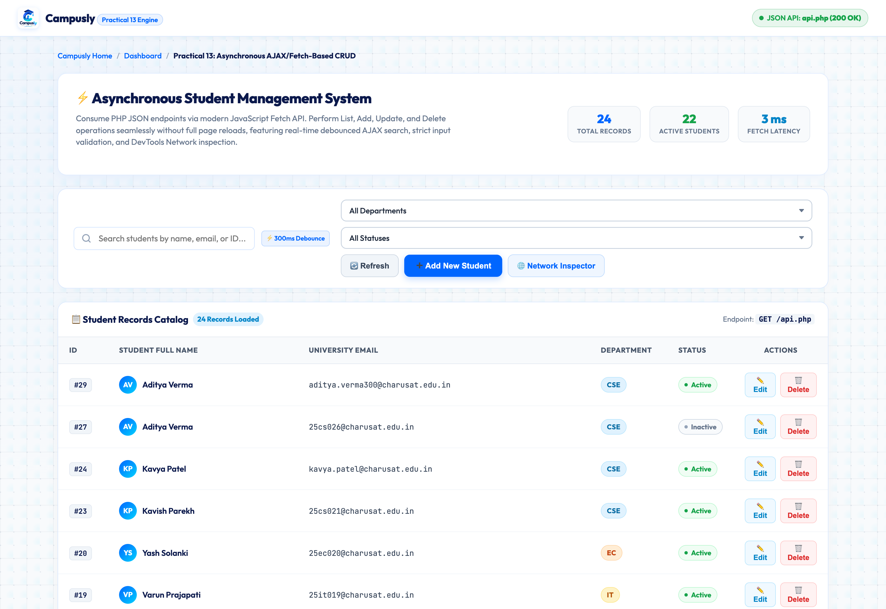
Figure 4.1: UI: Asynchronous Student Catalog Loaded via Fetch GET (api.php) (01_student_list_interface.png)

4.2 UI: Add New Student Modal Dialog
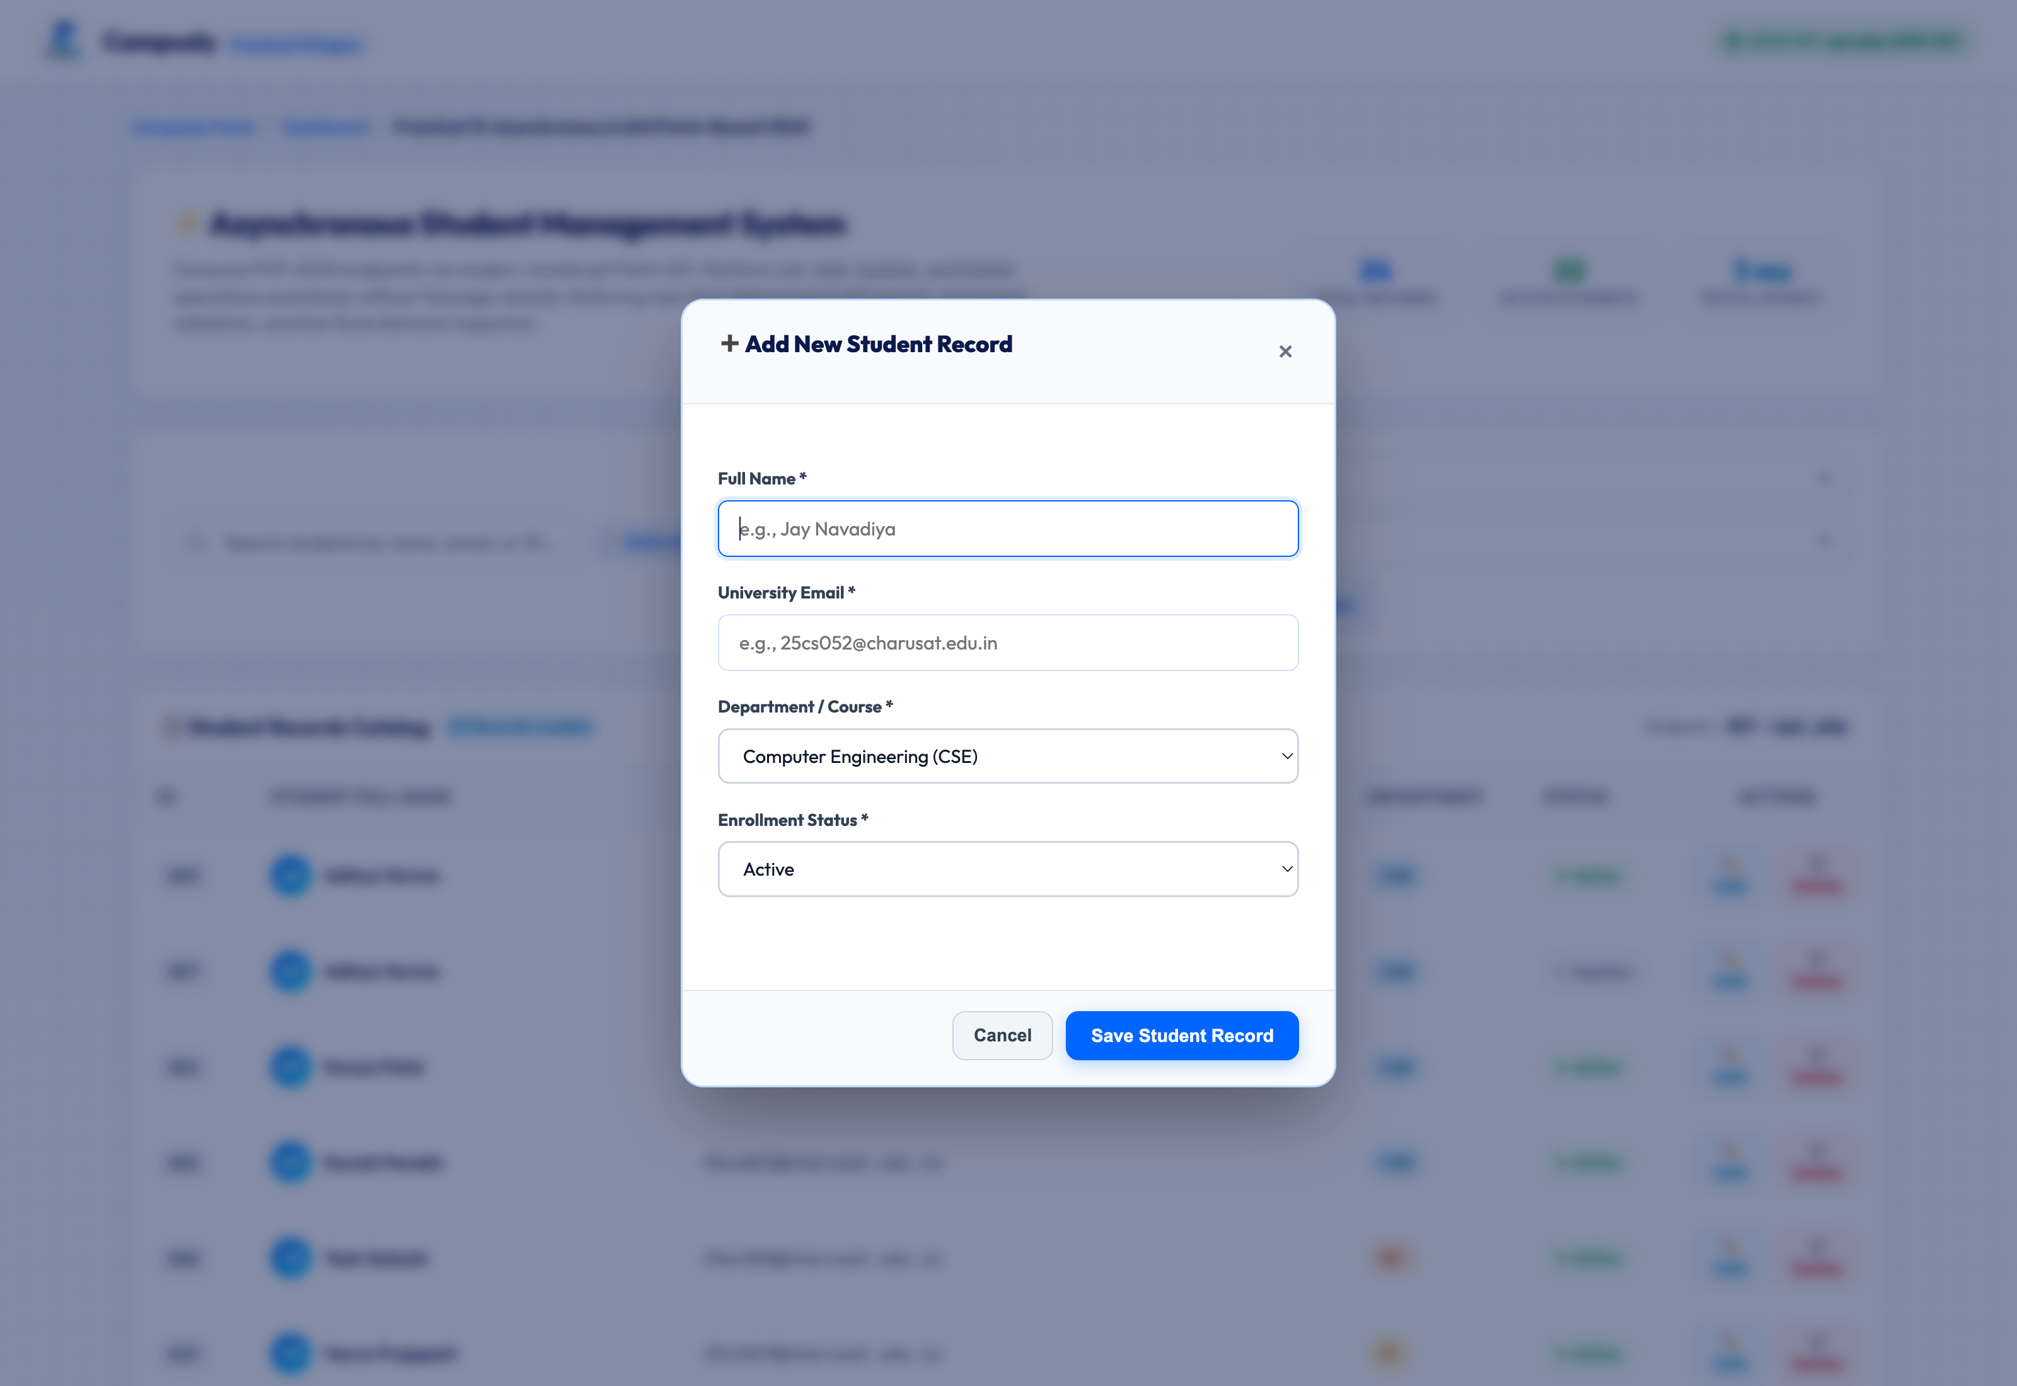
Figure 4.2: UI: Add New Student Modal Dialog (02_add_student_modal.png)

4.3 UI: Add Student Form Input Data Entry (Pooja Trivedi)
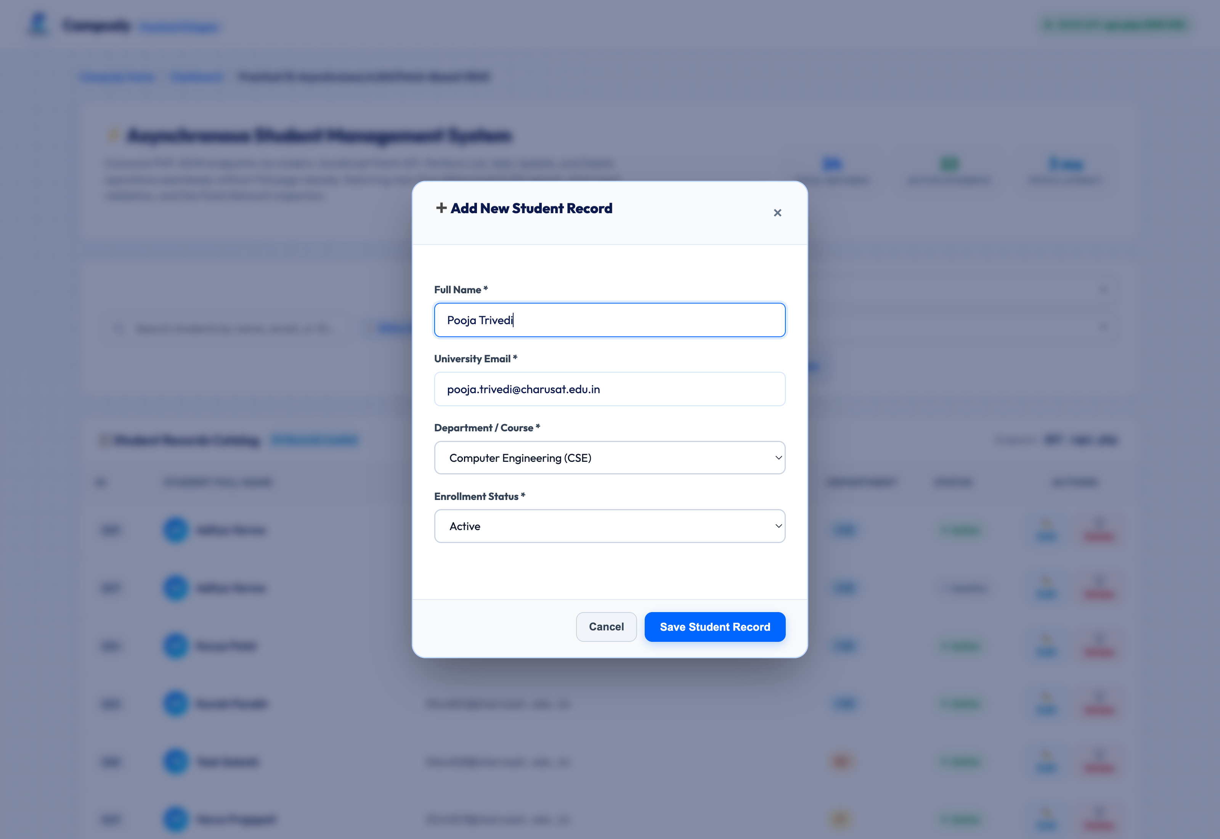
Figure 4.3: UI: Add Student Form Input Data Entry (Pooja Trivedi) (03_add_student_form_filled.png)

4.4 UI: Successful Asynchronous Record Insertion (HTTP 201 Created) without Page Reload
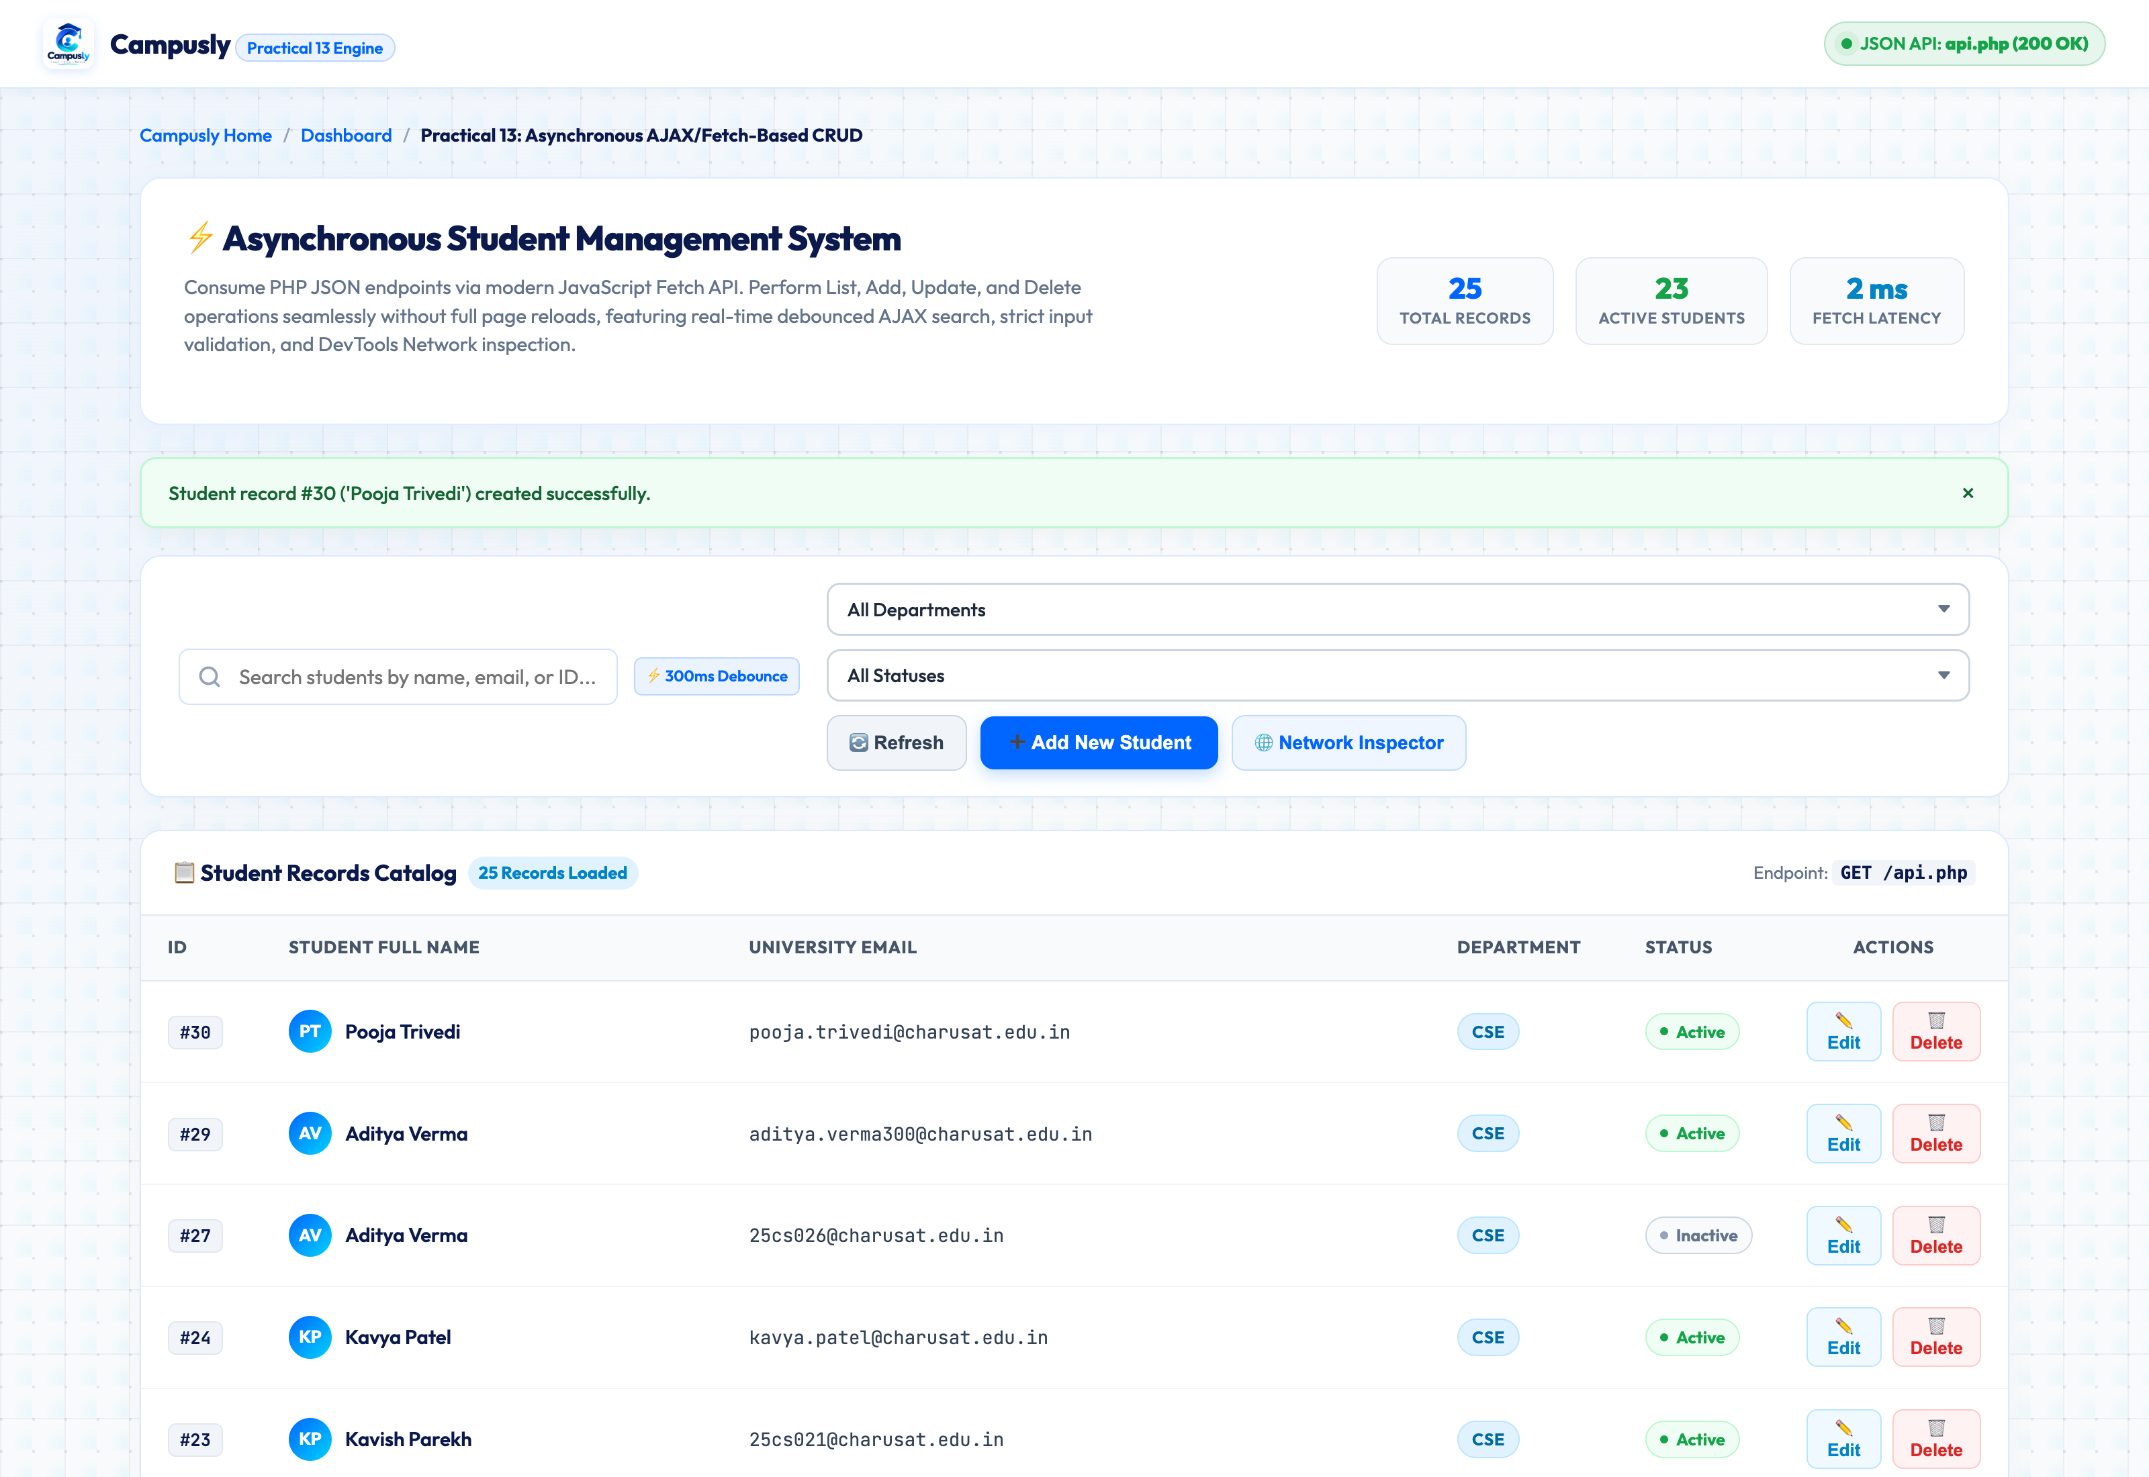
Figure 4.4: UI: Successful Asynchronous Record Insertion (HTTP 201 Created) without Page Reload (04_add_student_success.png)

4.5 UI: Edit Student Record Modal Populated with Existing Data
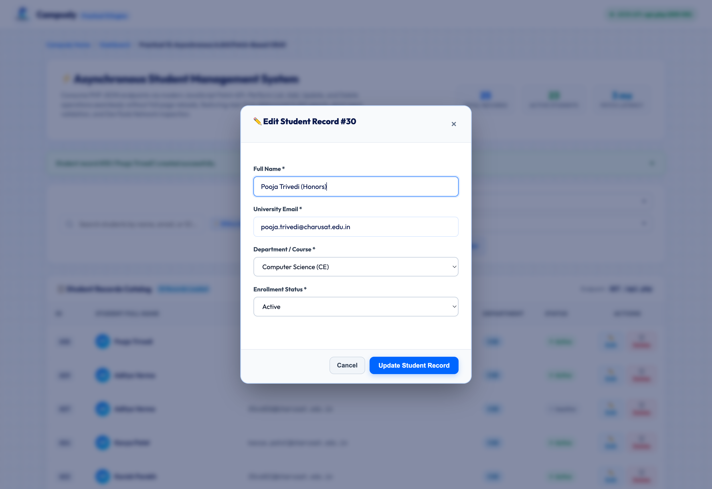
Figure 4.5: UI: Edit Student Record Modal Populated with Existing Data (05_edit_student_modal.png)

4.6 UI: Successful Asynchronous Record Update (HTTP 200 OK) without Page Reload
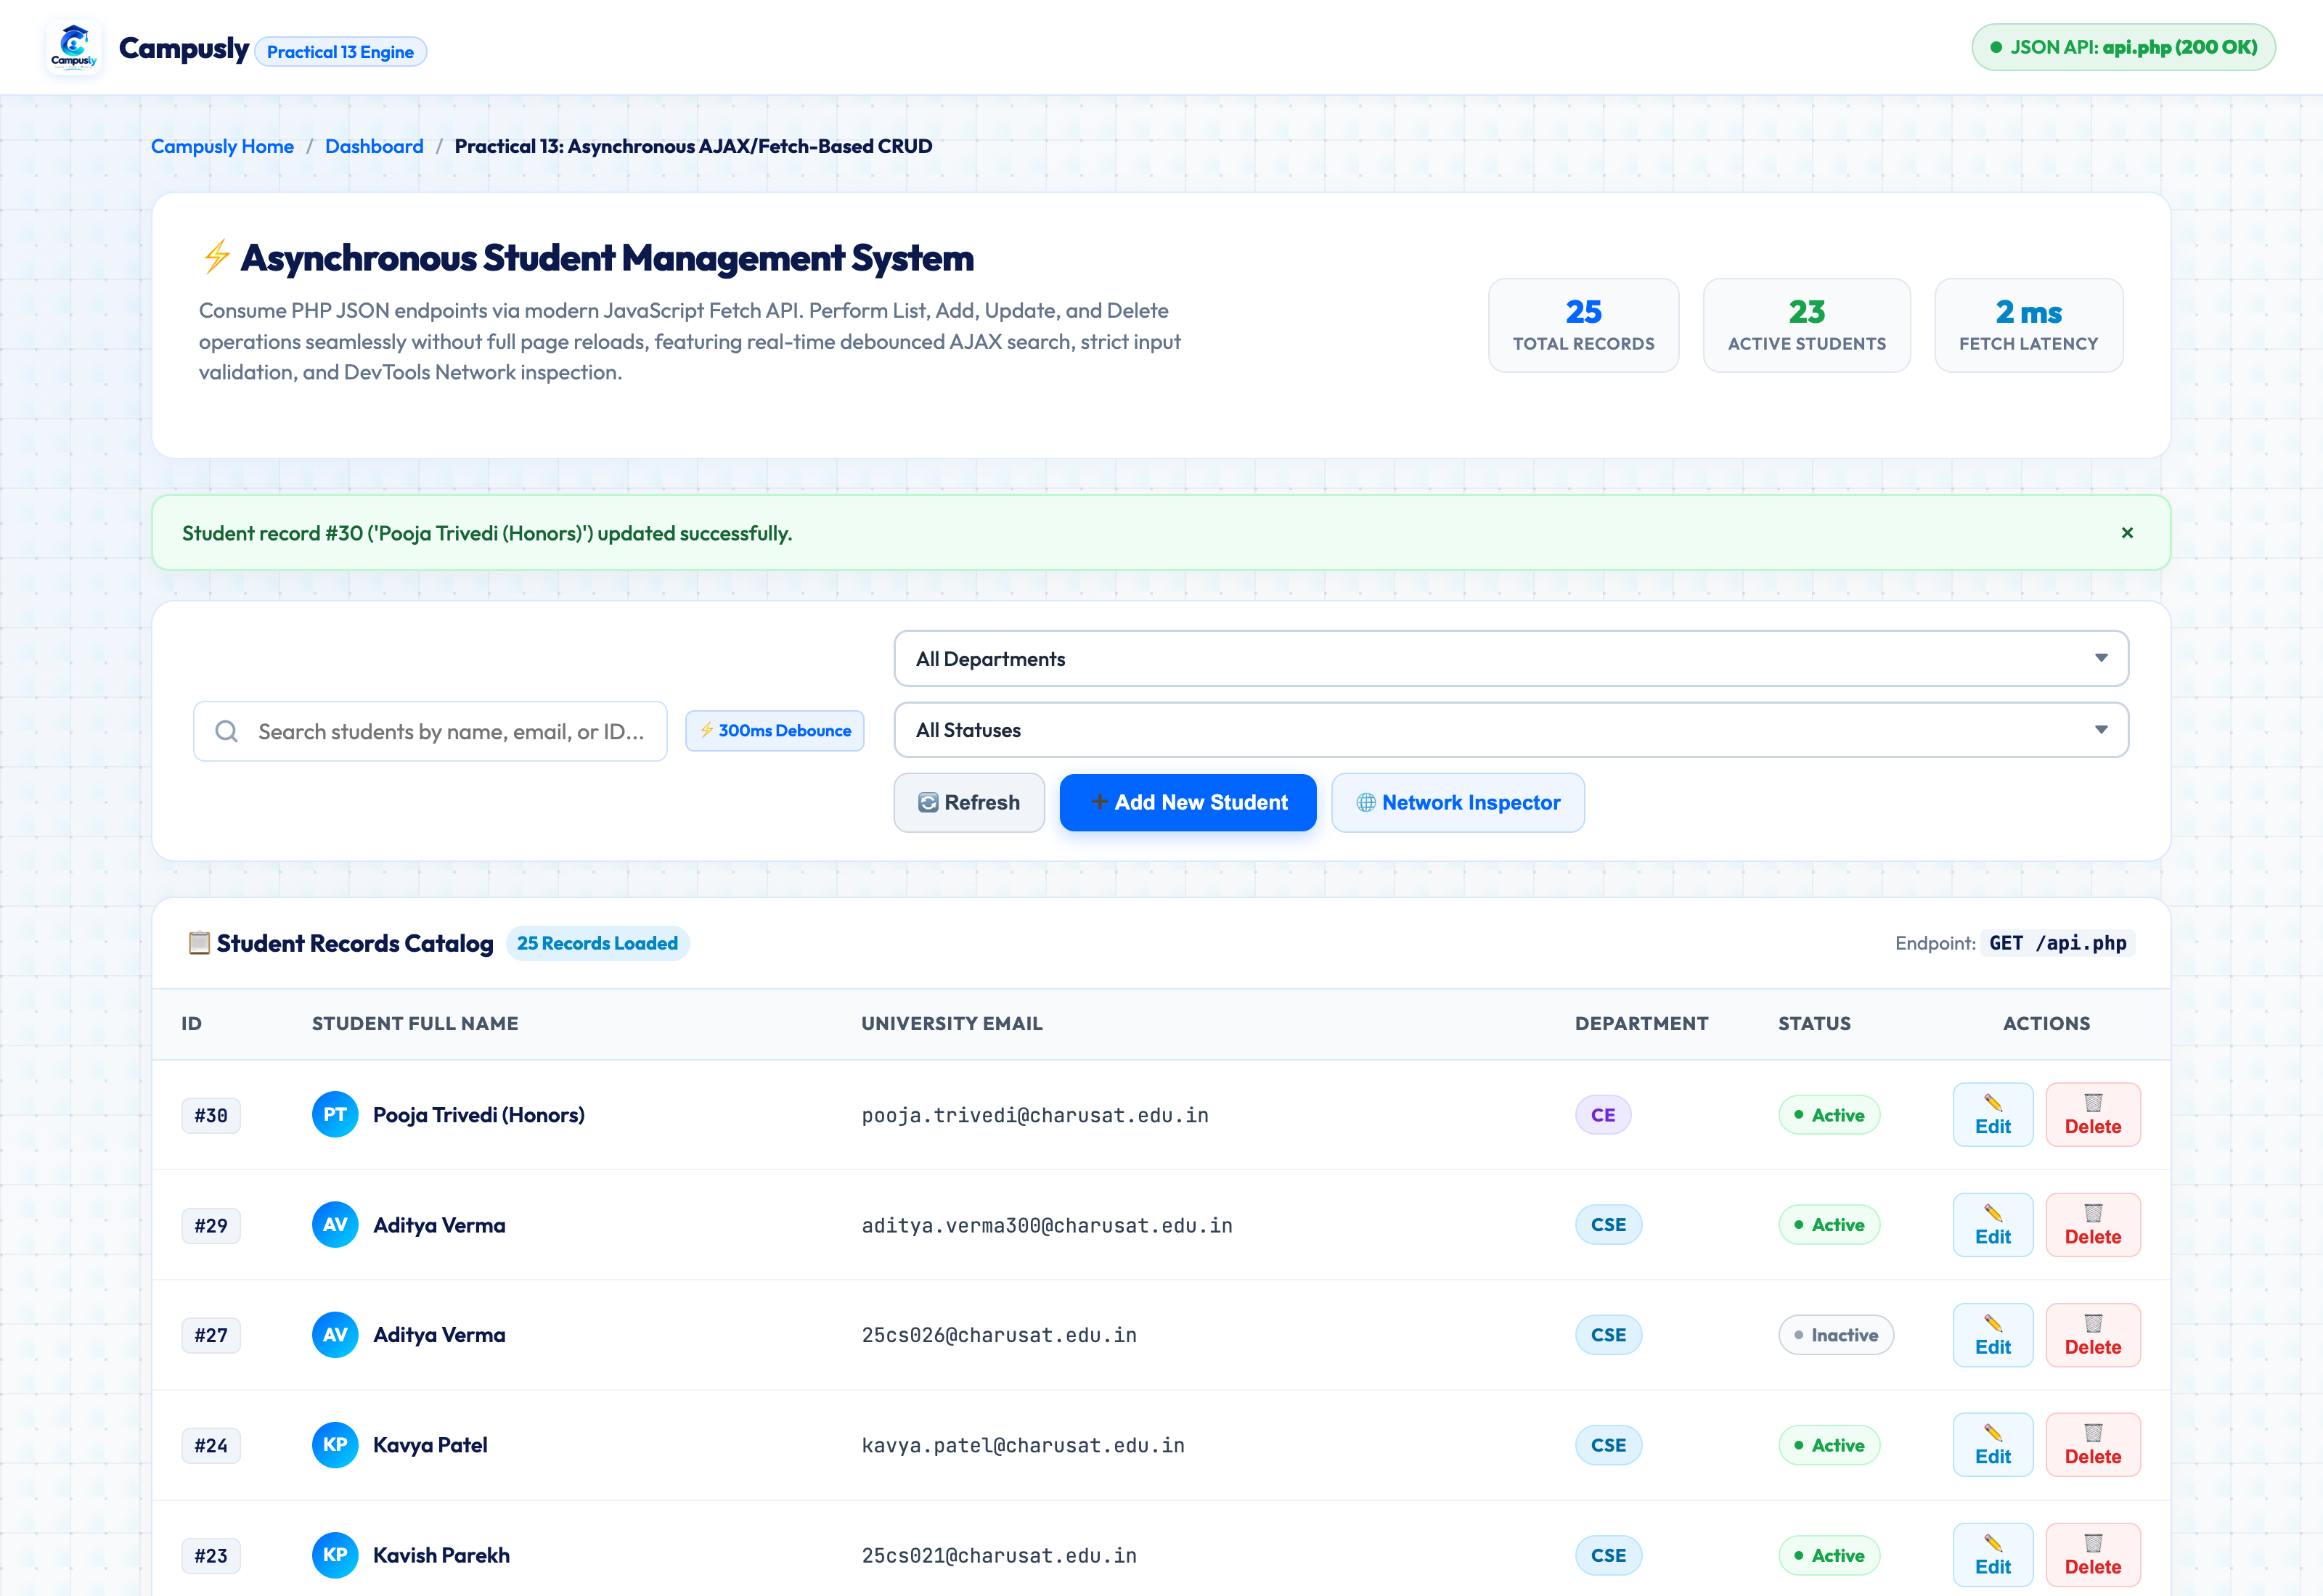
Figure 4.6: UI: Successful Asynchronous Record Update (HTTP 200 OK) without Page Reload (06_edit_student_success.png)

4.7 UI: Delete Record Confirmation Warning Dialog
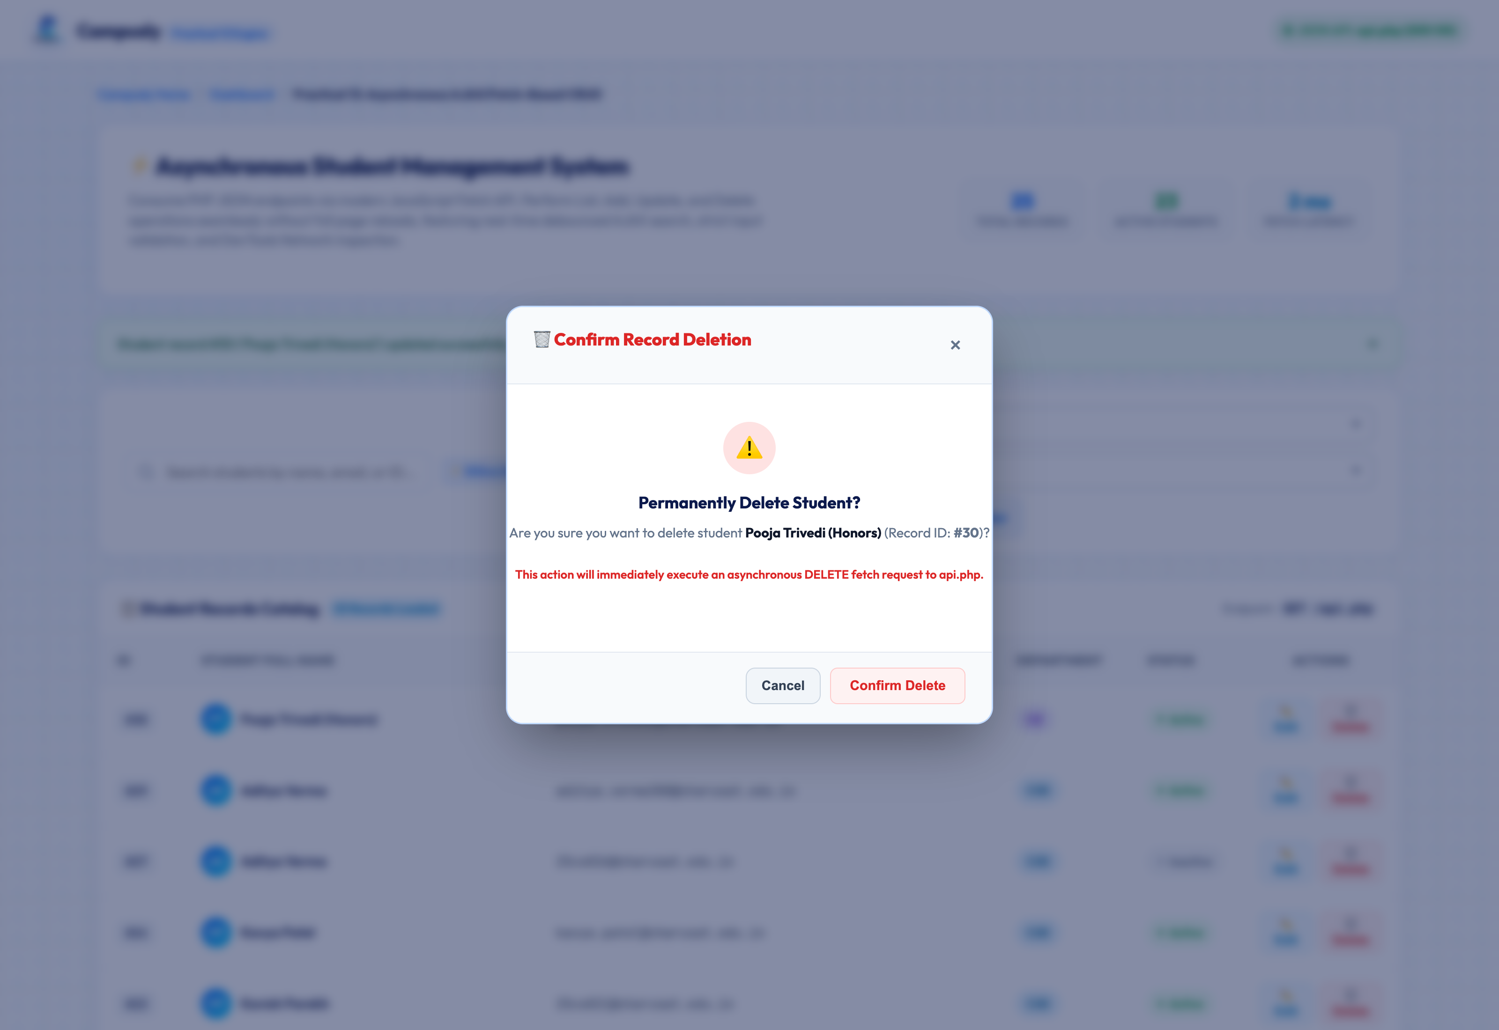
Figure 4.7: UI: Delete Record Confirmation Warning Dialog (07_delete_student_confirmation_modal.png)

4.8 UI: Successful Asynchronous Deletion (HTTP 200 OK) with Dynamic Row Removal
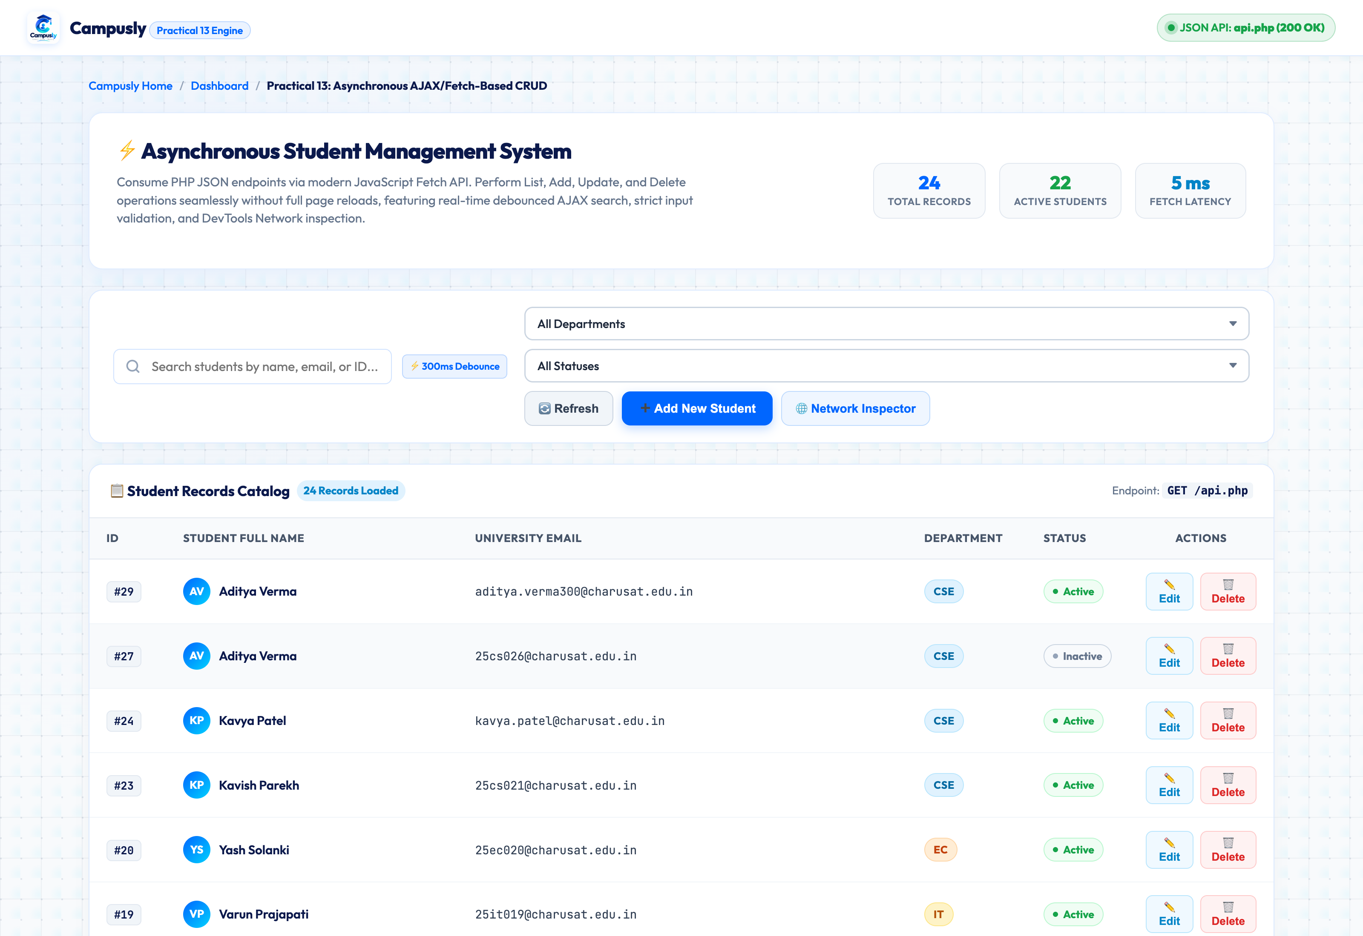
Figure 4.8: UI: Successful Asynchronous Deletion (HTTP 200 OK) with Dynamic Row Removal (08_delete_student_success.png)

4.9 UI: Asynchronous Fetch Loading Spinner & Progress State
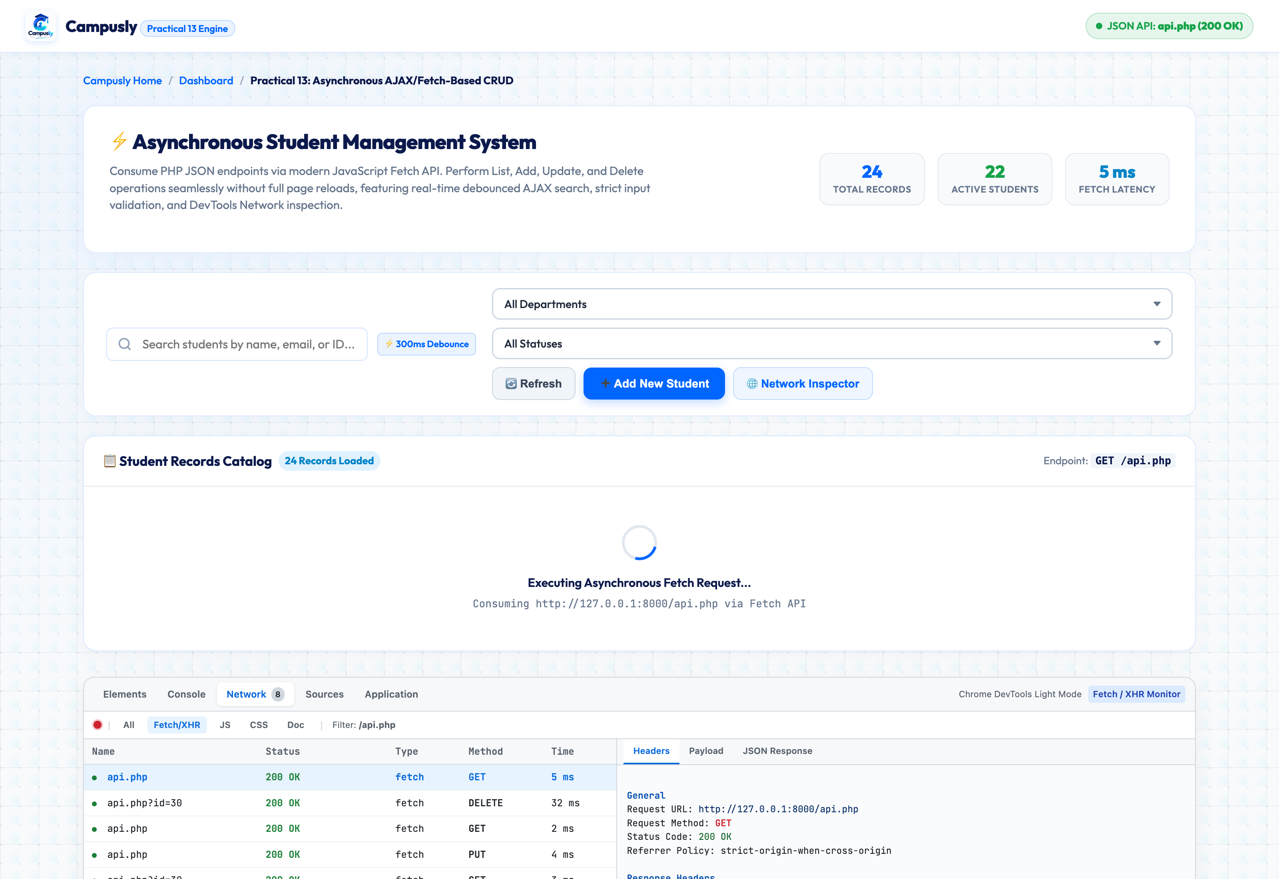
Figure 4.9: UI: Asynchronous Fetch Loading Spinner & Progress State (09_loading_state.png)

4.10 UI: Client-Side Input Validation Error Indicators
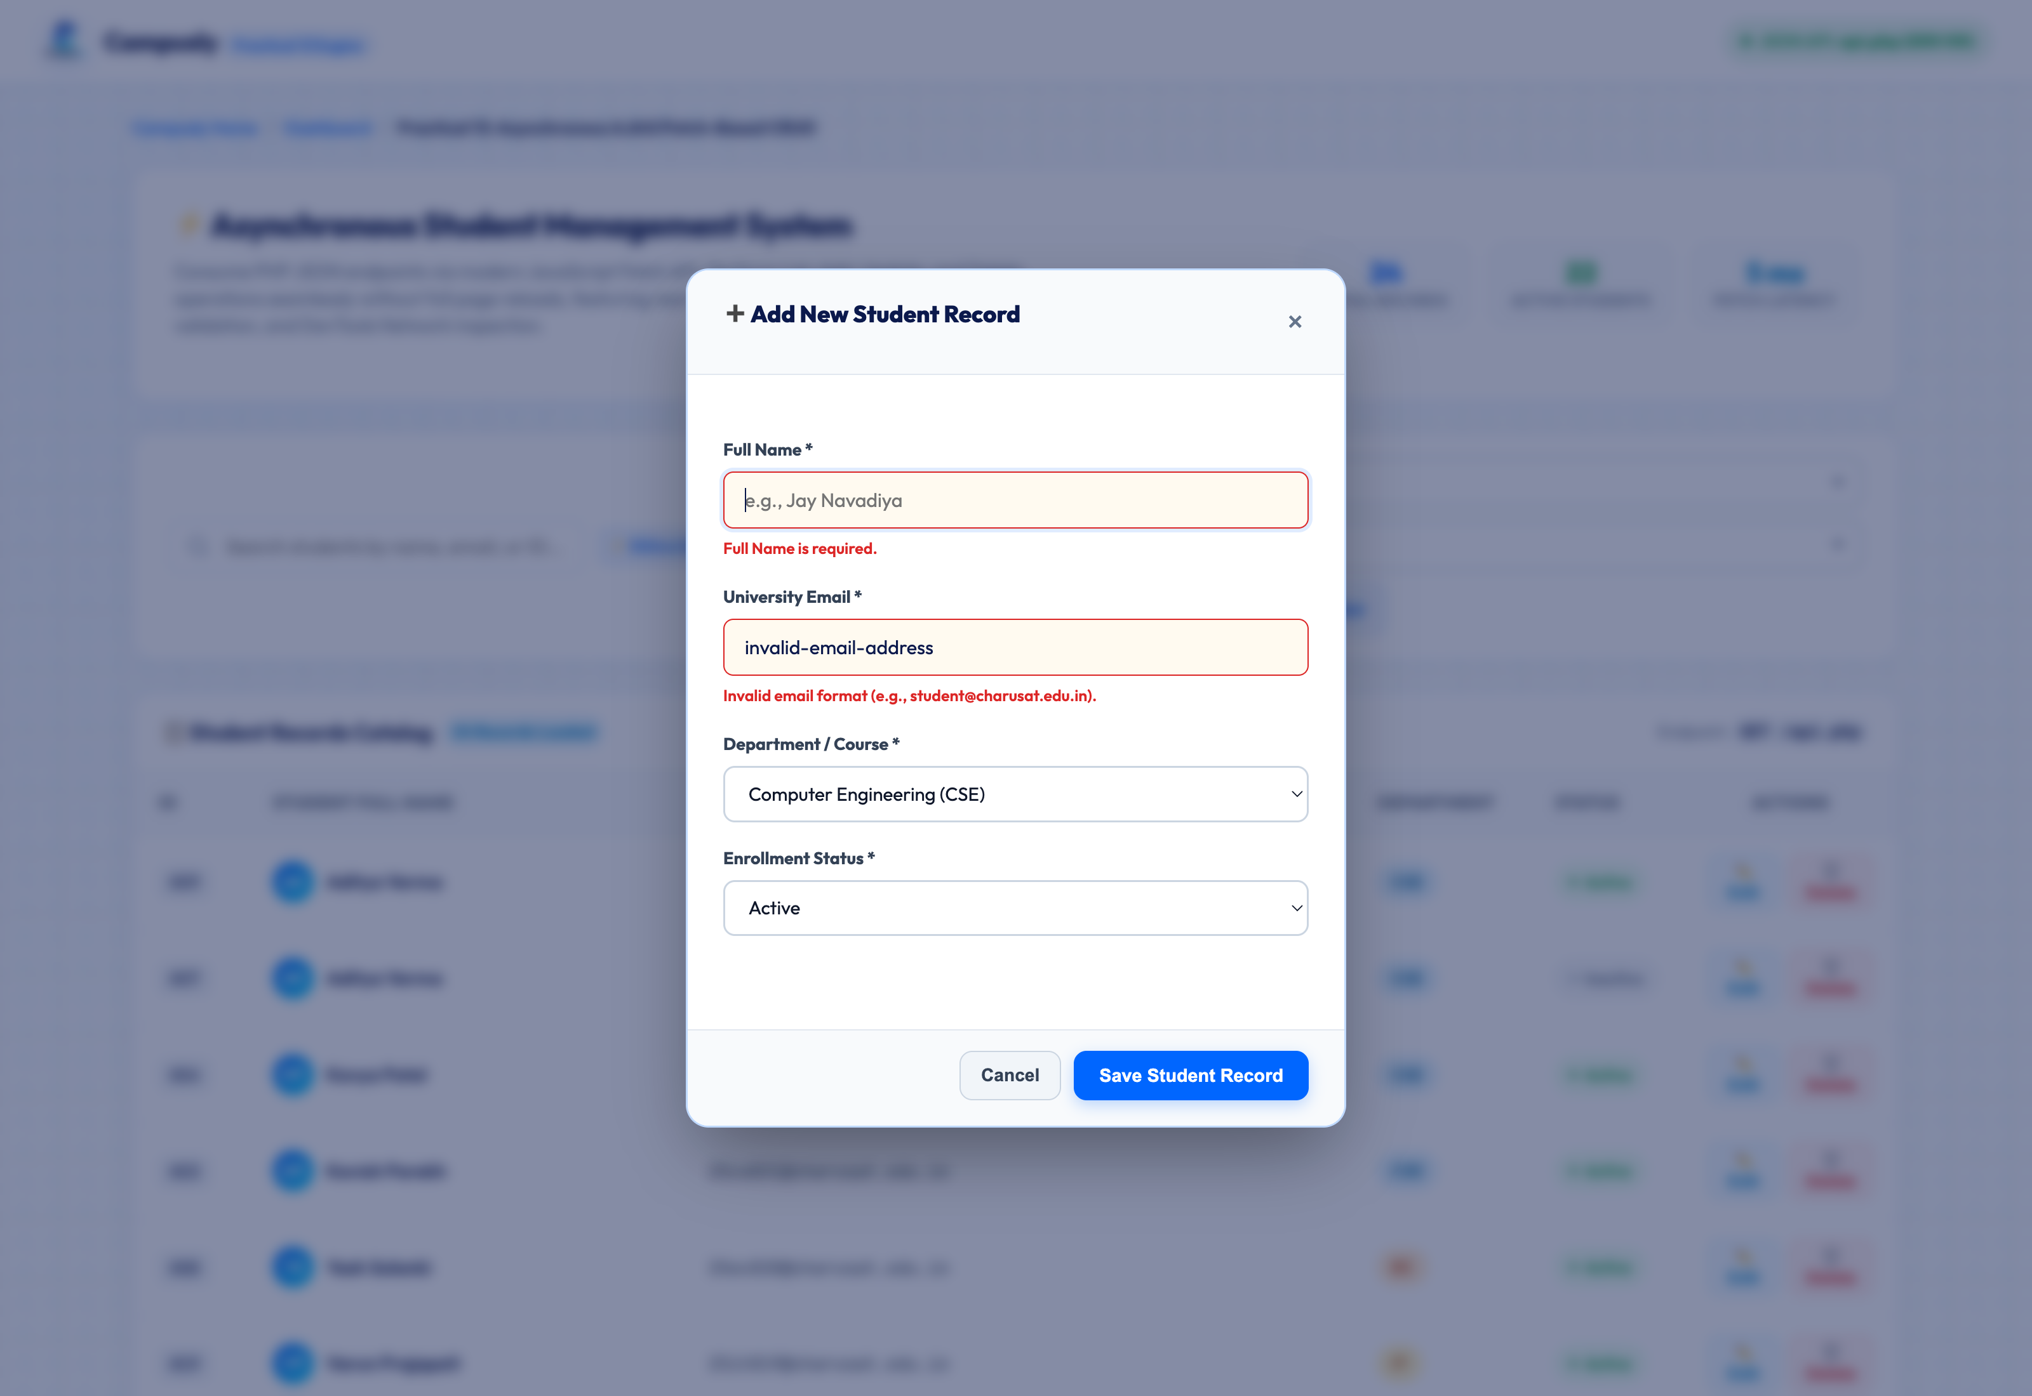
Figure 4.10: UI: Client-Side Input Validation Error Indicators (10_error_state_client_validation.png)

4.11 UI: Server-Side Duplicate Email Validation Error (HTTP 409 Conflict)
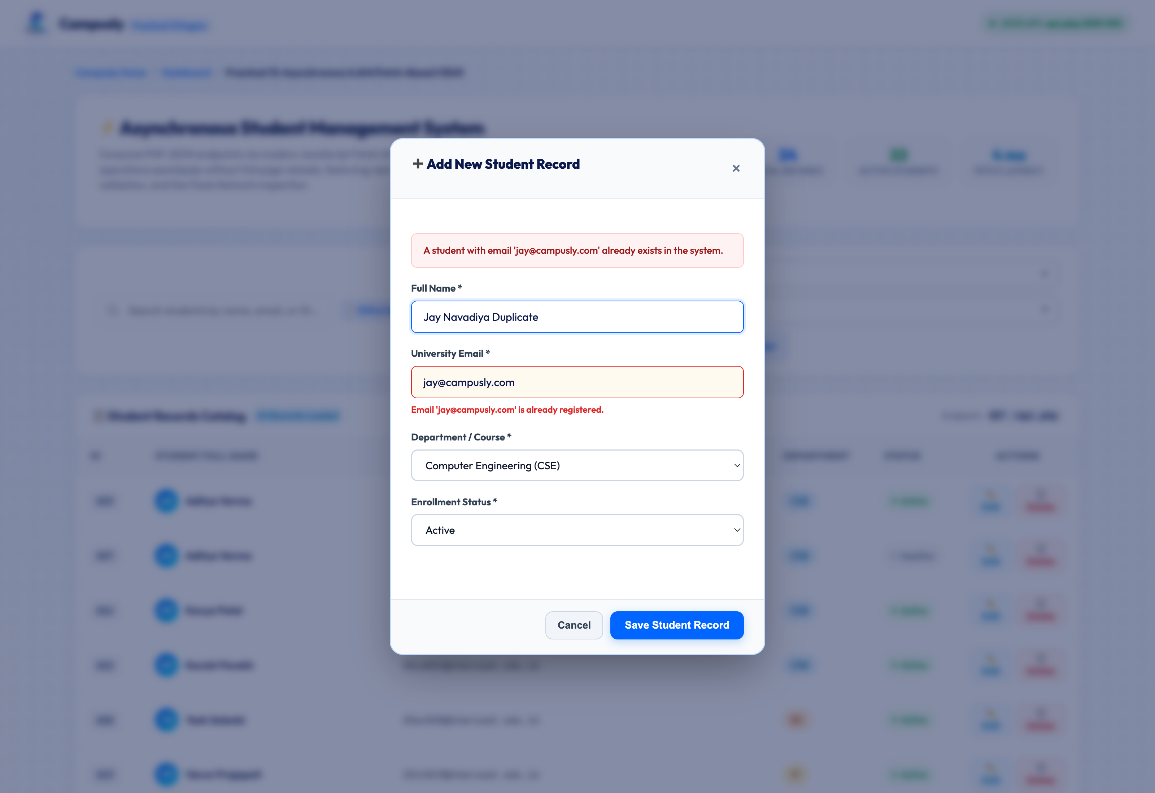
Figure 4.11: UI: Server-Side Duplicate Email Validation Error (HTTP 409 Conflict) (11_error_state_duplicate_conflict.png)

4.12 Intermediate Extension: Real-Time AJAX Search with 300ms Debounce
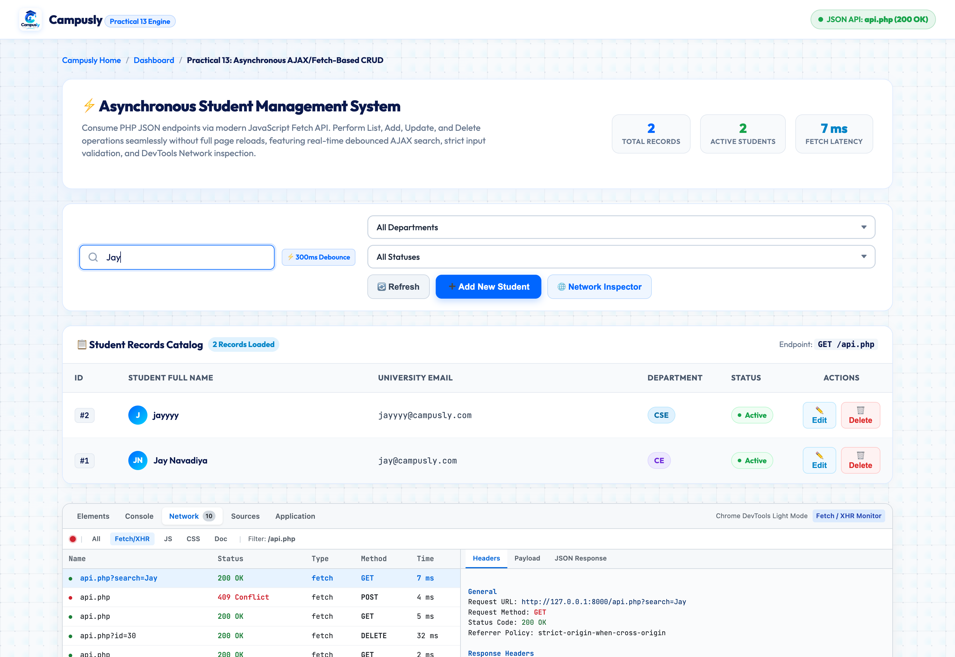
Figure 4.12: Intermediate Extension: Real-Time AJAX Search with 300ms Debounce (12_ajax_search_debounce.png)

4.13 Browser Network Tab: Overview of All Fetch Requests, HTTP Verbs & Status Codes
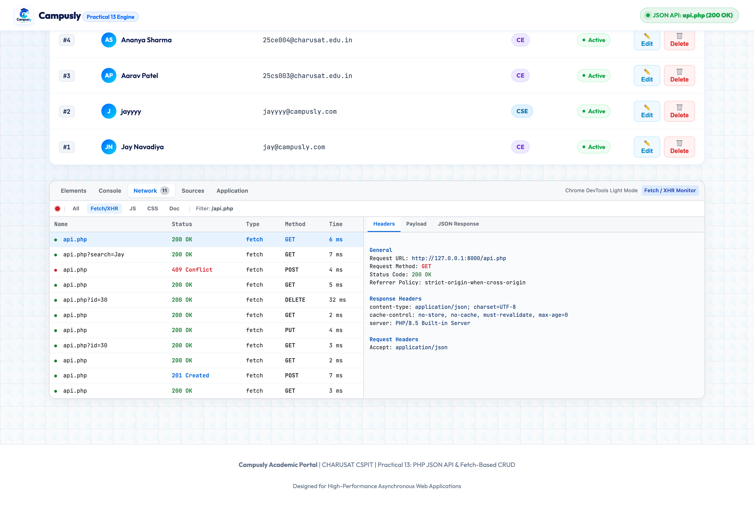
Figure 4.13: Browser Network Tab: Overview of All Fetch Requests, HTTP Verbs & Status Codes (13_network_tab_overview_all_requests.png)

4.14 Browser Network Tab: GET /api.php Response Headers & Structured JSON Response
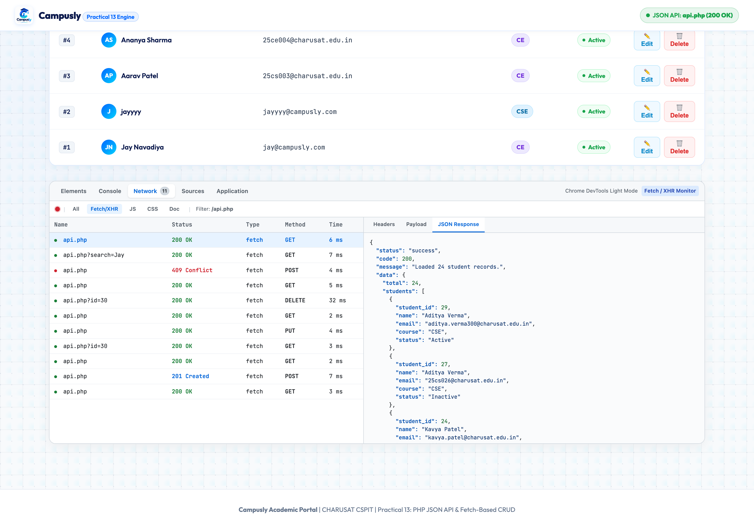
Figure 4.14: Browser Network Tab: GET /api.php Response Headers & Structured JSON Response (14_network_tab_fetch_get_response.png)

4.15 Browser Network Tab: POST /api.php Request Payload & 201 Created Response
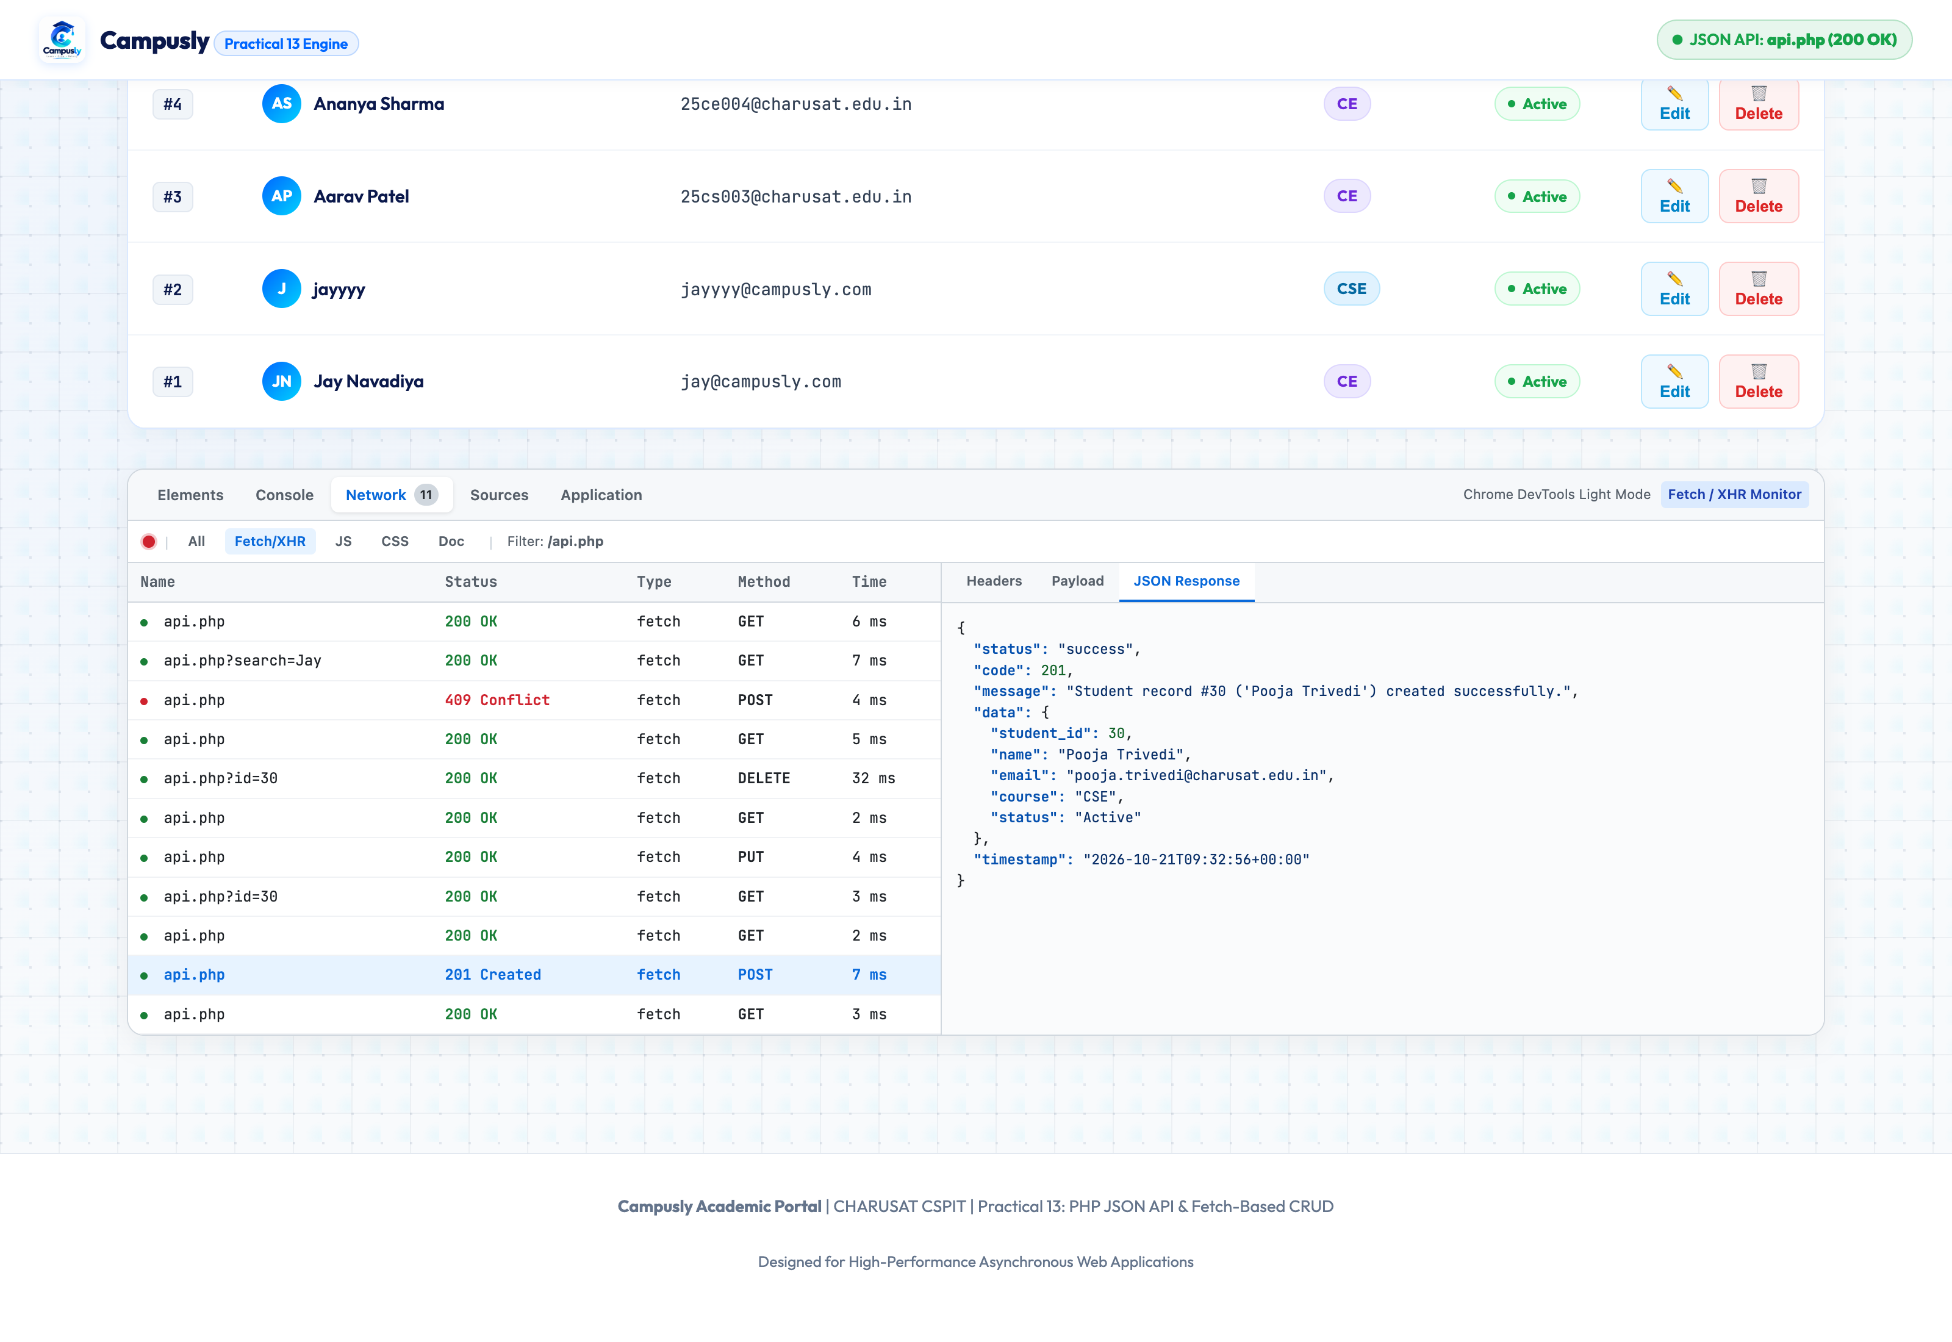
Figure 4.15: Browser Network Tab: POST /api.php Request Payload & 201 Created Response (15_network_tab_fetch_post_payload_201.png)

4.16 Browser Network Tab: PUT /api.php Request Payload & 200 OK Response
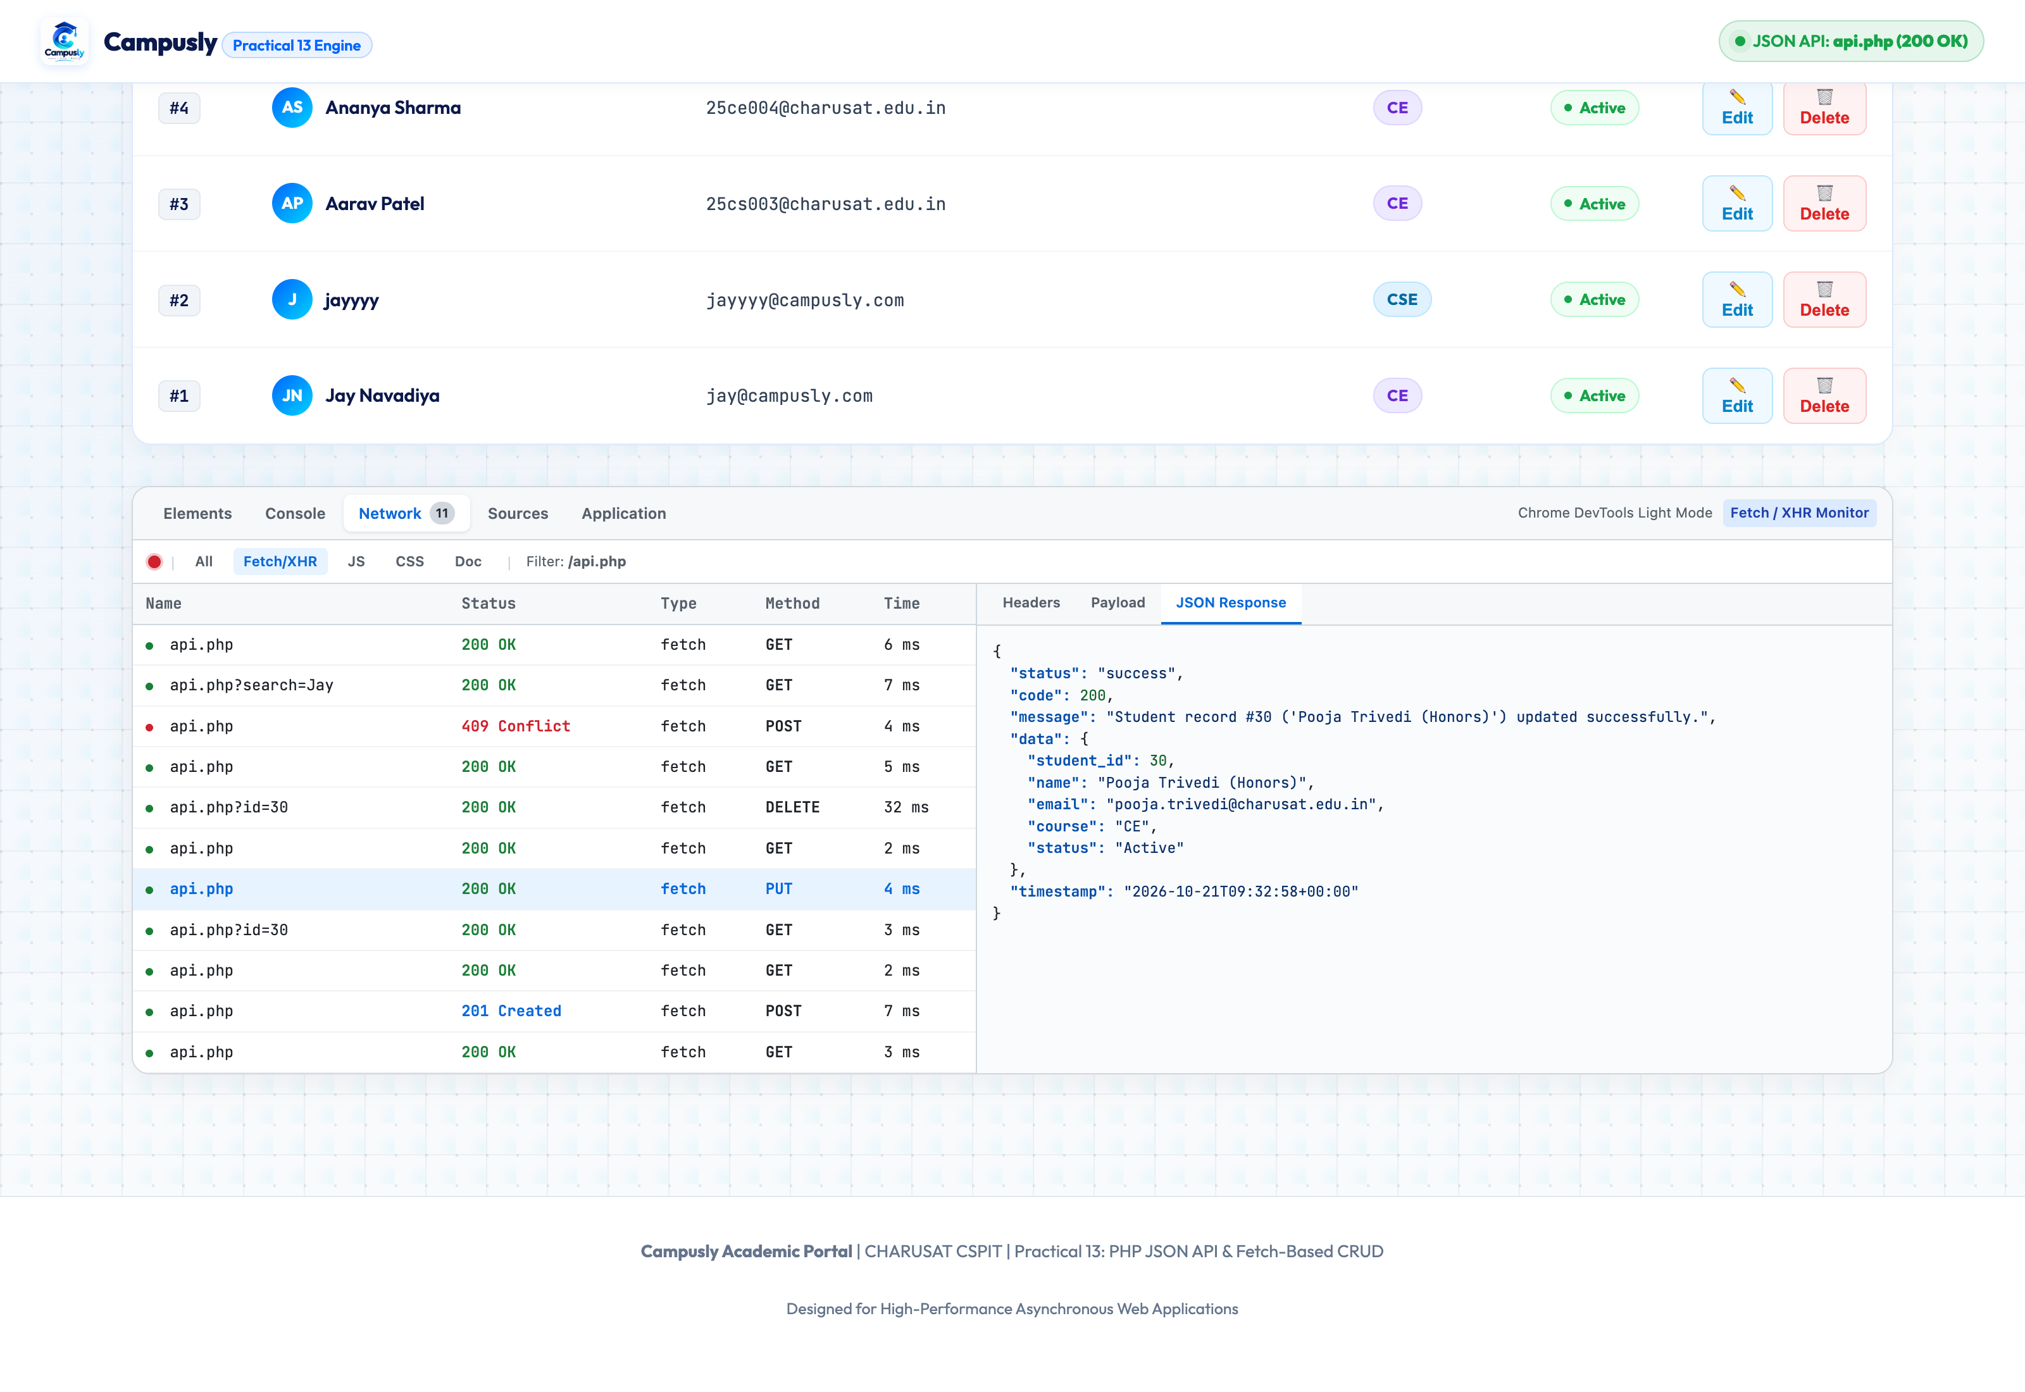
Figure 4.16: Browser Network Tab: PUT /api.php Request Payload & 200 OK Response (16_network_tab_fetch_put_payload_200.png)

4.17 Browser Network Tab: DELETE /api.php Status 200 OK Response
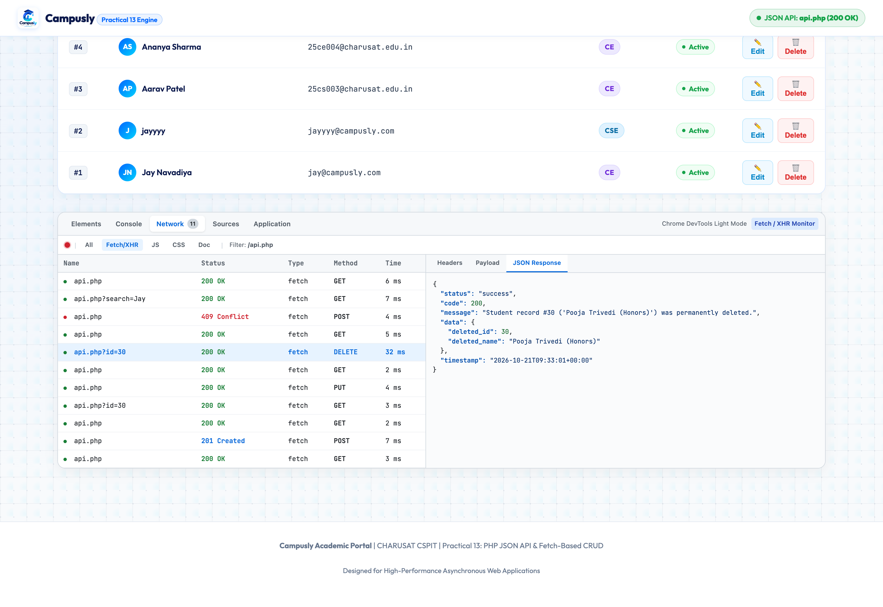
Figure 4.17: Browser Network Tab: DELETE /api.php Status 200 OK Response (17_network_tab_fetch_delete_200.png)

4.18 Browser Network Tab: POST Conflict (409) Error JSON Response Envelope
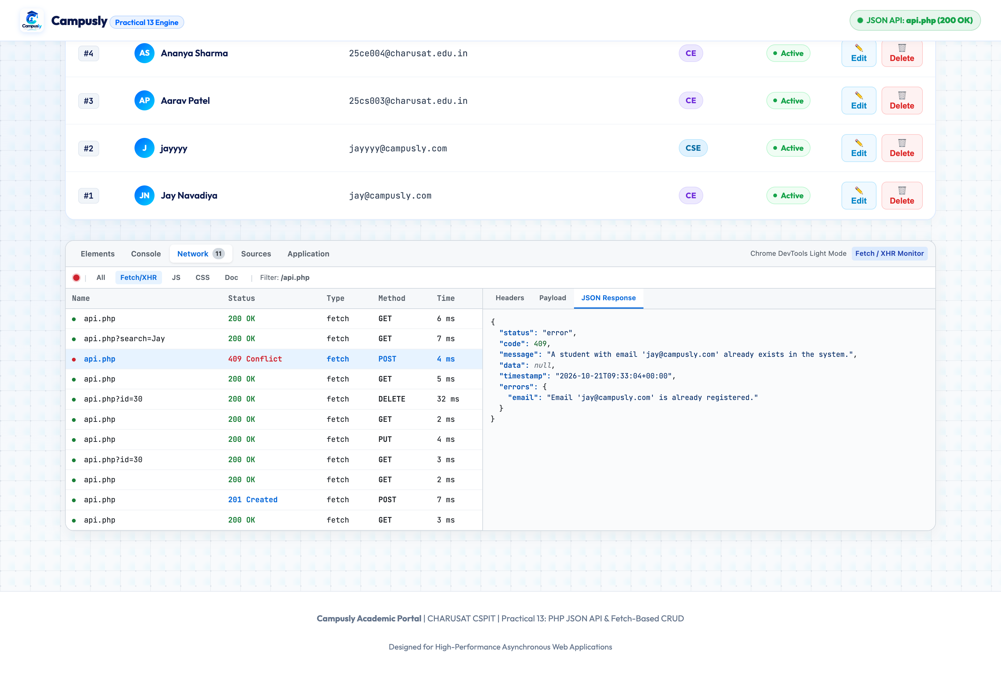
Figure 4.18: Browser Network Tab: POST Conflict (409) Error JSON Response Envelope (18_network_tab_fetch_error_409_conflict.png)

4.19 Direct Browser Endpoint: Standalone JSON Response Output (GET /api.php)
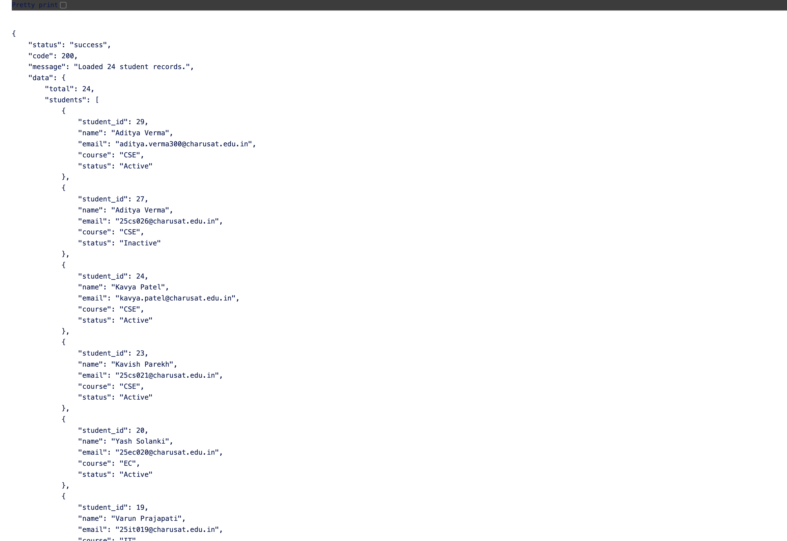
Figure 4.19: Direct Browser Endpoint: Standalone JSON Response Output (GET /api.php) (19_raw_api_php_json_endpoint.png)

5. Conclusion
In Practical 13, a full-stack asynchronous student management portal was successfully implemented using pure PHP RESTful JSON APIs and modern JavaScript Fetch API. All CRUD operations (Create, Read, Update, Delete) operate seamlessly in the background without requiring any browser page reloads. The system achieves robust reliability through dual-stage input validation, standard HTTP status code communication (200, 201, 400, 404, 409, 500), debounced live search (300ms), and real-time DevTools Network inspection.

