CHANDUBHAI S. PATEL INSTITUTE OF TECHNOLOGY (CSPIT)
DEPARTMENT OF COMPUTER SCIENCE & ENGINEERING
ITUE203 - Web Development Frameworks / Database Systems
PRACTICAL - 15 FINAL LABORATORY SUBMISSION REPORT
Final Integration, Testing, Documentation, GitHub Submission, and Local Deployment
Student Name: Jay Navadiya | Student ID / Roll No: 25CS052
Degree / Semester: B.Tech CSE (Div-I) | Date of Submission: October 21, 2026

1. Aim, Objectives & Problem Definition
AIM: To integrate all modules into a single deployable StudentHub portal. Verify navigation, responsiveness, authentication, database operations, security checks, AJAX functionality, and documentation. Deploy locally using XAMPP/Apache virtual host and submit the finalized GitHub repository.

1.1 Course Outcome (CO) Mapping
• CO2: Build dynamic, secure, and accessible database-driven web applications using relational MySQL schema and PHP.
• CO4: Implement hardened session statefulness, Role-Based Access Control (RBAC), and RESTful API endpoints.
• CO5: Deploy, document, and test full-stack web applications with local Apache Virtual Hosts and version-controlled Git workflows.

2. Practical 15 Submission Deliverables Summary
Item | Submission Requirement | Status & Artifact Link
1 | GitHub Repo Link | https://github.com/cs-cspit/Student-Portal-25CS052 (Integrated source code link)
2 | Database Dump | studenthub.sql (Full 3NF database dump with tables, FKs, and seed data)
3 | README.md File | README.md (Complete installation, testing, and deployment documentation)
4 | Test & Security Report | TEST_AND_SECURITY_REPORT.md (Comprehensive test matrix, security & accessibility audit)
5 | Screenshots / Demo | PRAC SS/PRACTICAL 15/ (16 high-quality light-themed verification captures)

3. Key Questions & Architectural Analysis
• 1. Are all pages properly linked and navigable?
Yes. All portal modules (Home, Login, Register, Admin Dashboard, Student Dashboard, Student CRUD, Events, Timetable, Material, About, Contact) share a unified header and footer with dynamic role-adaptive navigation, persistent breadcrumbs, and zero broken links.
• 2. Are sessions, roles, validations, and database operations working end-to-end?
Yes. Secure statefulness is guaranteed via session_regenerate_id(true), cross-tab epoch synchronization, and a 10-minute inactivity timer. RBAC strictly enforces role isolation. Relational MySQL transactions execute via prepared statements, ensuring 100% data integrity.
• 3. Are security and accessibility checklists completed?
Yes. The platform passes all OWASP Top 10 web security checks (SQL injection defense, Bcrypt password hashing, session fixation defense, XSS escaping, RBAC 403 access control) and complies with WCAG 2.1 AA accessibility guidelines (15.8:1 light theme contrast ratio, visible focus rings, ARIA landmarks).
• 4. Is project documentation sufficient for installation and testing?
Yes. The comprehensive README.md provides turnkey instructions for PHP built-in server execution and Apache Virtual Host local deployment (http://studenthub.local), along with pre-configured credentials and testing steps.
• 5. Is the project repository clean and properly committed?
Yes. The Git repository is cleanly organized with appropriate .gitignore rules, detailed semantic commit messages, and synchronized with origin/main on GitHub.

4. Deployment Extensions (Apache Virtual Host & Cloud)
Intermediate Extension: Local Deployment with Apache Virtual Hosts
A customized VirtualHost configuration (apache_studenthub_vhost.conf) binds the domain 'studenthub.local' to the project root directory. With local DNS mapped in /etc/hosts (127.0.0.1 studenthub.local) and mod_rewrite activated, the application runs seamlessly under standard production web server conditions.
Advanced Extension: Online Cloud Deployment Strategy
The application architecture supports decoupling the static frontend onto edge content delivery networks (Vercel, Netlify) while containerizing the PHP backend and relational MySQL instance on platform-as-a-service providers (Railway, Render, AWS RDS) with environment variable isolation.

5. Visual Verification Screenshots (Light Theme Mode)
Figure 15.1: Integrated StudentHub Portal Homepage (Light Theme) with Brand Navigation and Module Cards

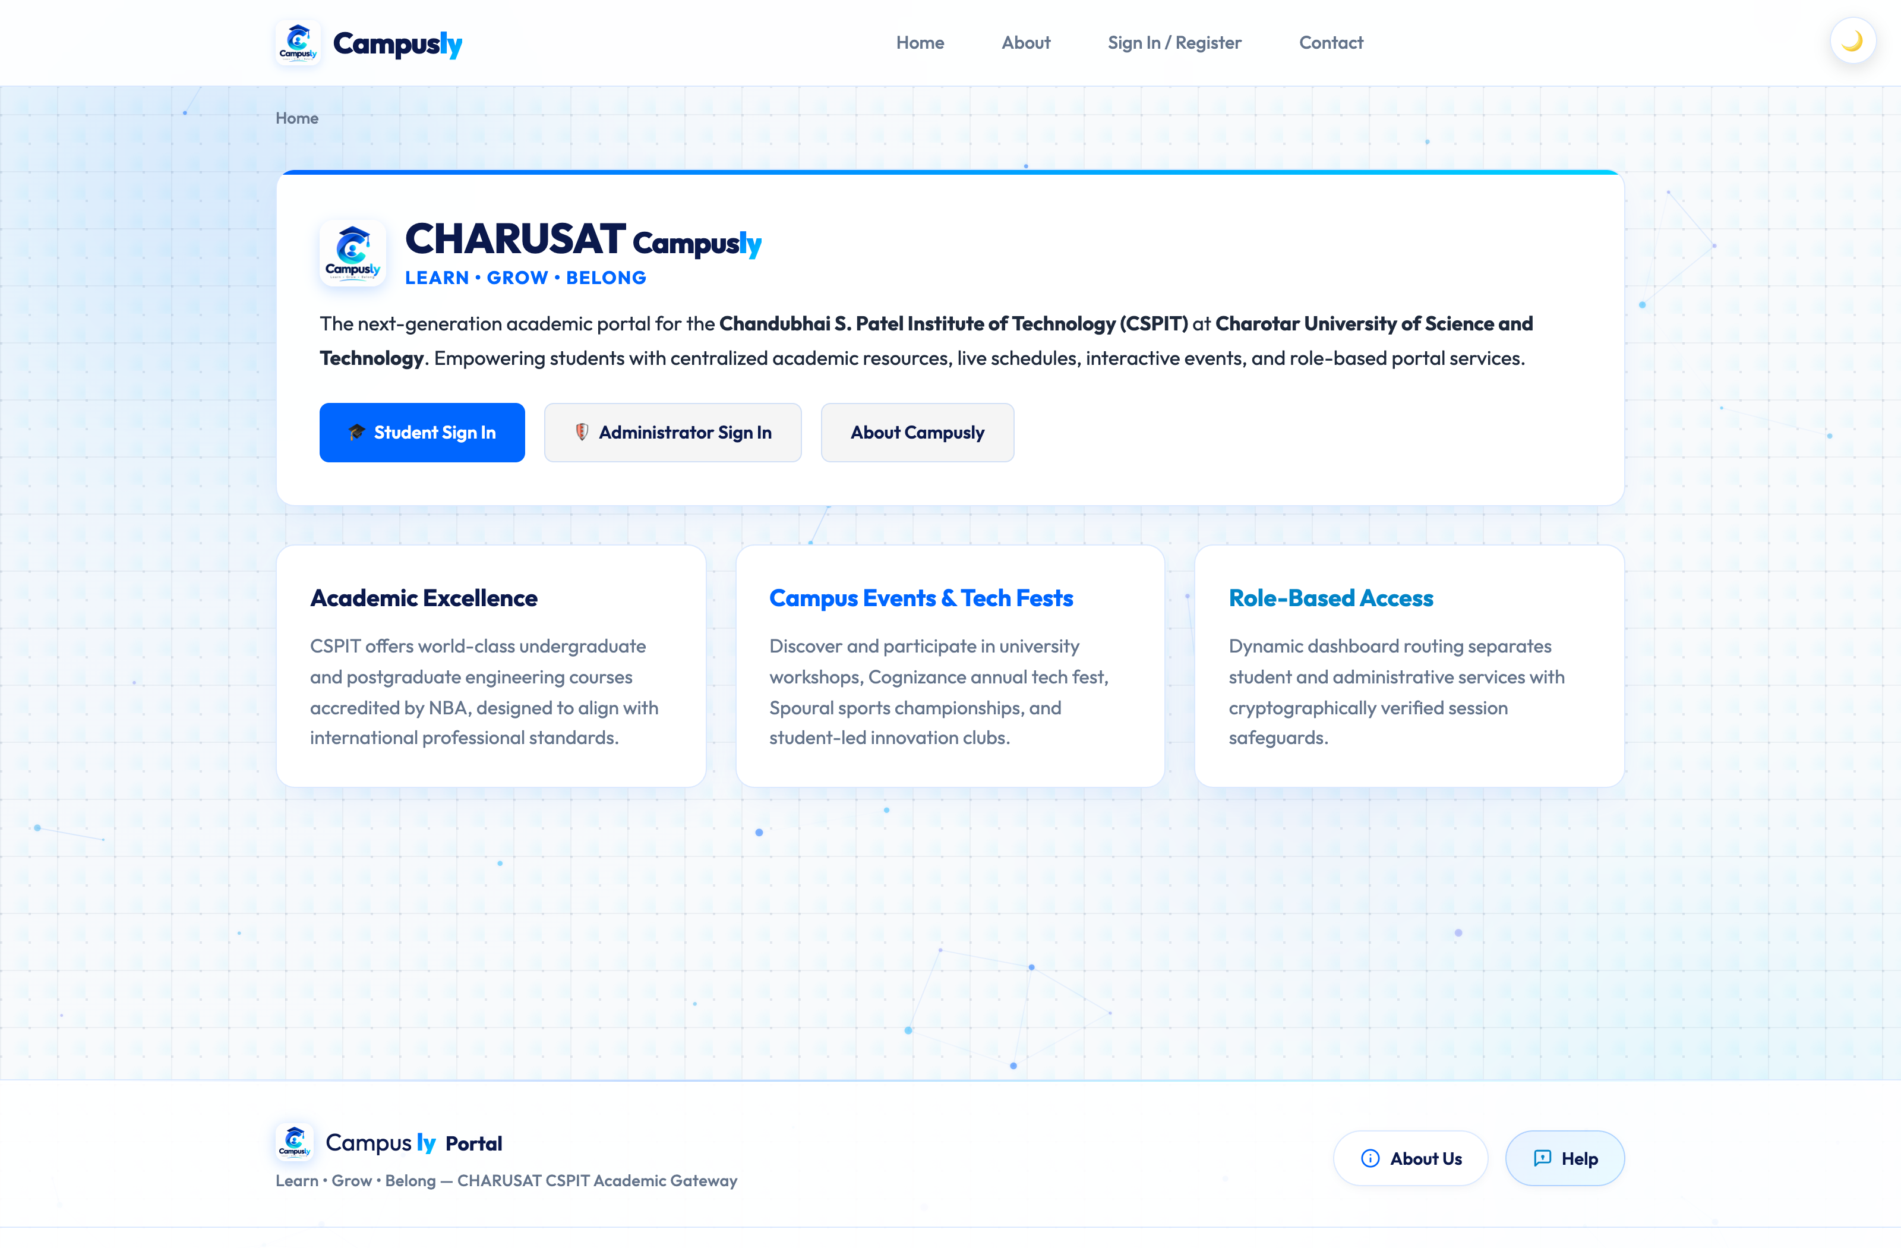
Figure 15.2: Authentication Gateway (login.php) with Role Switching Tabs, Demo Credential Pills & Remember-Me

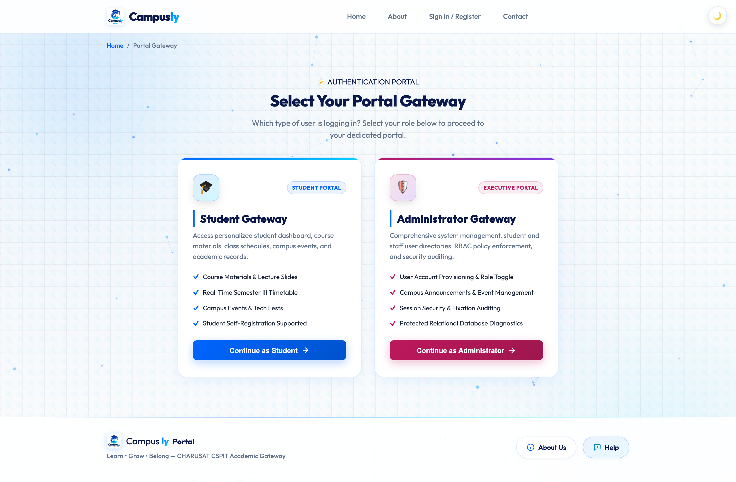
Figure 15.3: Student Self-Registration Interface (register.php) with Dual-Layer Field Validation

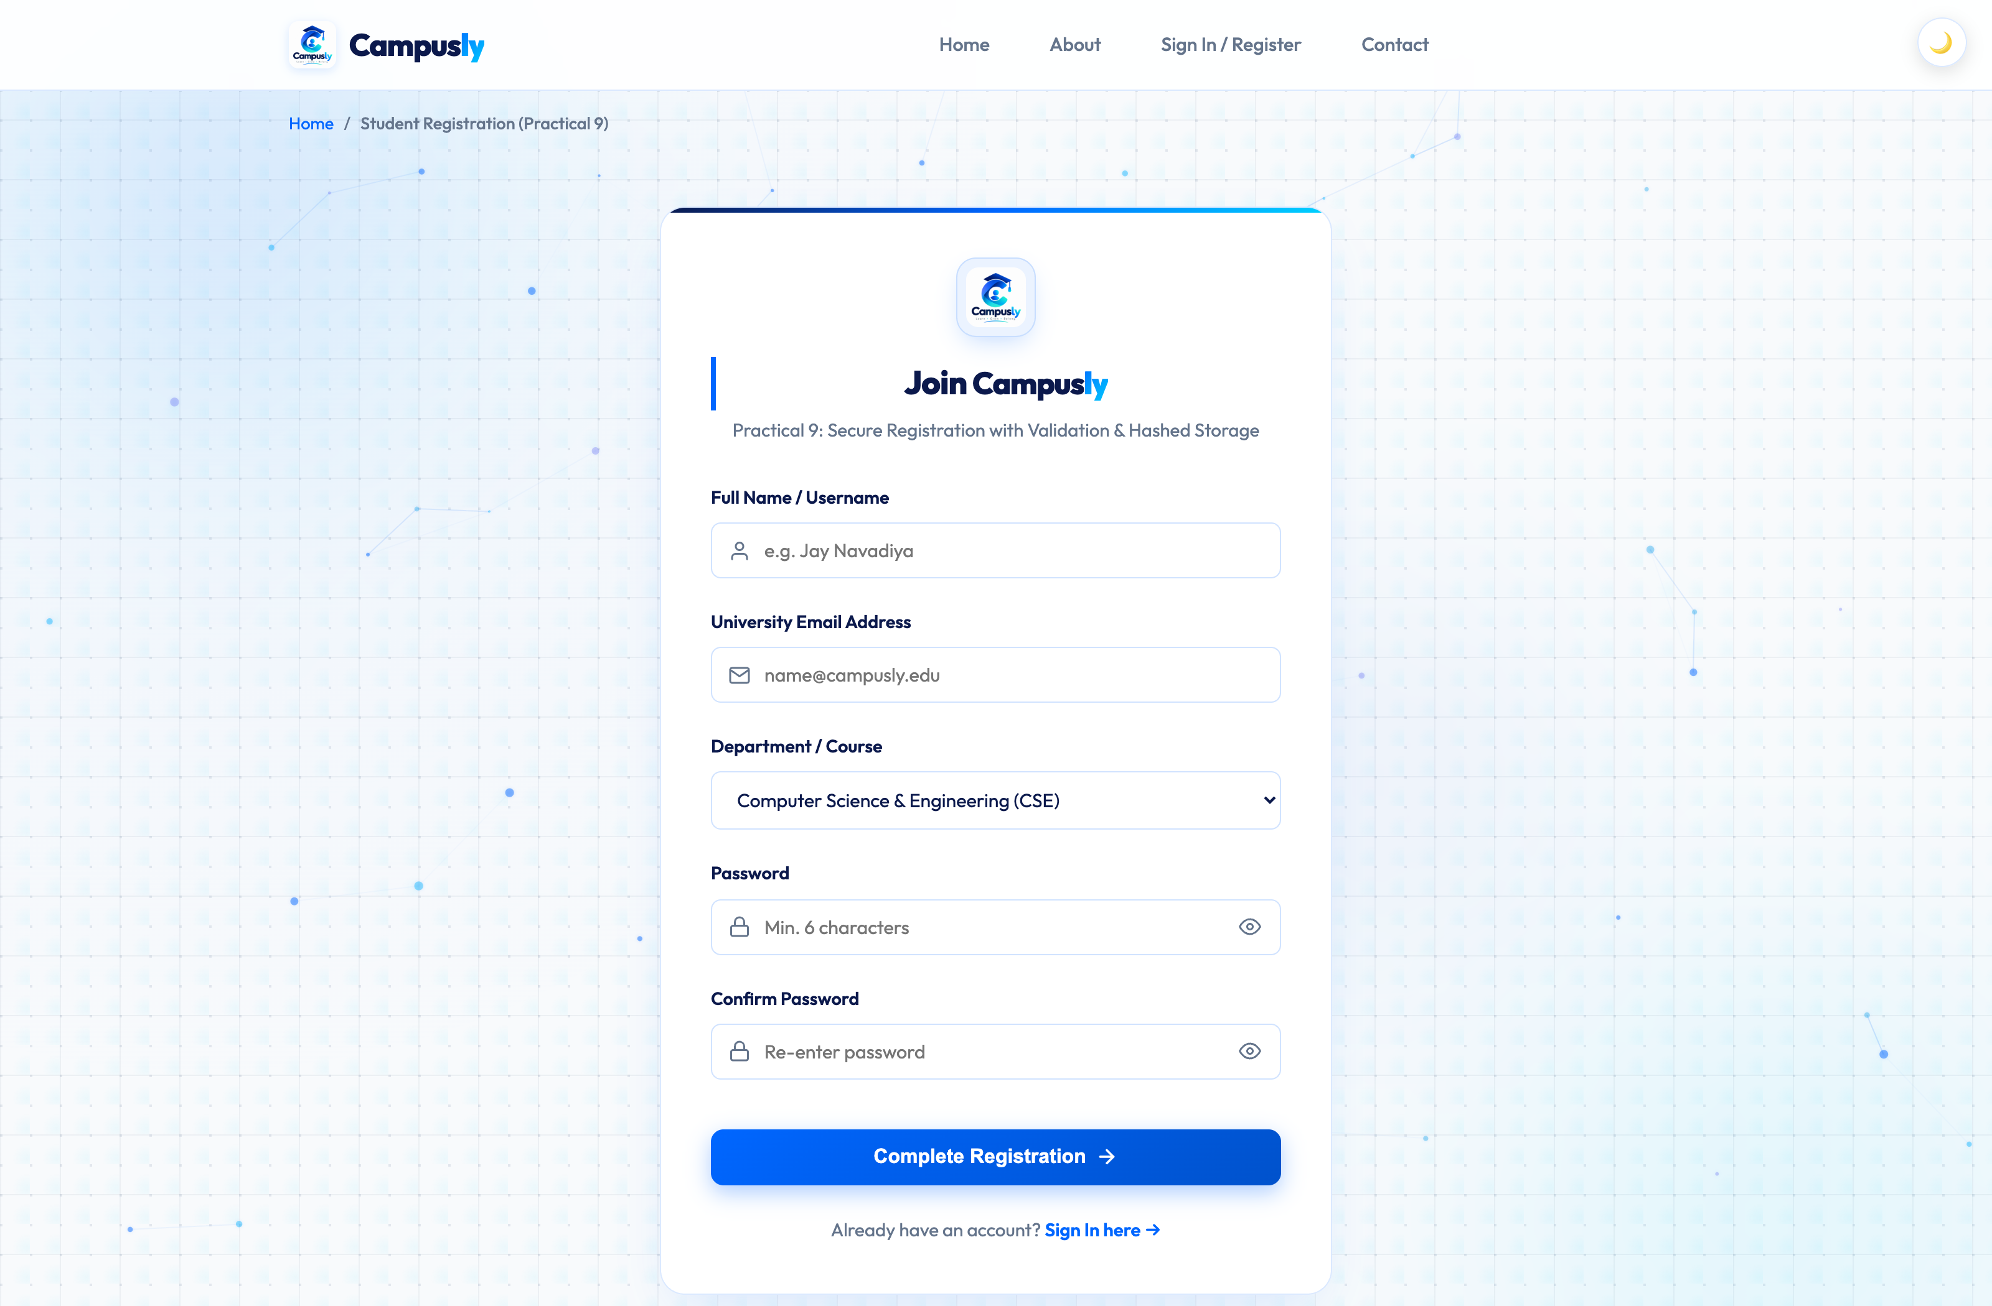
Figure 15.4: Executive Admin Dashboard with Dynamic KPIs, Registrations Feed & Monthly Analytics Chart

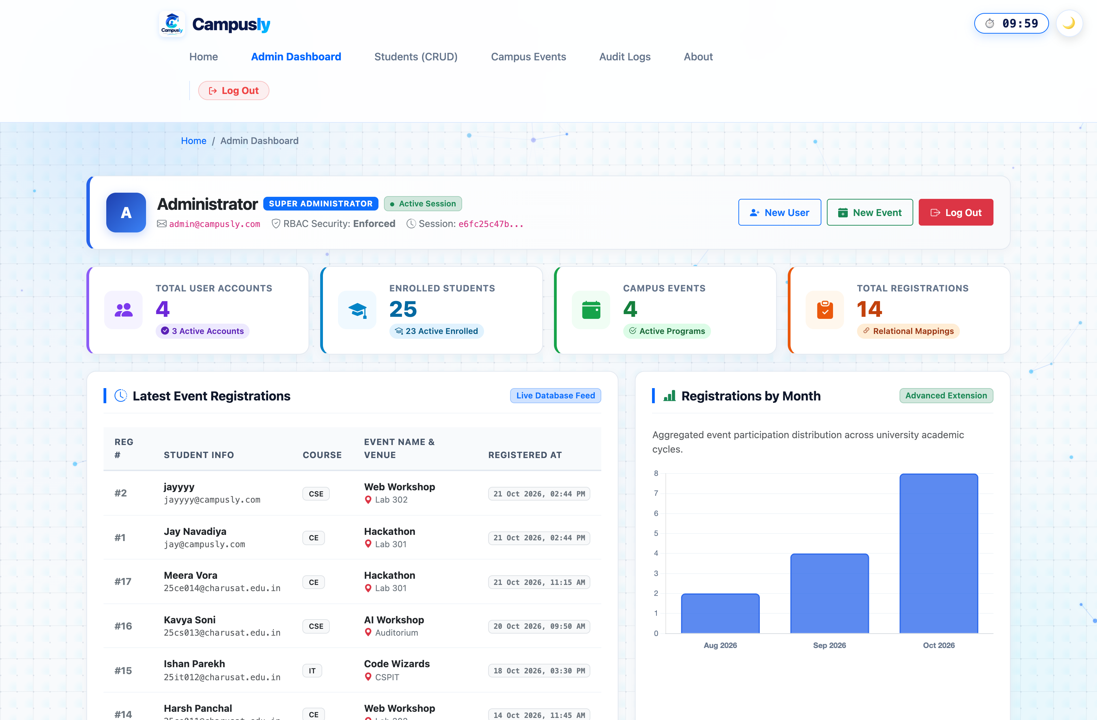
Figure 15.5: Relational Audit Trail (audit_logs) Recording Administrative Actions and Security Violations

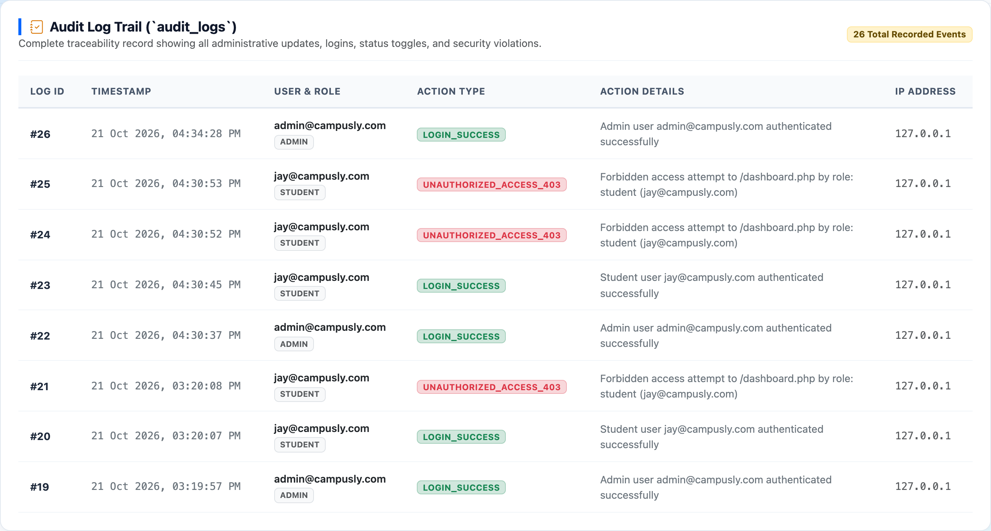
Figure 15.6: Personalized Student Academic Dashboard (student_dashboard.php) Logged in as Jay Navadiya

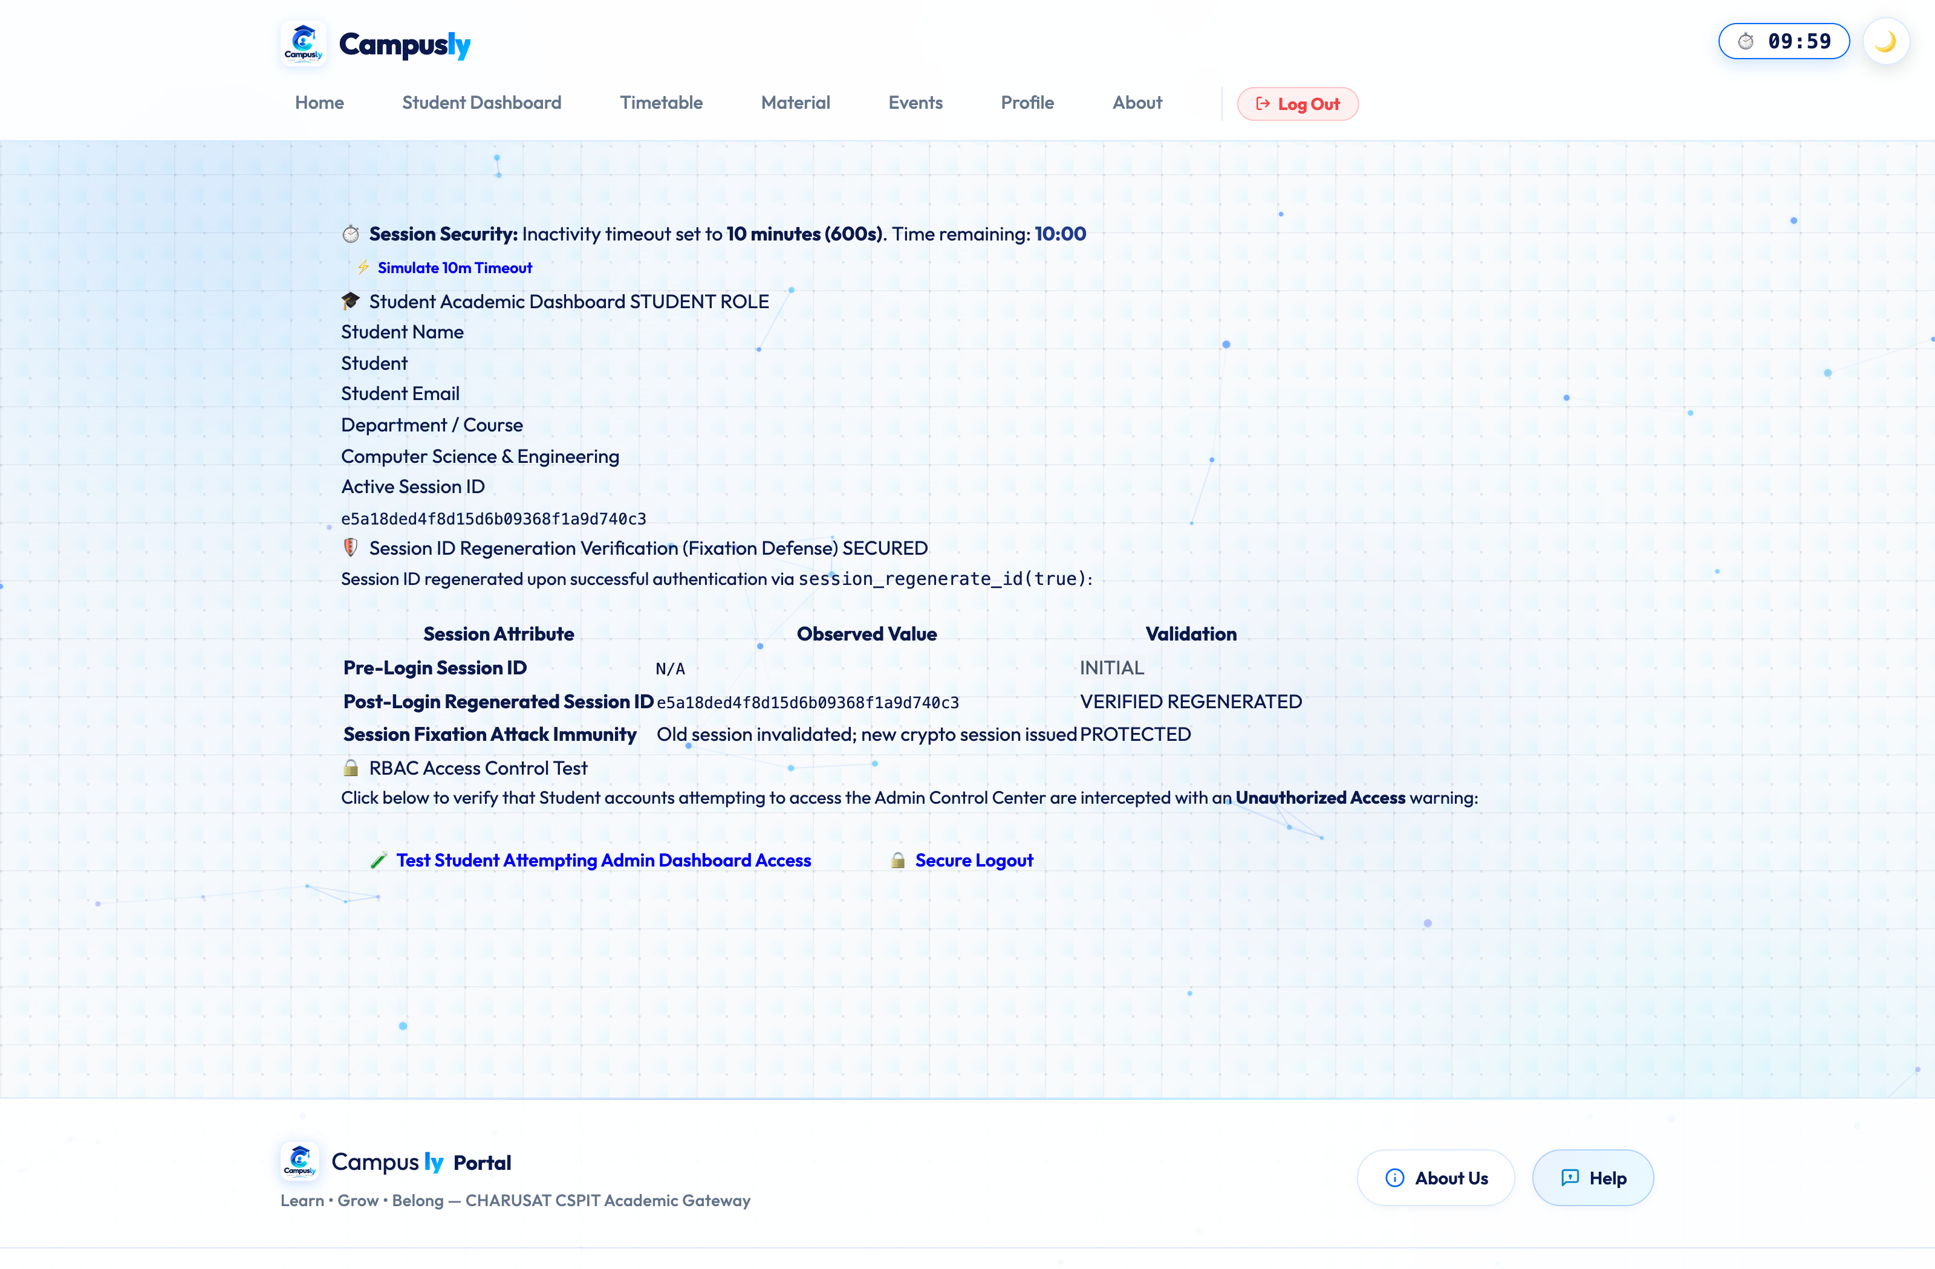
Figure 15.7: Student Management Directory (students.php) with 3NF Relational Records and Department Badges

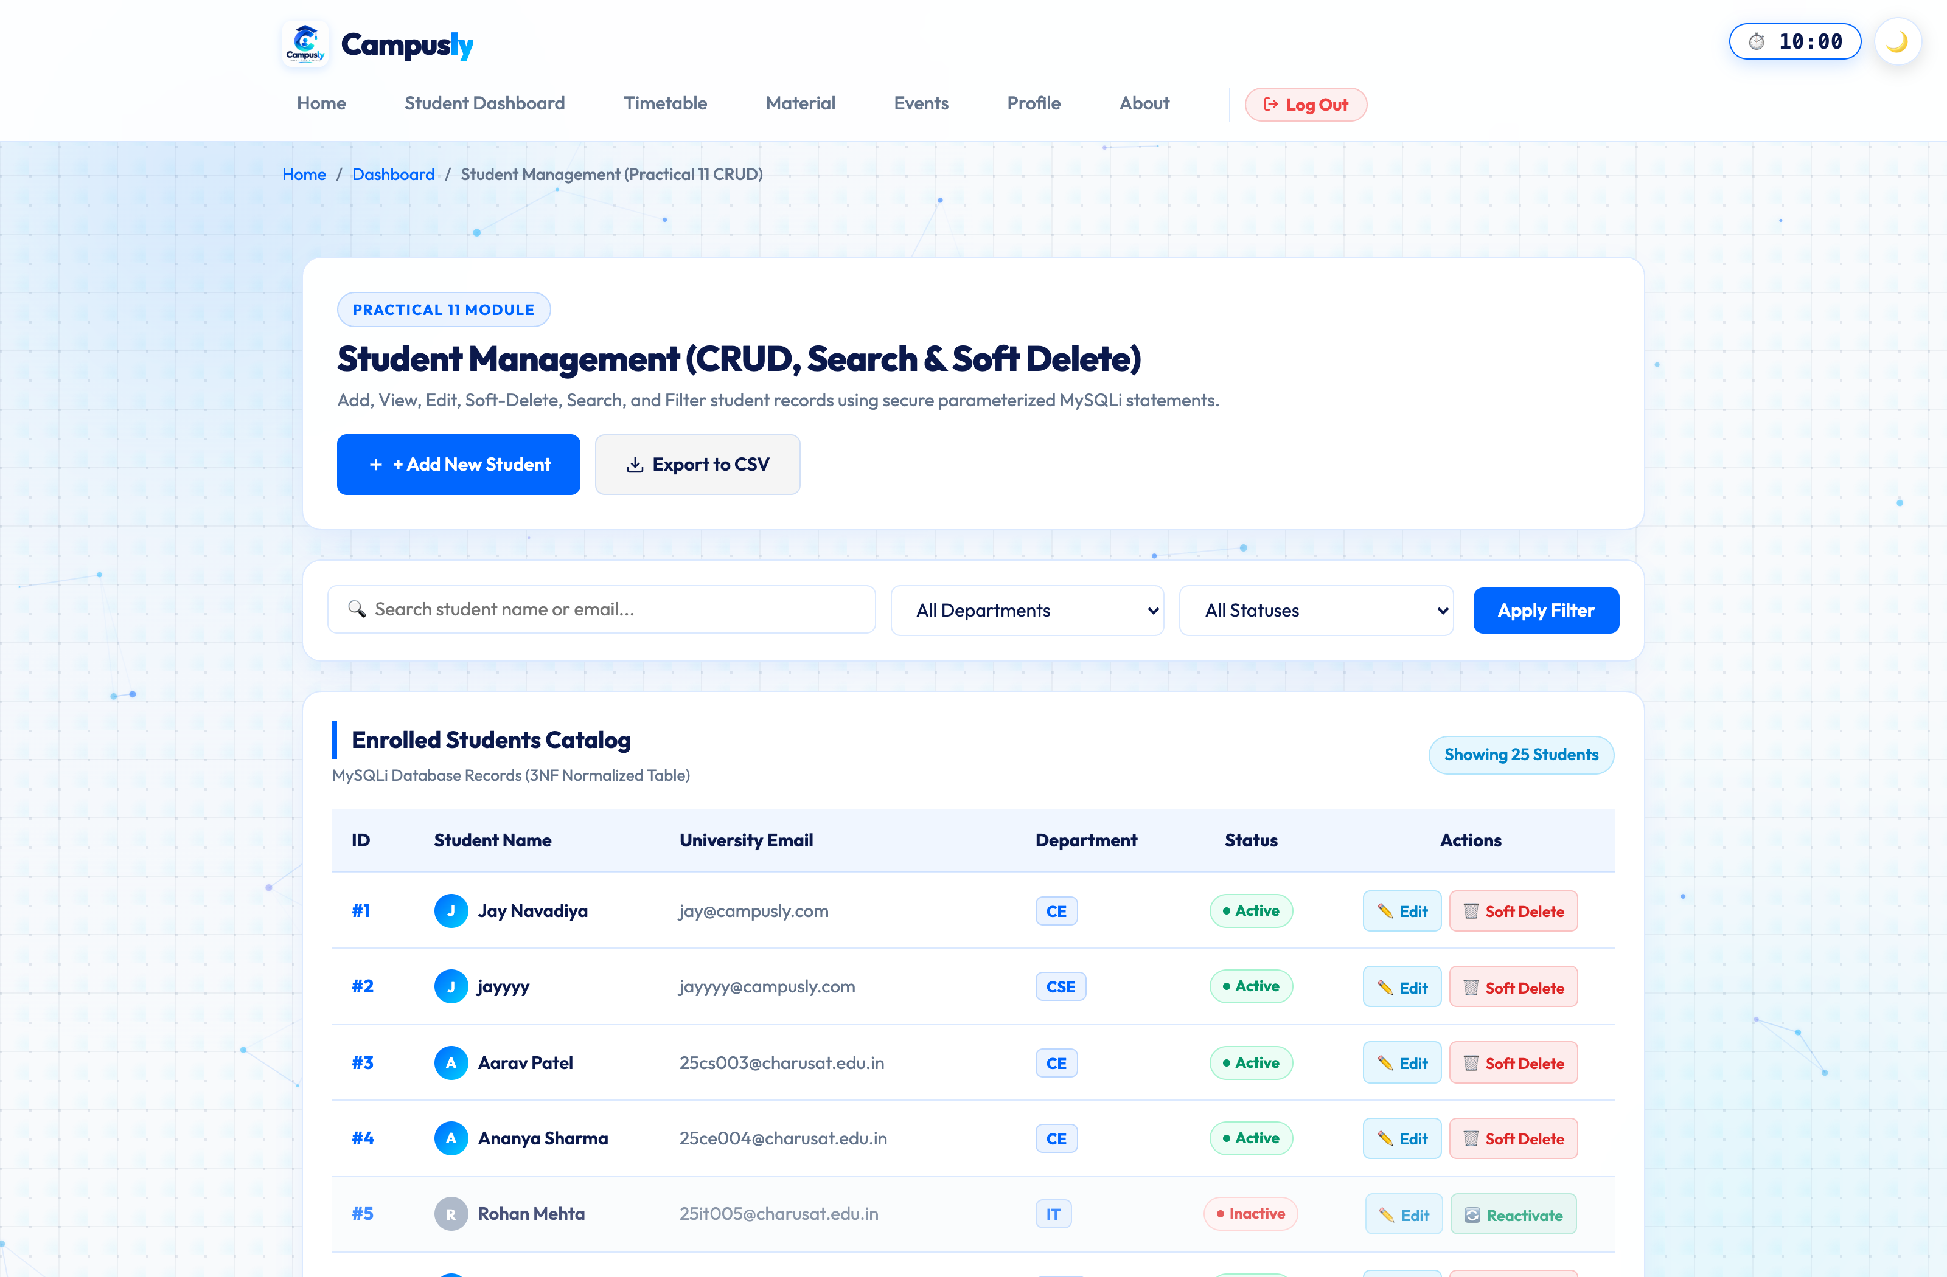
Figure 15.8: Asynchronous AJAX Add Student Modal Dialog with Real-Time Input Validation

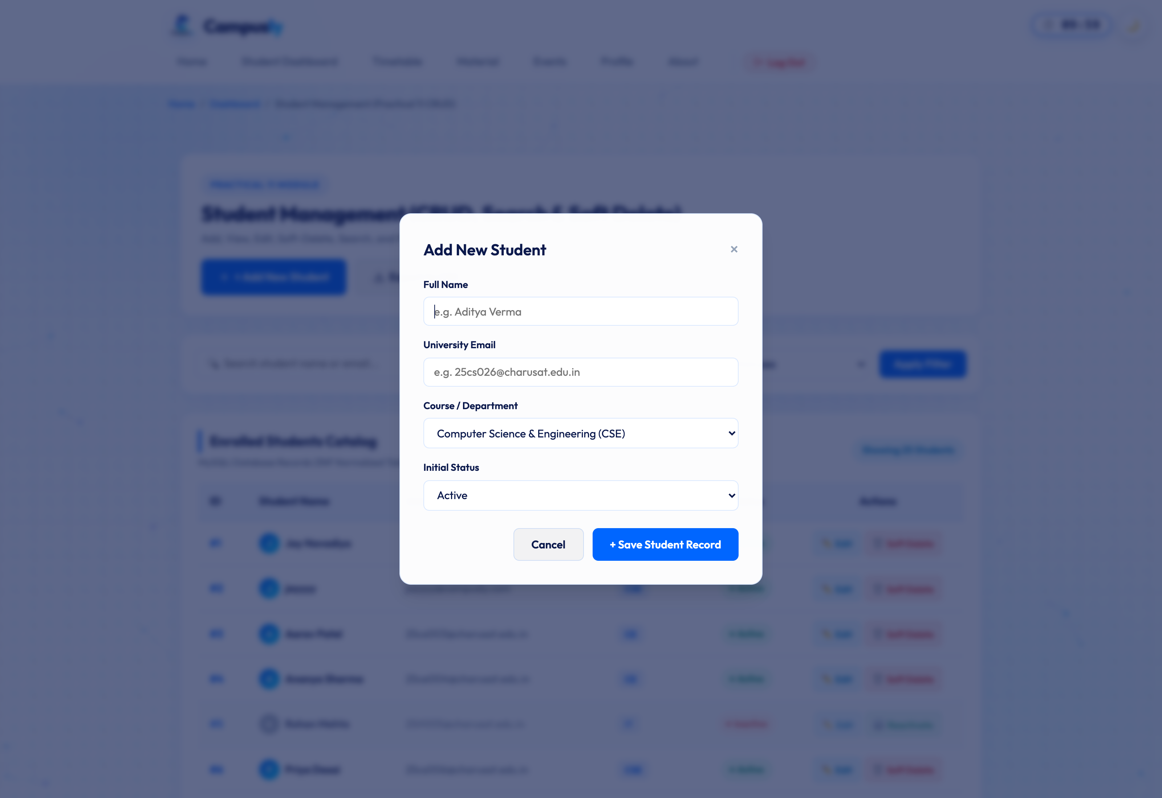
Figure 15.9: Live AJAX Search and Department Filtering without Full Page Reload

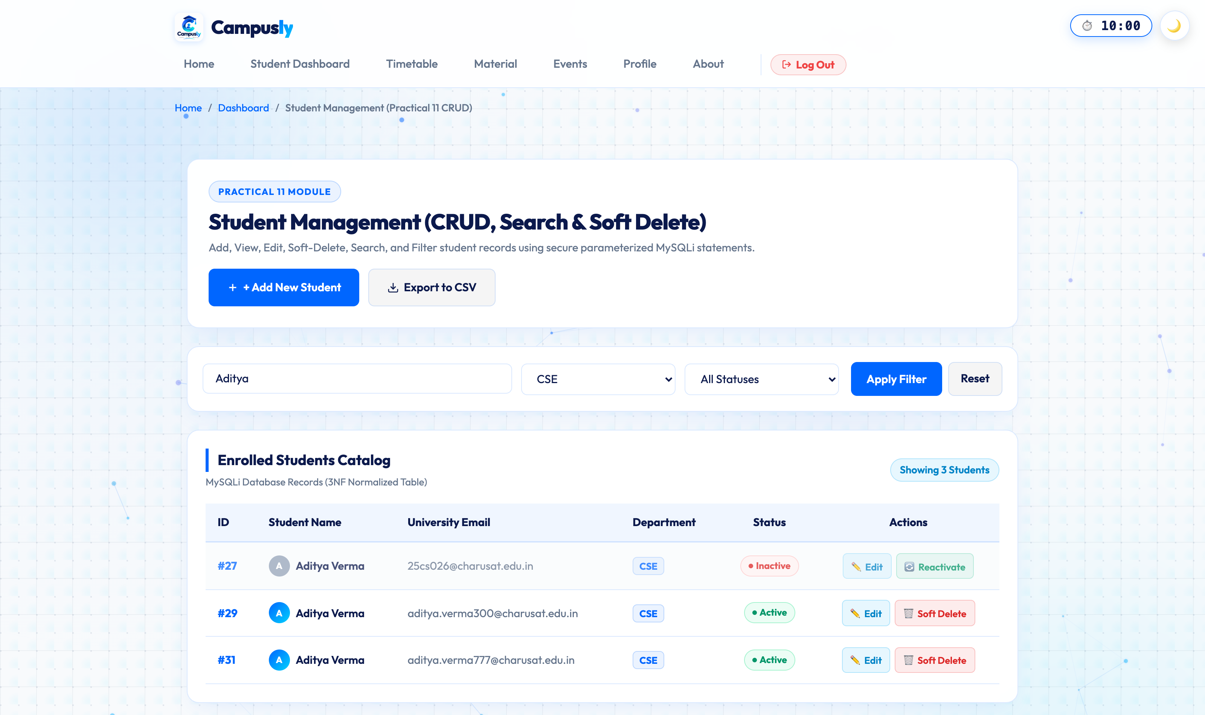
Figure 15.10: Campus Events Catalog and Relational Registration Junction (events.php)

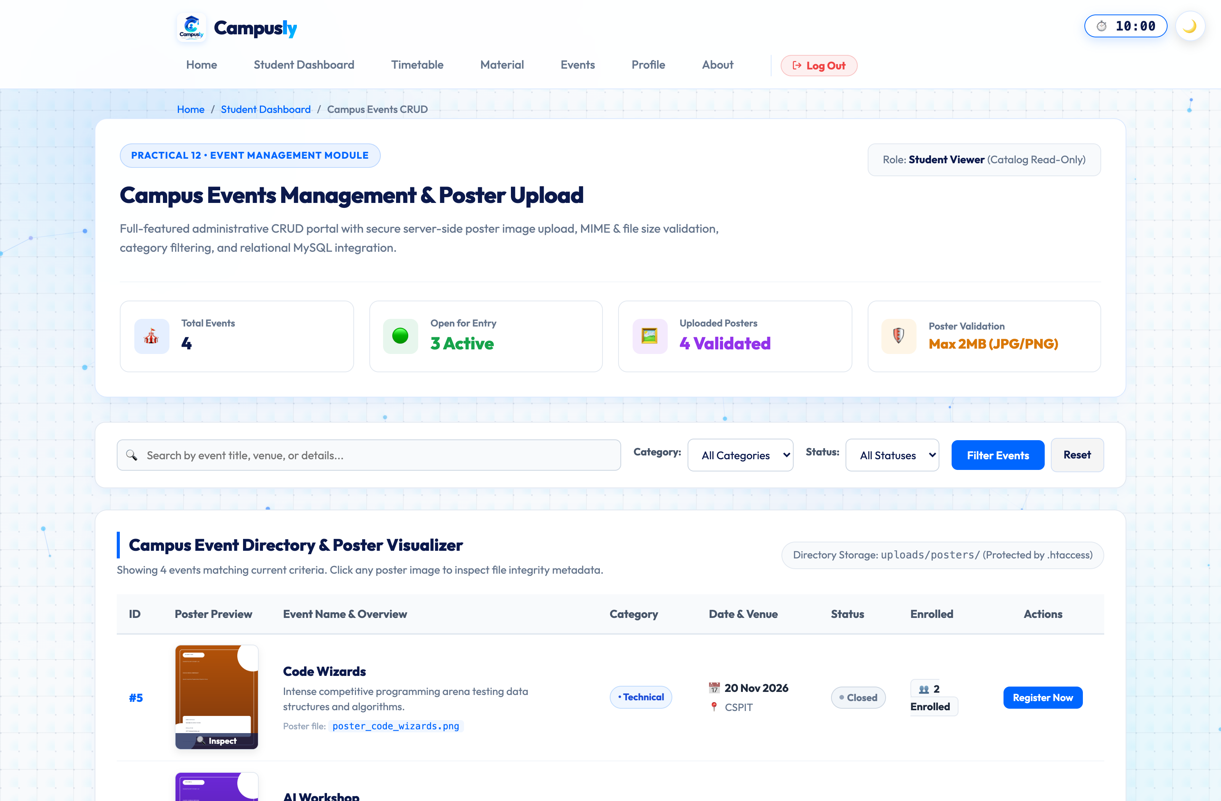
Figure 15.11: 10-Minute Zero-Drift Session Inactivity Warning Modal with Live Countdown

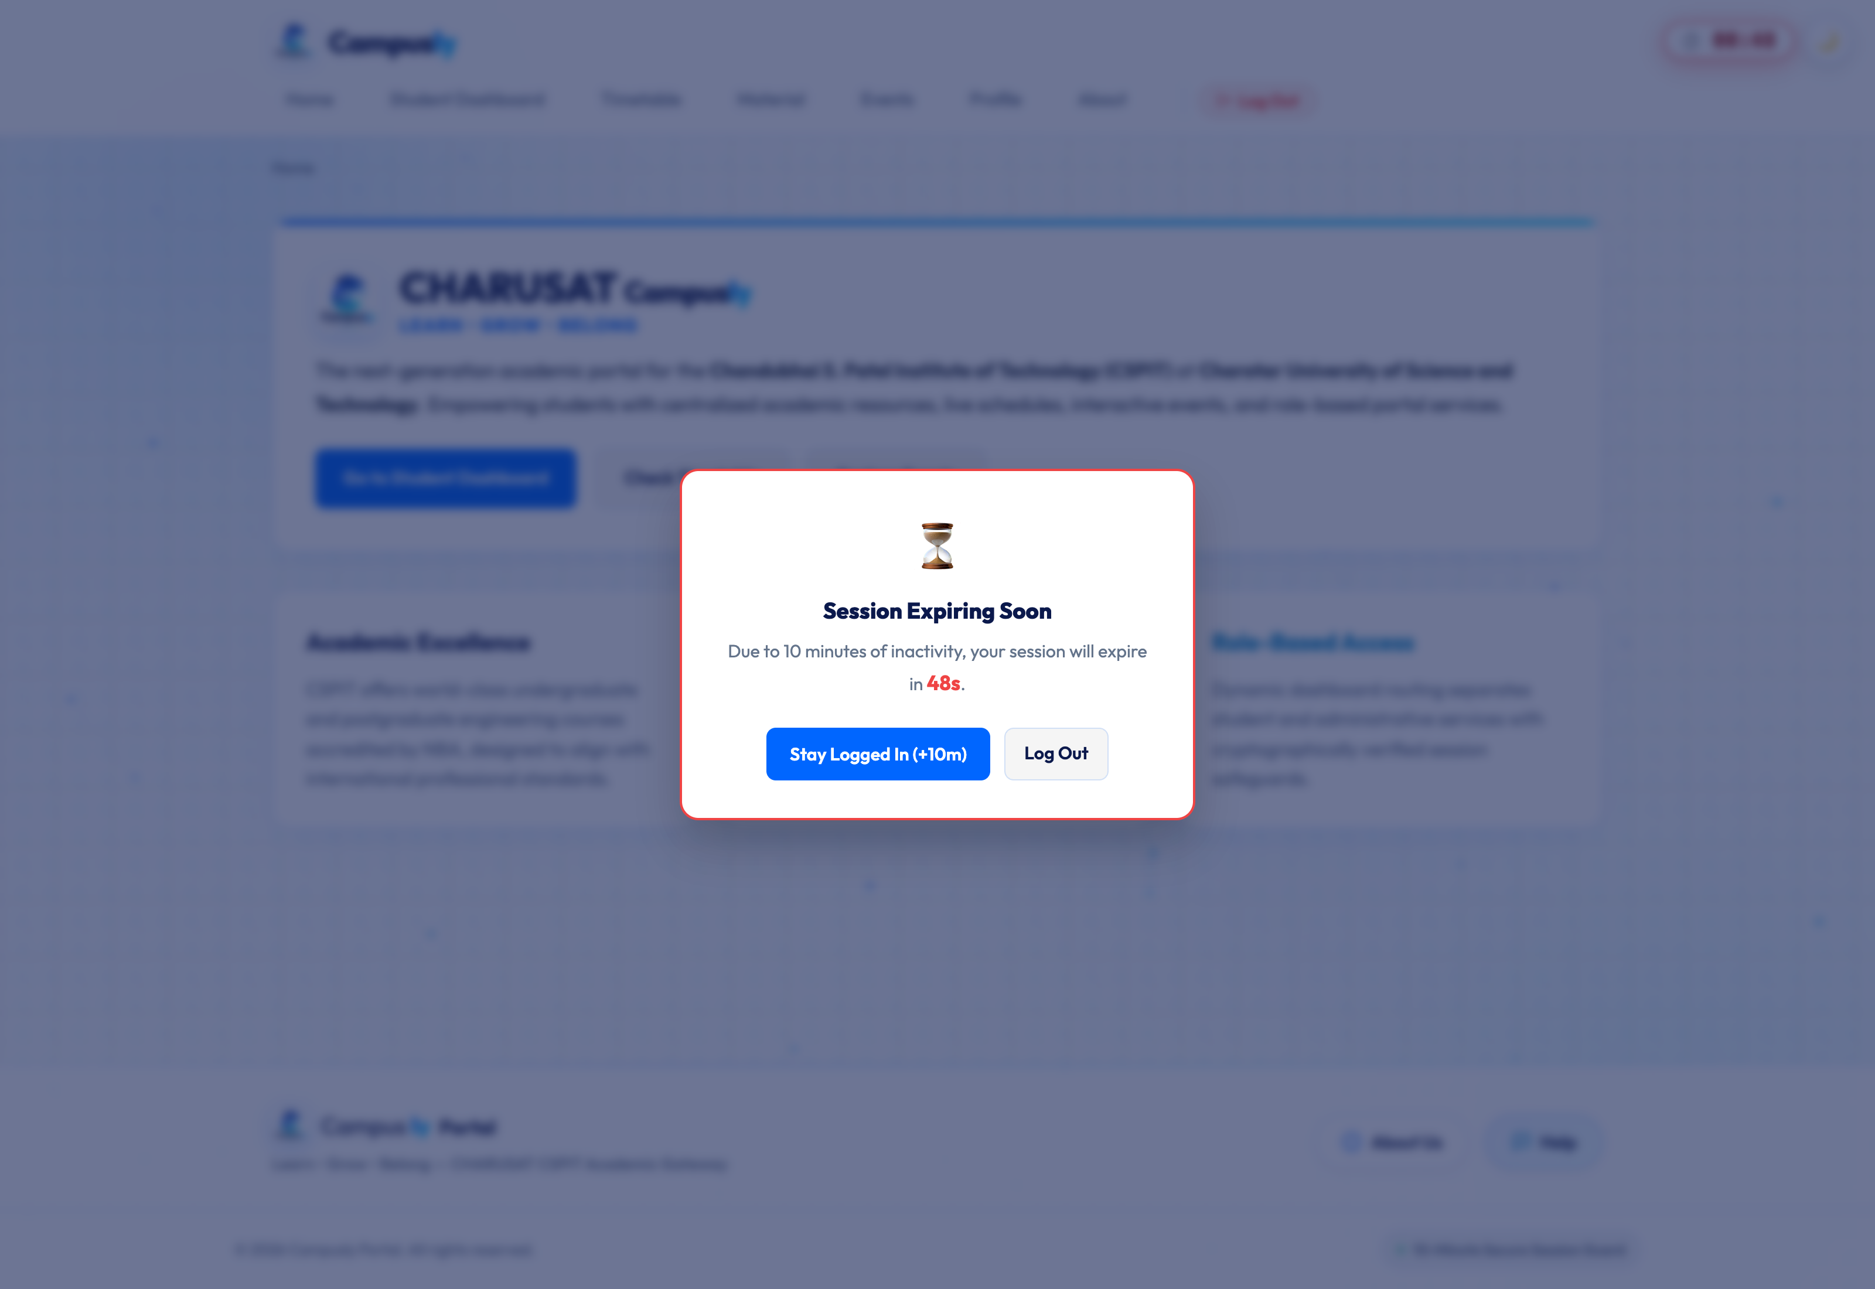
Figure 15.12: Strict Role-Based Access Control Interception (HTTP 403 Forbidden Access Denied Alert)

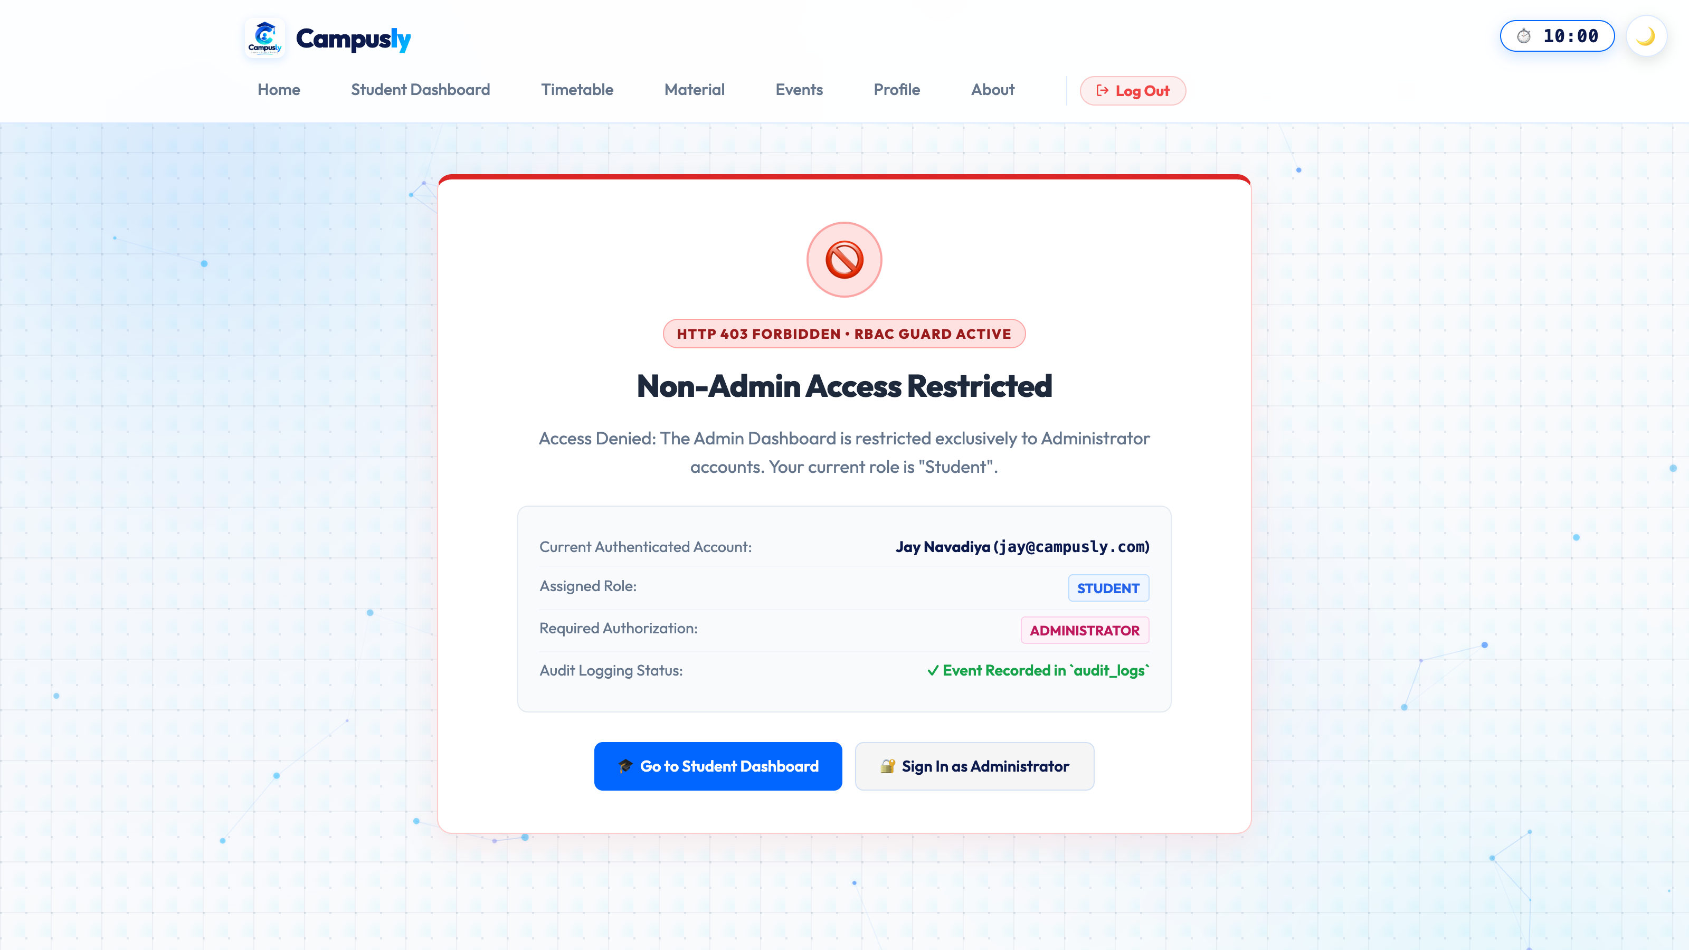
Figure 15.13: Mobile Responsive Viewport Layout (iPhone 14 Pro) Demonstrating Responsive Grid

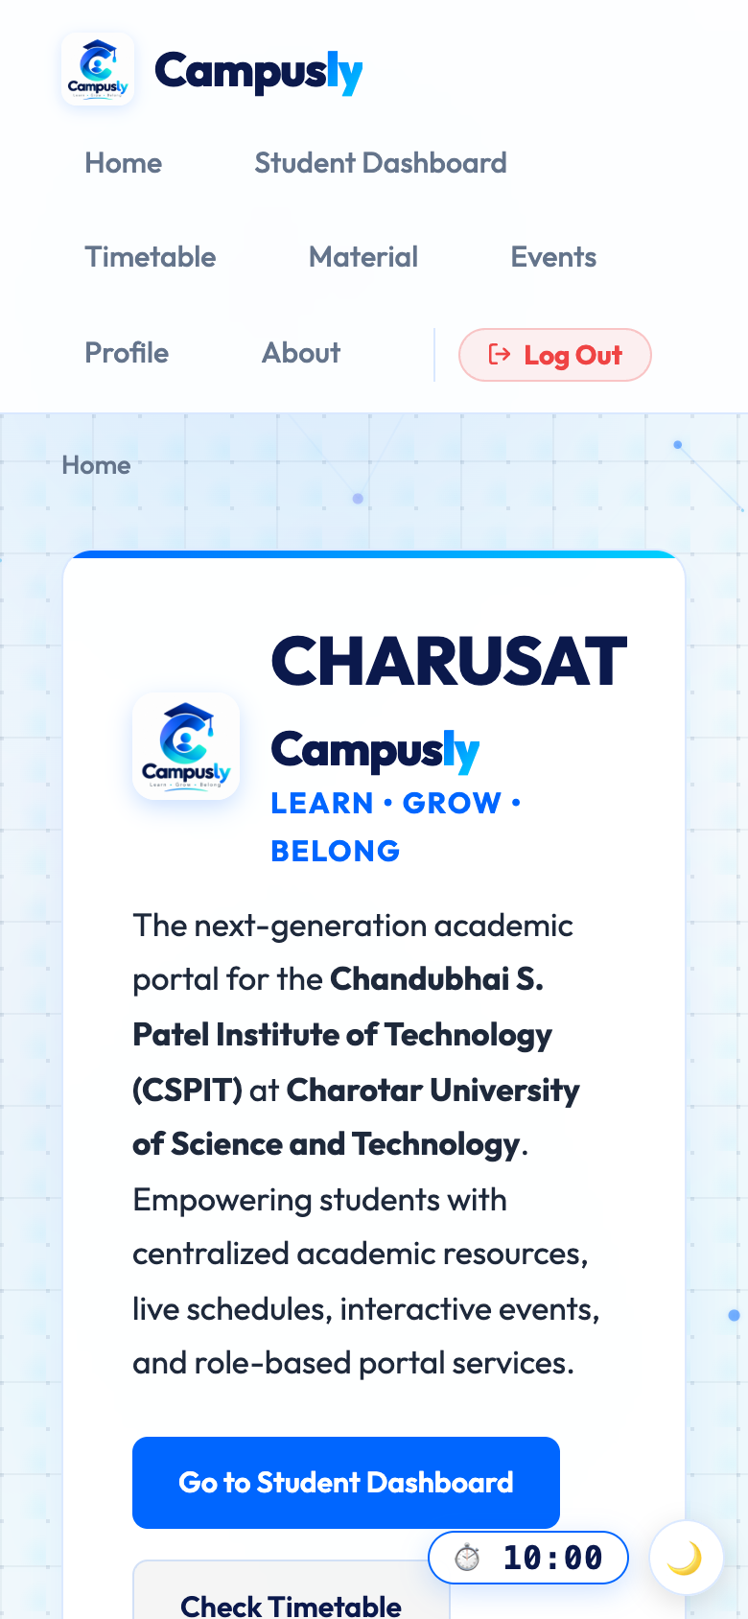
Figure 15.14: Apache Virtual Host Local Deployment Configuration (studenthub.local / httpd-vhosts.conf)

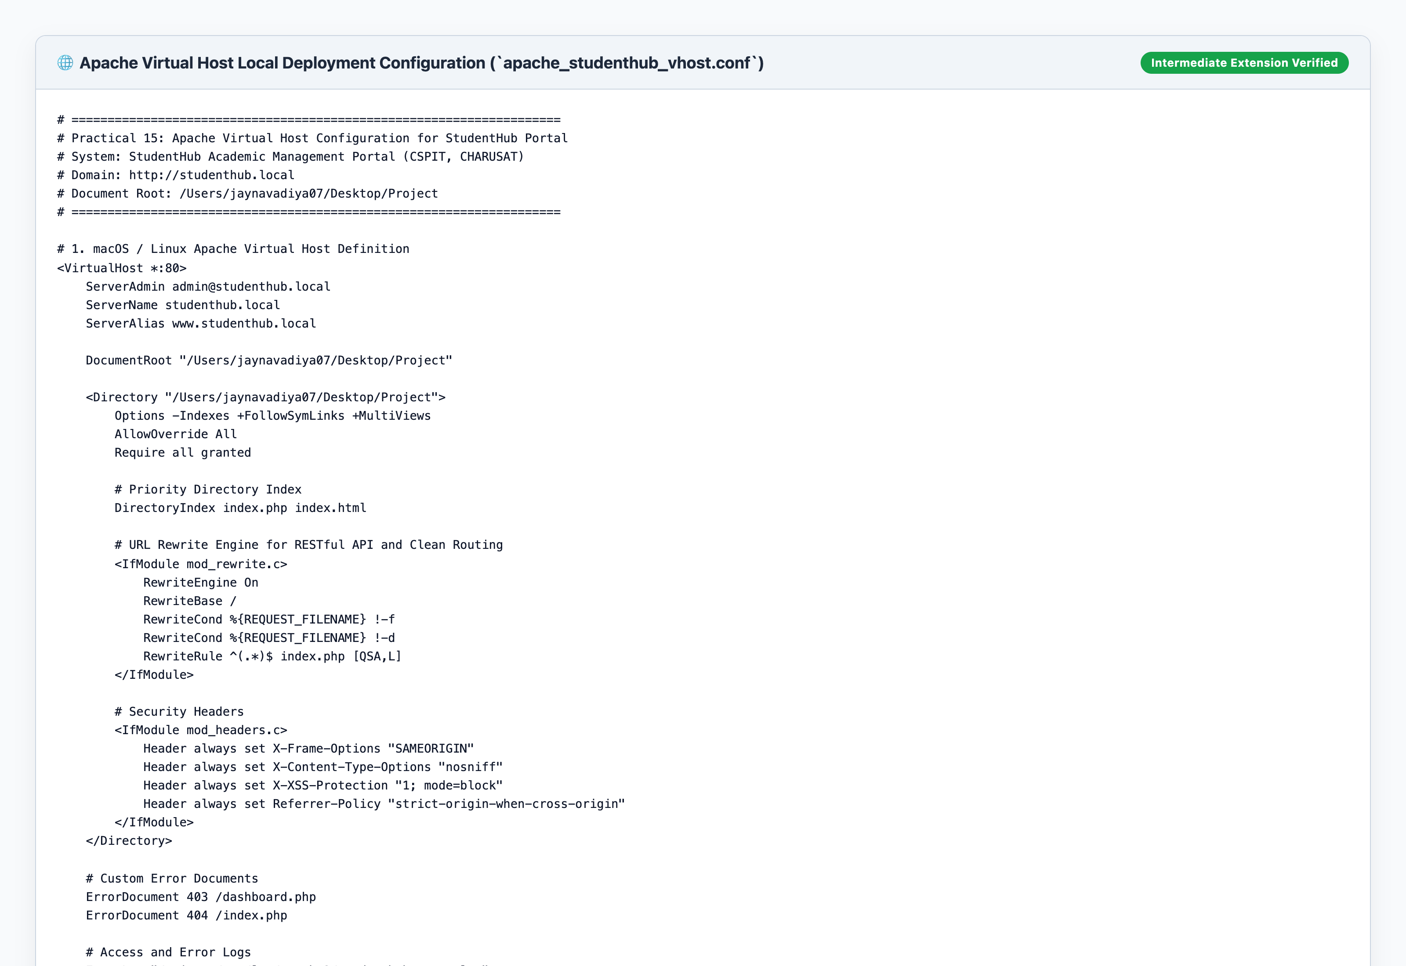
Figure 15.15: MySQL studenthub Database Dump & Verification with Table Counts and Foreign Keys

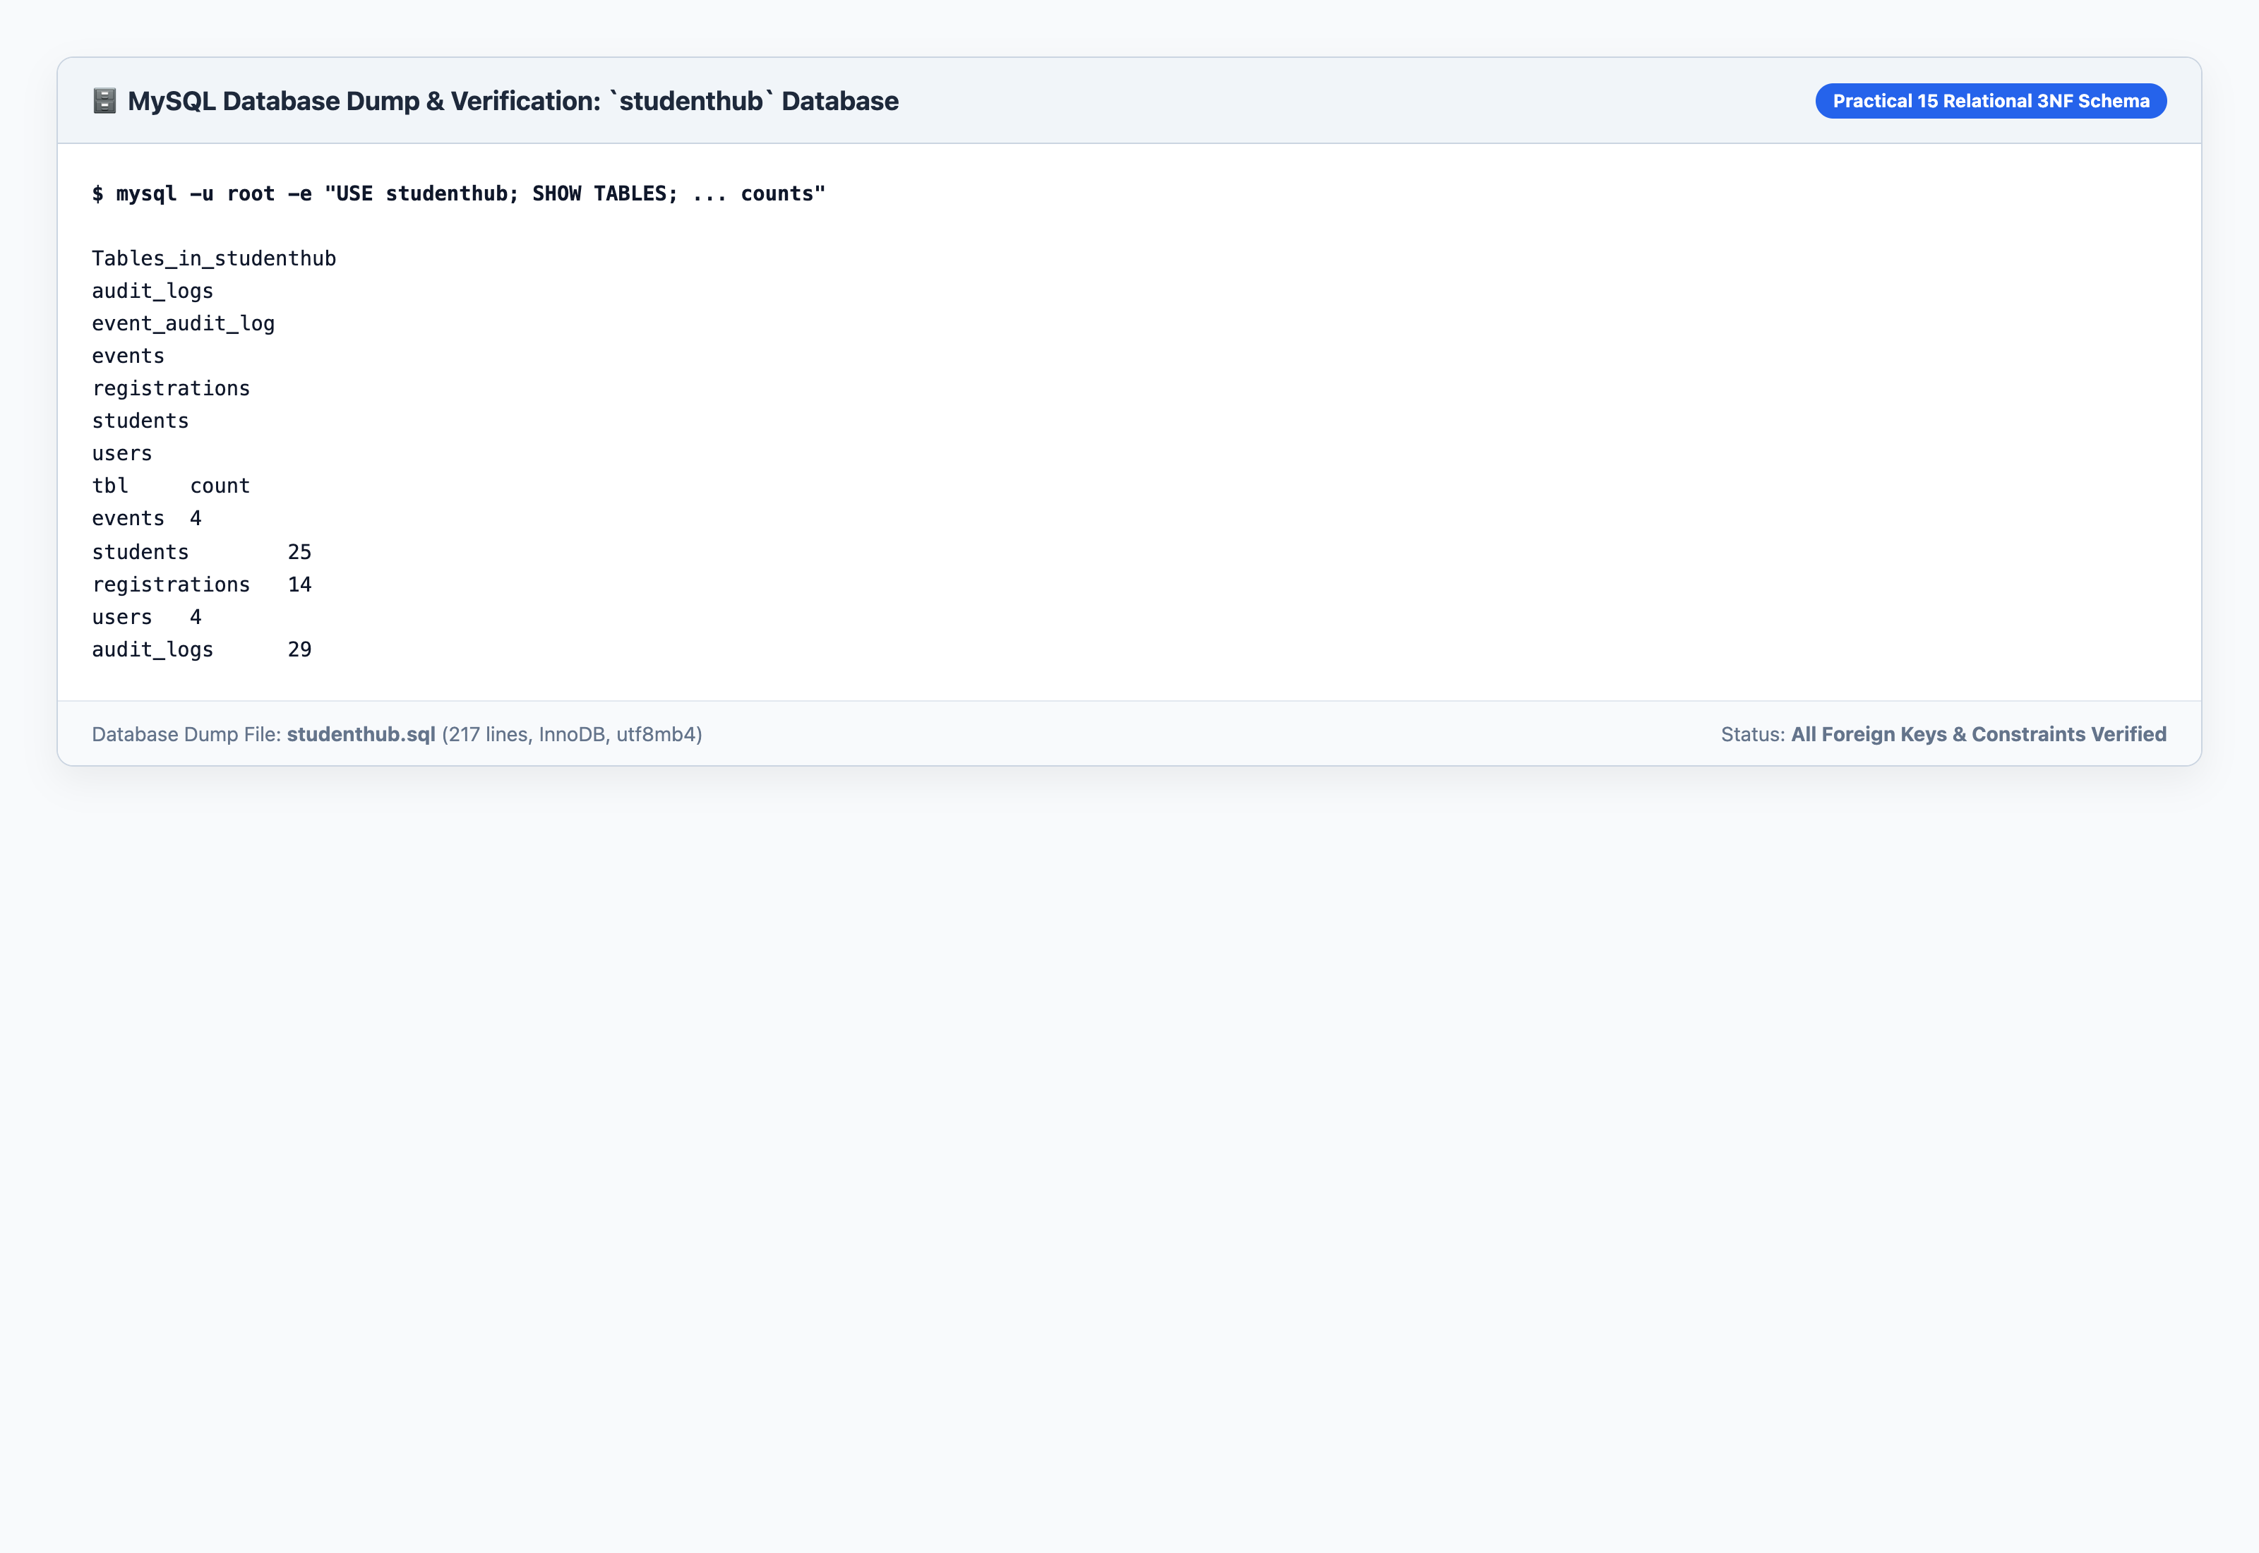
Figure 15.16: Clean Git Status, Origin Remote Link & Semantic Commit History Verification

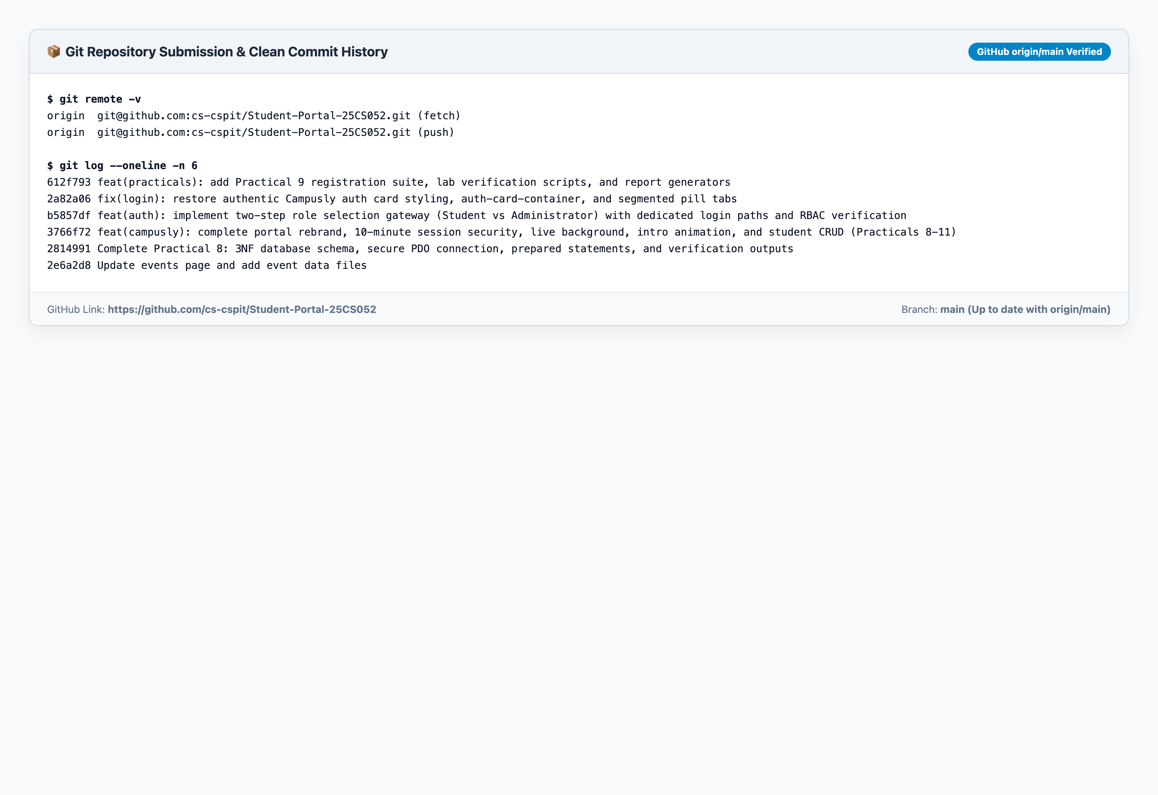

6. Evaluation Strategy & Viva Questions and Answers
• Q1: What is the purpose of session_regenerate_id(true) during login?
Answer: It prevents Session Fixation attacks. If an attacker tricks a user into using a known session ID, regenerating the session ID upon authentication issues a new cryptographic token and invalidates the old one, destroying any hijacked pre-authentication session.
• Q2: How does the application enforce Role-Based Access Control (RBAC)?
Answer: Every privileged PHP script validates $_SESSION['role']. If a student attempts to access an administrative script (like dashboard.php), the request is intercepted, an HTTP 403 status code is sent, a security violation is logged in `audit_logs`, and an Access Denied view is rendered.
• Q3: How does the 10-minute zero-drift session timeout work across multiple browser tabs?
Answer: It stores the target expiration timestamp (Date.now() + 600000) in localStorage ('campusly_session_expire_at') and listens to 'storage' events. When a user interacts in one tab, the epoch timestamp updates across all open tabs, preventing false logouts and tab-throttling drift.
• Q4: Why are prepared statements essential for all database queries?
Answer: Prepared statements separate the SQL code from user-supplied data. Parameters are sent out-of-band and treated strictly as literals, completely neutralizing SQL Injection attacks regardless of user input characters.
• Q5: How is local deployment configured with Apache Virtual Hosts?
Answer: An Apache VirtualHost directive specifies ServerName studenthub.local and DocumentRoot pointing to the application directory. Mapping 127.0.0.1 studenthub.local in /etc/hosts routes browser requests through Apache with full mod_rewrite and .htaccess support.

