**Lab 1 Draft – Traffic Tamer Product Description**

Emily Reyna, Anthony Akintunde, Antonio Qerozi, Alexis Jones, Aaron Edwards, Caitlyn Edwards, Gain Clendenin, Joshua Pablo

Old Dominion University

CS411W, Professor Kennedy

September 4 2024

Gavin Clendenin

Table of Contents

1 Introduction 3

2 Traffic Tamer Product Description 3

2.1 Key Product Features and Capabilities 4

2.2 Major Components (Hardware / Software) 5

3 Identification of Case Study 7

3.1 For whom is Traffic Tamer being developed? 7

3.2 Why is the product for them? 7

3.3 Who else would benefit from the product? 8

4 Traffic Tamer Product Prototype Description 8

4.1 Prototype Architecture 8

4.1.1 Hardware 8

4.1.2 Software 8

4.2 Prototype Features and Capabilities 10

4.3 Prototype Development Challenges 10

5 Glossary 10

6 References 11

Index of Figures

Figure 1: MFCD Diagram 4

Figure 2: Database Schema 5

Index of Tables

Table 1: Prototype Features 7

# Introduction

Understanding traffic law poses a challenge for the average individual due to the complex and varied nature of these regulations across different localities. Legal jargon further complicates the understanding of these laws, making simplified explanations essential for compliance and safety. Nearly half of all cases heard in state courts pertain to traffic violations (National Center for State Courts, 2024). It is evident that convenient access to the traffic laws of individual jurisdictions is necessary.

The solution is the development of a web application that will assist users in navigating and understanding traffic law with ease: Traffic Tamer. This application will present a simplified explanation of relevant traffic laws through the use of machine learning, and the laws displayed will be based on the user's state, county, local police code, and violation code.

One key feature of Traffic Tamer is its ability to reduce complex legal terminology to common verbiage. Users may look up any traffic law and receive a straightforward explanation from Traffic Tamer. Those who are still confused will be guided through follow up questions to further illuminate and assess their situation. This ensures the user understands the law and can make informed decisions on their next steps.

# Traffic Tamer Product Description

Traffic Tamer is a web application designed to help users easily navigate and understand traffic law. It analyzes current traffic laws and checks regularly for updates to them. Through intelligent application of machine learning algorithms to this data, Traffic Tamer presents traffic laws based on the user's specified state, county, local police code, and violation code. This ensures users can easily and reliably find information relevant to them based on their specific circumstances.

The application’s ability to simplify complex laws into digestible terms will improve the user experience for those encountering difficulties understanding what they are reading. The application will offer automated law lookup based on violation code and a simplified explanation of said laws. Users seeking additional information can follow the application’s guided questions to further assess their situation, ensuring they understand the law and can make informed decisions on their next steps.

## Key Product Features and Capabilities

Traffic Tamer will analyze current traffic laws and emerging changes to said laws in order to remain up to date with possible changes. It will categorize laws by locality to offer users relevant information based on where they are. The software will offer simplified explanations of traffic laws, making legal language more accessible to users. This feature will be available for all traffic laws a user might search for in order to enhance understanding.

## Major Components (Hardware / Software) The software will run on a Linux system and use an Apache web server. MySQL and SQLite databases will handle data. Node.js will be used for server-side programming while HTML, CSS, and JavaScript will be used for client-side. React or Angular will be used for the front-end. Docker will manage deployment, ensuring the software runs in any environment. This setup will ensure software efficiency, maintainability, and ensure that only up-to-date traffic laws are provided to users.

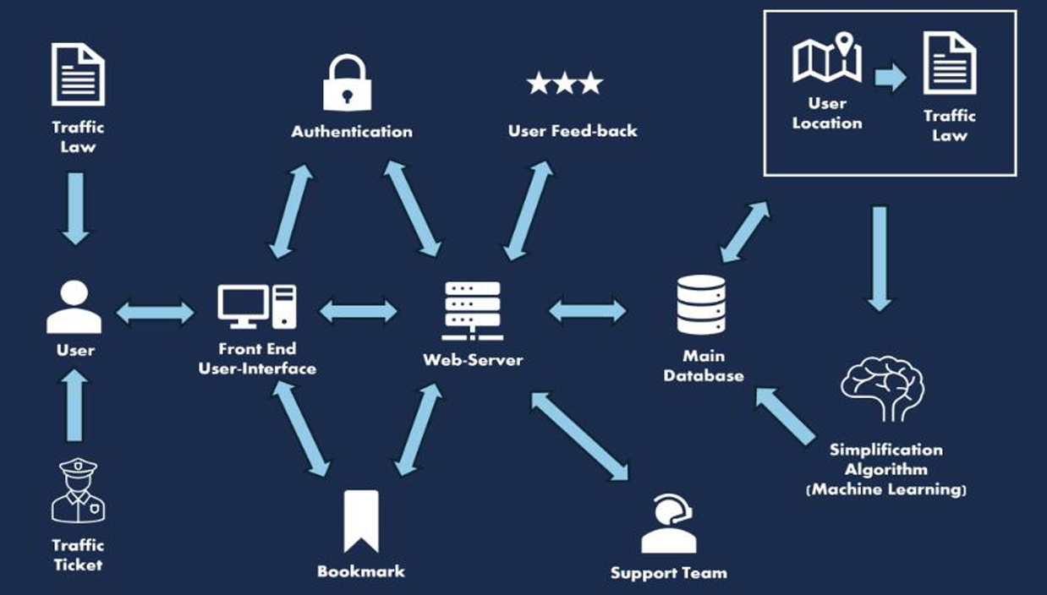Figure 1: MFCD Diagram

Figure 2 shows how Traffic Tamer will manage traffic laws and user interactions through the interconnected tables. ‘Users’ stores user information such as username, email, password, and creation date. ‘Search History’ logs search queries and results for later reference. ‘Bookmarks’ allows a user to save particular laws for faster access in the future. ‘Feedback’ records user ratings and comments on each stored traffic law, which help administrators rectify inaccuracies. ‘Locations’ holds information about various locations including their names, abbreviations, and types. ‘Traffic Laws’ contains detailed information about each law, including location, category, description, simplified description, and time of last update. ‘Traffic Law Categories’ categorizes laws into discrete types. ‘Admin’ manages administrator credentials. This schema allows for easy administrative management as well as retrieval of traffic law information and user interactions.

# Identification of Case Study

## **For whom is Traffic Tamer being developed?**

Traffic Tamer is designed to assist a wide range of users. **General drivers**, who operate vehicles on government roadways, benefit from the platform's ability to clarify complex traffic laws. **Drivers who have broken the law** and received violations also find value in Traffic Tamer, as it helps them understand the legal implications of their infractions and respond appropriately. For **driving students**, whether they are learning to drive for the first time or participating in driver improvement courses, the platform offers essential educational tools to enhance their understanding. Additionally, **law students** specializing in traffic law can rely on Traffic Tamer as a valuable resource for education and research, providing them with the insights they need for their studies and future practice.

## Why is the product for them?

Traffic Tamer serves a variety of users, each with distinct needs. **General drivers** must navigate complex traffic laws, and understanding these regulations can be difficult. Traffic Tamer simplifies the legal explanations, making it easier for drivers to comprehend and follow the rules of the road. For **drivers who have broken the law**, clear guidance is essential for understanding their infractions and managing their next steps. Traffic Tamer provides much-needed clarity during these stressful situations, helping them move forward. **Driving students** benefit from quick access to legal explanations, enhancing their learning experience and aiding in the retention of crucial traffic law knowledge. Finally, **law students** who need to stay up to date on traffic law for their studies and future practice find Traffic Tamer invaluable. Its resources categorize and simplify traffic laws, supporting their academic progress and professional development.

## **Who else would benefit from the product?**

Traffic Tamer's benefits extend beyond individual drivers, offering valuable insights to several other sectors. **Insurance companies** and their agents can use the platform to better understand traffic laws specific to each region, helping them assess claims more accurately and efficiently. **Municipalities and government agencies** may find Traffic Tamer useful for educating the public about traffic regulations, ultimately contributing to safer roadways and improved compliance with laws. **Driving schools** could recommend Traffic Tamer to students as a supplemental resource, allowing them to strengthen their understanding of traffic laws outside the classroom. **Researchers and policymakers** studying traffic regulations and their impact on public safety can leverage Traffic Tamer to analyze frequent infractions and propose meaningful changes to existing laws.

# Traffic Tamer Product Prototype Description

The Traffic Tamer prototype will simulate the functionality of the final product within reasonable expectations by focusing on key components such as account management and legal database. This will serve as the proof of concept and framework for the future implementation of a more robust final product.

## Prototype Architecture

### Hardware

Any internet-capable device

### Software

The development of the Traffic Tamer platform utilizes a wide range of technologies and tools across various stages of the project. The **database** system relies on **MySQL** and **SQLite** for efficient data management. The platform operates on a **Linux**-based **operating system**, with **Apache** serving as the **web server**. For coding, the team works within **VS Code** as the chosen **IDE**. Version control is managed through **GitHub**, ensuring smooth collaboration, while **Trello** is used for **project management**, keeping tasks organized. **Group meetings** are conducted via **Discord**, facilitating seamless communication.

On the frontend, development is done using **HTML**, **CSS**, and **JavaScript**, with the frameworks **React** and **Node**.**js** aiding in creating interactive and dynamic interfaces. **React** and **Angular** frameworks provide additional structure to frontend development. On the backend, the primary language is **Python**, with the **Django** framework handling most of the backend development needs.

For **AI and machine learning**, the project incorporates **PyTorch**, while **BeautifulSoup**, **Scrapy**, and **Selenium** are used for **web scraping** to gather necessary data. Real-time updates are managed with **ApScheduler**, ensuring timely and efficient task scheduling and execution within the system.

## Prototype Features and Capabilities

|  |  |  |  |
| --- | --- | --- | --- |
| **Features and Functionality** | **Real World Product** | **Prototype Planned** | **Prototype Actual (Current)** |
| **User Account Creation** | Fully Implemented | Fully Implemented | Not Implemented |
| **User Account Deletion** | Fully Implemented | Fully Implemented | Not Implemented |
| **Login Authentication** | Fully Implemented | Simulated | Not Implemented |
| **Locations Updates via GPS** | Fully Implemented | Not Implemented | Not Implemented |
| **Traffic Law Updates via Notification** | Fully Implemented | Simulated | Not Implemented |
| **Search Bar and Filtering System** | Fully Implemented | Fully Implemented | Not Implemented |
| **Bookmark/Quick Access System** | Fully Implemented | Fully Implemented | Not Implemented |
| **Regional Support Team** | Fully Implemented | Not Implemented | Not Implemented |

Table 1: Prototype Features

## Prototype Development Challenges

Several key challenges must be addressed in order to develop Traffic Tamer effectively. Training the planned AI to accurately and reliably translate complex legal terms into simpler, more digestible language is essential. The goal is to minimize or eliminate any chance of misinterpretation, ensuring users fully understand the legal information provided. The service must also be capable of efficiently storing and processing the large volume of scraped data that will be necessary to power its features. Acquiring sufficient server storage space and processing power will be critical for maintaining uninterrupted access to the service, and for allowing users to rely on Traffic Tamer at all times.

# Glossary

• Apache: An open-source web server software that is widely used to serve web content over the internet.

• CSS (Cascading Style Sheets): A style sheet language used for describing the presentation of a document written in HTML or XML, defining the look and layout of a web page.

• Docker: A platform for developing, shipping, and running applications in containers. Containers are lightweight, portable, and self-sufficient environments that include all the necessary components to run a piece of software.

• HTML (HyperText Markup Language): The standard markup language used to create web pages. HTML elements are the building blocks of web pages.

• JavaScript: A programming language that enables interactive web pages and is an essential part of web applications. Along with HTML and CSS, it is one of the core technologies of the web.

• Linux: An open-source operating system based on UNIX. It is used to run servers, desktops, and mobile devices.

• Machine Learning: A branch of artificial intelligence that focuses on building systems that can learn from and make decisions based on data.

• MySQL: An open-source relational database management system (RDBMS) that uses SQL (Structured Query Language) to manage and manipulate databases.

• Node.js: A JavaScript runtime built on Chrome's V8 JavaScript engine, allowing developers to use JavaScript to write server-side code.

• React: A JavaScript library for building user interfaces, particularly single-page applications where data changes over time.

• SQLite: A C-language library that implements a small, fast, self-contained, high reliability, full-featured, SQL database engine.

• State Court: A court that has jurisdiction over disputes with some connection to a U.S. state.

• Traffic Law: Rules and regulations that govern how vehicles operate on the roads and how road users must behave to ensure safety and order.

• Web Application: An application software that runs on a web server and can be accessed through a web browser.

# References

* Aghayari, H., Kalankesh, L. R., Sadeghi-Bazargani, H., & Feizi-Derakhshi, M.-R. (2021, August 2). Mobile applications for Road Traffic Health and safety in the mirror of the Haddon’s Matrix – BMC Medical Informatics and decision making. BioMed Central. <https://bmcmedinformdecismak.biomedcentral.com/articles/10.1186/s12911-021-01578-8>. Retrieved June 11, 2024.
* Online legal services and legal advice. LegalShield. (2024, June 6), <https://www.legalshield.com/>. Retrieved June 11, 2024.
* Traffic attorneys in North Carolina. iTicket.law - Powered by Hatley Law Office. (n.d.), from <https://www.iticket.law/>. Retrieved June 11, 2024.
* Traffic Caseload Highlights. (2024, April). National Center for State Courts,  
  <https://www.courtstatistics.org/__data/assets/pdf_file/0029/99920/Traffic-CLHL.pdf>. Retrieved June 11, 2024.
* Web Application Security: Risks, Technologies & Best Practices.” CyCognito, [www.cycognito.com/learn/application-security/web-application-security.php](http://www.cycognito.com/learn/application-security/web-application-security.php). Retrieved 26 June 2024.
* Odnoletkov, Pavel. “Top 8 Web Application Security Threats and How to Mitigate Them.” MBC Managed IT Services, [www.mbccs.com/web-application-security-threats/](http://www.mbccs.com/web-application-security-threats/). Retrieved 9 August 2024.
* “7 Common Web Security Threats for an Enterprise.” Fortinet, [www.fortinet.com/resources/cyberglossary/web-security-threats](http://www.fortinet.com/resources/cyberglossary/web-security-threats). Retrieved 26 June 2024.