Development of a Teacher-Focused Mobile Application for Colegio De Alicia Website

Members:
Amaya, Janssen Carl T. Carbajal, John Albert V. Galagar, John Mark H. Lacorte, Daryl Bench P. Mata, Beryl Paece C.
Santerna, Andrea Loren A.

Course: ELDROID12
Instructor: Wilson Gayo
School: University of Cebu – Main Campus
Date Submitted: March 15, 2026

ABSTRACT

This project focuses on the design and development of a mobile user interface for teachers of Colegio De Alicia. The goal of the application is to provide a structured and user-friendly interface where teachers can access important school-related modules such as schedules, grades, attendance monitoring, and profile information.

The application prototype was developed using Kotlin and Jetpack Compose in Android Studio. The system demonstrates modern mobile interface design principles using composable UI components and navigation architecture.

The project is limited to the UI/UX implementation of the application. Backend services, authentication systems, and database functionality are not included in the scope of this project. However, the prototype provides a foundation that can later be expanded into a fully functional teacher management system.

INTRODUCTION

Background of the Study
Mobile technology is widely used in education to help manage academic tasks more efficiently. Teachers often need quick access to information such as schedules, grades, and attendance records. However, many school processes are still done manually or through scattered systems, making it harder for teachers to organize their work.
To address this, the Teacher-Side Application was designed as a mobile interface prototype for teachers of Colegio De Alicia. The application provides an organized interface where teachers can navigate features such as dashboard, schedule, grades, attendance, and profile. The system was developed using Android Studio, Kotlin, and Jetpack Compose to demonstrate modern Android UI development.

Problem Statement
Many schools lack a dedicated mobile interface that allows teachers to easily manage academic information in one place. Because of this, teachers may find it difficult to quickly access schedules, record attendance, or manage grades.
This project aims to address the following questions:
    - How can a mobile interface be designed to help teachers manage academic tasks efficiently?
    - How can a simple and organized navigation system improve user experience for teachers?

Purpose of the Project
The purpose of this project is to design a mobile application user interface prototype for teachers of Colegio De Alicia. The system demonstrates how teachers can navigate different modules such as schedule, grades, attendance, and profile within a single application interface.

Significance of the Project
The mobile app is significant to:
Teachers: Provides a concept of a mobile platform that organizes important teaching-related tasks.
School Administration: Demonstrates how digital tools can support academic management.
Developers and Students: Serves as an example project for learning mobile UI development using modern Android tools.

OBJECTIVES

General Objective
To design and develop a mobile user interface prototype for teachers of Colegio De Alicia.

Specific Objectives
    - To create a clean and intuitive mobile interface for teacher users.
    - To implement UI components using Jetpack Compose.
    - To design a dashboard that serves as the central navigation point of the application.
    - To create modules for schedule viewing, grade management, attendance tracking, and profile information.
    - To demonstrate how a teacher management mobile application may function through a UI prototype.

SCOPE AND LIMITATIONS

Scope
The project includes:
    - Mobile application user interface
    - Dashboard interface for navigation
    - Schedule viewing interface
    - Grades interface layout
    - Attendance interface layout
    - Teacher profile interface
    - Navigation system between screens

Limitations
The system does not include:
    - Backend server integration
    - Database connectivity
    - Authentication systems
    - Real-time data processing
    - Student-side application
The application functions purely as a UI/UX prototype.

DEVELOPMENT TOOLS AND TECHNOLOGIES
The application was developed using the following technologies:

TOOLS | DESCRIPTION
Android Studio | Main development environment
Kotlin | Programming language used to build the application
Jetpack Compose | Framework used to design the UI
Android Jetpack Navigation | Handles navigation between screens
GitHub | Used for version control and collaboration
Gradle | Used for project build management

UI ARCHITECTURE
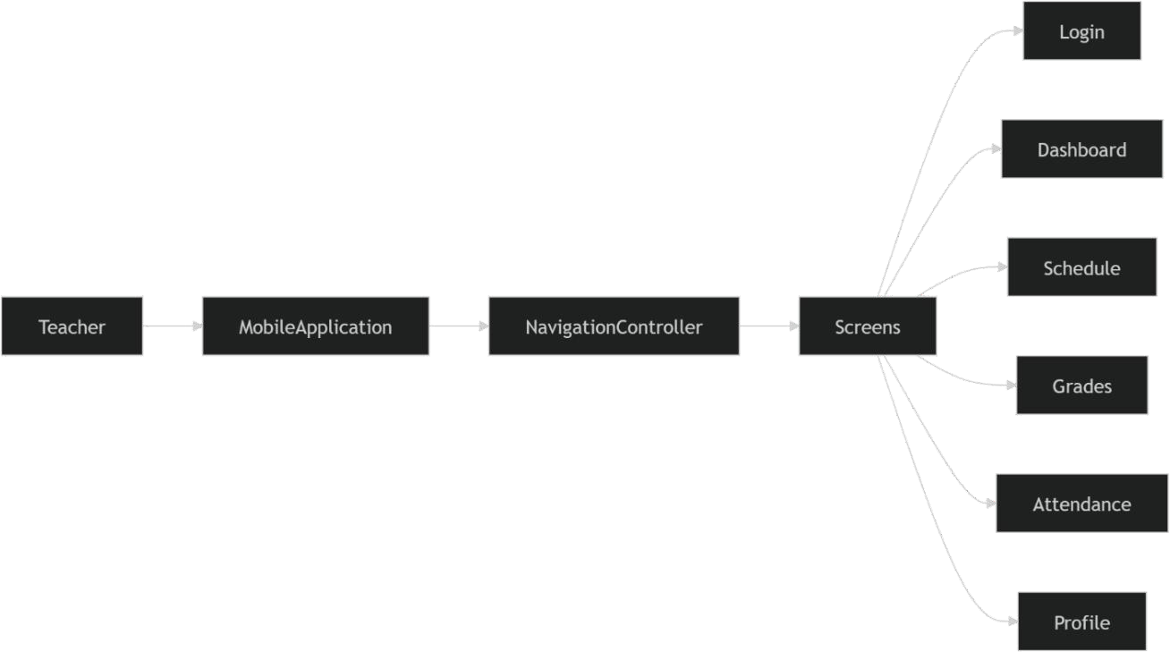

NAVIGATION FLOW

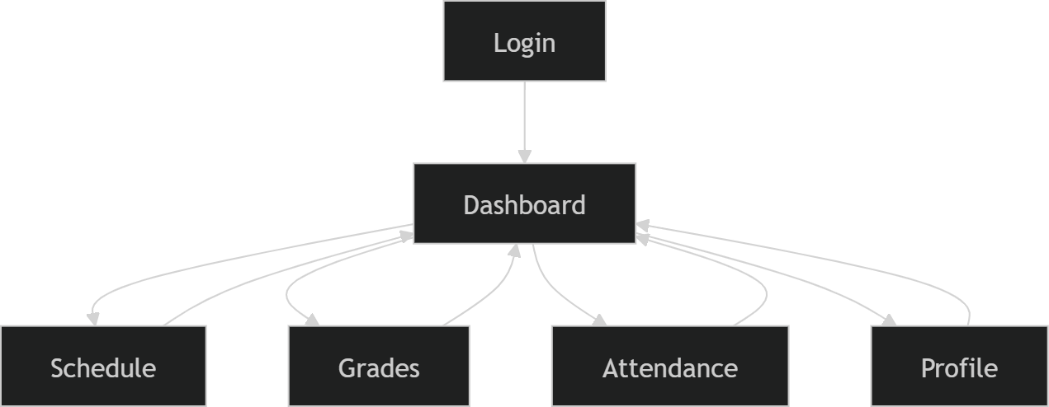

Explanation:
  - The application starts with the Login Screen.
  - After login, the user is directed to the Dashboard Screen.
  - From the dashboard, teachers can access the other modules.

APPLICATION MODULES
The application consists of several key modules that provide teachers with essential tools to manage their academic responsibilities. Each module focuses on a specific functionality and is designed to be intuitive and easy to navigate.

SCREEN | DESCRIPTION
Login | Acts as the entry point of the application. Allow teachers to access the system before navigating to the main interface.
Dashboard | The main screen of the application. Serves as the navigation hub where teachers can access the following modules: Schedule, Grades, Attendance, Profile.
Schedule | Displays the layout for viewing teacher class schedules. Help teachers monitor their daily teaching activities.
Grades | Provides the interface for managing grading-related information.
Attendance | Contains UI components intended to track or manage student attendance.
Profile | Displays the teacher’s personal information and account details.

VIII. DATA ARCHITECTURE AND MANAGEMENT

1. Data Overview
In its current implementation, the application functions as a high-fidelity UI/UX prototype. Consequently, the data displayed across the various modules—Schedule, Grades, Attendance, and Profile—is currently mocked (static data). This approach was chosen to demonstrate the application's reactive UI capabilities and layout structure without requiring an active backend connection.

2. Data Modules and Entities
The application is designed to handle several key data entities essential for teacher management:
- User Profile Data: Contains personal and account details for the teacher, such as name, employee ID, and department.
- Academic Schedule Data: Managed as a list of class objects, including subject names, room assignments, and time slots.
- Grading Information: Structured to display student lists and corresponding grade fields for management.
- Attendance Records: Data components designed to track and display student attendance status.

3. Data Implementation (Jetpack Compose & ViewModel)
To ensure the application is ready for future backend integration, data is managed using modern Android architectural patterns:
- State Management: Composables react to UI state changes using State and ViewModel. This ensures that once real-time data is introduced, the UI will update automatically.
- Modular Storage: All screen-specific data logic is organized under ui/screens/, keeping the data handling separate from the reusable UI components in ui/components/.

4. Future Data Integration (Scalability)
While backend services and database connectivity are currently out of scope, the project provides a foundation for the following data enhancements:
- Authentication: Integration of secure login systems and biometric data (fingerprint).
- Cloud Synchronization: Transitioning from mocked data to real-time API processing for live schedule and grade updates.
- Local Persistence: Implementation of a local database (such as Room or SQLite) for offline access to teaching records.

IMPLEMENTATION
The mobile application implemented using Jetpack Compose, a modern declarative framework for Android UI development. This approach allows the interface to be written entirely in Kotlin, eliminating the need for XML layouts and enabling reactive and modular UI components.

Key Implementation Details:

  - Screen Structure
    - Each module—Login, Dashboard, Schedule, Grades, Attendance, Profile—is implemented as a separate composable function.
    - Screens are organized under ui/screens/ for modularity, while reusable components such as buttons, cards, and toolbars are placed in ui/components/.
    - This structure ensures maintainability and allows easy addition of new modules in the future.

Navigation System
    - Navigation between screens is managed using NavController and NavHost from Android Jetpack Navigation.
    - The Login Screen is the start destination, and the Dashboard acts as the central hub for accessing all other modules.
    - Proper back stack handling ensures smooth transitions and a predictable navigation

flow.
  - UI Design and Principles
    - The application follows Material Design 3 guidelines, emphasizing clarity, consistency, and accessibility.
    - Elements such as elevated cards, rounded buttons, and dynamic typography enhance readability and user experience.
    - The Dashboard provides a clear layout where teachers can access all modules efficiently.

State Management and Reactivity
    - Composables are reactive to UI state changes using State and ViewModel, allowing dynamic updates for components such as schedule and grades lists (mocked data for the prototype).

CONCLUSION
The Teacher-Side Application successfully demonstrates the design and development of a mobile user interface prototype intended for teachers of Colegio De Alicia. The project focuses on creating a clean and organized interface that allows teachers to navigate important modules such as the dashboard, schedule, grades, attendance, and profile.
The application was developed using Android Studio, Kotlin, and Jetpack Compose, which enabled the implementation of modern Android UI design practices. Through the use of composable functions and navigation components, the project demonstrates how a mobile interface can be structured to improve usability and organization for teachers.
Although the project is limited to the UI/UX aspect of the system, it provides a strong foundation for future development. With the addition of backend integration, database connectivity, and authentication systems, the application could be expanded into a fully functional teacher management platform that supports academic activities more efficiently.

USER’S MANUAL

System Requirements

To run the Teacher-Side Application, the following requirements are needed:

Hardware Requirements

    - Android smartphone or emulator

    - Minimum 2GB RAM recommended

Software Requirements

    - Android operating system

    - Application built using Android Studio

    - Developed with Kotlin and Jetpack Compose

How to Use the Application Step 1: Launch the Application
- Open the Teacher-Side Application on your Android device or emulator.
- The Login Screen will appear.

Step 2: Login

- Enter the required login information.

- Tap the Login Button or use the Fingerprint Biometrics.

- The system will navigate to the Dashboard Screen.

Step 3: Dashboard Navigation

The Dashboard serves as the main menu of the application. From here, the user can navigate to different modules:
  - Schedule
  - Grades

  - Attendance

  - Profile

Tap any module to open its screen.

Step 4: Schedule Screen

The Schedule Screen allows teachers to view their teaching schedule. This helps teachers keep track of their daily classes.

Step 5: Grades Screen

The Grades Screen provides the interface where teachers can view or manage grading-related information.

Step 6: Attendance Screen

The Attendance Screen provides the layout for monitoring or managing student attendance.

Step 7: Profile Screen

The Profile Screen displays the teacher’s account information and personal details.

6.3 Navigation

Users can navigate between screens using the navigation buttons or menu available in the application. The dashboard acts as the central hub for accessing all modules.

