

Alicia, Bohol, Philippines
Application Testing (Teacher Side) UI / UX TEST SCRIPT
Note: In MSWord go to View then Web Layout for a pageless presentation.
Script Pre-requisites:
Pre-requisites Steps
Step No. | Action | Expected Result
1 | Run / Open the Application | The system will start and will display the Log In/Sign In interface

Script Execution:
Test Scenario | Interface | Description | Expected Result | Actual Results | Pass / Fail | Remarks
TS1 – Log In / Sign In | I. Logo | I. Centered | I. Shown | Landing Interface  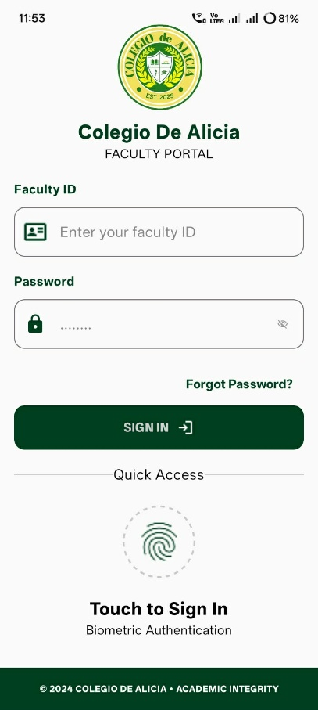 | Passed | The Forgot Password? is still on process…
 | II. School Name (Text) | II. Centered | II. Bold and Visible.
 | III. Faculty ID and Password | III. TextBox | III. Can be filled up in the box/field for credentials.
 | IV. Forgot Password | IV. Text Left | IV. Will open a new tab for changing password.
 | V. Sign In | V. Button | V. Can be pressed and proceed to Main Dashboard of the Application.
 | VI. Quick Access | VI. Fingerprint (Biometric Authentication) | VI. For easy access to the application just like our fingerprint lockscreen.
TS2 – Main Dashboard | I. Dark / Light Mode Icon | I. Top Right Side | I. Can be pressed and it will change the mode, dark or light. | Main Dashboard  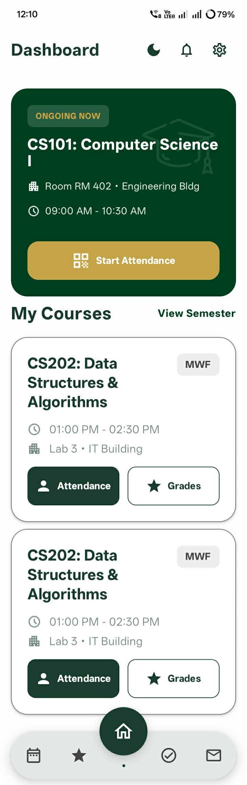  Dark Mode:  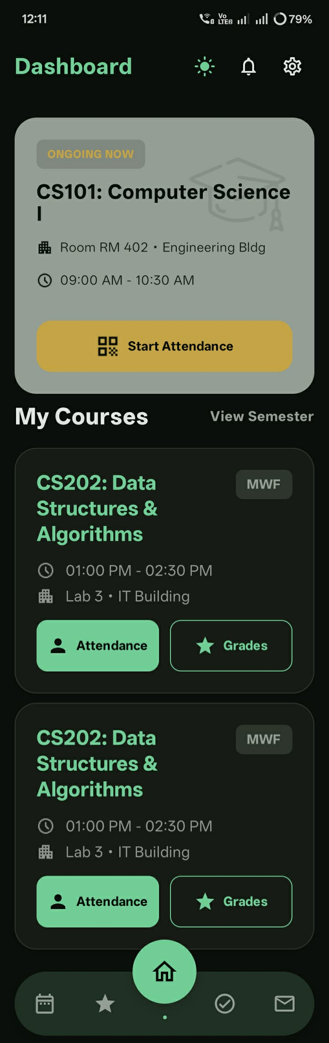 | Passed | All buttons are clickable, but the View Semester text is still on decision what to show/do.
 | II. Bell Icon | II. Top Right Side | II. Can be pressed and it will show notifications.
 | III. Settings Icon | III. Top Right Side | III. Can be pressed and it will bring you to the settings.
 | IV. Ongoing Class | IV. Card Layout with Button | IV. Will show the teacher for his/her current class and it will show the Subject, Room Number and Building, Time Schedule, and lastly can start/check the Attendance.
 | V. My Courses (instructor classes courses) | V. Card Layout and Buttons (scrollable) | V. Can check the lists of enrolled subjects and can scroll down for more subjects under. Also, you can see the Subject, Room Number and Building, Date Time Schedule, and additionally can check the Attendance and Grades of the Students.
TS3 – Faculty Schedule | I. Calendar | I. Event Calendar, a calendar layout centered. (click the Month to expand) | I. Can check the day/date and serve as a reminder what are the things to be done within this day or for upcoming days. | Faculty Schedule Tab  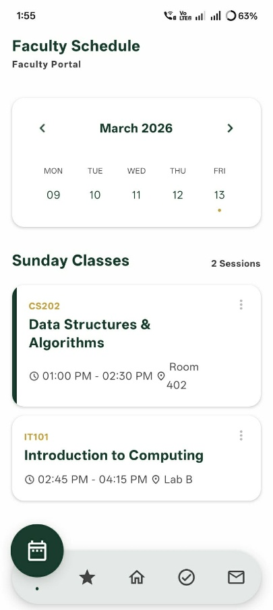 | Passed | II. The three dots are just visual presentation no functionalities at this moment.
 | II. Class Schedules | II. List of card layout as schedules of classes, below the calendar. (scrollable) | II. Can check the schedules and classes you are having today. Also, the rooms and building.
TS4 – Grades | I. Course  II. Statistics  III. Search Students  IV. Students  V. Finalize Grades | I. Using spinner to insert the handled subjects of the instructor.  II. Card layout as the holder for statistics of students’ grades and students’ status.  III. Search bar, for student easy tracking.  IV. Card layout, holder for their grades.  V. Button | I. Can change class by just clicking the subject, and there will be a list of classes the instructor has.  II. Can check the statistics of your class, their status, and if they have already been graded.  III. Can sort automatically students based on what you typed.  IV. A visual presentation for your students’ grades, also shows their name and ID’s and current rank in your class because of the built-in calculator when you input their grades.  V. When you’re finally done working with their grades just click the button Finalize Grades. | Grades Tab  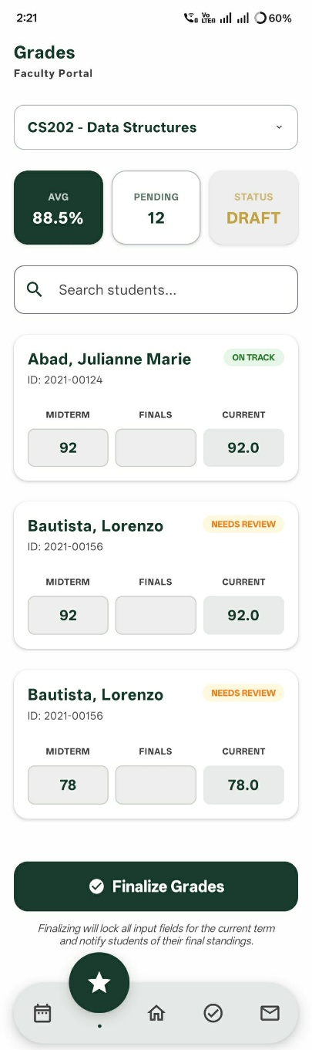 | Passed | At the moment,  I. Spinner is not functionalized just a presentation.  II. Statistics are not functionalized, just a presentation.  III. Search Bar is not functionalized to sort the students.  IV. Built-in Calculator is not functionalized.  V. Button is not functionalized just a presentation.
TS4 – Attendance | I. Subject  II. Calendar  III. Mark All Present  IV. Search Student  V. Student List | I. Button, upper top right.  II. Card layout, for calendar.  III. Button, below calendar.  IV. Search bar, for student easy tracking.  V. Card layouts for students, on the bottom, and scrollable. | I. Can change the subject by clicking the button. It has lists of classes the instructor has.  II. Can check the day/date of attendance for week.  III. If you feel generous, we have Mark All Present button to attend all of the students.  IV. Can sort automatically students based on what you type.  V. Can show the student names and IDs. And a legend, P for Present, L for Late (where you can use the search bar for that), and A for Absent. For the attendance of the meeting/day. | Attendance Tab  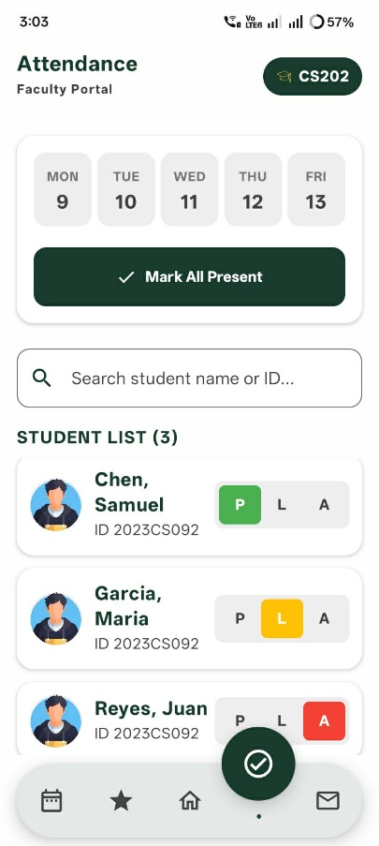 | Passed | At the moment,  I. Button is not working, just a presentation. (Subject)  III. Button is not working, just a presentation. (Mark All Present)  IV. Search Bar is not functionalized to sort the students.
TS4 – Messages | I. Search Messages  II. Messages | I. Search Bar  II. Chat UI Kit | I. Can sort messages, just type or enter names in the search bar.  II. Can exchange conversations with the parents of your students, or your co-instructors and heads. Additionally, when you are chatting you can send files by clicking the plus icon on the lower left side. And a send button on the lower right side. | Messages Tab  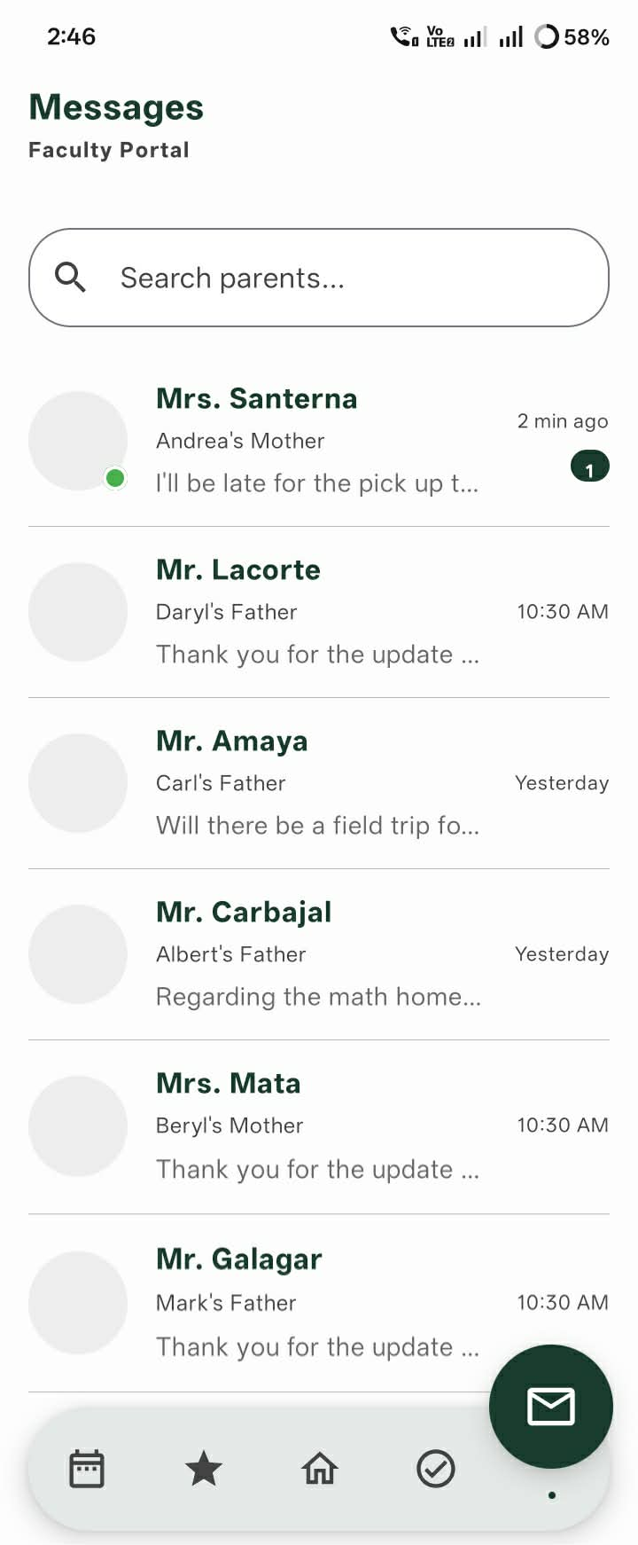  Chat UI Kit: (canvas)  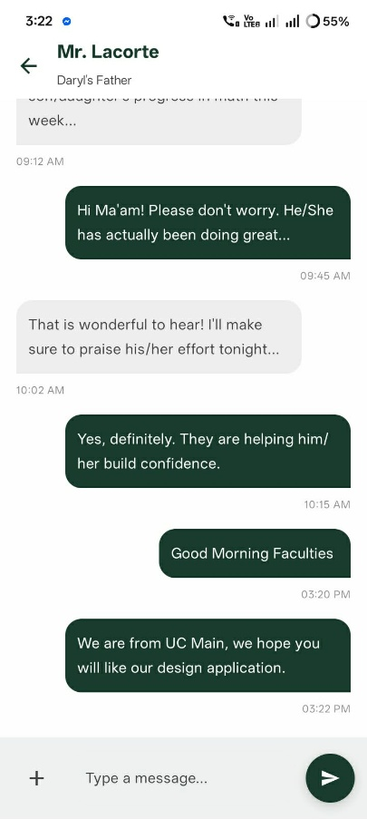  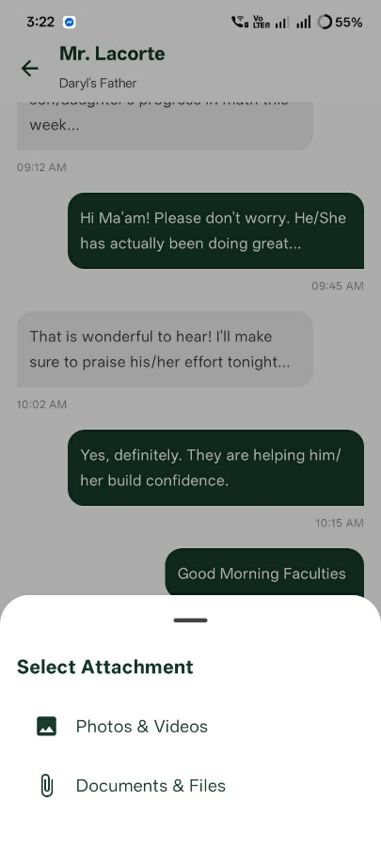 | Passed | At the moment,  I. Search Bar is not functional to sort messages.  II. Just a presentation, not working.
TS4 – Settings | I. Profile  II. Name and Role and ID  III. Edit Profile  IV. Share Profile  V. General Settings  VI. Help and Security  VII. Log out | I. Centered, using image picker can pick photos from your device.  II. Text  III. Button  IV. Button  V. Buttons  VI. Buttons  VII. Button | I. Can change your profile picture to set as standard, and professionalism. Just tap the pencil icon or click the Edit Profile then click the camera icon to change your profile picture.  II. How you can be seen, your name, role, and ID.  III. Can modify your full name, contact details, address. And saved it.  IV. Share icon, when click it will give you a URL copy of your profile in the app.  V. In General Settings, you can modify your Personal Information, Academic Credentials, and Department Settings.  VI. In Help & Security, you can modify Security & Privacy, and FAQs or Frequently asked questions about how to use the application.  VII. When clicked you will be turned over in the Log In / Sign In interface. | Settings Tab  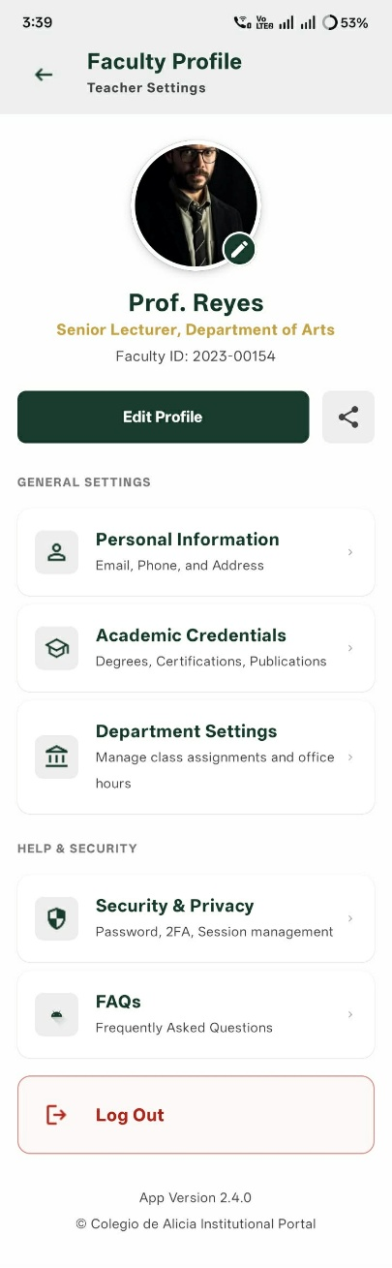  Edit Profile:  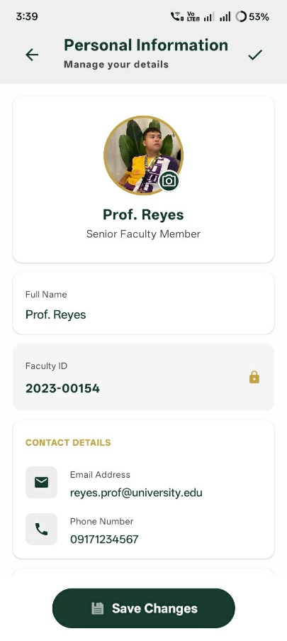  Sharing Profile:  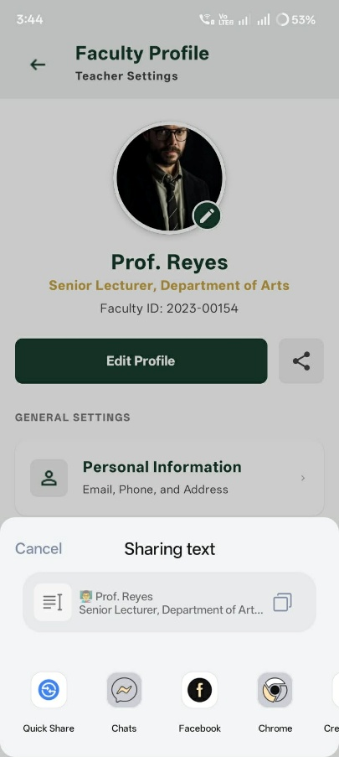  General Settings:  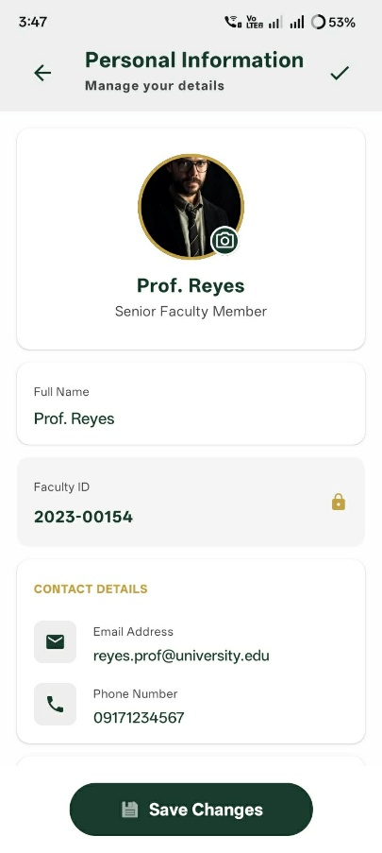  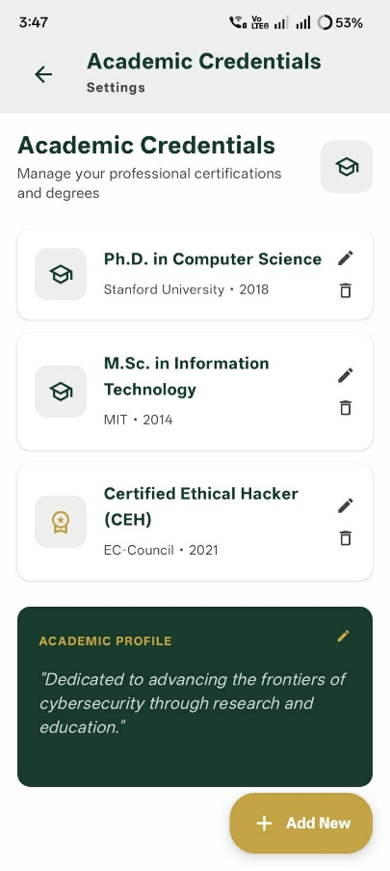  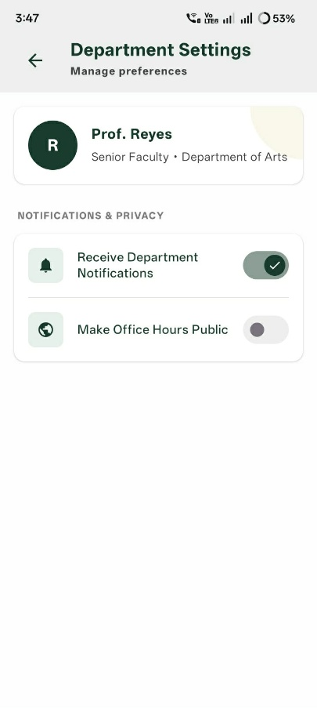  Help & Security:  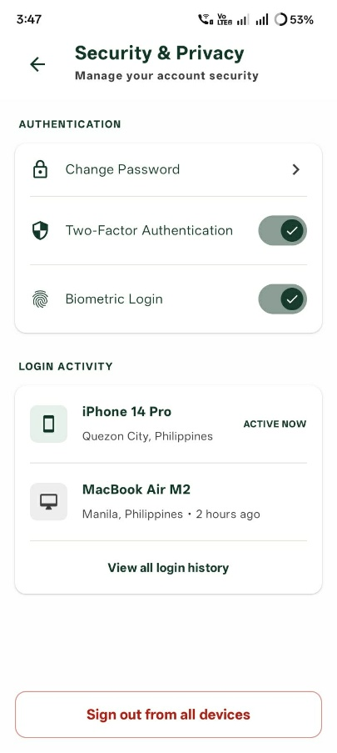  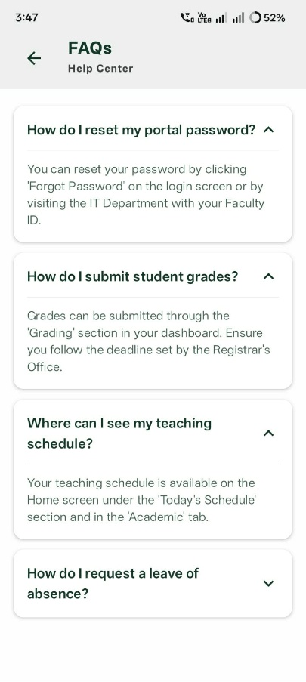 |  | Settings are all functional but have no database so all changes are not saved.
TS4 – Gestures |  |  |  |  |  | In Dashboard it is not necessary to click the button icon in the bottom to change tab because you can just swipe left or swipe right. Then scroll down and scroll up.
 |  |  |  |  |  | Quality Test by Daryl

