- What is the difference between CSV and JSON formats?
- CSV - Coma Separated Values, JSON - JavaScript Object Notation
- CSV stores data in a tabular form using rows and columns, data within rows is separated by comma ”,” and between rows by newline ”\n” whereas JSON stores data in a hierarchical structure using key–value pairs similar to dictionaries in python
- CSV Stores values as plain text which easily readable by humans whereas JSON stores data in objects like numbers, strings, arrays which is easily understandable by machines
- CSV is more suitable for simple, flat datasets whereas JSON can handle nested or structured data very easily

- Explain the importance of version control (Git) in data science projects
- Git records the complete history of all modifications made by the user which allows it to revert to earlier versions when required.
- The project can easily be collaborated with multiple team members simultaneously and work without hampering other work.
- When an user wants to test new ideas / code he can branch the existing version without altering the main project
- Git can be used as code backup and also share your work with others.

- Design a flowchart to illustrate how merge conflict issues are resolved in GitHub

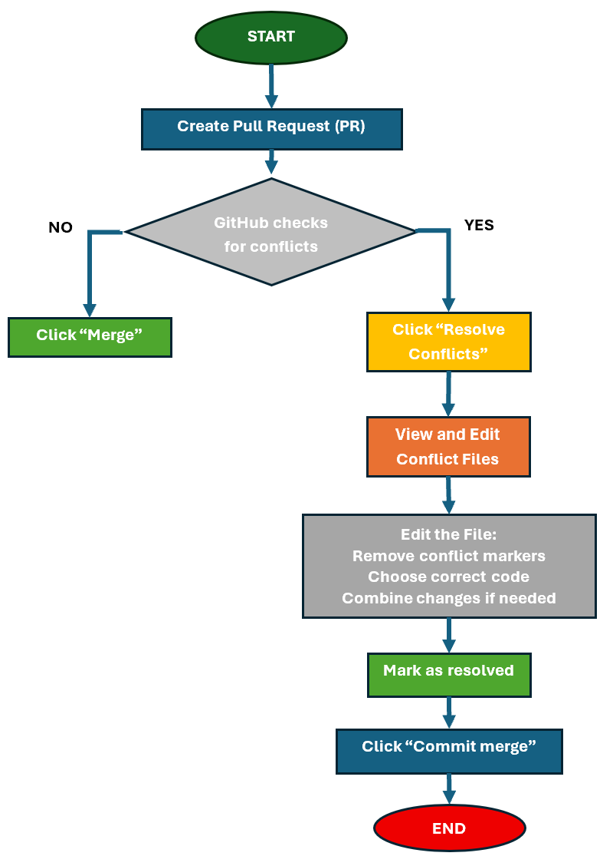
Key Steps to resolve conflict issues in GitHub:
- Create Pull Request – Compare branches and request merge.
- Conflict Detected – Happens when the same lines were edited in both branches.
- Resolve Conflicts – Manually edit and decide which changes to keep.
- Commit & Merge – Save resolved version and complete merge.

- Define imputation and name two techniques with examples.

Imputation is the process of replacing null values or missing data or wrongly collected data during data collection

Mean/median Imputation : Replace missing value with the mean of the column.
Example: If an feature ‘age’ = [20, 25, NaN, 30]
Mean(age) = 25 so we replace ‘NaN, with 25

Mode Imputation : Replace missing categorical value with most frequent value.
Example: In a "City" feature, if most entries are "bangalore," then we will NaN with "bangalore"

For time-series data:
Forward Fill : Replacing a missing value with the most recent previous observation.
Example: If a stock price is missing for Tuesday, you use Monday's price to fill the gap..

Linear Interpolation: filling the missing values by using the equation of a line.
Example: If the temperature was 20°C at 1:00 PM and 22°C at 3:00 PM, you estimate the missing 2:00 PM value as 21°C.

- What is feature engineering and why is it important?

Feature engineering is a one of the major steps in AI / ML model development because it helps to extract or create or transform the features based on the domain knowledge which helps in AI /ML models to learn the data easily.

Feature engineering iterative modifies or transforms data through techniques like

- Feature Transformation - Modifying data using mathematical operations, scaling , encoding to convert categorical features to numbers and log transformations for skewed data.
- Feature Creation: creating new features using existing features
- Feature Extraction - Reducing no of features by Principal Component Analysis (PCA)
- Feature Selection: this is the final step in feature engineering is to identify the most relevant features to build the model

Feature engineering is an important step in AI / ML model building because it helps in improving model accuracy, reduces overfitting, and improves model interpretability.

