**Part 1: Create an Account**

**Username:** cs03553n

**Part 3: GitHub**

1. **What is GitHub?**

**GitHub** – A web-based, development platform inspired by the way you work. From open source to business, you can host and review code, manage projects, and build software alongside 28 million developers.

***Source: GitHub, Inc.***

1. **When was it created?**

**Founded:** February 8, 2008

**Launched:** April 10, 2008

1. **Why?**

GitHub revolutionized the way people contributed to an open source code with its centralized, public platform. Prior, contributors would have to download the project’s source code, edit the project locally, and e-mail the patch to the project’s original owner. The owner would then determine whether or not to merge the changes.

1. **By who?**

Chris Wanstrath, PJ Hyett, & Tom Preston-Werner

1. **What similar platforms exist?**

GitLab, BitBucket, SourceForge, & LaunchPad

1. **Why would you use such a platform?**

It can serve as resume for college students searching for employment, since profiles display their contributions determining their reputation and credibility.

**Part 5: Definitions**

* **Repository** – Contains all of the projects files (including documentation), and stores each file’s revision history.
  + Classified as **public** or **private**
* **Commit / Revision** – An individual change to a file or set of files.
  + Every time a user saves a revision, it creates a unique ID (“SHA” or “Hash”) that allows the user to keep record of what changes were made when & by whom.
* **Push** – Refers to sending a user’s committed changes to a remote repository
* **Branch** – Parallel version of a repository used for isolate development without affecting the primary or master branch
* **Fork** – Personal copy of a user’s repository that lives on another user’s account
  + Allows a user to freely make changes to a project without affecting the original
* **Merge** – Takes the changes from one branch (in the same repository or from a fork), and applies them into another
* **Clone** – Copy of a repository that lives on a user’s computer instead of being on a website’s server somewhere, or the act of making that copy.
* **Pull** – Refers to when a user is fetching *in* changes *and* merging them.
* **Pull Request** – Proposed changes to a repository submitted by a user and accepted or rejected by a repository’s collaborators.

***Source: GitHub Glossary***

**Part 7: README.md**

**Steps:**

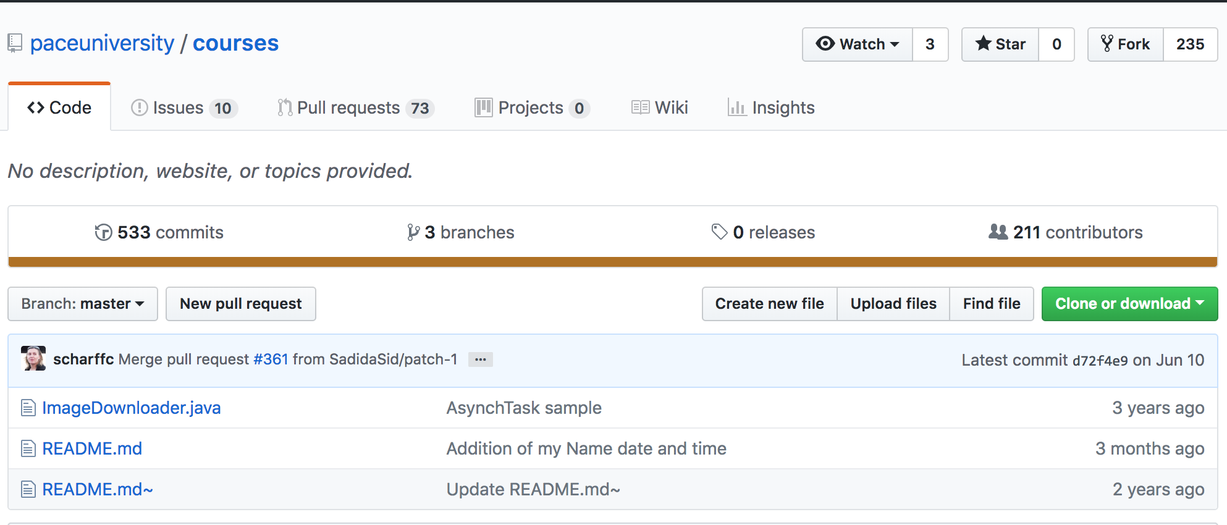

1. Open the preferred web browser and enter <https://github.com/paceuniversity/courses> into the URL & click on **README.md** to open the file.
2. 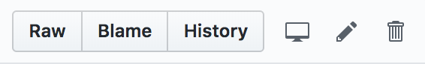Once the file is open, click on the pencil icon to edit the file in your fork of this project
3. Before the user adds his or her name, read the blue banner across the top of the screen. **Note:** *This is where the commit will be stored for the pull request.*
4. 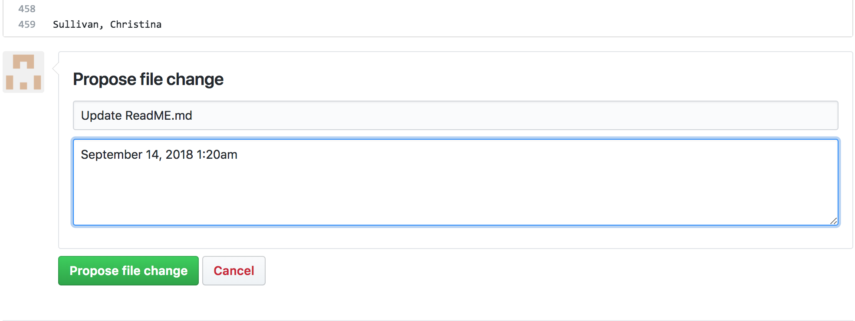Add name to the file, (Last Name, First Name), type in “***Update ReadME.md***” in the subject, & a comment (date & time). Then, click on **Propose File Change**.
5. 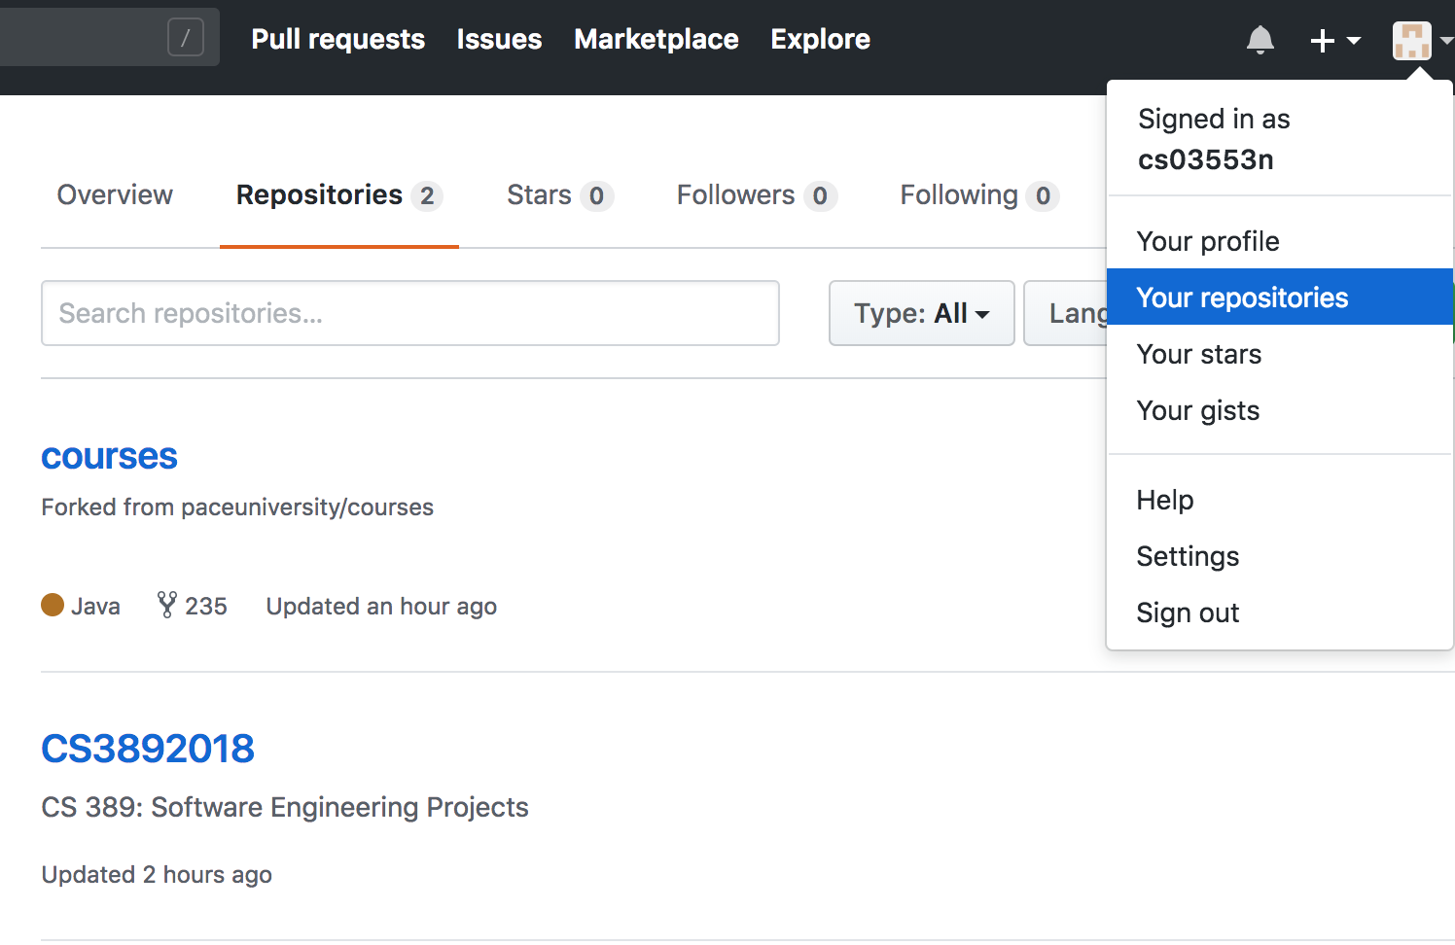Once the file change is submitted, click on ***Your Repositories*** to access the ***courses*** repository forked from ***paceuniversity/course***. Then, click on the ***courses***.
6. Once the ***courses*** repository is open, click on ***Branches*** to view commits.
7. Once you open ***Branches***, click on ***New Pull Request*** to create the pull request onto the ***paceuniversity/course repository***.
8. 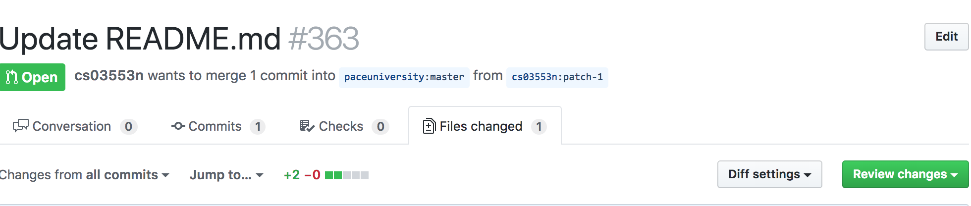Once the pull request is complete, it should populate under the poll requests in the ***paceuniversity/course*** repository & show a similar screen if the user chooses to edit it. (***Note:*** *The request should be able to merge)*