Cassandra Sommer

A5: Change Point Detection

IMSE 641

I wrote my code using the ruptures package in Python. This was a great project for me to start learning Python. I used pip install and also imported a few libraries into the code. I imported the data and turned it into an array of float types using numpy. I used the ruptures dynamic programming function to specify model, minimum distance between change points, and the number of “jumps” between points. I chose to use the l1 model option the minimum size was 1 and the jump was 1. I chose the jump to be one because it is basically like standard deviation (s) in the distance function that Sullivan’s paper mentions. The next line shows the prediction for the number of breakpoints, which I chose to be one. The next two lines display the results.

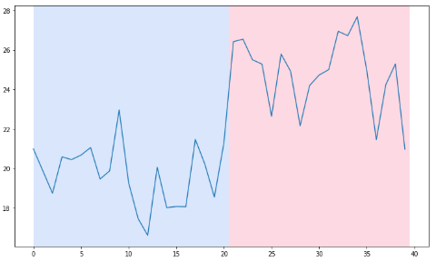

I validated this code using the Minitab macro (cp2.mac) provided. It shows a fairly similar graph, where the change point is around the time of 21. One graph shows the location and distance plotted against the time and the next graph shows the data set being graphed against time.

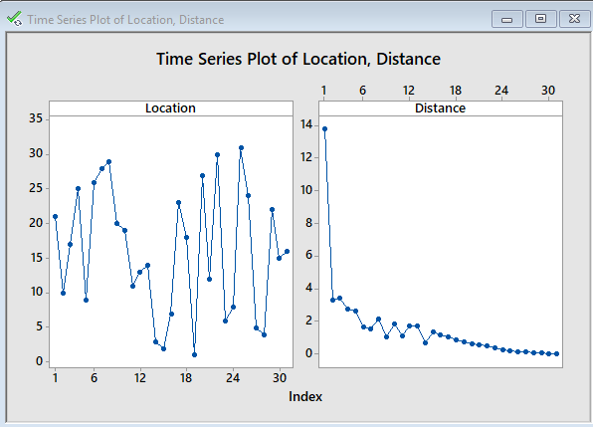

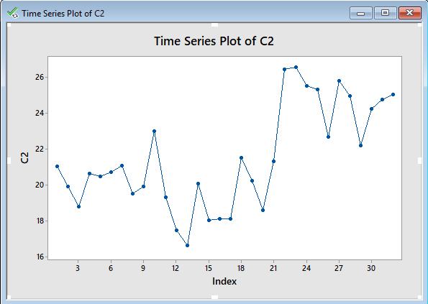

The data set given has a change point. This means the assumption of a constant mean is violated, and there is no steady state. The i.i.d assumption involves data where each sample has the same probability distribution as every other sample and all samples are mutually independent. This data would also have a uniform distribution. The examples below show i.i.d behavior vs non-i.i.d behavior. The test641data.txt was graphed and it is observed to have non-i.i.d behavior.

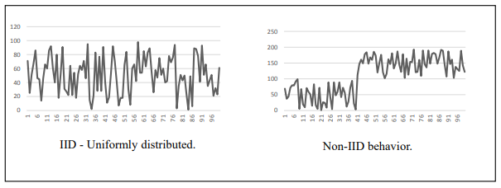

References

[1] M. S. Turan, “Random Bit Generation Workshop 2016,” in Random Bit Generation Workshop 2016, Available: <https://csrc.nist.gov/csrc/media/events/random-bit-generation-workshop-2016/documents/presentations/sessionii-3-meltem-sonmez-turan-presentation.pdf>. [Accessed:13-Mar-2020]

[2] “Welcome to ruptures,” Welcome to ruptures - ruptures documentation, 27-Feb-2020. [Online]. Available: http://ctruong.perso.math.cnrs.fr/ruptures-docs/build/html/index.html. [Accessed: 03-Mar-2020].