Homework 02 – Brick Wall & Movie work

This homework is to see how we can use broadcast to break a very hard problem up into much easier problems. After seeing other student’s movies in class you might also want to go back and add a bit to your movie.

A brick wall!
The goal is to draw a brick wall that looks like this. You are free to change how the wall looks, but we recommend you get this working first.
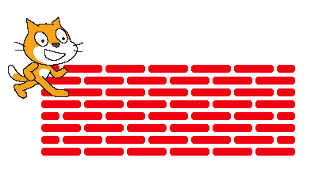
- To get started, write blocks to draw half of a brick, a block that draws a full brick and a block that uses to make a space.



- You may want to change your pen color and pen size using these pieces.


- The bottom row of the wall has all full bricks.
  - Using a repeat, try to make “row1” that creates this line of bricks


- We think that answering these questions might help you…
  - How many spaces are there in row1? _____________
  - How many bricks are there in row 1? _____________
  - How long is the entire row1 of bricks? _____________

- The second row of bricks has a half-brick at the beginning and end.
  - Use a repeat to try to make “row2” that creates this line of bricks.

- We think that answering these questions might help you…
  - How many spaces are there in row2? _____________
  - How many bricks are there in row 2? _____________
  - How many half-bricks are there in row2? _____________
  - How long is the entire row2 of bricks? __________________

- We think that answering these questions might help you…
  - We want row1 and row2 to be the same length. What can we use as the length for these:
    - Brick length ______
    - Half brick length ______
    - Space length ______

