Homework 03 –

This homework is to get more experience with ifs by modifying the programs from lab. We also want you to have some fun with keyboard input.

Rock Paper Scissors against the computer
- Modify the Rock Paper Scissors to take in input from the user. They should be able to type “Rock”, “Paper” or “Scissors” to play.
  - Do something sensible if the user types in something other than “Rock”, “Paper” or “Scissors”
- Keep score of the number of times each player has won.

Number guessing in reverse
- Make a project where the user gets to pick a random number and the computer has to guess it.
  - Have the computer ask the user to type in the maximum value.
  - Have the user type in “higher”, “lower” or “correct” to respond to the computer’s guesses.
  - Have the computer keep guessing a number until the user types in “correct”.
  - Make the computer smart so that each guess cuts the number of possible numbers in half.

Electric Keyboard

- Using what we’ve learned so far, you should be able to make an electric keyboard! Here is a little example of what you could do:
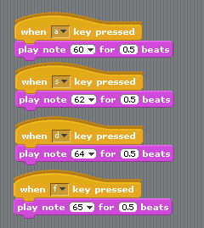

- Try turning your computer keyboard into an electric keyboard.
  - Make notes on the next page about how the piano keys relate to the computer keys.
- What your program should do:
  - Create a block so that you can control the volume with the up and own arrow keys.
  - Have at least 5 other keys that do something (you can do WAY more than this if you want)
