Lab 01 – Broadcast and Animations

Result of running the Scripts
Check out the scripts for the Cat and Duck below. When you press the green flag, each step on the left happens in order.
- In the Scripts for the Cat and Duck (below), figure out which piece corresponds to each step.
- Try to make these scripts in Scratch.
- Add to the scripts so that the cat and duck each speak once more.
- Your homework will involve extensive practice with broadcast, but play around with it till you feel pretty comfortable now.

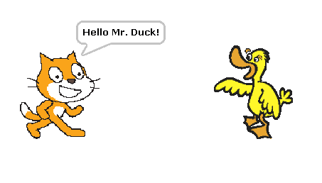
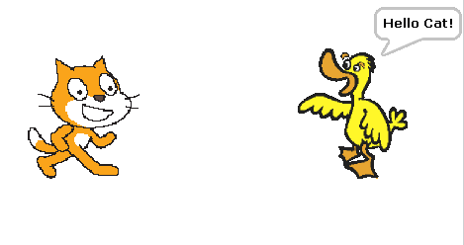
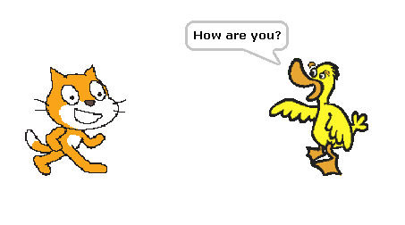
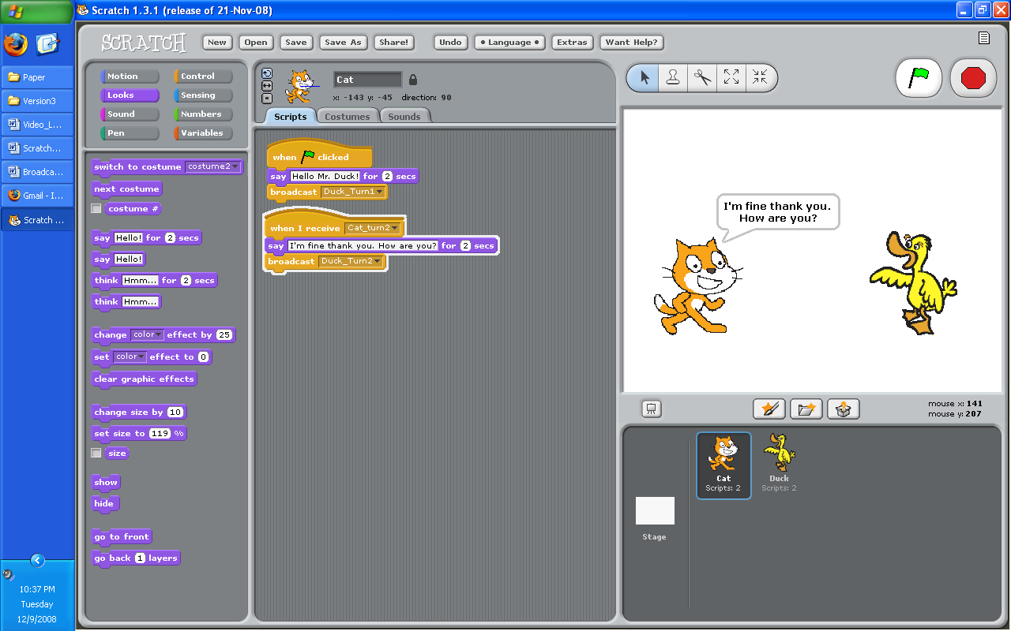
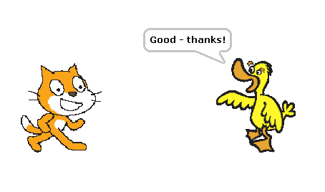

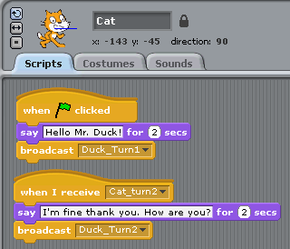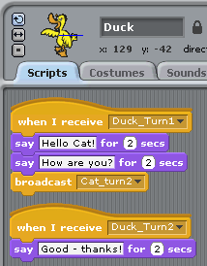
Scripts for the Cat

Scripts for the Duck

Animations!
- Open up a new sprite by clicking on the 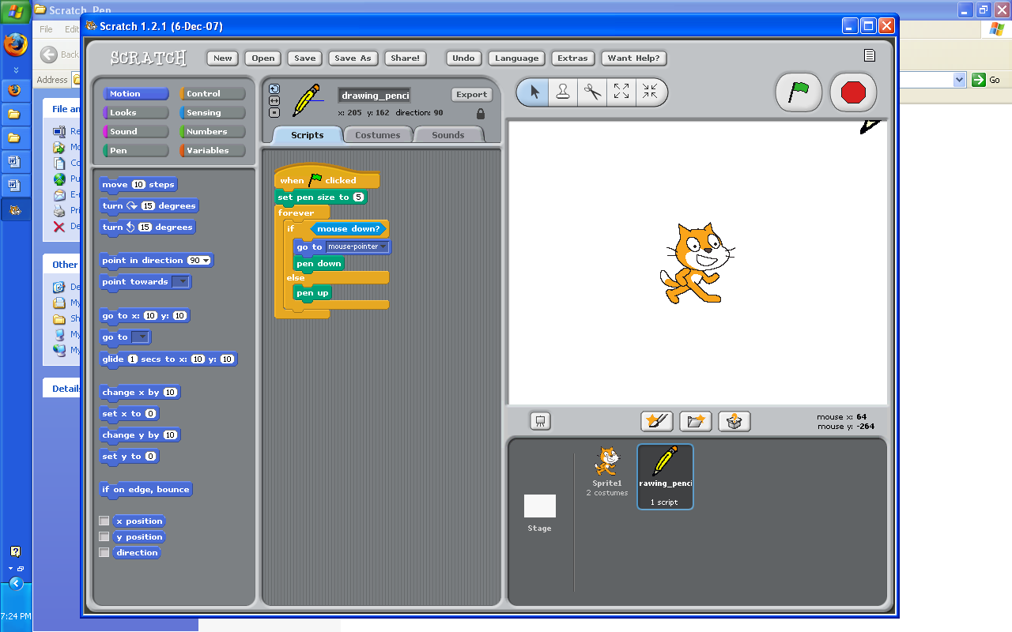 button.
- Click on the costumes tab to see the cat’s two different “costumes”.
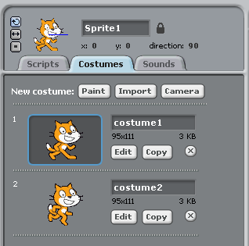

- Think about what this will do and then try it. Was it different than you expected? Why?
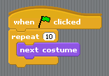
- Make the cat walk across the screen smoothly using repeat.

Introduction screen…
A lot of games start off with an intro screen that fades away when you click.
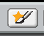
- Open a new file by clicking on the 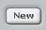 button.
- We’re going to create a sprite in a new way for this. This time, create a new sprite by clicking on this button.
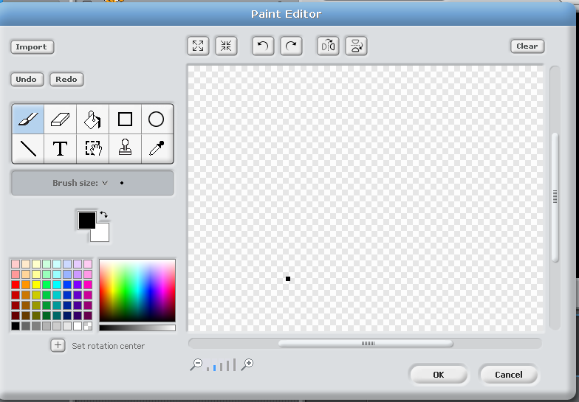
- You should see something like this

- Select a color and then click on the paint bucket icon.
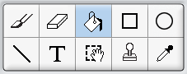
Using the paint bucket color the entire canvas the color you selected.
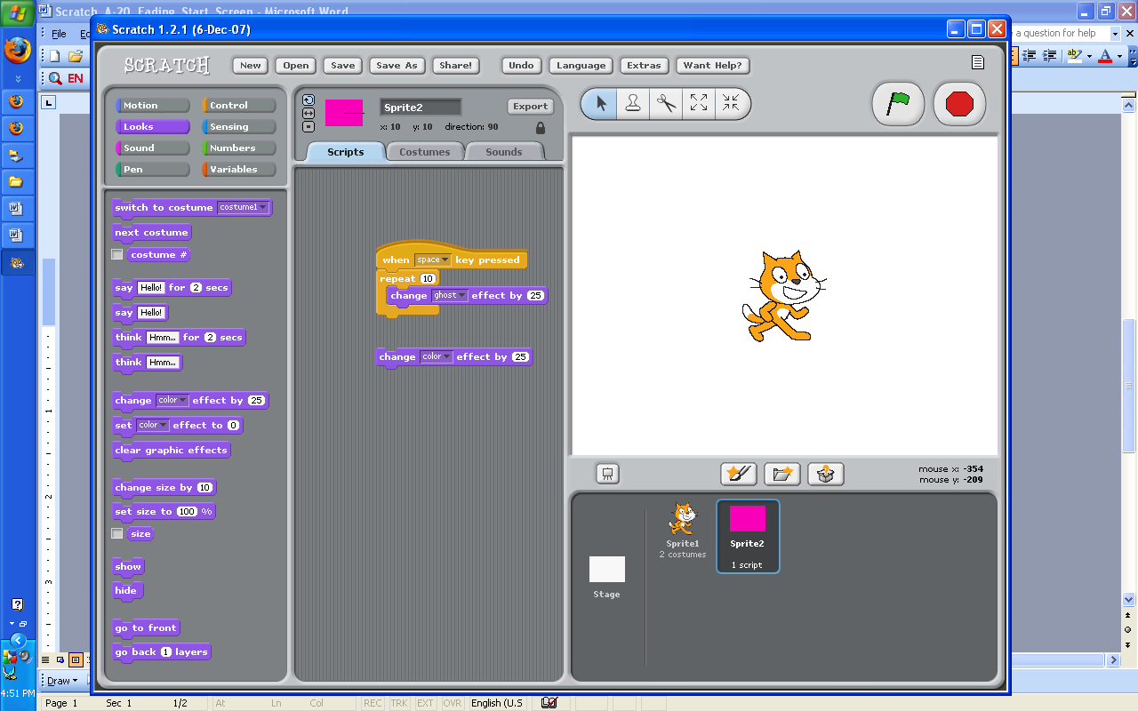
- Click Okay. There should be a big rectangle on your screen now.

- In this scripts area of this new sprite (the big rectangle) put a block like this.
  - If you have trouble finding the “change ghost effect” piece, start with the “change color” piece and click the black triangle.
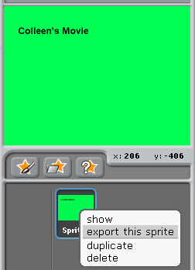

- Make the rectangle reappear when you click R.

- Export your intro screen sprite by right clicking on the sprite and selecting “export this sprite”
- Open up your story from inside your movie.
  - Click on this icon to put your new intro screen into your story.

