Lab 02 – Drawing with Variables & Broadcast

Drawing

- Try to move the cat around the screen and back using these pieces.
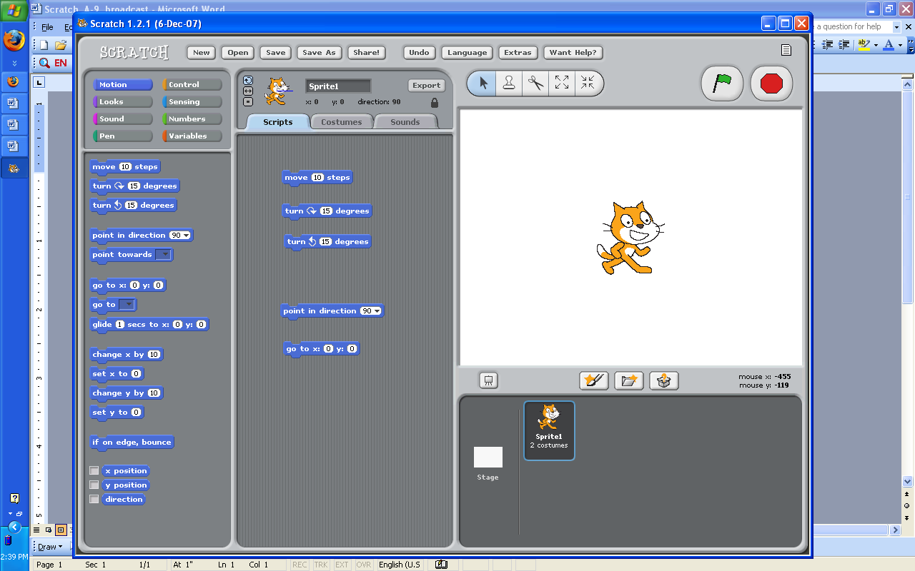

- Sometimes we want to see where the cat has moved. Try clicking on this “pen down” piece and then having the cat move in a square.
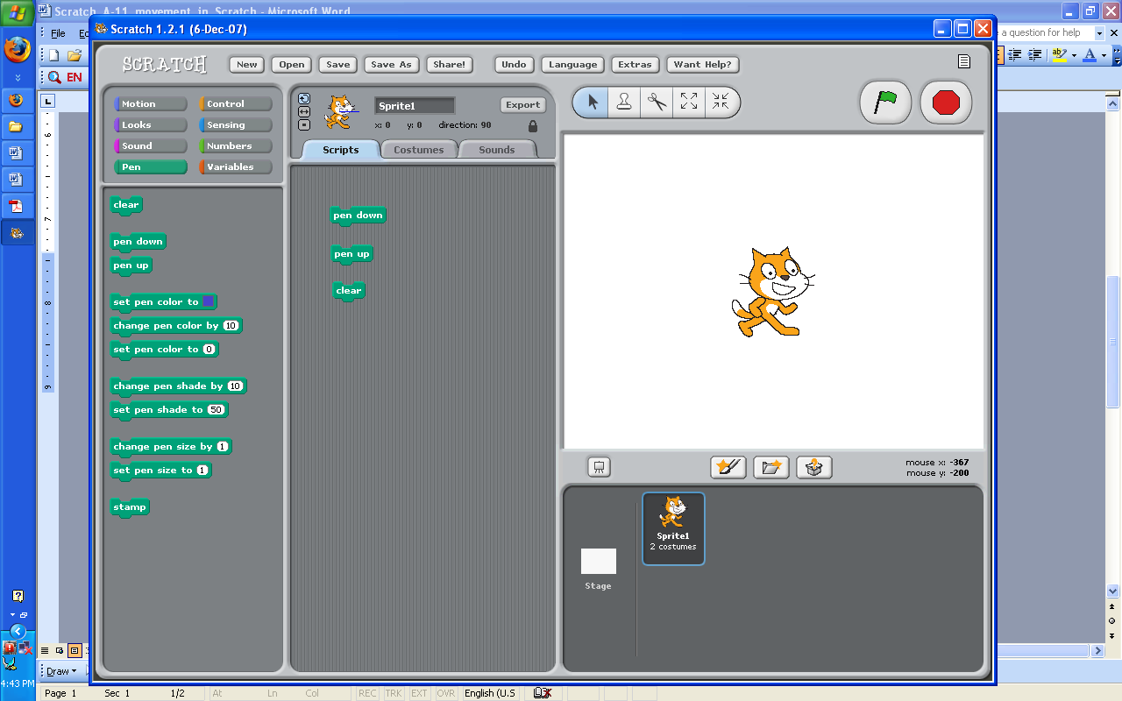

- These pieces might be helpful too! Try to figure out what they do.

- Try to draw a simple picture using only these two pieces.

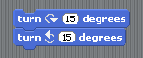
- Someone found out that you don’t see the cat move when you put these two pieces together and run them. Make sure you understand why.

- Change the turn piece above to turn 360 degrees. What happens? Why?

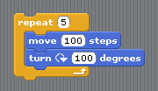
- Draw the shapes below.
  - Hint: You might want to use the repeat that we used in the animations.

- square

- star
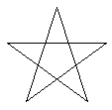
- pentagon

- triangle

Variables

- Below is the start of the song “Mary had a little lamb”. Try to recreate this song like below:
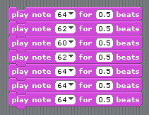

- Now if we want the notes to play for a shorter amount of time we have to change every 0.5 to 0.2.
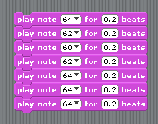

- But it doesn’t have to be this difficult. We should be able to control all of the notes by using a variable.
  - In the Variables tab – click on “Make a variable”

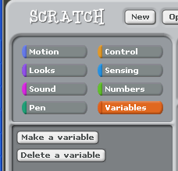

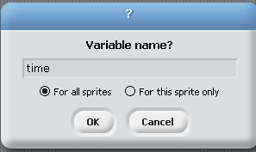

- Name your variable “time”:

- When you click “OK” you should see a new variable:
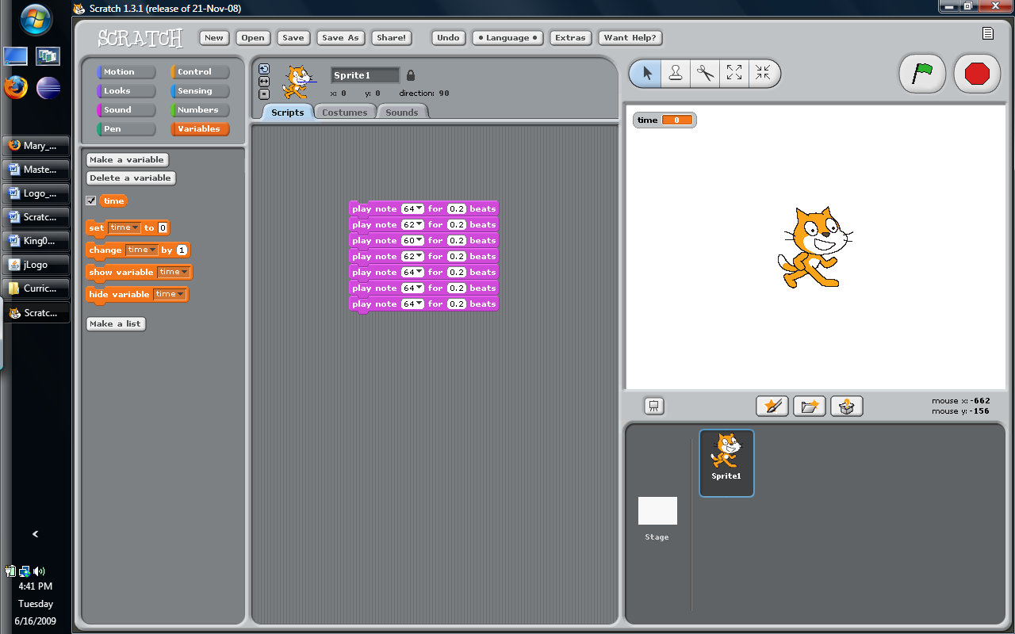

- Now instead of typing 0.5 or 0.2 in our song, we can use the variable.
  - Drag the piece into the spots like below
  - Put 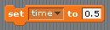 on top of your song. Remember to type 0.5 for the new value of .
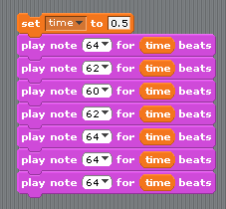

- Now try changing how fast the song plays a few times, you should only have to change the value in the first block:

Drawing with Variables

- Now try using variables in your drawings. Try to draw the square-spiral (squiral) below.
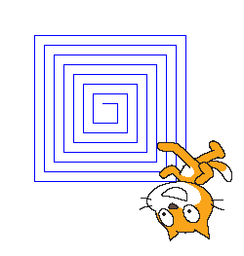
- Go back to the shapes that you drew and allow the length of each side to be controlled by a variable.


Using Broadcast in Drawing

- Click on the black triangle and click “new”. Then type “draw-square” to name your message.

- Now we can use these two pieces in our blocks

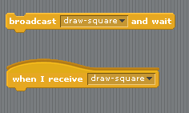
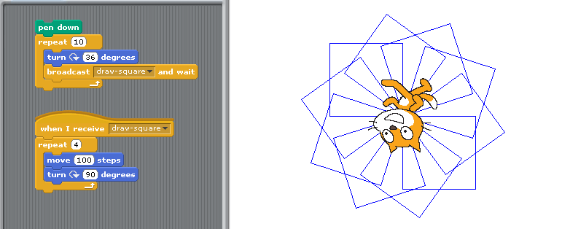
- Here is an example of what we can draw when we draw multiple squares. Before you look at the code, try to count the squares.

- Without the “Broadcast and wait” piece we would have had to put the block for the square right inside the other block.
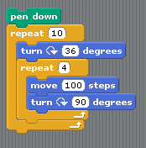

- Try the version on the left and then see what other pictures you can draw using these pieces.
- Make a new shape and see what happens when you use that instead of draw-square in your design.

