Homework 02 – Brick Wall & Movie work

This homework is to see how we can use broadcast to break a very hard problem up into much easier problems. This homework will also help you get more experience with ifs by modifying the programs from lab.

A brick wall!
The goal is to draw a brick wall that looks like this. You are free to change how the wall looks, but we recommend you get this working first.
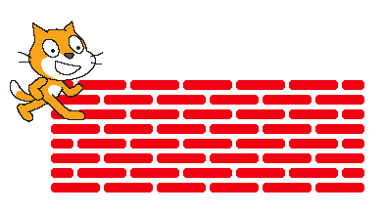
- To get started, write blocks to draw half of a brick, a block that draws a full brick and a block that uses to make a space.



- You may want to change your pen color and pen size using these pieces.

- The bottom row of the wall has all full bricks.
  - Using a repeat, try to make “row1” that creates this line of bricks

- We think that answering these questions might help you…
  - How many spaces are there in row1? _____________
  - How many bricks are there in row 1? _____________
  - How long is the entire row1 of bricks? _____________

- The second row of bricks has a half-brick at the beginning and end.
  - Use a repeat to try to make “row2” that creates this line of bricks.

- We think that answering these questions might help you…
  - How many spaces are there in row2? _____________
  - How many bricks are there in row 2? _____________
  - How many half-bricks are there in row2? _____________
  - How long is the entire row2 of bricks? __________________

- We think that answering these questions might help you…
  - We want row1 and row2 to be the same length. What can we use as the length for these:
    - Brick length ______
    - Half brick length ______
    - Space length ______

Rock Paper Scissors against the computer
- Modify the Rock Paper Scissors to take in input from the user. They should be able to type “Rock”, “Paper” or “Scissors” to play.
  - Do something sensible if the user types in something other than “Rock”, “Paper” or “Scissors”
- Keep score of the number of times each player has won.

Number guessing in reverse
- Make a project where the user gets to pick a random number and the computer has to guess it.
  - Have the computer ask the user to type in the maximum value.
  - Have the user type in “higher”, “lower” or “correct” to respond to the computer’s guesses.
  - Have the computer keep guessing a number until the user types in “correct”.
  - Make the computer smart so that each guess cuts the number of possible numbers in half.

