Homework 03 – High Scores!

This homework is to get practice with using multiple lists. In it we will use lists to keep track of high scores in a game.

Un-named High Scores

We’ll start with a high-score list that just keeps track of overall high scores as numbers without recording the name of the player.

- First we’ll need a way to generate scores. Make a variable called “new-score” and a button to add that new score to your high-scores list. You don’t need to worry about the ordering yet – just get the button set-up.
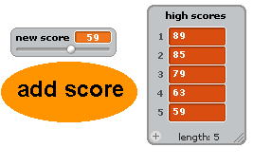

- First, remove everything from the list. Now modify the button’s script so that when you insert the new score it always put it in the correct location in the list.
- Make a tester that generates random values for the variable “new score” and adds them to the list high-scores.
- Typically we don’t just save EVERY high score. We want a high score list that only has a maximum number of elements. Make a variable “max” that keeps track of the maximum number of high scores that you should maintain. The high score list may have fewer high scores than this, but make sure that it never has more scores than “max”.

Named High Scores
- Now we want to associate high scores with the name of a person. When the player clicks the “add score” button have the button ask for their name. Then add their name and high score at the same position in the “names” and “high scores” lists. For example, below the new high score of 59 is associated with the name “Colleen”.
  - Note – In the upcoming weeks we’ll have good ways to store the names and scores in a single list!
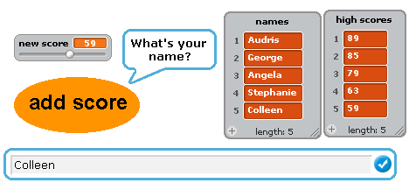

Using High Scores
- Add your high scores functionality to another game you have created.
  - Note – when you export a sprite it will save the code but it will not take a copy of the variables and lists used in the project. To add it to the new project you will need to make new variables and lists and then replace the broken references to the old variables in the code.
  - Even though it is a pain to recreate the code – we highly recommend that you experiment with getting new features to work in their own project.

A little brainstorming
- In a few weeks were going to start working on our mid semester project. You might want to spend a little bit of time on the Scratch website or talking to a potential partner about your ideas for the project. There is nothing to turn in for this part of the homework.

