Lab 02 – Random, If & Input

Rock - Paper - Scissors! 1
Saying Hello and Guessing a Number… 2
Using the keyboard to control the cat 3
A Flying Helicopter 4
Check-off (4 points) 5

Rock - Paper - Scissors!
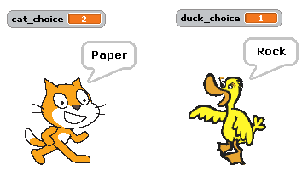
- We want to have the duck and the cat play Rock-Paper-Scissors!
- The cat and duck can pick a number 1 through 3.
  - If the cat or duck picks 1, it should say “Rock”
  - If the cat or duck picks 2, it should say “Paper”
  - If the cat or duck picks 3, it should say “Scissors”
- Fill out the table below:
 | Cat says: |  | Duck says: | Who WINS?
1 |  | 1
1 |  | 2
1 |  | 3
2 |  | 1
2 |  | 2
2 |  | 3
3 |  | 1
3 |  | 2
3 |  | 3
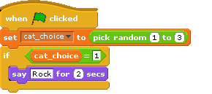
- Make the cat and the duck pick DIFFERENT random numbers and say either “Rock”, “Paper” or “Scissors” based upon the rules above. The block to the right might help you get started.

- Now have the cat announce who wins after they both say what they picked. The block below might help you get started!
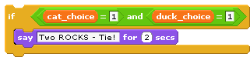
- Can you use fewer ifs? How many did you use before? _______ after? _____

Saying Hello and Guessing a Number…
- Try to make the block below:
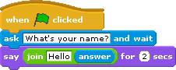
- Now that you’ve used the “ask” and “answer” pieces, let’s play a guessing game. Here is a start:
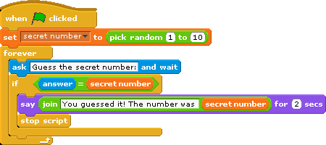

You should add:
- The cat should welcome the player and ask for their name before beginning.

- If they guess incorrectly, the cat should tell them “Sorry, that is not the right answer” before asking them to guess again.

- If they guess incorrectly, the cat should tell them if the secret number is bigger or smaller than the number that they guessed.

- Right now the cat always picks a number between 1 and 10. Change that to be between 1 and a variable named “maximum”.

- Ask the player what they want to be the maximum number before choosing a random number. Use that maximum number as the highest number that the cat will chose.

- Keep track of how many guesses it takes before they guess the right number.

- When the player guesses the secret number, tell them how many guesses it took them and congratulate them using their name.

Using the keyboard to control the cat

- Try out the piece “point in direction” shown below. Double click on it to see what each of the directions does.
(90) right
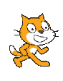
(-90) left
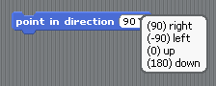
(-90) left
(180 down)

- Now find the piece “When space key pressed” and click on the black triangle to select “up arrow”.

- Make the block below. When you press the up arrow it should face the cat up and move forward 10 spaces.
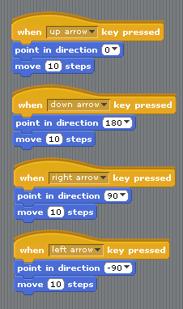

- If we want all of the arrow keys to move the cat around we could do something like this.

- Add another block so that when you press the “H” key he goes back to the center of the screen.

A Flying Helicopter
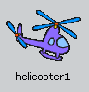
- Open up a new sprite by clicking on the 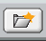 button.
- In the “transportation” folder double click on the helicopter1
- Fly up and down.
  - When you press the up arrow make the helicopter move up
  - When you press the down arrow make the helicopter move down
- Fly left and right.
  - When you press the left arrow make the helicopter move left
  - When you press the right arrow make the helicopter move right
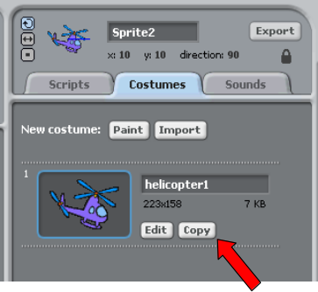
- The helicopter might look a little funny flying left while it faces right. You could turn the helicopter but that would make it be upside down.
  - Try to figure out what each of these three buttons do to the left of the helicopter

- Whenever the up arrow is not pressed, the helicopter should float down like it is being pulled down by gravity.

Check-off (4 points)
- Show your rock paper scissors code
- Show your number guesser game
- Explain how the variable “answer” changes throughout the number guesser game.
- Show your helicopter, controlled by the keyboard and simplistic gravity.

