Lab 03 – Lists

A List of Players 1
Using Loop Variables 2
Check-off (4 points) 3

A List of Players

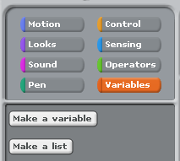
We’ve made a few games that ask the player for their name. We want to remember who has played the game so that we can greet them appropriately.

- First we need to make a list. Click on the button “Make a list” and name the list “players”.

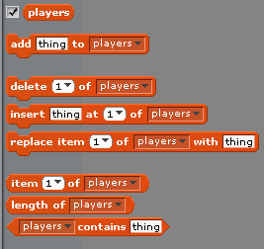
- Now that we have the “players” list we can do a lot of different things! Try these out to see what they do!

- EXPERIMENT!!!! Try to figure out the answer to these questions:
  - When you add something to the list, at what index does it appear?
  - When you insert something at an index, what happens to the thing there before?
  - What types of things can you put into a list? What happens if you put 3 < 2 into the players list? Or 2 < 3?

  - Does captialization matter when using the block “contains” shown below?

  - What happens when you try to get item 1 of an empty list?

  - What happens when you try to insert something at a non-existant location in the list? For example what happens if you insert thing at 19 of the player list and there are only 2 elements?

- Make a script that you can use to remove all of the elements from the “players” list.

- Make a list called “Numbers” and build a script that adds the numbers 1-100 to the “Numbers” list.
- Now that we know more about how lists work, try to make something like this to greet your players more appropriately. We also added a way to exit the loop. If the user types “exit” the loop will end.
  - There is a bug in this code. Try the code and then fix the bug.
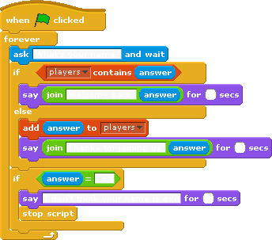
- Try to add this to your number guessing program.

Using Loop Variables

- We made code below to have the cat read the names from the player list. We had to use an extra variable “index” to keep track of where we are in the list.
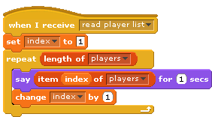
- Instead have the cat say everyone’s name at one time like is shown below.
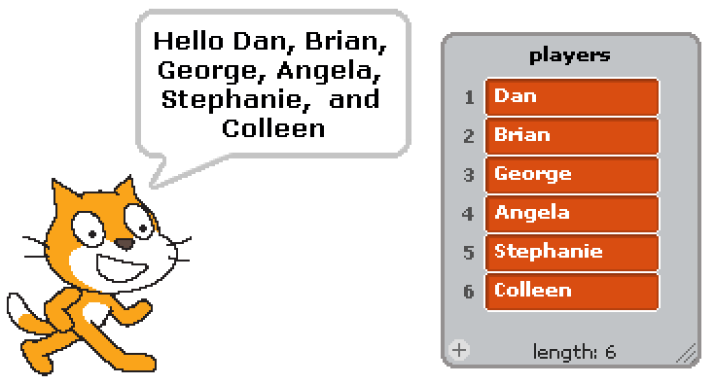

- Now have the cat say everyone’s name in reverse order. You should try this saying the names one at a time, and saying the names all at once.

- Remove any name from the players list if it is “Colleen”. In our current version of the program, each name is in the list once, however, try to make yours code remove “Colleen” regardless of how many times it appears in the list

- There are a lot of games where the players rotate whose turn it is. In this activity you will make a “Turn Reminder” that you can use in any old or new games that you write. When the flag is clicked pick a random person to start. Each time you click on the cat it should tell you who should go next, starting with the random person that was chosen. You should be able to click on the cat as many times as you want so that each player can have multiple turns.
  - This piece might be helpful. Right click on it in Scratch to see the help menu.
- In games like UNO you can reverse the direction of play. When you press R have the direction of play reverse.

Check-off (4 points)
- Explain your answers to the questions under the EXPERIMENT lab activity.
- Explain the bug in the player greeting code and show your working version.
- Show your program that says everyone’s name from the “players” list at once.
- Show your program to keep track of whose turn it is, including reverse.

