Lab 05b – More Functions!

Tic-Tac-Toe with BYOB (is AWESOME)
- Open up the example tic tac toe program in the BYOB (Build Your Own Block) version of Scratch: http://inst.eecs.berkeley.edu/~cs39n/fa09/hw/04/
  - We want to modify the script that changes whose turn it is and calculates if someone has won.
- We want to make all of the new blocks that are below.
  - Make a command block called “change player” to change the variable “Player” based upon whether X or O goes next.
  - Make a reporter block to calculate the value total, which is the sum of all of the positions for the next set of possible winning moves.
  - Follow the directions below to make the Boolean block “X wins?” and “O wins”

OLD NEW
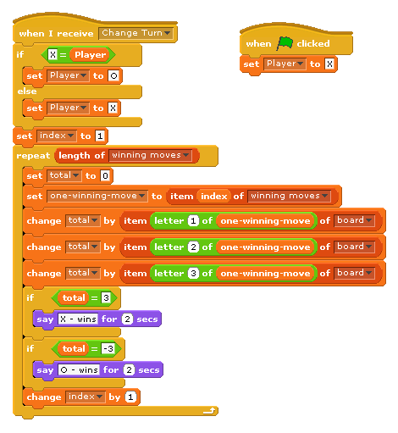
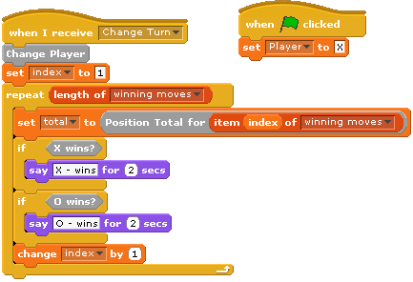

  - To make the Boolean block “X wins?” we click on “Make a Block” and select “Boolean”. A Boolean block returns a value just like a reporter block. However instead of returning a number or a word, it will report a true or a false.
  - The actual script to put in the block editor for “X wins” is pretty short. We just want to return true if total is equal to 3 and false otherwise.
