Lab 06 – More Functions!

Getting the First Word
- Open up the BYOB (Build Your Own Block) version of Scratch.
- We want to ask people their name and then say only their FIRST name. To do this we wrote a block “first of” that reports the first word in a sentence, assuming that spaces separate words. The example to the right shows that it should work for any kind of sentence.
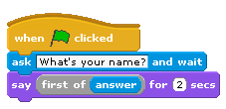
User types: | First of Reports:
Kate Greenwood | Kate
Hugh Oh | Hugh
How are you? | How

- Before you look at the completed version of “first of” below. Try to brainstorm how you would do it yourself.
  - What block variables would you need?
- Below is an example of how you could create a new “reporter” block to give the first word in a sentence.
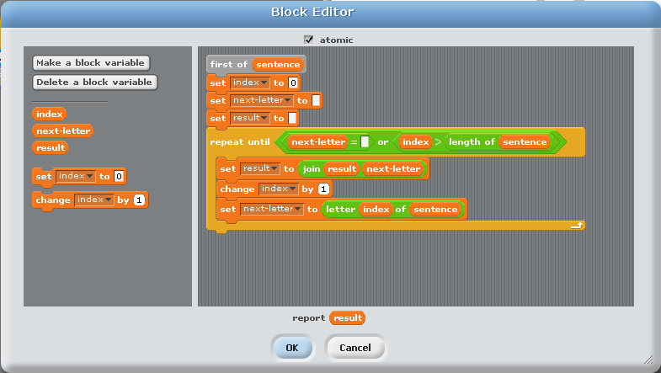
These two are blanks
This is a space!
Which word? You choose!

- Make a new reporter block that reports everything EXCEPT the first word of the sentence (later in the worksheet we refer to this as “everything but first”)
- Make a new reporter block that reports the 3rd to last word of the sentence using only “first of” and “everything but first” that you made above.
- We want to make a program that can answer questions like:

 | QUESTION | ANSWER
#1 | “Am I _________?” | “You are _________.”
 | ↑starts “Am I” and ends with a “?” | ↑ replace the “Am I” with “You are”  replace the “?” with “.”
#2 | “Are you _________?” | “I am _________.”
 | ↑starts “Are you”  ends with a “?” | ↑ replace the “are you” with “I am”  replace the “?” with “.”
#3 | “some-word I _________?” | “You some-word _________.”
 | ↑the second word is “I”,  the first word was not “Am” and  ends with a “?” | ↑remove the second word,  add “You” to the front,  replace the “?” with “.”
#4 | “some-word you _________?” | “I some-word _________.”
 | ↑the second word is “you”,  the first word was not “Are” and  ends with a “?” | ↑remove the second word,  add “I” to the front,  replace the “?” with “.”

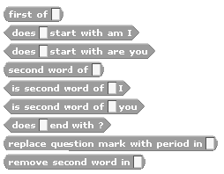
Below are blocks that we recommend you try to make. This is a great example of abstraction! This problem is REALLY hard, but if you have a better set of tools to work with (like the blocks below) it can become easier to solve!
From Lab
Boolean for question type 1
Boolean for question type 2
For the Boolean blocks below
Boolean for question type 3
Boolean for question type 4
Boolean for ALL question types
Reporter for ALL question types
Reporter for question types 3 and 4

- Once you’ve made the new blocks above, try to combine them into one new block “answer to the question” that takes whatever the user types and creates an appropriate answer. For example, the script below should continue to ask and answer questions that the user types in.
  - Note: If the user doesn’t type in a question that matches one of the formats above, just replace the “?” with a “.”.
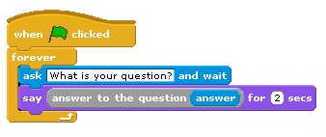
Extras (for fun or practice)

Extra Practice
- Make a reporter block that reports the number of words in a sentence.
- Make a new reporter block that reports the “Last word of” a sentence.
- Find places in your previous homework or lab where using BYOB would have made things a lot easier and modify them appropriately.

Extra Difficult
- Make a new reporter block called “get ___ index” that takes in one argument, the “index”, and returns that index word in the sentence.
- Make a new Boolean block that reports whether a sentence that the user types in contains the word “please”.
  - If the user types in something that doesn’t include the word “please” have the character say “What do you say?”.
  - If the user types in something that DOES include the word “please” have the character say “Okay”.

Extra Creative
- Use the BYOB to make something beautiful (you might use some of the stuff from lab and homework in the fifth week).
- Modify the AI program from this homework to handle more complicated sentences or to be more interactive somehow.

Extra Helpful - High Score List in BYOB

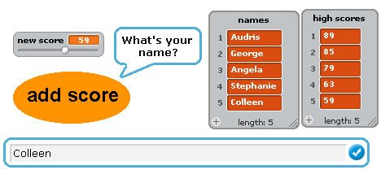
In Homework 3 we had to use TWO lists to associate the player names and their scores. This was pretty inconvenient because we had to do everything twice; once to the list with the names and once to the list with the high scores. The next set of activities will help you build a high score list with only one list.
We Had:

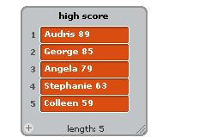
We Want:


- First make a new list called “high scores”.
- You should already have written blocks like the following →
- The things that will go in the list will be both names AND scores. So the “first of” the entry will be the name and the “everything but first of” will be the score. To make this less complicated we’re going to make a reporter block called “name at index” and “score at index” so that we can take in an argument specifying the index number and report the name or score, respectively.
  - “name at index” is shown below
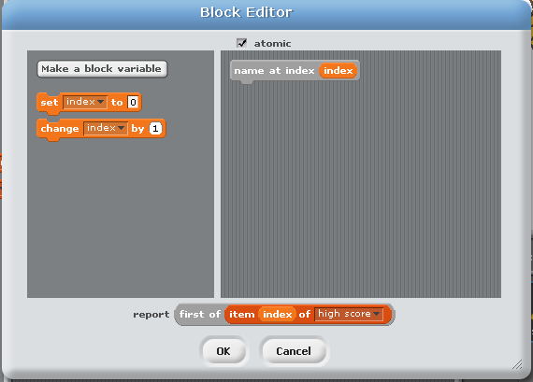

  - Before continuing, create the new block “score at index”

- You may remember that it was a bit of a pain to insert new scores into the high score list. We can now make a block that adds high scores to the new – 1 high score list. As part of the check-off for today’s lab you will need to explain the following code to a member of course staff.
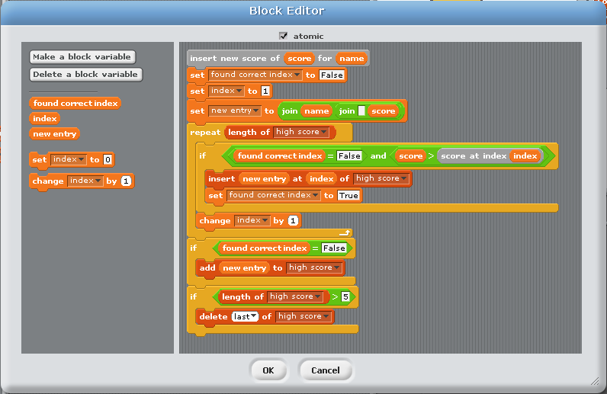

- Now use the “insert new score of” block to be able to add new high scores that you type in.
