Lab 10 - Recursion

Squiral (Square + Spiral) 1
More Recursive Geometry 1
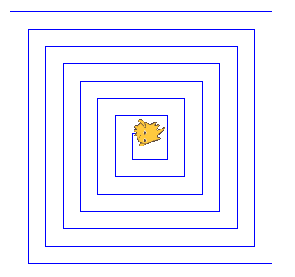
Squiral (Square + Spiral)
- Draw the following diagram of a squiral (square + spiral) once using repeat and once using recursion. You should be able to control the number of levels, where each level draws one line. The character should always end in the center of the squiral.

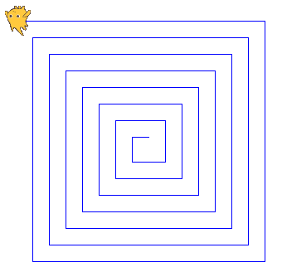
- Now, draw the same shape but have the character start at the center of the squiral and finish on the outside. Can you do it with both repeat and recursion? Talk to a member of course staff about your answer.

More Recursive Geometry
- Try to do a few of these as practice
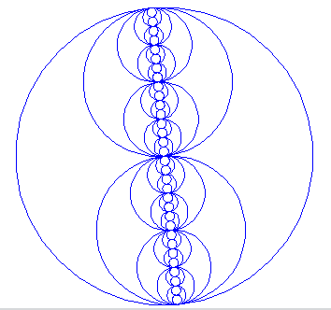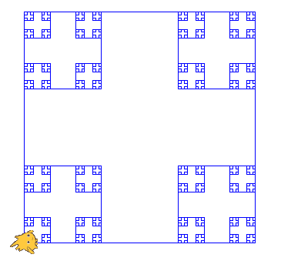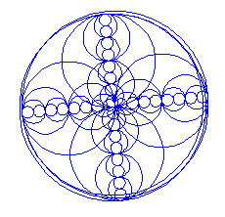

- For homework design your own recursive picture and create it using Scratch!

