Music Media Production Program

MMP305 Midterm Whitepaper
Presented in class
2024 November 11 Muncie, IN USA

Feedback Loop Stability in Modular Synthesizer Chains
ABSTRACT
Feedback loop stability is a multifaceted challenge that offers significant potential for innovative solutions and experimental exploration within Reaktor. Feedback loops are common in modular synth design, but they can easily lead to instability or harsh, unintended sounds. We present solutions to mitigate instability arising from the complex interplay between feedback stability and the inherent risks intrinsic to modular design.

Introduction
In modular synthesizer design, feedback loops play a crucial role in shaping complex, evolving sounds. By routing an audio signal from a module back into itself or another module, feedback loops create intricate textures, harmonics, and modulation effects. feedback inherently creates a risk of signal escalation, which can quickly spiral out of control, resulting in distortion, unpleasant spikes, or even damaging output levels. Some specific problems faced with feedback stability is risk of runaway signal amplification, avoiding distortion and harsh artifacts, preserving tonal quality, etc.

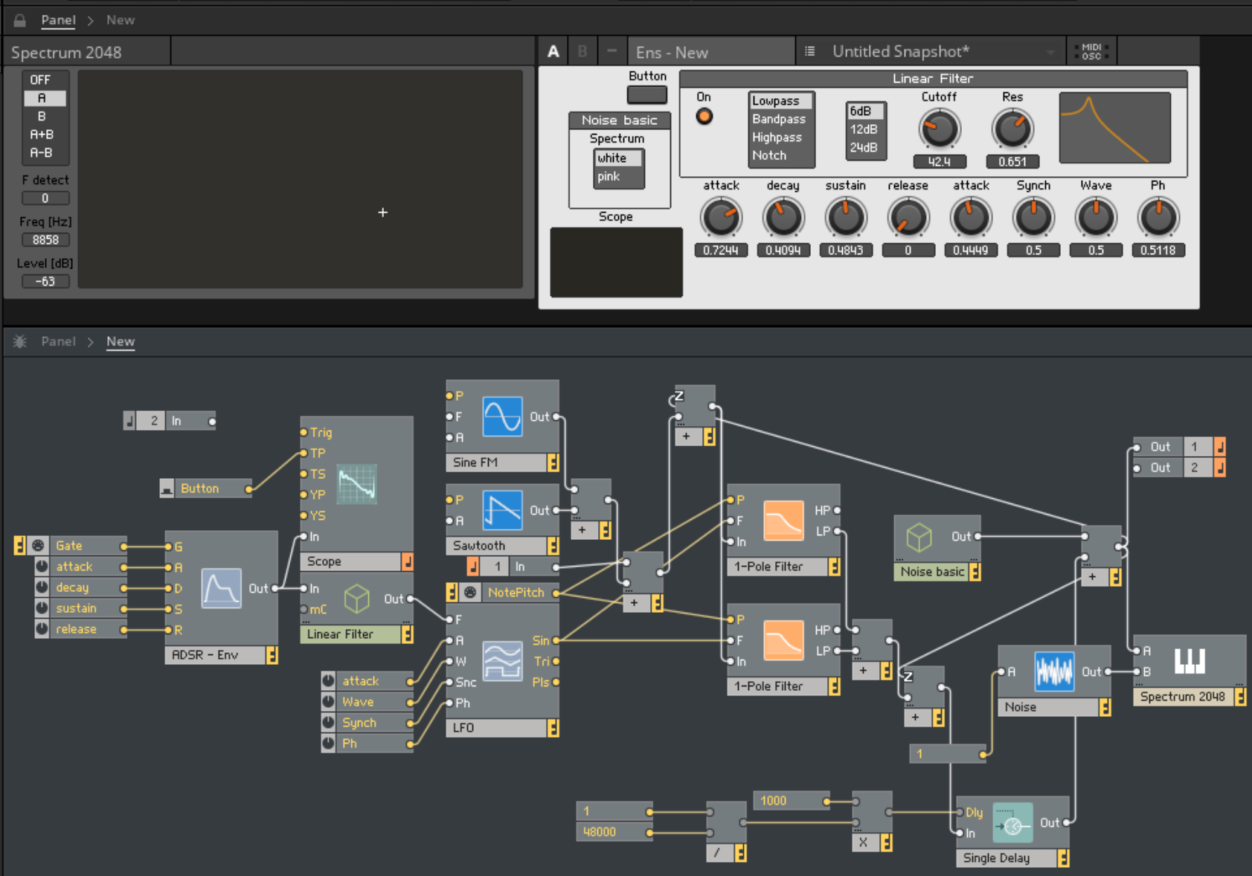
Figure 1. Figure caption.

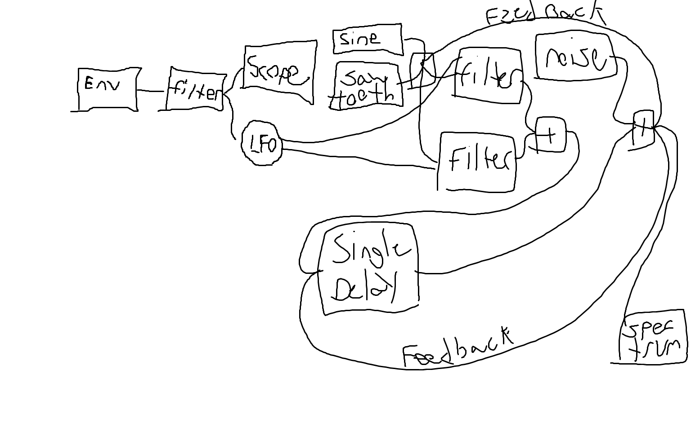
Figure 2. Flow Chart

Body
The feedback stability loop dynamically monitors and controls feedback levels to prevent runaway amplification and ensure sound quality remains intact. I used prior notes to make sure I have used filters and delays correctly without setting the values too far out of bounds. The system features a modular synth chain with oscillators, filters, and effects like delay and reverb, each contributing to rich, evolving sounds while adding complexity to the feedback path. To stabilize this setup, the loop employs a dynamic gain control module that actively reduces feedback gain when levels approach instability, preventing harsh distortion or clipping. Additionally, a user-controlled interface allows adjustments to sensitivity and feedback thresholds, letting users explore varying levels of feedback intensity with stability intact. Together, these components ensure that the feedback loop enhances creative sound textures without compromising audio fidelity or control.

Conclusions
Things that were easy with this was looping back through to the filters and delays to cause the instability issues. The hard part was trying to fix these issues and have a proper sound come out. In the future I would like to show more options to the user such as gain and frequency knobs. Unsolved issues would be the fact my sound isn’t perfect and the looping is causing a value outside of my graph.

