

Micah Lyle | CS 160 | February 5, 2016

CalorieConverter

AN android application

# Instructional Video

See this link:

# Github Repository

Navigate to this link:

# Example App Usage

Welcome to the CalorieConverter application. This is a simple app that allows the user to input an activity, the amount of time spent doing the activity or number of reps completed, and then automatically calculates the calories burned. Additionally, the app can give equivalent amounts of “exercise” between two different activities the user is able to select.

Consider the initial screenshot on the next page:

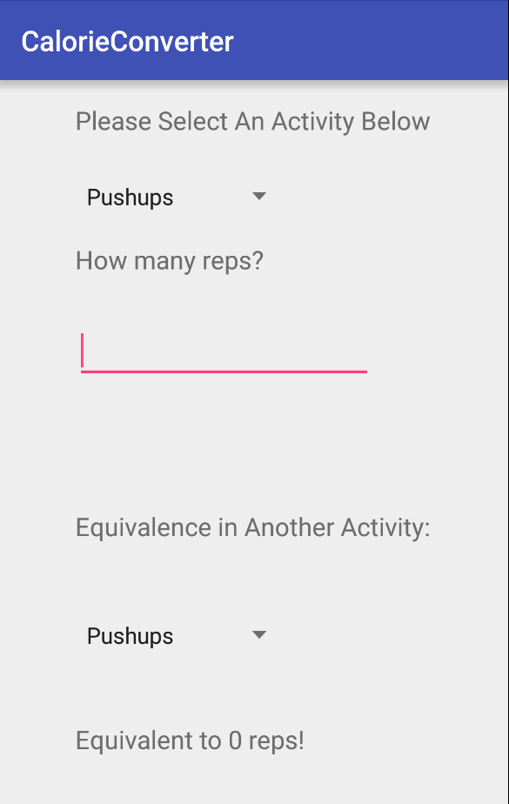

The user is first confronted with the activity to select. Pushups is initially selected, but dropping down (see next image below), there are many different options for exercise activities that the user can select, with the ability to scroll down to the bottom of the list, which is stair climbing.

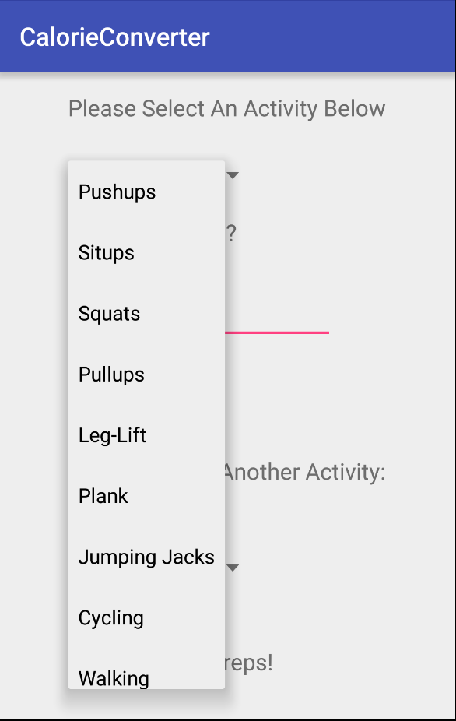

Once the user has selected the desired activity, the next step is to enter the amount of the activity done. In the example below, the user, after selecting walking as the activity from the top selector, inputs 120 minutes as the number of minutes spent walking (a nice 2 hour walk).

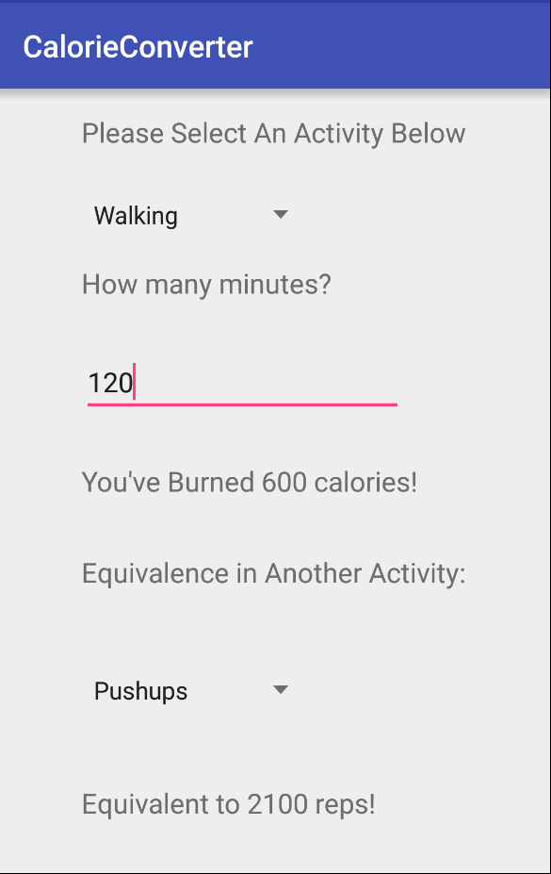

Viola! Underneath the 120 that was entered pops out the result: “You’ve burned 600 calories.” Notice that the moment the user edits the amount of minutes/reps completed in an activity, the calories are immediately updated below.

Now, in the example of our current user, say he/she wants to know how to burn an equivalent amount of calories doing another activity, such as swimming. By selecting the bottom drop down menu and picking swimming, the result will be immediately displayed at the very bottom (see picture below).

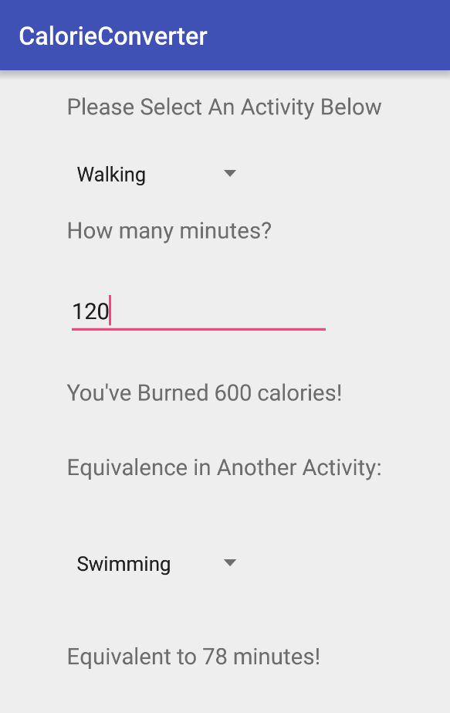

So we see that a two hour walk is approximately equivalent to a one hour and 18 minute swim. Now, the user can change any one of the fields (top activity field, middle amount of activity field, or bottom activity field), and all the relevant numbers on the screen will update automatically. For example, changing the minutes field from 120 to 180 in our example immediately updates the swimming conversion factor to 117 minutes (see below).

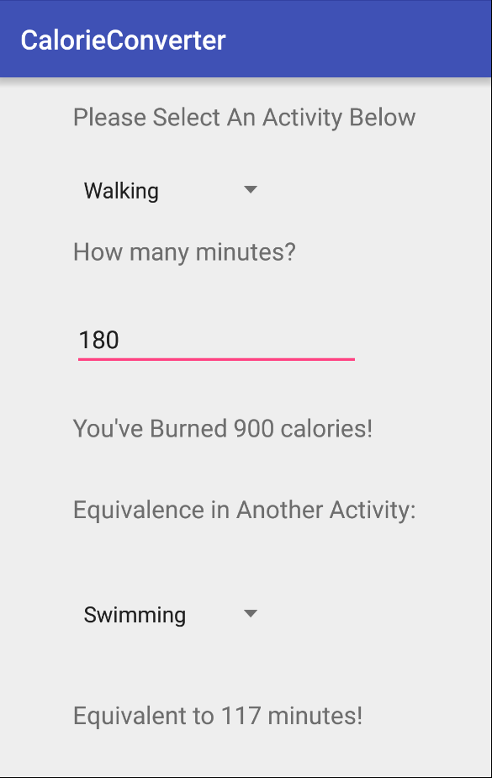

Now suppose that user decides they want to look at the calories burnt by doing 200 situps and then find out how many pull ups are equivalent to those 200 sit ups. He/She can change the top activity field to sit ups and input 200 for the reps (it changes from minutes to reps in the description automatically) and as we see below, it a new calorie conversion will appear along with a pull up equivalence version at the bottom.

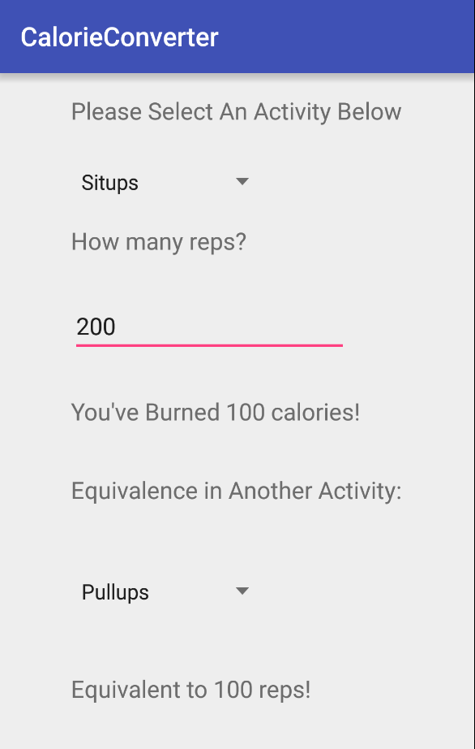

And that’s really all there is to it. There are many other activities a user could experiment with, but the core user interaction with the app is the three input fields (top activity, middle activity amount, bottom activity), the app does the rest of the work in generating the numbers the user is curious about. One cool feature is that the app instantly updates every result the moment a new activity is selected (in either the .top or bottom field) and every moment even one digit of the middle input field changes.