**CalCalc:***The Calorie Conversion App*

**What is this? TLDR;**

An android app that converts exercise to calories burned.

**Show me the Specs**

CalCalc will:

* Provide a number field for entering how many reps/minutes, a radio button to select if the input was reps or minutes, and another radio button to select the type of exercise done
* Provide a text field for showing the converted value (calories burned)
* Provide a button to update the converted value

**How do I use this??**

After opening the app you will come across a screen featuring . Do not worry this screen is where you want to be. Staring at this screen is interesting, but as the minutes tick by you have to impulse to find out how many calories are burned by doing 20 pushups. You chose “pushups” in the scrollable exercise input and then punch in 20 to the number of reps. Hitting “convert” you find that it is only 5 (lame!). Scrolling through the list of exercises below you see what it takes to burn 5 calories.

**Candid Screenshots**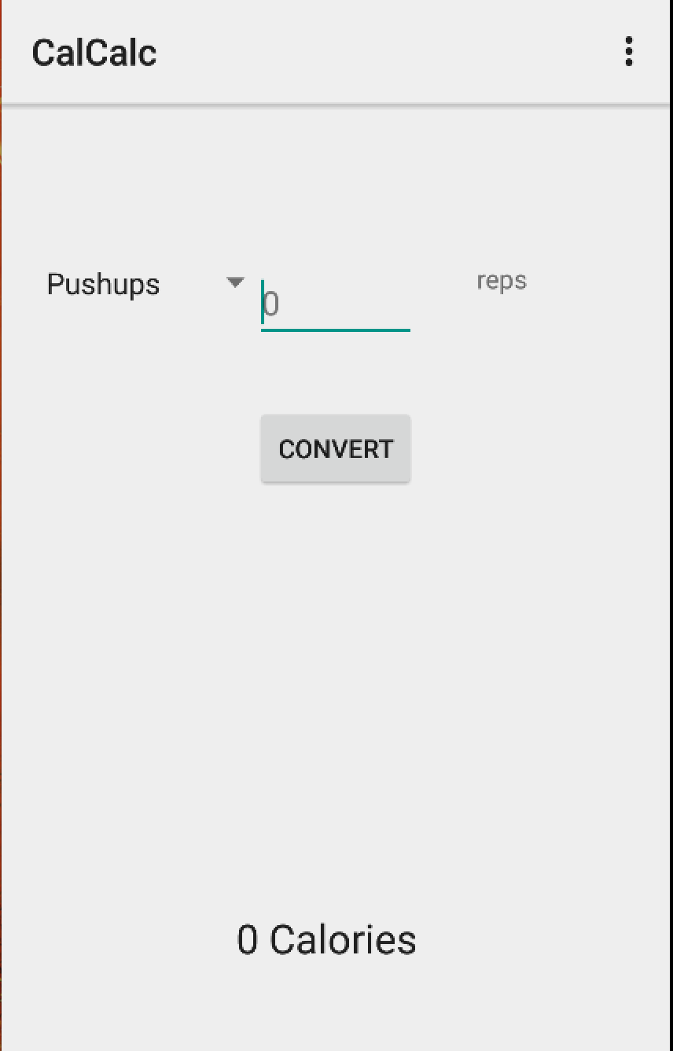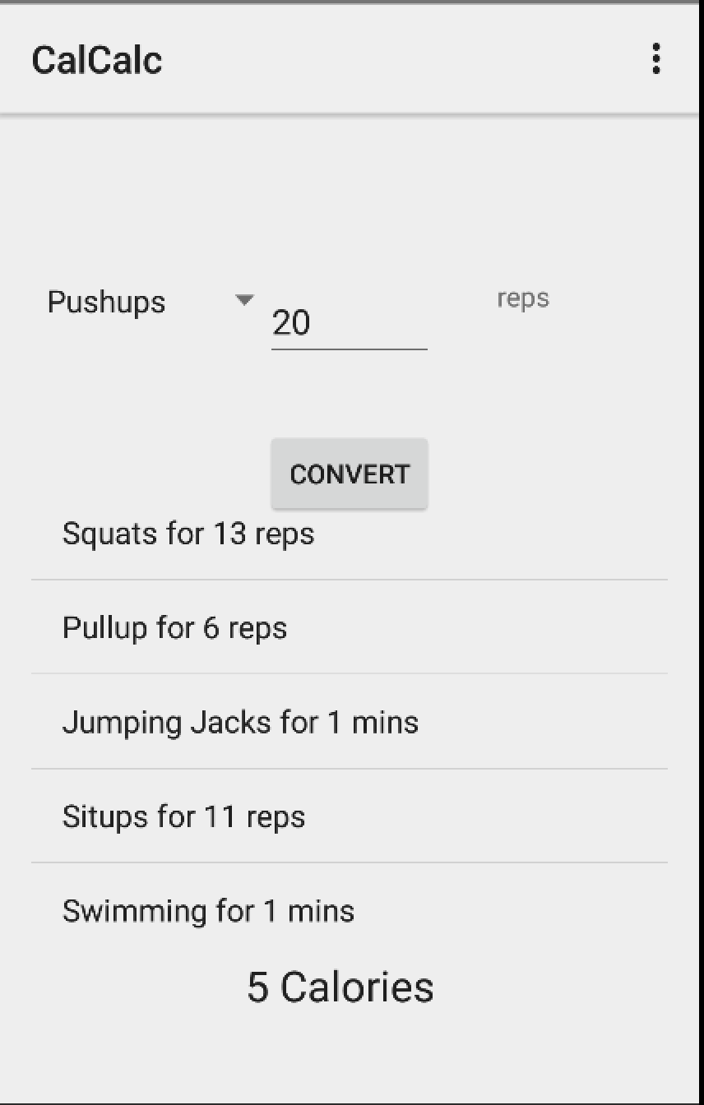

Conversion Screen

Home Screen

**How do you use this?**

Check out how I use it… <https://www.youtube.com/watch?v=T8OHffCs-a4>

**I want it! Where can I find this?**

Go to **<https://github.com/chasesmith95/calcalc.git>**