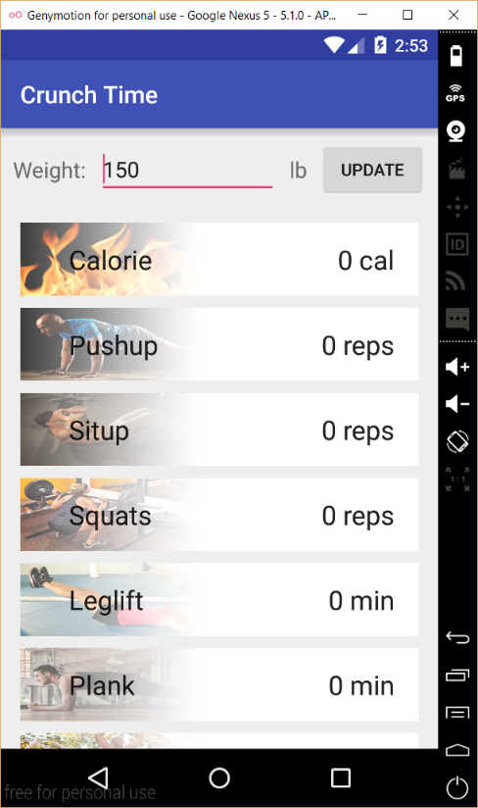



**Crunch Time**

**Introduction**

Crunch time is an android application for android smart phone that allows users to easily convert amount of daily exercises to calories burned and/or other exercises. Use this converter to discover exercises that suit you best.

Video Demonstration Link (Youtube): <https://youtu.be/Bmrib4xTrVI>

Github Repository Link: https://github.com/cs160-sp16/prog-01-crunch-time-jlee257

**Features**

* Conversion between:
  + Pushup
  + Situp
  + Squats
  + Leg-lift
  + Plank
  + Jumping Jacks
  + Pullup
  + Cycling
  + Walking
  + Jogging
  + Swimming
  + Stair-Climbing
* Convert calories to exercises and exercises to calories. Users can set target calorie and see how much exercise they need.
* Adjustable weight
* Supports vertical and horizontal orientation. All elements are auto scaled.

**How to use**

Convert



Crunch Time’s UI is very simple: it has only one activity.

The main page—the only page—consists of the title bar, weight bar and the list of exercises.

1. To convert, simply click or tap on the exercise that needs to be converted

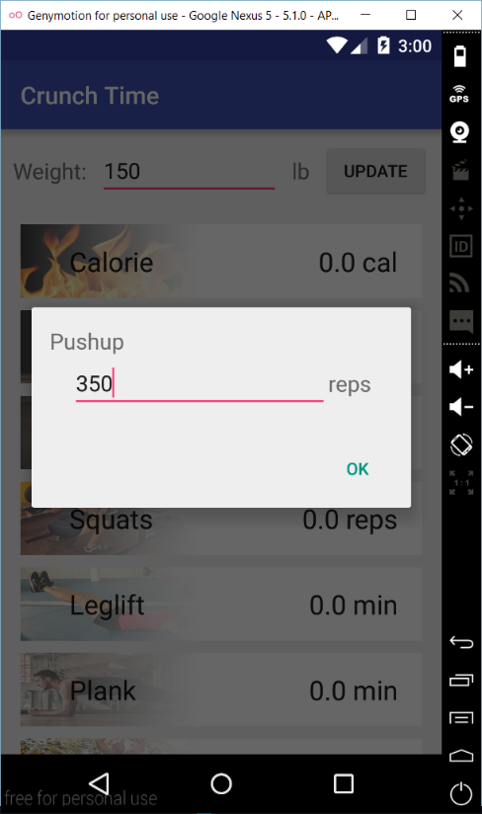

2. After a small window popup, type in the amount of the exercise and click/tap on “OK”

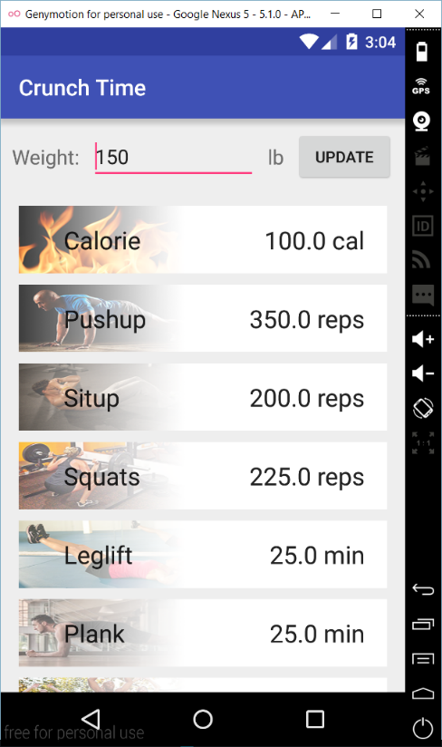

3. Values for all exercises changes.

Notice that the app also shows how much calorie is burned.

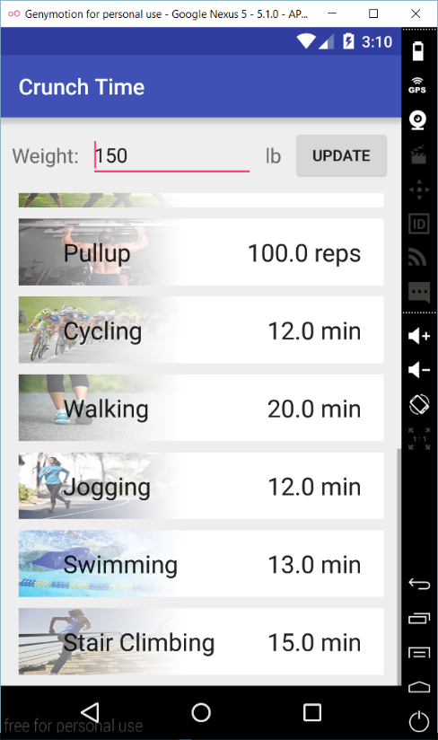

4. Scroll down to see the rest of the list.

The title bar and the weight bar are always fixed on top.

Adjust weight

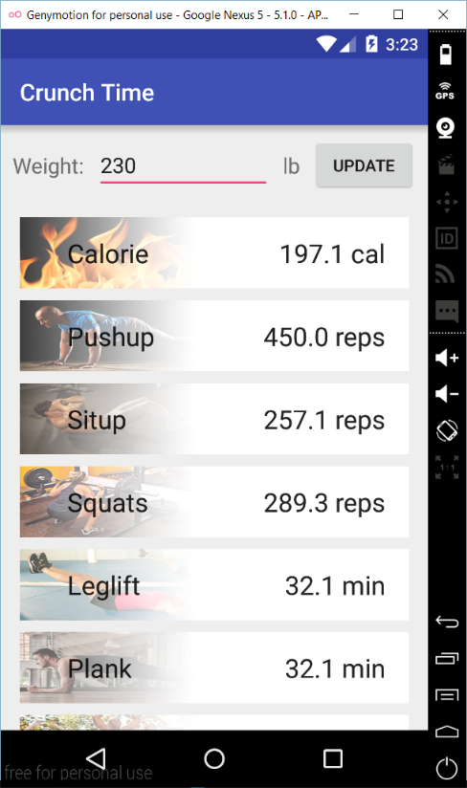

1. Input number in pounds and press “UPDATE” on the weight bar to adjust weight. The burned calorie is also changed.

Calculate exercise using calorie

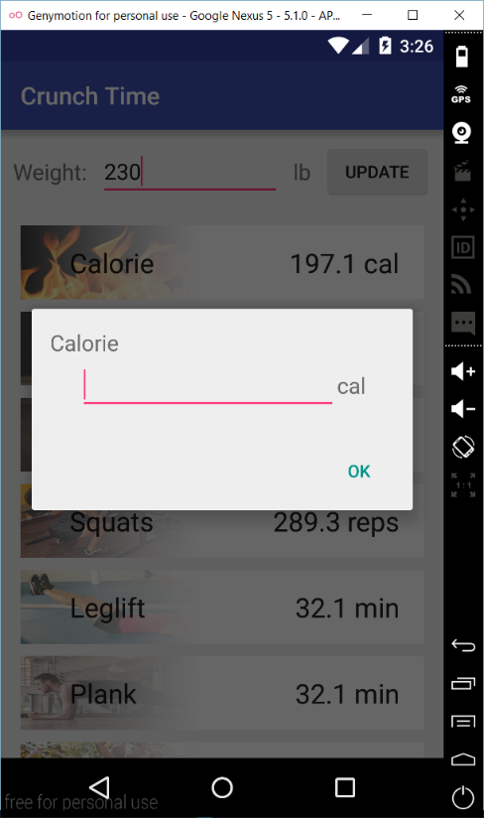

1. Click/tap on “Calorie” and type in the amount of calorie.

2. The amount of exercises that equivalent to the calories is shown once the user press “OK”.

Rotate

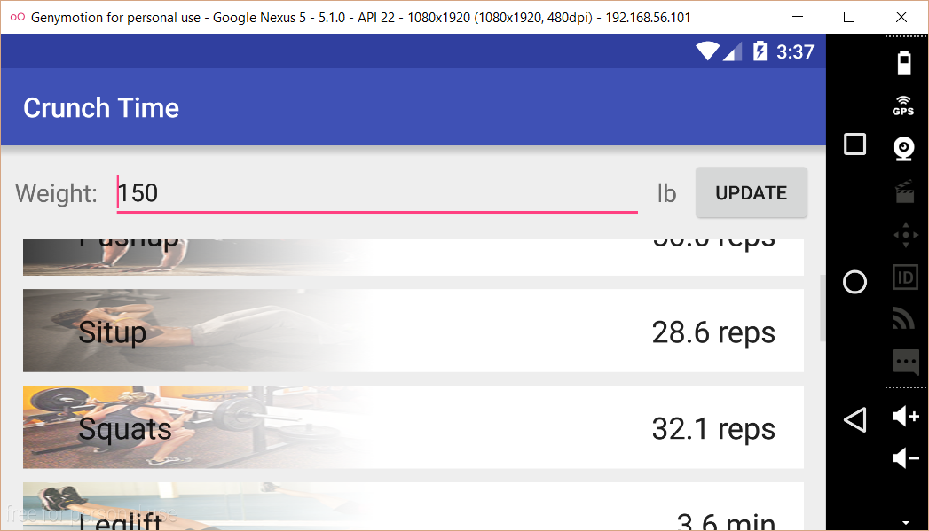

Rotate the device to see horizontal view.