Crunch Time

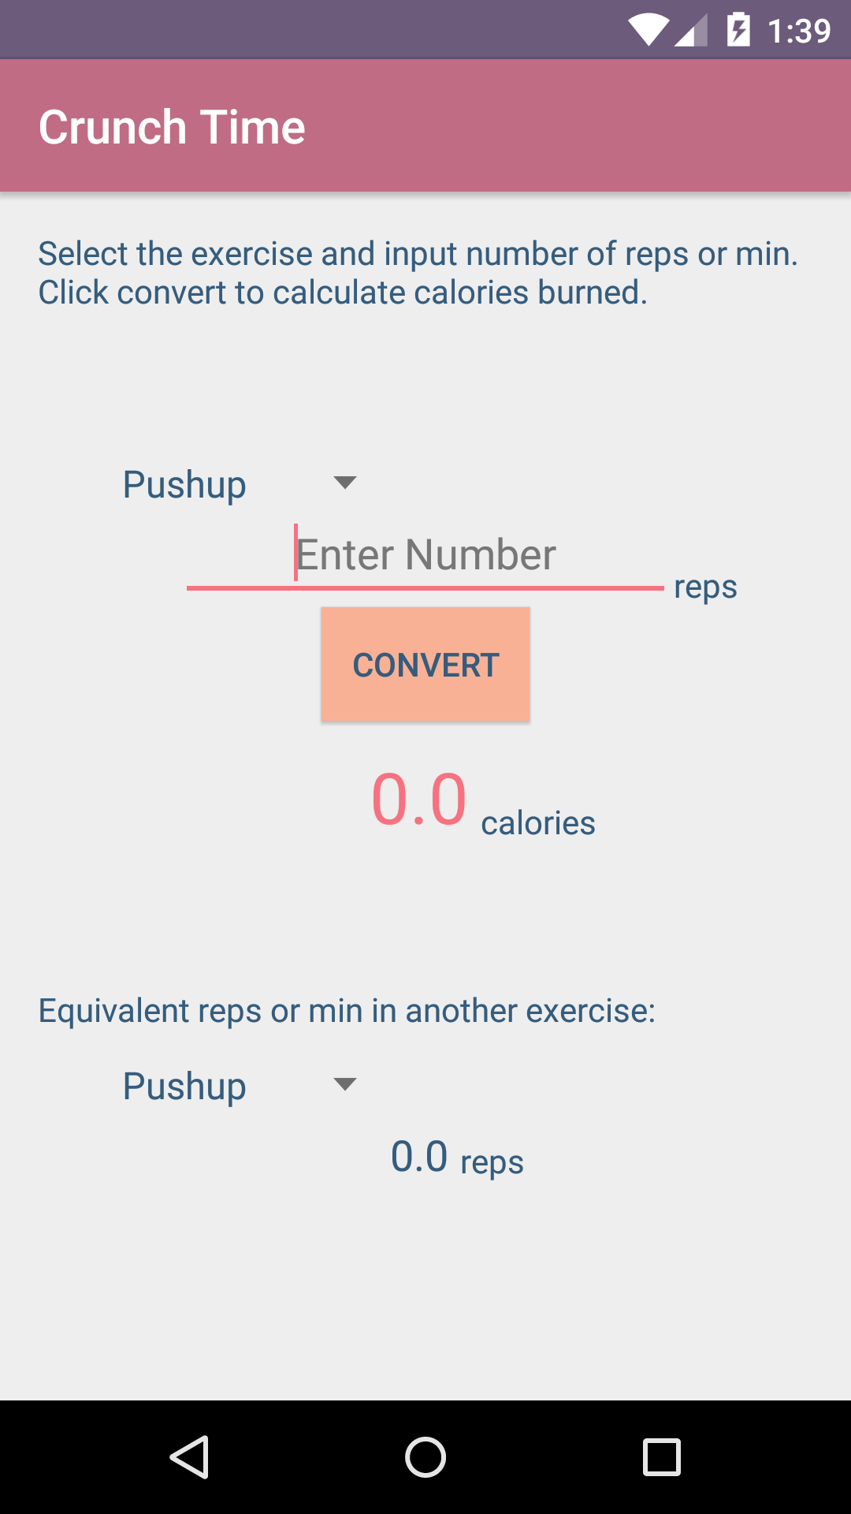

Kathy Liang

Functionality

* This Android application converts repetitions or minutes of an exercise to number of calories burned.
* It also automatically shows the number of repetitions or minutes required in another exercise to burn the same number of calories.
* The label changes automatically depending on the exercise.
* Twelve exercises are included in the list.

How to Use

* Select an exercise from the drop down list.
* Enter the number of repetitions or minutes completed.
* Press the convert button to calculate the number of calories burned as well as repetitions or minutes required in another exercise to burn the same number of calories.
* To see the calorie calculation for a different exercise and/or a different number of repetitions or minutes, input them and press the convert button again.
* Equivalent exercises are generated automatically based on the calories shown and do not need button presses.

Screenshots

