CAL2 (CALories CALculator)

CS160 Programming Assignment 1: Crunch Time

**

*Jian Qiao (Jack)*

Video: https://youtu.be/3LRFfCp3J5c

Github link: https://github.com/cs160-sp16/prog-01-crunch-time-qiaojianjack

CAL2 is a simple app that let users convert between their workout efforts and calories counts. It features a simple-to-use interface, in which user can input the amount of the exercise they do and immediately see the equivalent calories burned or equivalent amount of other types of exercises. It also supports converting calorie counts to the amount of exercises needed. Currently it supports 12 types of common exercises.

Interaction

Following is a description of the interactions on the app, along with screenshot.

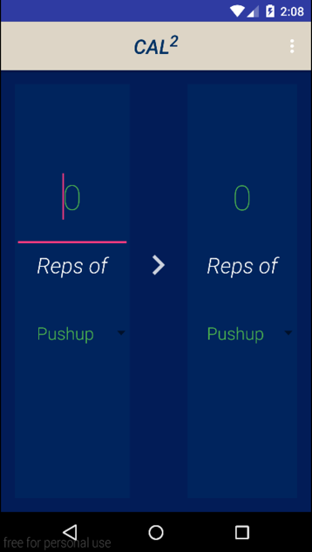

When user opens the app it goes into the following screen. The app is divided into two parts: the left parts where user could input their exercise/calories and the amount, and the right part where user see the converted value and change the desired destination exercise type.

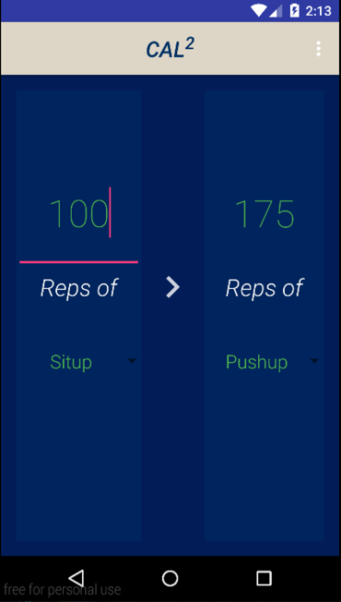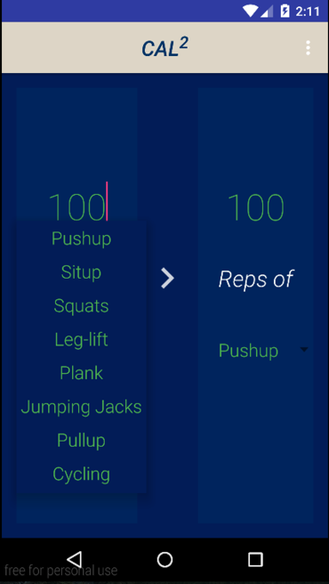

User could input the amount of exercises, and tap the spinner on the bottom left to select their exercise type.

After input, the converted value is automatically calculated, no need to click and buttons.

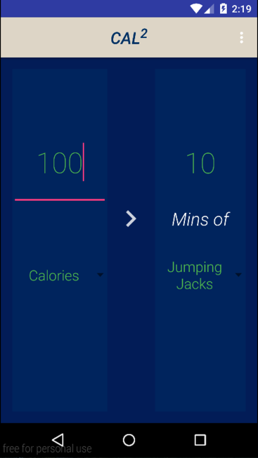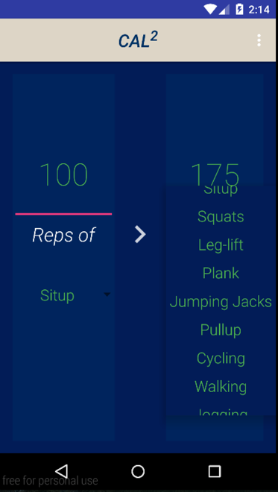

User can also tap the spinner on the bottom right to change the type of exercise they would like to convert to. After the type of exercise on the right is changed, the converted value on the right will be updated automatically.

The app also supports converting calories to exercises, by just selecting “calories” at the left side. Also, when user updates the exercise type, the unit will automatically change according to the selected exercise type so that user knows what the value actually stands for (e.g. reps for pull-up, mins for jogging, and none for calories)