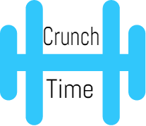

**By:** Yang Yu

[**Demo Video**](https://www.youtube.com/watch?v=Mx7_0RYuk_w)[**Download**](https://github.com/cs160-sp16/prog-01-crunch-time-theyangyu96)

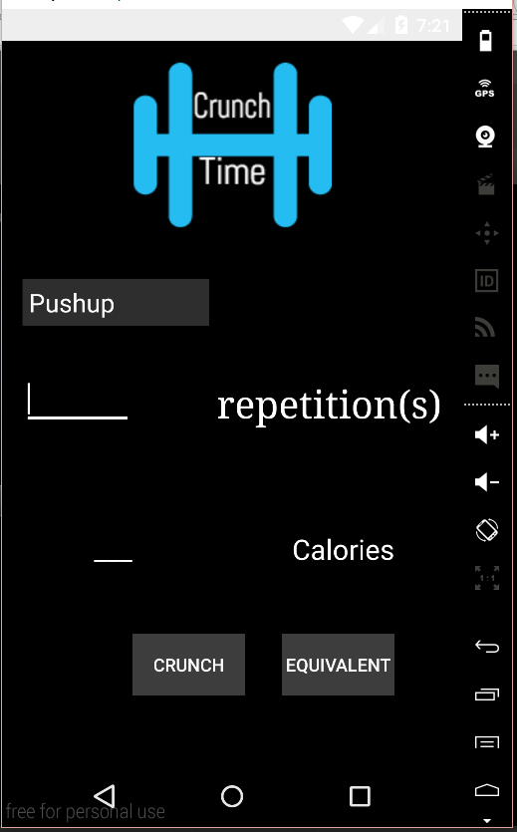

Welcome to CrunchTime, the personal health tracker. The user can

select an exercise by first clicking the spinner and picking an exercise.

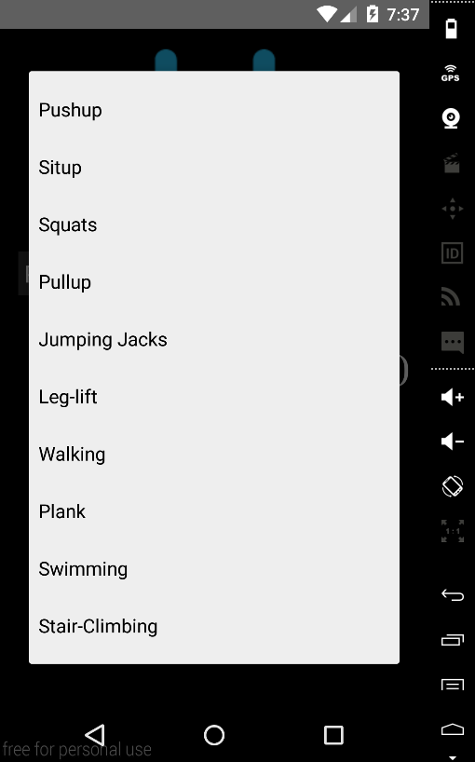

The spinner allows the user to pick one of the ten different exercises. Depending on the exercise type, the app responds by changing between repetition mode and time mode.

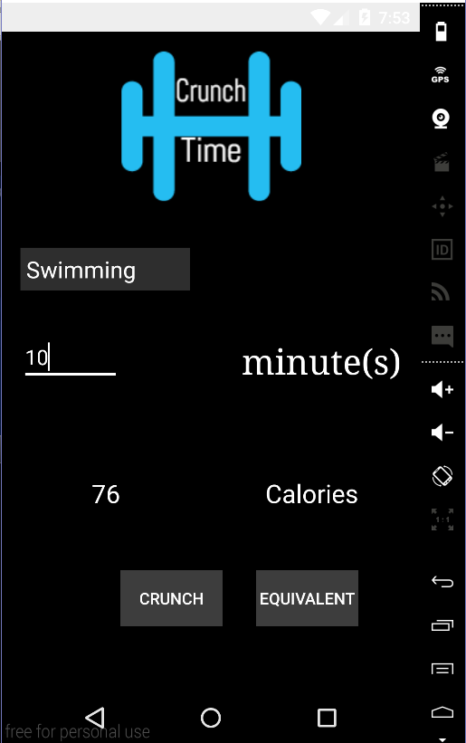

After selecting an exercise, the user can enter the amount of the exercise to **CRUNCH** amount of calories burned.

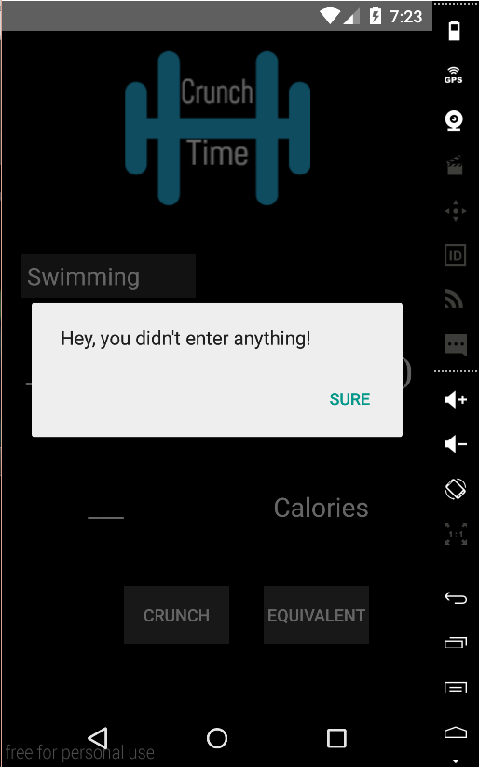

The application performs a sanity check – If the user does not enter any number in the TextField but attempts to crunch the numbers, an alert would pop up.

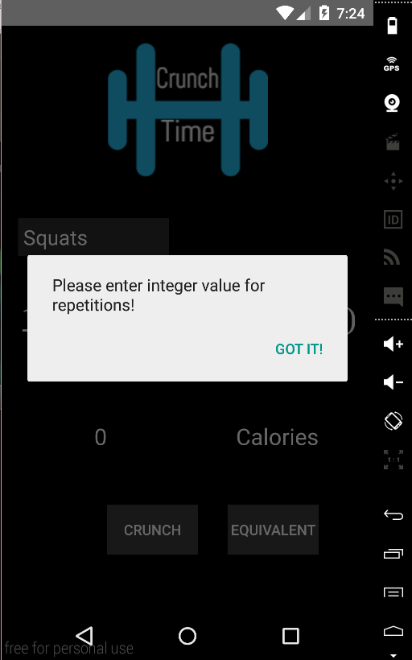

The sanity check also makes sure any repetition exercises are integer numbers.

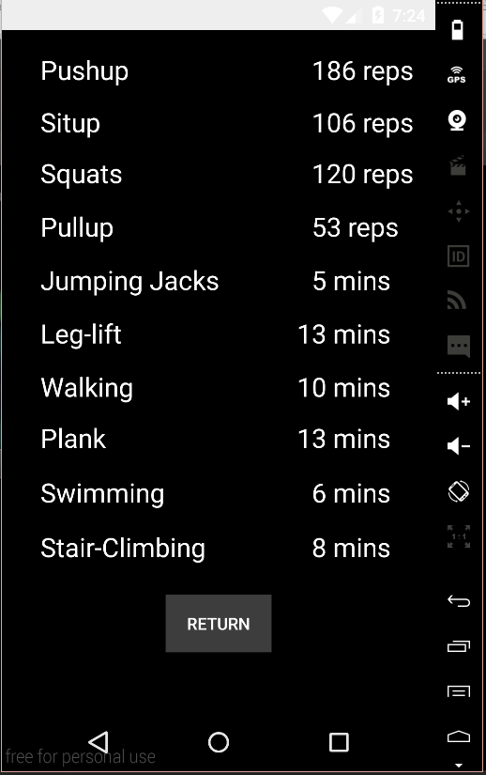

Finally, by pressing **EQUIVALENT**, the user can see what the equivalent exercises would be if the user wants to burn the same amount of energy.

Welcome to **CrunchTime**