Location Input Screen



Current Location

On click, this button gets the current GPS location from Google Location API.

Zip Code

On click, the zip code “button” erases its placeholder text and presents the onscreen keyboard.

Nuts and Bolts

Each way of getting location is piped to the Google Geolocation API, which returns data including the location’s state and county.

The location is used to request data from the Sunlight API. This includes a Twitter handle which is used by Twitter Fabric to get the user’s last Status (aka Tweet) and profile image url. The url is used to download the image.

Iteration

This screen remained the same as when I initially conceived it for Figma wireframes.

Representative List View

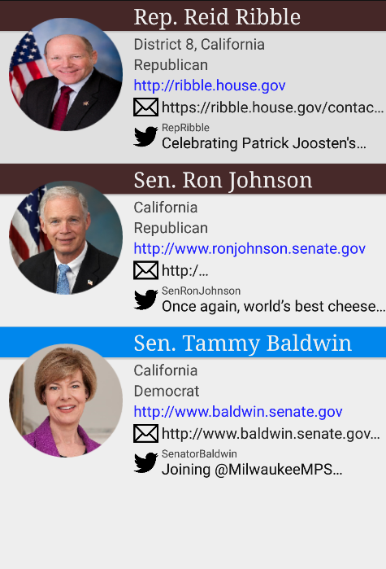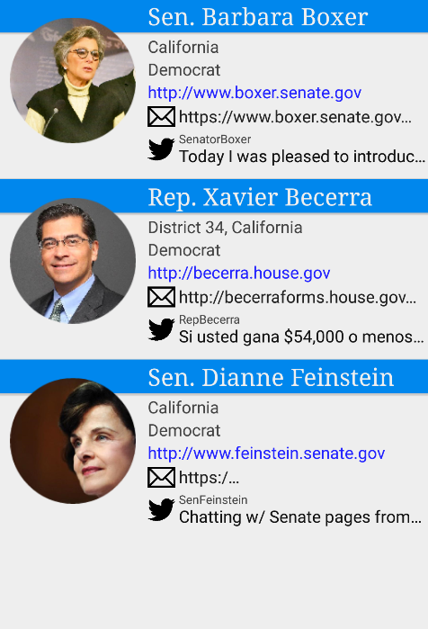

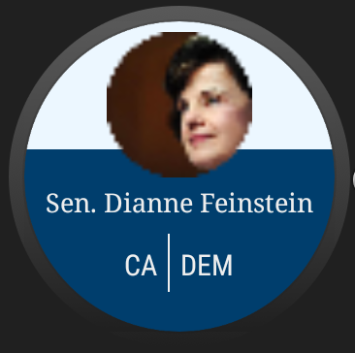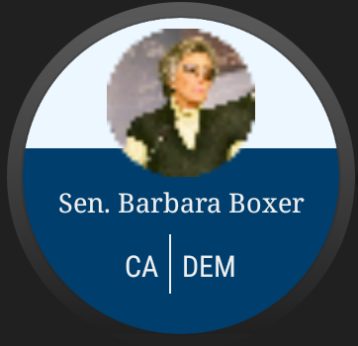

Interaction

On click, the representative view for the clicked representative will be brought up. During this view, the watch also shows its

Presentation

The color of the title bar adapts to the party of the representative. The primary two being obvious, independents show in green.

Iteration

(original wireframe)

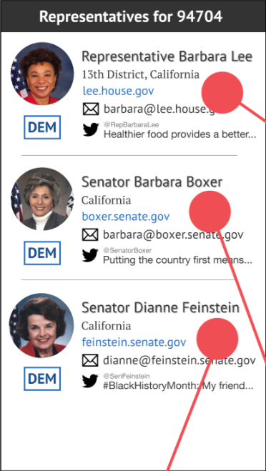I decided to go with larger images to take advantage of modern smartphones’ high resolution screens. I also added a colored title bar to each item in lieu of the party icon. The icon seemed out of place, perhaps implying that party is the most important part of a representative, which I dislike.

Representative View

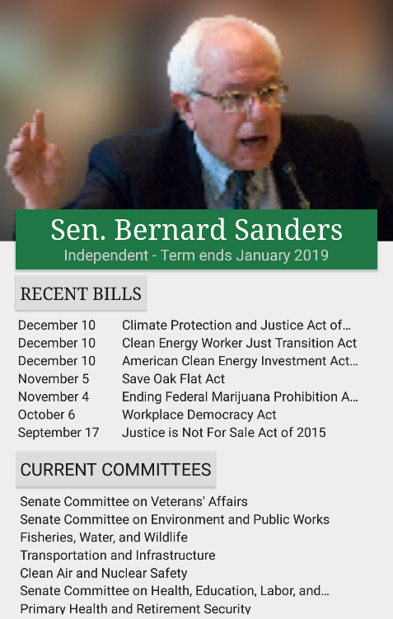

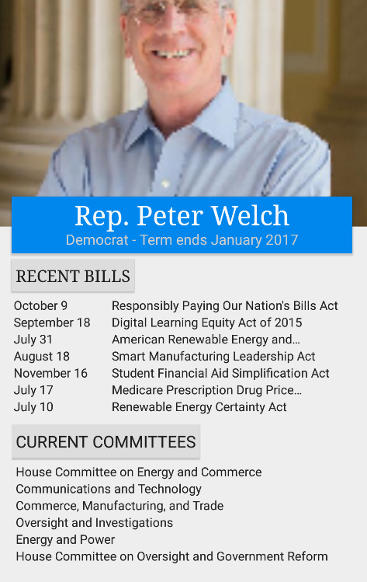

Presentation

The color of the title bar adapts to the party of the representative.

Iteration

(original wireframe)

I decided to go with larger images to take advantage of modern smartphones’ high resolution screens. I also added a colored title bar to each item in lieu of the party icon. The icon seemed out of place, perhaps implying that party is the most important part of a representative, which I dislike.

Election View

Interaction

On click, the representative view for the clicked representative will be brought up. During this view, the watch also shows its

Presentation

The color of the title bar adapts to the party of the representative. The primary two being obvious, independents show in green.

Iteration

(original wireframe)

I decided to go with larger images to take advantage of modern smartphones’ high resolution screens. I also added a colored title bar to each item in lieu of the party icon. The icon seemed out of place, perhaps implying that party is the most important part of a representative, which I dislike.