Software Requirements

Specification

for

SiQuoia

Version 2.0

Prepared by
Ryan Alcoran
Joe Lee
Shivalik Narad
Nam Phan
Swapna Vemparala
Amber Wong

CS 160 SQ06

9/29/2013

Revision History
Name | Date | Reason For Changes | Version
v1 | 9/11/2013 | Initial creation | 1
v2 | 9/29/2013 | Final draft | 2

Table of Contents

Table of Contents
1. Introduction
1.1 Purpose
1.2 Scope
1.3 Definitions, Acronyms, and Abbreviations
1.4 References
1.5 Overview
2. Overall Description
2.1 Product Perspective
2.1.1 System Interfaces
2.1.2 User Interfaces
2.1.3 Hardware Interfaces
2.1.4 Software Interfaces
2.1.5 Communications Interfaces
2.1.6 Memory
2.1.7 Operations
2.1.8 Site Adaptation Requirements
2.2 Product Functions
2.2.1 Homepage Functions
2.2.2 User Functions
2.2.3 Userpage (Personal) Functions
2.2.4. Play (Take Quiz)
2.2.5 Game Reporting
2.2.6 Referrals
2.2.7 Submit Questions
2.2.8 SiQuoia Store
2.3 User Characteristics
2.4 Constraints
2.5 Assumptions and Dependencies
3. Specific Requirements
3.1 External Interfaces
3.1.1 Database
3.2 Functions
3.2.1 Homepage Functions
3.2.1.1 Register
3.2.1.2 Login
3.2.1.3 Tutorial
3.2.2 User Functions
3.2.3 Userpage Functions
3.2.4 Take Quiz
3.2.4.1 Play
3.2.4.2 Game Mode
3.2.4.3 Mode Options
3.2.4.4 Answer Question
3.2.4.5 Mid-Quiz Menu
3.2.5 Game Reporting
3.2.6 Referrals
3.2.7 Submit Questions
3.2.8 SiQuoia Store
Appendices
Appendix A: Hardware Requirements
Appendix B: Project Plan
Appendix C: Team Staffing
Appendix D: Background Information
Index

1. Introduction

1.1 Purpose
The purpose of this document is to provide a detailed description of the quiz program known as SiQuoia. It will provide detailed descriptions on what this application will do, including functions and features of the program; interfaces; and constraints in which the program will operate on. This document is intended for the stakeholders at SiQuo
ia Inc.

1.2 Scope
The software system known as SiQuoia is a simple quiz program with packages consisting of one question and four answers, with only one answer being correct. The program is designed to increase the intelligence quotients of users or provide training or help in a certification processes. Each question will have a rank based on the number of times it is answered correctly.
The system will have a Web browser interface in which users may play as a guest or a registered user. If registered, the system will allow users to log in, resume their most recently unfinished quiz (if such a quiz exists), select a game mode and begin a new quiz, view and publish their progress analysis, and submit new quiz questions. The system will also allow registered users to claim rewards in the game store using cash or SiQuoia points and refer new users.
The Web interface will interact with a database to keep track of user and game information.

1.3 Definitions, Acronyms, and Abbreviations
- Gamer - See User
- MCQ - Multiple Choice Question
- Product - The MCQ game known as SiQuoia
- Progress Analysis - The user’s highest quiz score (most number of questions answered correctly) in a particular quiz packet, as well as the combined score percentage of all quizzes taken by the user.
- SeQuoia - See SiQuoia
- SiQuoia - Simple Intelligence Quotient Increasing Application
- Stakeholder - The person(s) with an interest or concern in the success of SiQuoia, including the client, development team, and gamers.
- User - The person(s) who operate or interact directly with the product

1.4 References
- IEEE 830 Software Requirements Specifications.pdf <https://sjsu.instructure.com/courses/1016334/files/29202258>

1.5 Overview
The next section, Overall Description, will contain an overview of the functions and features of the program. Following it, the third section, Specific Requirements, will go further into detail of the functions defined in section two.

2. Overall Description

2.1 Product Perspective
The SiQuoia program is independent of any other system and is intended to run on its own.

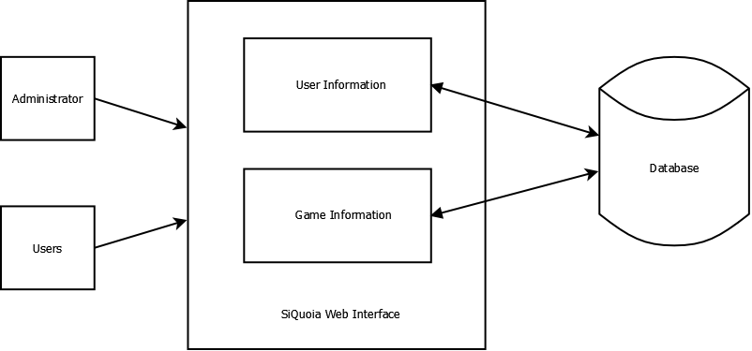
Figure 1 - SiQuoia System Overview

The SiQuoia program will allow users and administrators to log in and access the Web interface. The interface interacts with the database to display user information and game information.

2.1.1 System Interfaces

2.1.2 User Interfaces

2.1.3 Hardware Interfaces

2.1.4 Software Interfaces

2.1.5 Communications Interfaces

2.1.6 Memory

2.1.7 Operations

2.1.8 Site Adaptation Requirements

2.2 Product Functions
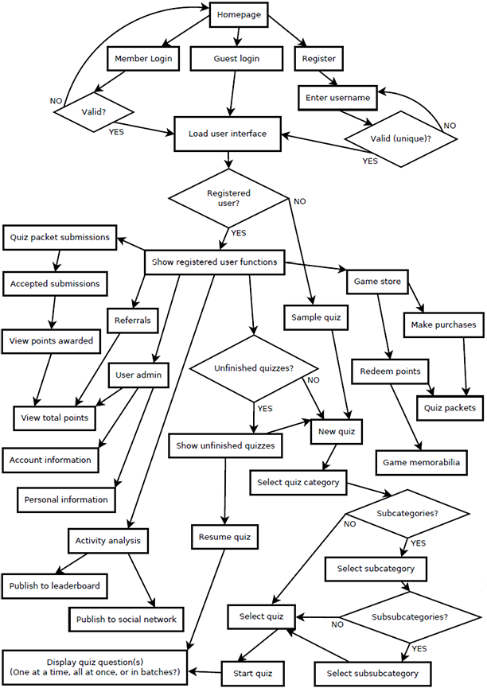
Figure 2 - SiQuoia Flow Chart

2.2.1 Homepage Functions
- Register (create member account)
- Login
  - Member
  - Guest

2.2.2 User Functions
- Access userpage (see 2.2.3)
- Access game store (see 2.2.8)
- Resume quiz
- Start new quiz (see 2.2.4)
- Track user progress (see 2.2.5)

2.2.3 Userpage (Personal) Functions
- Change password
- Update information
  - Personal information
  - Payment information

2.2.4 Play (Take Quiz)
- Tutorial
- Test
  - Select
  - Random
- Practice
  - Select
  - Random
- Answer Question

2.2.5 Game Reporting
- Post progress analysis to SiQuoia leaderboard
- Post progress analysis to social networking website

2.2.6 Referrals
- Copy personal referral link that may be sent to friends
- View total points received for referrals

2.2.7 Submit Questions
- Submit 1 question with 4 answers (1 correct, 3 incorrect)

2.2.8 SiQuoia Store
- Redeem points
- Pay with credit card

2.3 User Characteristics
People who want to test or improve their knowledge may use this software to do so. These users must have the ability to see and recognize the graphics on the screen, as well as manipulate input devices (such as a mouse and keyboard).

2.4 Constraints
- Regulatory policies:
  - One question, four answers, only one correct answer
- Platform:
  - Web application with Web server
- Control functions:
  - Mouse or Keyboard
- Tools and language requirements:
  - The software is to be implemented in Java and developed on the Eclipse platform.
- Safety and security considerations:
  - Login with unique username and strong password
  - Secure private user information, such as full name, address, and credit card information.

2.5 Assumptions and Dependencies
- SiQuoia requires a device with a Web browser and Internet access.
- The cash payment currency is in USD.

3. Specific Requirements

3.1 External Interfaces

3.1.1 Database
The system will interface with an external database. The database will house user information which includes usernames, personal information, and payment information. The system will retrieve a valid username and password from the user input, and it output all of the user information attached to the username.
The database will also contain game information.
- Name of item:
  - Database
- Description of purpose:
  - contains data of user’s information, questions and answers
- Source of input or destination of output:
  - SiQuoia Web interface
- Valid range, accuracy, and/or tolerance;
- Units of measure;
- Timing;
- Relationships to other inputs/outputs:
  - provide data to the web application
- Screen formats/organization;
- Window formats/organization;
- Data formats;
- Command formats;
- End messages.

3.2 Functions

3.2.1 Homepage Functions

3.2.1.1 Register
Precondition: The user has accessed the registration page.
- The system presents a page with a form requesting user information.
- The user then enters his or her information in each corresponding field and submits the form.
- The system checks that required fields are not blank, the username is unique, the field for 'Password' and 'Confirm Password' match, and the password and payment information are in the correct format.
  - If a required field is left blank, the user is prompted to fill in the field.
  - If a username is not unique and is already registered in the database, the user is prompted to create a new username.
  - If the password is not at least 8 characters long and/or the two password fields do not match, the user is prompted to re-enter a password in a valid format.
  - If the credit card information is not in a valid format, the user will be prompted to re-enter his or her credit card information in a valid format.
- The information is entered into the database.
Postcondition: The user has been added to the database.
Other: The user information includes name, username, password, and billing information.

3.2.1.2 Login
Precondition: The user has registered with SiQuoia (created an account) and accessed the login page.
- The system presents a page with required fields for user input of his or her login information.
- The user then enters his or her username and password in each corresponding field and submits the form.
- The system checks that the inputted values exist in the system.
  - If a required field is left blank, the user is prompted to fill in the field.
  - If an inputted value does not exist in the system, the user is prompted to reenter all login information.
Postcondition: The user input is verified, and the user successfully logs into SiQuoia.
3.2.1.3 Tutorial
Precondition: The user has accessed the homepage.
- The system presents a page with the free demo quiz.
- Jump to 3.2.4.2-1ai.
Postcondition: The system loads the pre-made quiz for the user to play.
3.2.2 User Functions
- Access game store (see 3.2.8)
- Take quizzes (see 3.2.4)
- Track user progress (see 3.2.5)

3.2.3 Userpage Functions
Precondition: The user has logged into his or her account and accessed the Userpage.
- The system presents a page to update user information.
  - The user chooses to change his or her password.
    - The system presents a page with a form to enter the current password, a new password, and confirm new password.
    - The user enters the required information.
      - If a required field is left blank, the system prompts the user to fill in the field.
      - If the current password is entered incorrectly, the system prompts the user to reenter the password.
      - If the new password is not at least 8 characters long and/or the new password field does not match the confirm password field,, the user is prompted to re-enter a password in a valid format.
    - The user password updated in the database.
  - The user chooses to update his or her personal information.
    - The system presents a page with a form to enter the user’s name, credit card number, and billing address.
    - The user enters the required information.
      - If a required field is left blank, the system prompts the user to fill in the field
    - The information is updated in the database.
Postcondition: The system updates to reflect any changes the user makes to his or her information.

3.2.4 Take Quiz
Play menu’s structure:
- Start New Game
  - The system displays a page to choose the game mode
    - Tutorial
    - Practice (only available after login)
      - Quizzes are not timed, unlimited guesses, and tells the answer.
      - The system display a page to choose the submode
        - Normal: User selects the quiz packet (packets generated from pools of ALL questions, TOPIC of questions, or SUBTOPIC of questions owned by the user)
        - Random: System randomly generates packet from ALL questions owned by the user
    - Test (only available after login)
      - Quizzes are timed (20 seconds per question), only 1 guess per question, and it does not tell the correct answer (only says correct or incorrect when the user makes a guess).
      - The system display a page to choose the submode
        - Normal: User selects the quiz packet (packets generated from pools of ALL questions, TOPIC of questions, or SUBTOPIC of questions owned by the user)
        - Random: System randomly generates packet from ALL questions owned by the user
- Option
  - The system displays a page to change the game configuration
    - Music
      - The user can change it from level 0 to level 10
    - Sound
      - The user can change it from level 0 to level 10
- Rankings
- Quit
  - The user choose this option, the game is closed
3.2.4.1 Play
Precondition: The user has logged into his or her account and accessed the Play page.
- The system presents the Play menu.
  - The user selects Resume.
    - If the user does not have an quiz saved in the database, the system alerts the user that there are no unfinished quizzes to resume.
    - If the user has an unfinished quiz, the system resumes the quiz.
      - Jump to 3.2.4.3-2.
  - The user selects Start New.
    - Jump to 3.2.4.2.
Postcondition: The system either loads the user’s unfinished quiz, or presents choices for a new game.
3.2.4.2 Game Mode
Precondition: The user has accessed the Play page and chosen to start a new quiz.
- The system presents a page with game modes.
  - The user selects Tutorial mode.
    - The system selects the free demo quiz.
  - The user selects Test mode.
    - Jump to 3.2.4.3.
  - The user selects Practice mode.
    - Jump to 3.2.4.3.
Postcondition: The system registers the selected game mode, then presents the user with mode options.
3.2.4.3 Mode Options
Precondition: The user has selected a game mode and accessed the mode options page.
- The system presents a page with mode options.
  - The user selects the option Normal.
    - The system loads quiz packets available for the user to choose from.
      - The user selects a quiz packet to play.
  - The user selects the option Random.
    - The system selects questions from all quiz packets available to the user.
- The system arbitrarily selects 100 questions from the chosen topic and loads the quiz.
Postcondition: The system loads the quiz and the user begins playing.
3.2.4.4 Answer Question
Precondition: The system has loaded the quiz that the user chose.
- The system presents a page with information available to the game mode.
  - If the user selects Tutorial mode, the system presents a page with one question and four answers.
  - If the user selects Test mode, the system presents a page with a one question, four answers, and a 20 second timer that counts down to zero.
  - If the user selects Practice mode, the system presents a page with one question and four answers.
- The user selects the radio button corresponding to the answer that user believes is correct and clicks submit.
  - If an answer is selected, it is submitted to the system.
  - If no answer is selected, a null value is submitted to the system.
  - If gaming in Test mode and the timer reaches zero before the user submits an answer, the currently selected answer is automatically submitted to the system.
- The system checks whether the user has selected the correct answer.
  - If the correct answer is submitted, the system displays “Correct” on the page.
    - If gaming in Test mode, the system updates the database by increasing the question’s rank attribute by 1 and increasing the user’s current quiz score attribute by 1.
  - If the correct answer is not submitted, the system displays “Incorrect” on the page.
    - If gaming in Practice mode, the user is given another chance to answer correctly. Jump to 3.2.4.4-2
- The system saves the current state of the quiz in the database and presents a mid-quiz menu page.
Postcondition: The system presents a page with an option to continue or pause the quiz.
3.2.4.5 Mid-Quiz Pop-Up Menu
Precondition: The user has finished a quiz question and the system presents a page with the option to continue or pause the quiz.
- The user chooses to continue to the next question.
  - Jump to 3.2.4.3.
- The user chooses to pause the quiz.
  - The system saves the current state of the quiz in the database.
Postcondition: The system updates and responds to the user’s input.

3.2.5 Game Reporting
Precondition: The user has logged into his or her account and accessed the Progress page.
- The system presents a page with the option to post his or her progress analysis to the leaderboard or to a social networking website.
  - If the user chooses to post the progress analysis to the leaderboard, the system updates his or her statistics on the SiQuoia leaderboard.
  - If the user chooses to post the progress analysis to a social networking website, the system presents the user with website options.
    - The user may select which external social networking website the system will to post to.
Postcondition: The user’s progress analysis is successfully posted.

3.2.6 Referrals
Precondition: The user has logged into his or her account and accessed the Referral page.
- The system presents a page with a textbox that contains the user’s unique referral link that may be sent to friends externally.
Postcondition: The user copies his or her unique referral link to send to friends.

3.2.7 Submit Questions
Precondition: The user has logged into his or her account and accessed the Submission page.
- The system presents a page with a form that contains fields to enter one question, one correct answer, and three incorrect answers.
- The user enters the information into the appropriate fields.
  - All questions and answers are entered by the user in text format.
    - If a user chooses to include multimedia (image or video) in the submission, then the user must provide a link to the aforementioned multimedia.
- The system receives the submission and returns the user to the Submission page.
- The system verifies the submission internally.
  - If the submission is valid, SiQuoia Administration accepts it into the database; the question is added to the appropriate quiz packet(s) and 1 point is awarded to the user.
  - If the submission is invalid, SiQuoia Administration rejects it; the question is not added, and 0 points are awarded to the user.
Postcondition: Quiz packet(s) are updated accordingly, and the user is awarded the appropriate number of points.

3.2.8 SiQuoia Store
Precondition: The user has logged into his or her account and accessed the store page.
- The system presents a page with table with the quiz packets , game memorabilia along with their costs in terms of points.
- The user chooses an item to purchase.
  - If the user chooses to purchase additional quiz packets, the system presents the user with purchasing options.
    - If the user chooses to purchase a packet with SiQuoia points, the system subtracts the point cost from the user’s total points and unlocks the packet in the database.
    - If the user chooses to purchase a packet with money, this system charges the user’s credit card and unlocks the packet in the database.
  - If the user chooses to purchase game memorabilia, the system presents the user with purchasing options.
    - If the user chooses to purchase game memorabilia with SiQuoia points, the system subtracts the point cost from the user’s total points, subtracts 1 from the item’s stock in the database and allows the user to enter the billing and shipping address for the selected item.
    - If the user chooses to purchase game memorabilia with money, the system charges the user’s credit card, subtracts 1 from the item’s stock in the database and allows the user to enter the billing and shipping address for the selected item.
- The system registers the purchase and updates the database accordingly.
Postcondition: The system charges the user (either in SiQuoia points or monetarily) in exchange for the item purchased, and it updates the database accordingly.

Appendices

Appendix A: Hardware Requirements
- Computer (laptop or desktop)
- Phones (that can open Web browsers)
- Tablets (that can open Web browsers)

Appendix B: Project Plan
- Tools Presentation
- Project Milestone I Requirements submission
  - Do Cost Estimations
  - Start laying out the Design Patterns
    - Make Class Diagrams
    - List Design Patterns
    - Design Database
  - Do Risk Management and Analysis
- Project Milestone II Analysis and Design submission
  - Start Coding(based on Design Pattern and Class Diagram)
  - Do Code Testing
  - Do Risk Management and Analysis
- Project Milestone III Review
  - Optimize the existing code
  - Do Code Testing
  - Do Risk Management and Analysis
- Project Milestone IV Final Deliverable
- Project Presentations

Appendix C: Team Staffing
Name | Role | Portfolio
Joe Lee | Business Manager | Python, C, C++, SQL, Markup Latex,  GNU/Linux, FreeBSD
Swapna Vemparala | Project Manager | C, SQL, Java, worked for around 2 years as systems engineer
Nam Phan | Development Manager | Java, C++, C#, SQL, Oracle DB, like to work  with algorithm and database
Shivalik Narad | Development Manager | Java, MySQL, Oracle, some knowledge of JSON data format, HTML, CSS, PHP, Netbeans, Eclipse
Amber Wong | Risk Manager | Java, some C, C#, HTML/CSS, some PHP, JavaScript, work mainly with website design, currently taking database class, worked a little with MySQL
Ryan Alcoran | Test Manager | Java, MySQL, Oracle, SQL, Database Design,  Normalization etc, some basic experience with  Android dev, GIT

Appendix D: Background Information
- SiQuoia is similar to a MCQ quiz program, where one question and four relevant answers are presented, with one and only one answer being correct.
- Question sets need to be divided into three categories - Field → Subject → Area. For example, Science → Physics → Mechanics. Whether the questions appear from topics, subtopics, or at random depends on the gamer’s choice.
- Participation in SiQuoia requires a small registration fee. Sample game can be paid without requiring a registration fee, however registration fee will be require in order to continue beyond sample set. A login is required at the beginning of each game session.
- New achievements will be unlocked and points will be awarded as the player progresses through the game. Earned points can help a gamer to buy new quiz packets and game memorabilia.
- Points can also be earned in the following ways:
  - when the gamer submits a question and it gets verified
  - introducing a new member to play beyond sample sets
- Special game sets can be made such as quizzes based on DMV, multimedia, etc.
- Once the gamer leaves the game, it can be restored at the same level once gamer logins again.
- A leaderboard will also be created. Scores listed on the leaderboard are updated by the user.

Index
Gamer pg #
Multiple Choice Quiz (MCQ) .
SeQuoia .
SiQuoia .
Stakeholder .
User .

