Software Requirements

Specification

for

SiQuoia

Version 1.0

Prepared by
Ryan Alcoran
Joe Lee
Shivalik Narad
Nam Phan
Swapna Vemparala
Amber Wong

CS 160 SQ06

9/11/2013

Revision History
Name | Date | Reason For Changes | Version
v1 | 9/11/2013 | Initial creation | 1

Table of Contents

Table of Contents
1. Introduction
1.1 Purpose
1.2 Scope
1.3 Definitions, Acronyms, and Abbreviations
1.4 References
1.5 Overview
2. Overall Description
2.1 Product Perspective
2.1.1 System Interfaces
2.1.2 User Interfaces
2.1.3 Hardware Interfaces
2.1.4 Software Interfaces
2.1.5 Communications Interfaces
2.1.6 Memory
2.1.7 Operations
2.1.8 Site Adaptation Requirements
2.2 Product Functions
2.2.1 Homepage Functions
2.2.2 User Functions
2.2.3 Multiple Choice Quiz
2.2.4 Game Reporting
2.2.5 Submit Questions
2.2.6 Referrals
2.2.7 Redeem Points
2.2.8 Make Purchases
2.3 User Characteristics
2.4 Constraints
2.5 Assumptions and Dependencies
3. Specific Requirements
3.1 External Interfaces
3.1.1 Database
3.2 Functions
Appendices
Appendix A: Hardware Requirements
Appendix B: Project Plan
Appendix C: Team Staffing
Appendix D: Notebook Log
Appendix E: Background Information
Index

1. Introduction

1.1 Purpose
The purpose of this document is to provide a detailed description of the quiz program known as SiQuoia. It will provide detailed descriptions on what this application will do including functions and features of the program, interfaces, and the constraints in which the program will operate on. This document is intended for the stakeholders at SiQuoia Inc. as well as the developers.

1.2 Scope
The software system known as SiQuoia is a simple quiz program with problem sets consisting of one question and four answers with only one correct answer. The program is designed to increase intelligence quotient in users, provide training and certification processes. Each question will have a difficulty ranking based on the average number of tries it takes to answer the question correctly.
The system will have a web browser interface in which users can log in and view any of their unfinished quizzes or start a new quiz, see their stats and achievements, or submit new questions. The user can also claim rewards such as memorabilia or other question sets and refer new users to join.
The web interface will interact with a database to keep track of user and game information.

1.3 Definitions, Acronyms, and Abbreviations
- Gamer - See User
- MCQ - Multiple Choice Questions
- SeQuoia - See SiQuoia
- SiQuoia - Simple Intelligence Quotient Increasing Application
- Stakeholder - The person(s) with an interest or concern in the success of SiQuoia, including client, gamers, and development team
- User - The person(s) who operate or interact directly with the product

1.4 References
- IEEE 830 Software Requirements Specifications.pdf <https://sjsu.instructure.com/courses/1016334/files/29202258>

1.5 Overview
The next section, Overall Description, will contain an overview of the functions and features of the program. Following it, the third section Specific Requirements will go more into detail of the functions defined in section two.

2. Overall Description

2.1 Product Perspective
The SiQuoia program is independent of any other system and is intended to run on its own.

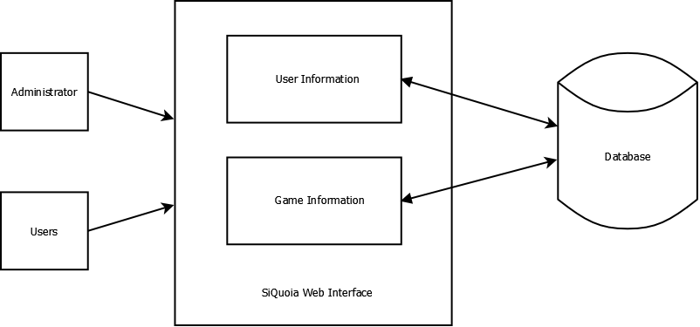
Figure 1 - SiQuoia System Overview

The SiQuoia program will allow users and administrators to login and access the Web interface. The interface interacts with the database to display user information and game information.

2.1.1 System Interfaces

2.1.2 User Interfaces

2.1.3 Hardware Interfaces

2.1.4 Software Interfaces

2.1.5 Communications Interfaces

2.1.6 Memory

2.1.7 Operations

2.1.8 Site Adaptation Requirements

2.2 Product Functions
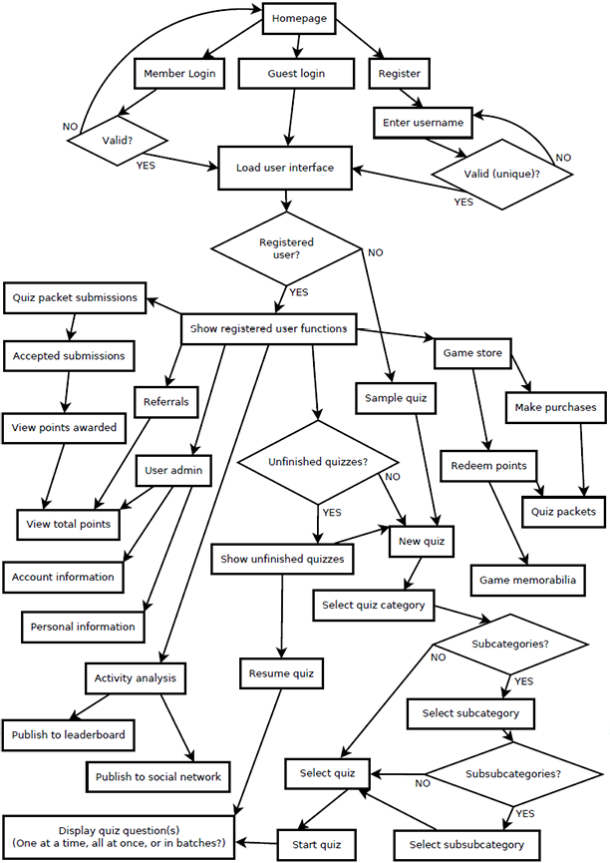
Figure 2 - SiQuoia Flow Chart

2.2.1 Homepage Functions
- Register (create member account)
- Login
  - Member
  - Guest

2.2.2 User Functions
- Change password
- Update personal information
- Update payment information
- Access game store (see 2.2.6 and 2.2.7)
- Take quizzes (see 2.2.3)
- Track user progress (see 2.2.4)

2.2.3 Multiple Choice Quiz
- “One question, four answers”
  - One correct, three incorrect (but relevant to the question)
- Questions organized in topics/3 levels of subtopics
  - Questions presented within topic/subtopic
- Question ranking
  - Different level of difficulty among questions
    - Rank based on number of tries it takes users to answer a question
      - Harder questions worth more points than easier (see Features > Earning points)
    - Easy: average number of tries before answering correctly → t = 1
    - Medium: average number of tries → 1 < t <= 3
    - Hard: average number of tries → t > 3
- Interactive (user given choices)
- Questions presented at random

2.2.4 Game Reporting
- Post progress analysis to leaderboard
- Post progress analysis to social network

2.2.5 Submit Questions
- Submit questions from within game
  - Each has 4 relevant answers (1 correct, 3 incorrect)
- Submissions verified, edited, and categorized within system
- 50 points awarded for verified and accepted submissions

2.2.6 Referrals
- Users may refer friends. Points are awarded for referrals when the friend registers and plays beyond the sample set.
  - 1-4 referrals: 50 points
  - 5 referrals: 100 points
  - 10 referrals: 200 points, special game packet
  - Every 10 referrals thereafter: 200 points
  - 100 referrals: option of 1,000 points or special memorabilia

2.2.7 Redeem Points
- Additional question packets can be purchased with points earned
- Game memorabilia can be purchased with points earned

2.2.8 Make Purchases
- Additional question packets can be purchased using credit card

2.3 User Characteristics
People who want to test their knowledge can use this software. They need to have the ability to see and recognize the graphics on the screen, as well as manipulate input devices (such as mouse and keyboard).

2.4 Constraints
- Regulatory policies:
  - One question, four answers, only one correct answer
- Platform:
  - Web application with Web server
- Control functions:
  - Mouse or Keyboard
- Tools and language requirements:
  - The software is to be implemented in Java and developed on the Eclipse platform.
- Safety and security considerations:
  - Login with unique username and strong password
  - Secure private user information, such as full name, address, and credit card information.

2.5 Assumptions and Dependencies
None.

3. Specific Requirements

3.1 External Interfaces

3.1.1 Database
The system will interface with an external database. The database will house user information which includes usernames, personal information, and payment information. The system will retrieve a valid username and password from the user input and output all the user information attached to the username.
The database will also contain game information.
- Name of item:
  - Database
- Description of purpose:
  - contains data of user’s information, questions and answers.
- Source of input or destination of output:
  - SiQuoia web interface
- Valid range, accuracy, and/or tolerance;
- Units of measure;
- Timing;
- Relationships to other inputs/outputs:
  - provide data to the web application
- Screen formats/organization;
- Window formats/organization;
- Data formats;
- Command formats;
- End messages.

3.2 Functions
- The system shall determine the type of user based on user input.
  - The system shall ask the gamer to enter a username and password in order to log in to the user account.
  - The system shall allow the gamer to log in as a guest.
- The system shall accept the selected answer choice by the gamer and notify the gamer if the answer is correct or not.
- The system shall allow the gamer to select only one answer choice at a time.
  - The system shall allow multiple answer submissions per question until the correct answer is submitted.
- The question sets shall be categorized into topics and subtopics, up to three levels.
- The system shall provide questions to the gamer in a random fashion or by the gamers choice of topic or subtopic.
- The system shall require all gamers to register to take the SiQuoia quiz
  - All users shall be able to access the sample quiz
  - The system shall check for users who have paid the specified registration fee and only allow those users to playing beyond the sample set.
- The system shall allow the players to progress through levels.
  - The system shall track the player's achievements and award points.
  - The system shall allow the gamer to accumulate Points which can later be exchanged for rewards such as quiz packets and game memorabilia.
- The system shall allow gamers to submit questions within the game
  - The system shall only accept questions with four relevant answers of which one and only one is correct.
  - The system shall only allow authorized members to verify, edit and categorize (Topic, subtopics) these questions.
  - The system shall award these Gamers with points for the verified questions submitted.
- The system shall allow the Gamers to earn points for introducing new gamers that register and play beyond the sample game.
- The system shall make the Games available in question packets that can be purchased with either cash or reward points.
- The system shall allow the Game status for each gamer to be stored when a gamer leaves the system and restored when a gamer logins again.

Appendices

Appendix A: Hardware Requirements
- Computer (laptop or desktop)
- Phones (that can open Web browsers)
- Tablets (that can open Web browsers)

Appendix B: Project Plan
- Tools Presentation
- Project Milestone I Requirements submission
  - Do Cost Estimations
  - Start laying out the Design Patterns
    - Make Class Diagrams
    - List Design Patterns
    - Design Database
  - Do Risk Management and Analysis
- Project Milestone II Analysis and Design submission
  - Start Coding(based on Design Pattern and Class Diagram)
  - Do Code Testing
  - Do Risk Management and Analysis
- Project Milestone III Review
  - Optimize the existing code
  - Do Code Testing
  - Do Risk Management and Analysis
- Project Milestone IV Final Deliverable
- Project Presentations

Appendix C: Team Staffing
Name | Role | Portfolio
Joe Lee | Business Manager | Python, C, C++, SQL, Markup Latex,  GNU/Linux, FreeBSD
Swapna Vemparala | Project Manager | C, SQL, Java, worked for around 2 years as systems engineer
Nam Phan | Development Manager | Java, C++, C#, SQL, Oracle DB, like to work  with algorithm and database
Shivalik Narad | Development Manager | Java, MySQL, Oracle, some knowledge of JSON data format, HTML, CSS, PHP, Netbeans, Eclipse
Amber Wong | Risk Manager | Java, some C, C#, HTML/CSS, some PHP, JavaScript, work mainly with website design, currently taking database class, worked a little with MySQL
Ryan Alcoran | Test Manager | Java, MySQL, Oracle, SQL, Database Design,  Normalization etc, some basic experience with  Android dev, GIT

Appendix D: Notebook Log
# | Meeting Logs
1 | Note meeting - Sep 5 2013  -Java  -Git  -Egit for eclipse  -Eclipse -swapna  -OpenProject - Joe  -Bugzillar  -Amazon (Ryan), account on CS department GNU/Linux server  *Question to professor
2 | Time:  Sep 06 2013, at 9:00 PM through Skype  Member present:  Nam, Amber, Shivalik  Member not present:  Topic:  Role & Tools  Details:  reschedule meeting for 9/7/2013 so hopefully more members can make it. post when you are available in “Meeting weekend Sep 1-7” thread on Google Group  Rough Draft Presentation (by Joe):  0-tools.pdf 0-tools.tex  222 KB View Download 3 KB View Download
3 | Time:  Sep 07 2013, at 9:00 AM through Skype  Member present:  Nam, Swapna, Shivalik  Member not present:  Topic:  Role & Tools (cont.)  Details:  Collect in formation and screen shot  -Shivalik: OpenProject  -Swapna: Eclipse  -Nam: Git, Github, Bugzilla  Next meeting: Sep, at night 07 and morning 08
4 | Time:  08 Sept 2013, 9:00 - 9:55AM on Skype  Members Present:  Amber, Shivalik, Swapna  Topic:  Roles, Tools/Presentation  Details:  - Agreed to set meeting dates at least a week in advance so that everyone has time to plan accordingly, and those who do not attend the meeting do not have a say in whatever is on the meeting agenda (makes it easier to decide things, since it is hard to get everyone together all at once for a group decision)  - Who is comfortable/interested in presenting? See Amber’s Google Group thread to volunteer.  - Requested Roles:  - Nam: Development, Test  - Joe: Project, Business  - Swapna: Project, Risk, Business (no development)  - Ryan: Development, Test  - Shivalik: Project, Development  - Amber: Risk (don’t care, but no business)  - Tentative Roles (post in Google Group if you object):  - Nam: Development  - Joe: Business  - Swapna: Project  - Ryan: Test  - Shivalik: Development  - Amber: Risk  * Note: Everyone will help in all roles, you are just officially responsible for your position  To Do:  - Monday: Assignment 1 Tools  - See GitHub for presentation  - Submit presentation on Canvas  - Tuesday: Assignment 1 Tools PRESENTATION  - Do we need to print the instruction sheet and write our names next to the tools we plan to use?  - Thursday: RFP Requirements (See IEEE format)  Next Meeting: Tuesday, 9/10 at 9:00 PM on Skype
5 | Time:  10 Sept 2013, 9:05 - 10:32PM on Skype  Members Present:  Amber, Ryan, Shivalik, Swapna  Topic:  RFP  Details:  - Discussed what SRS includes  - Flow Chart diagram  - High-level requirements (IEEE format)  - User Stories??  - Questions?  - What is “a small registration fee” that is required to participate? (Money? If so, how much?)  - What is the format that users submit questions to the game?  - What is the number of default questions (for the sample set, as well as for the question pack)?  - Shivalik(?) will e-mail Ishie for clarification  - We will all contribute to our list of requirements for now  - We will format the requirements after hearing back from Ishie  To Do:  - Thursday, 9/12: RFP Requirements (See IEEE format)  - Thursday, 9/19: Assignment 2 Cost Estimations  Next Meeting: TBA

Appendix E: Background Information
- SiQuoia is similar to a MCQ quiz program, where you have one question followed by four answers with one and only one correct answer.
- Question sets need to be divided into three categories - Field→Subject→Area. For example
Science → Physics → Mechanics. Whether the questions appear from topics, subtopics or at random depends on the gamer’s choice.
- Participation in SiQuoia requires a small registration fee. Sample game can be paid without requiring a registration fee, however registration fee will be require in order to continue beyond sample set. A login is required at the beginning of each game session.
- New achievements will be unlocked and points will be awarded as the player progresses through the game. Earned points can help a gamer to buy new quiz packets and game memorabilia.
- Points can also be earned in the following ways -
  - when the gamer submits a question and it gets verified
  - introducing a new member to play beyond sample sets
- Special game sets can be made such as quizzes based on DMV, multimedia, etc.
- Once the gamer leaves the game, it can be restored at the same level once gamer logins again.
- A leaderboard will also be made and regularly updated.

Index
Glossary
- Gamer - See User
- MCQ - Multiple Choice Questions
- SeQuoia - See SiQuoia
- SiQuoia - Simple Intelligence Quotient Increasing Application
- Stakeholder - The person(s) with an interest or concern in the success of SiQuoia, including client, gamers, and development team
- User - The person(s) who operate or interact directly with the product

Client - Interview Questions
Question:
Thursday, August 29, 2013 at 11:37 PM, Amber Wong <ayw92@yahoo.com>
The RFP says that users/gamers can earn points for submitting questions to the game. Does this mean that they earn points for any submission, or only ones that are verified and accepted?
Response:
Friday, August 30, 2013 8:08 AM, Badari S. Eswar <badari.eswar@sjsu.edu>
If gamers can earn points for any submission, would that be an opportunity to scam the game? You need to think about such issues while doing the analysis and design.

Emailed Questions

Q - My team is wondering
1) if we only have to turn in the things that are listed in the RFP document under the "Proposal Contents" ?
2) and do we also need to follow the IEEE standards?
A - Yes and yes! You need to turn in sections listed in RFP and follow
IEEE 830 1998 SRS standard. Idea is to get your SRS started and fill
out as much as possible. When you have detailed requirements, you will
refine the same SRS for completeness.

