

**Department of Computer Science**

**CS2005 Networks & Operating Systems Task 1**

Academic Year 2018-19

<Student Name>

<Student ID e.g. 1234567>

Table of Contents

1. Introduction 3

2. Test Network Documentation 4

3. bankClient and bankServer Documentation 5

4. bankClientUpdate and bankServerUpdate Documentation 6

5. Updated Software Problems and Suggested Fixes 7

6. Conclusions 8

# 1. Introduction

Introduce your report and give an overview of its contents.

# 2. Test Network Documentation

The purpose of this section is to allow you to demonstrate that your network is functioning correctly. To do this you will have set up the network topology as specified in the assignment (shown in the following diagram).

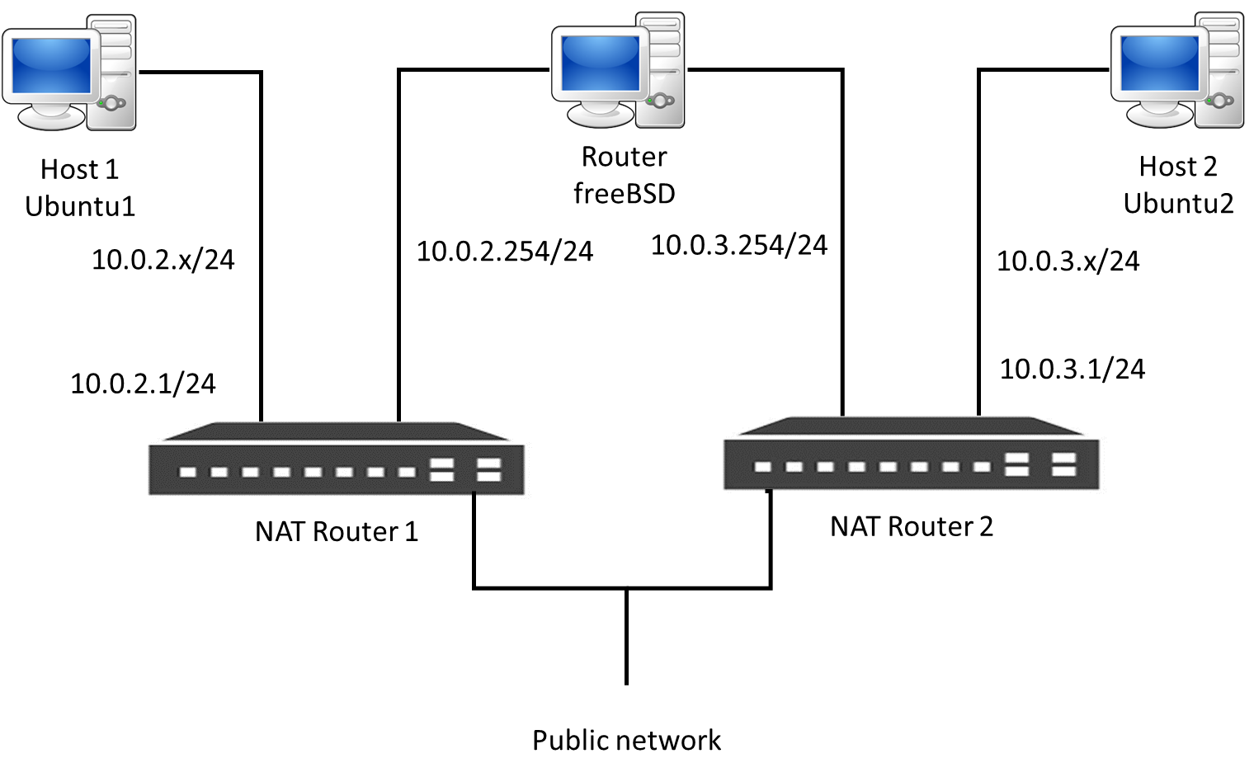

**Figure 1: Test Network Configuration**

Your network will therefore have two subnets that communicate via a router. You will have configured the subnet IP addresses as shown in Figure 1. The hosts’ IP addresses will be dynamically allocated by the DHCP server.

To demonstrate that your network is correctly working you will use screenshots of ifconfig, netstat, ping and wireshark as shown in the ICMP tutorial (note that If the routes between the two hosts do not exist in the routing tables of the hosts, add them as in the ICMP tutorial). To show that you know what these mean you will also need to write a short description (around half a page) of how each of these show that your network is correctly working. The key to this is demonstrating that you can identify the IP addresses of the source and destination hosts and that you can send and receive packets between the hosts.

# 3. bankClient and bankServer Documentation

Here you will show the **bankClient** and **bankServer** protocol. To do this, get a copy of bankClient and bankServer from BBL. Run the client and the server as you have done in the Distributed Systems tutorial (on your test network). Using wireshark, systematically capture the protocol for all the banking functions. Describe these in your report using a protocol table.

Basically you just need to add your protocol table. Nothing else (apart from a small amount of descriptive text).

# 4. bankClientUpdate and bankServerUpdate Documentation

This section captures your **bankClientUpdate** and **bankServerUpdate** protocol. To do this, get a copy of the updated software from BBL. Run the client and the server as you have done in the Distributed Systems tutorial (on your test network). Using wireshark, systematically capture the protocol for all the banking functions. Describe these in your report using a protocol table.

Basically you just need to add your protocol table and a small amount of descriptive text that shows where you think things have gone wrong with the application.

# 5. Updated Software Problems and Suggested Fixes

This section is your short report (maximum half a page) that describes the problem with the updated application and how you suggest it might be fixed. Refer to the two protocol tables to support your answer. For example you might want to start with identifying the problems…

* Problem 1
* Problem 2
* Problem 3

… and then describe each problem and a (brief) description of the fix.

Problem 1 description… Problem 1 fix… (e.g. it appears that the server crashes after the client sends message x… this might be due to the server not expecting the message in that format… etc.) We will discuss this in class.

# 6. Conclusions

Summarise what you have written in your report.